**GANDHARA UNIVERSITY**

**KABIR MEDICAL COLLEGE**

**URRICULUM**

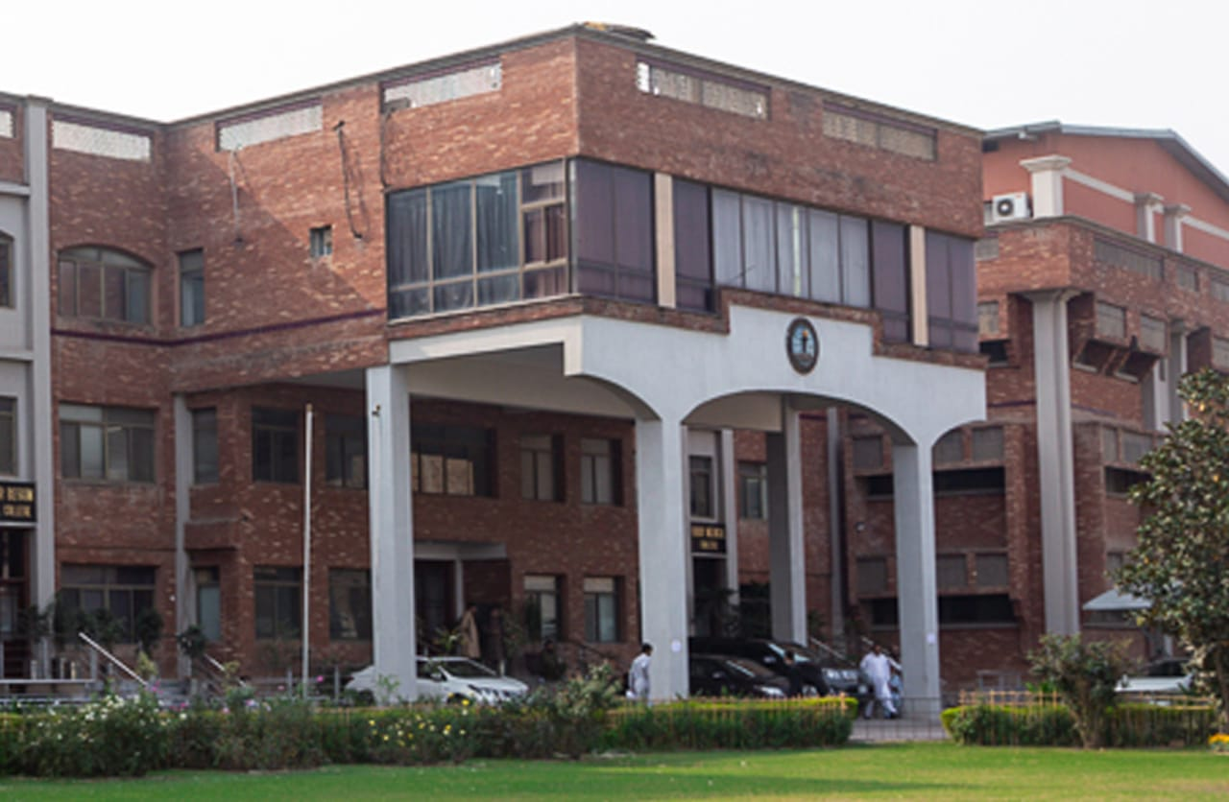

**FINAL YEAR MBBS 2024-2025**

**BLOCK 13**

**(FOUNDATION, NEURO & GIT)**

# FROM THE DESK OF PRINCIPAL

**BRIG AHMAD HUSSAIN MASHWANI(R)**

Kabir Medical College has evolved, since its inception, as an exceptionally outstanding facility to provide quality education to the students.

I must appreciate the hard work of our well experienced and dedicated faculty members and staff in maintaining high standards of medical education and the efforts they have put in Kabir Medical College to be a distinguished center of excellence.

By the grace of Almighty, we are starting the integrated curriculum for 1st year MBBS. We meet international standards of professional education by installing the system of integrated curriculum and system-based teaching of basic medical sciences. We advocate interactive sessions to improve comprehension of students as well as training them with skills of communication and self-expression.

Since the establishment of Kabir Medical College, we have been working constantly to upgrade services and facilities at the campus and the attached Naseer Teaching Hospital for our students and patients.

We would like our graduates to excel as confident, responsible, and self-learning medical practitioners. With a state-of-the-art campus, experienced faculty, an up-to-date digital library, I assure that your decision to study at Kabir Medical College will surely be a wise one, your experience here will be profoundly enriching and you will become a valuable asset to the nation and international community health care professionals.

Brig Ahmad Hussain Mashwani (R)

MBBS, FCPS(SURGERY)OJT (VASCULAR SURGERY)

CHPE, MHPE(KMU)

Principal

Kabir Medical College

Gandhara University  
 Peshawar

Dear Final Year MBBS Students,

It is my pleasure to welcome you to the Foundation of Neurosciences and GIT II module. This is a key component of your journey toward becoming a competent and compassionate physician. Throughout this course, you will build upon your previous medical knowledge and further hone the clinical skills that are essential for your professional growth. We encourage you to actively engage with the material, participate in discussions, and apply your knowledge during clinical rotations.

Your journey through this module will be challenging but immensely rewarding, as you gain the tools necessary to understand and treat some of the most intricate and critical systems of the human body. We look forward to supporting you every step of the way!

**Director DME = Dr. Marina Khan**

|  |
| --- |
| **Topic Page Number** |
| **Block Team** |
| **List of abbreviations…** |
| **Aims of the study guide…** |
| **Module distribution of Final year MBBS** |
| **Introduction of block 13…** |
| **General Outcomes…** |
| **Leaning Methodologies…** |
| **Rules Regulations** |
| **Learning objectives & Course contents** |
| **Assessment…………………………………………………………………………………………….** |
| **Learning Resources………………………………………………………………………………** |

**BLOCK TEAM**

|  |  |  |  |
| --- | --- | --- | --- |
|  | **Dr Marina Khan**  **Director of Department of Medical Education** | | **marinakahn@hotmail.com** |
| **DEPARTMENT OF GYNAECOLOGY** | |  | Prof Dr. Naheed  Prof Dr. Anjum Ara  Prof Dr. Taskin Rehana  Dr. Huma Sahibzada  Dr. Javeria |
| **DEPARTMENT OF MEDICINE** | |  | Prof Dr. Shafaq Naaz  Prof Dr. Muhammad Arshad  Prof Dr. Shafqat ur Rehman  Dr. Saleh Afridi |
| **DEPARTMENT OF SURGERY** | |  | Prof Dr. Amjad Naeem  Prof Dr. Ahmed Hussain Mishwani  Prof Dr. Ahmad Zeb  Prof Dr. Sadia Nawaz |
| **DEPARTMENT OF PEADS** | |  | Prof. Dr Aneela  Prof Dr. Rifayat Ullah  Assist Prof Dr. Irum Naz  Assist Prof Dr. Farida Shirazi  Senior Registrar Dr. Saman |
| **DEPARTMENT OF ANAESTHESIA** | |  | Prof Dr. Aurangzeb  Assist Prof Dr. Zain-ul-Abideen |
| **DEPARTMENT OF MEDICAL EDUCATION** | |  | Assist Prof Dr. Marina Khan  Assist Prof Dr. Syed Muhammad Junaid  Dr. Aalia Zaib  Dr. Usama Zeb |

**STUDY GUIDE:**

This study guidebook was designed by combining the efforts of all topics throughout the year to give medical students at Gandhara University a resource material that highlights significant components of the curriculum. By providing students control over their learning, the study guide aims to promote self-regulated lifelong learning.

Regarding the course content, the study guide provides an overview of the anticipated course outcomes and objectives. The assessment approach is also customized to the intuitional strategy.

A successful curriculum has a significant impact on the final product, as well as on society. This study guide was carefully designed with the PMC curriculum and rules in mind, and Gandhara University stakeholders and faculty members worked hard to personalize it to the needs of students. They are further working to build, implement, and exercise a well-built curriculum considering changing demographic needs and disease prevalence in our society. Throughout the construction of the study guide, students' feedback was received and included. Curriculum is a living, dynamic entity that is constantly changing. With each passing day, we hope to improve it.

Each module in this block has been created to cater the gap between basic and clinical subjects through pre-clinical learning. The block is divided into two modules in which the students are exposed to a variety of basic and clinical subjects. The integrated curriculum is enforced through interactive lectures, small group discussion, community outreach programs along with rotations at preclinical laboratory. There will be formative as well as summative assessment of the block throughout the modules.

**AIMS OF THE STUDY GUIDE**

It is an aid to:

* Inform students how student learning program of the BLOCK-wise module has been organized.
* Help students organize and manage their studies throughout the modules.
* Guide students on assessment methods, rules, and regulations.
* Communicates information on organization and management of the modules. This will help the student to contact the right person in case of any difficulty.
* Defines the objectives which are expected to be achieved at the end of each module.
* Identifies the learning strategies such as lectures, small group teachings, clinical skills and demonstration, tutorial that will be implemented to achieve the modules objectives.
* Provides a list of learning resources such as books, computer assisted learning programs, web- links, and journals, for students to consult to maximize their learning.
* Highlights information on the contribution of continuous and block examinations on the student's overall performance.
* Includes information on the assessment methods that will be held to determine every student's achievement of objectives.
* Focuses on information pertaining to examination policy, rules, and regulations.

**ORGANIZATION OF MODULAR CURRICULUM**

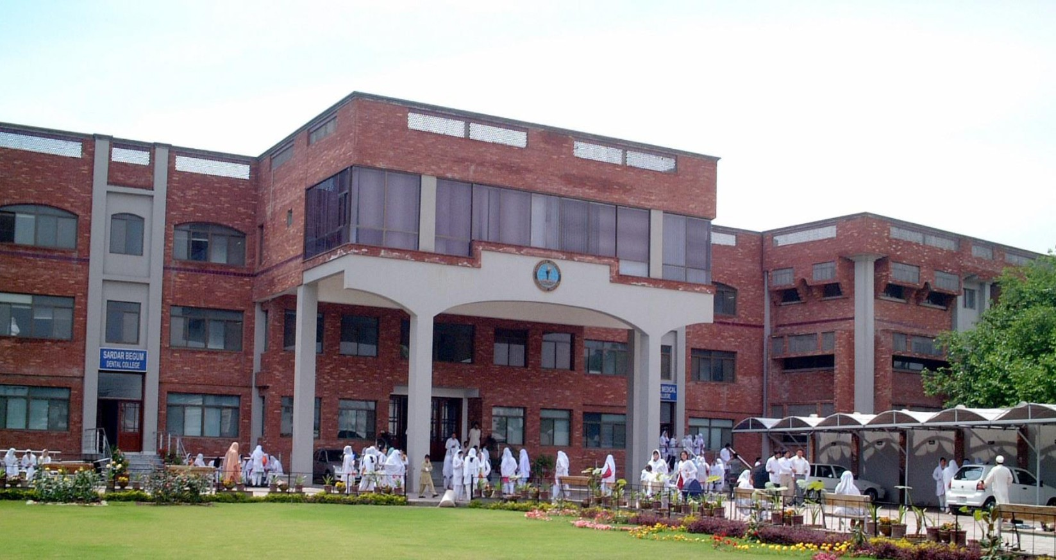

**FINAL YEAR MBBS**

|  |  |  |  |  |  |  |  |  |  |
| --- | --- | --- | --- | --- | --- | --- | --- | --- | --- |
| **Block-13** | | **Exam Block 13** | **Block-14** | | **Exam Block 14** | **Block-15** | | **Exam Block 15** | **Final Exam** |
| **Module**  **25**  Foundation | **Module**  **26**  Neurosciences & GIT | **Module**  **27**  Cardiorespiratory and reproduction module | **Module**  **28**  MSK | **Module**  **29**  Renal & blood | **Module**  **30**  Endocrinology |

**INTRODUCTION TO BLOCK-13:**

.

Welcome to the Final Year MBBS Module on Foundation of Neurosciences and GIT II. This course is designed to provide an in-depth understanding of two crucial systems in the human body: the nervous system and the gastrointestinal (GI) system. As future medical practitioners, a strong grasp of these systems is essential to diagnose and manage disorders related to the brain, spinal cord, peripheral nerves, and digestive tract effectively. This module integrates foundational knowledge with clinical skills, preparing you to face complex challenges in these specialties with confidence.Top of Form

**RATIONALE**

The final year of medical education is a pivotal period, where students transition from theoretical learning to practical clinical application. Neurosciences and Gastrointestinal (GIT) medicine are two areas that frequently overlap in clinical practice, whether in managing neurological complications of GI diseases or understanding the gut-brain axis. This module aims to equip students with the knowledge and clinical reasoning necessary to understand the intricate workings of the nervous system and gastrointestinal tract, as well as the interconnection between these systems. This understanding is fundamental for developing appropriate diagnostic and therapeutic approaches for neurological and GI disorders.

**GENERAL OUTCOMES:**

By the end of this block the students would be able to

**COGNITIVE DOMAIN:**

* Enumerate common CNS infection
* Define meningitis, enumerate & describe types, etiology & pathogenesis of acute pyogenic & aseptic meningitis
* Differentiate between acute pyogenic & aseptic meningitis
* Enumerate types of parenchymal infections
* Discuss etiology, pathogenesis of brain abscess and viral encephalitis
* Able to diagnose ambiguous genitalia
* Uterine abnormalities
* To predict antenatal complications and their
* prevention
* Learning the effectiveness of screening for prevention of carcinoma
* cervix
* Able to diagnose the malignancy
* To know the effect of treatment of women’s
* health
* To know the effect on fertility and health of
* Women.
* Able to differentiate between benign and malignant tumor
* Their management
* To differentiate between benign and malignant tumor
* Treatment methods
* Able to diagnose and treat accordingly
* Able to diagnose the disease, Its prospect on fertility - Preventive measures
* Able to diagnose the disease, Its prospect on fertility, Preventive measures
* To Learn indications for the procedure and its outcomes
* To know the indication of procedure
* Post-operative care, Future fertility prospect
* Able to diagnose the infection, its severity and effect on fetal and maternal health.
* Learn the outcome of stds
* Learn the effect on fertility, Preventive measures
* Define fever/PUO/FWLS
* Describe its causes
* Discuss a diagnostic plan & management criterion
* Enlist streptococcal diseases
* Describe their etiology, clinical manifestations, diagnosis & treatment, prevention
* Enlist staphylococcal diseases
* Describe their etiology, clinical manifestations, diagnosis & treatment, prevention
* Discuss etiology & epidemiology of disease
* Describe clinical features of diphtheria
* Outline investigations to diagnose diphtheria
* Devise a treatment plan for diphtheria & prevention
* Describe etiology & epidemiology of disease
* Discuss clinical features of tetanus
* Outline investigations to diagnose tetanus
* Discuss treatment of tetanus & prevention
* Discuss etiology & epidemiology of pertussis
* Describe clinical features of pertussis
* Outline investigations to diagnose pertussis
* Discuss treatment of pertussis & prevention
* Describe etiology & epidemiology of polio
* Discuss clinical features & differential
* diagnosis of polio
* Outline Diagnostic criteria
* Describe treatment of polio & prevention
* Define TB exposure, infection & disease
* Describe etiology & epidemiology of disease
* Discuss clinical features, types, diagnostic criteria, complications
* Discuss management phases of TB & prevention
* Describe etiology & epidemiology of measles
* Discuss clinical features & complication
* Discuss management of measles & prevention
* Describe etiology & epidemiology of the two diseases
* Describe clinical features of diseases
* Discuss management of diseases & prevention
* Describe etiology & epidemiology of disease
* Describe clinical features & complications
* Discuss management of chicken pox & prevention
* Describe etiology & epidemiology of disease
* Discuss clinical features & diagnosis
* Discuss management of malaria & prevention
* Describe etiology & epidemiology of disease
* Describe clinical features & diagnosis
* Discuss management of typhoid fever & prevention
* Define Dengue fever, dengue hemorrhagic fever, dengue shock syndrome
* Describe etiology & epidemiology of disease
* Describe clinical features & diagnosis
* Discuss management of dengue fever & prevention
* Classify different patterns of inheritance
* Classify different mechanisms of chromosomal disorders
* Discuss in detail Down/Edward/Patau syndromes
* Discuss in detail Turners/Klinefelter syndromes
* Define autism & ADHD
* Define enuresis
* Discuss the etiology & clinical features
* Describe diagnostic approach for such patients
* Outline briefly the management and prevention strategies for the diseases
* By the end of this lecture the students will be able to:
* 1-Understand the basics of General Medicine.
* 2- Enlist the major subspecialties.
* By the end of this lecture the students will be able to:
* 1-Recognize the importance of a good history.
* 2-Enlist the steps of history taking
* Know about skin appendages and their function & location
* Know about bacterial skin infections & clinical features and treatment
* Know about common viral infections and their skin manifestations & treatment
* Clinical manifestations of these and their diagnosis & treatment
* 1Eczema and its subtypes with clinical features

**ATTITUDE:**

By the end of this Block, the students will be able to:

* Follow the basic laboratory protocols.
* Participate in class and practical work efficiently.
* Maintain discipline of the college.
* Follow the norms of the college properly.
* Communicate effectively in a team with colleagues and teachers.
* Demonstrate professionalism and ethical values in dealing with patients,

cadavers, colleagues, and teachers.

* Communicate effectively in a team with colleagues and teachers.
* Demonstrate the ability to reflect on the performance.

**LEARNING METHODOLOGIES**

The following teaching / learning methods are used to promote better understanding:

* Large Group Interactive Lectures
* Small Group Discussion
* Practical
* Skills session
* E-Learning
* Self-Directed Learning

**LARGE GROUP INTERACTIVE LECTURES (LGIS)**

In large group, the lecturer introduces a topic or common clinical conditions and explains the underlying phenomena through questions, pictures, videos of, etc. Students are encouraged to actively involve in the learning process.

**SELF DIRECTED LEARNING SDL:**

Students assume responsibilities of their own learning through individual study, sharing and discussing with peers, seeking information from Learning Resource Center, teachers, and resource persons within and outside the college. Students can utilize the time within the college scheduled hours of self-study.

**E-LEARNING:**

E-Learning is a strategy by which learning occurs through the utilization of electronic media, typically the Internet. The basic aspects of medical professionalism and ethics will be addressed through an e-learning course.

**RULES AND REGULATIONS**

We will be making the journey through Block I0 in 11 weeks. Therefore, this course includes an intensive coursework load. Class attendance and participation are extremely important to learning and are considered in the evaluation of course grades. If there is anything that the module team can do to assist during the course, please feel free to contact them. Attendance will be monitored during the different teaching activities. If the attendance is less than 75%, the student will not be allowed to sit for both block and annual examination.

All examinations must be taken on the date scheduled. There will be a block exam at the end of each block covering two modules. There will be a total of 3 block examinations and the 30% weightage of these block exam will be added to the 70 % of the annual professional exam as an internal assessment. If a student faces any problem related to the block examination marks, he/she has the right to appeal for the rechecking or retotaling of the marks according to the university policy.

**MODULE –25**

**FOUNDATION**

**LEARNING OBJECTIVES & COURSE CONTENTS:**

**At the end of the teaching session the student should be able to achieve the following objectives:**

|  |  |  |
| --- | --- | --- |
| **GYNAECOLOGY** | | |
| **S.NO** | **TOPICS** | **LEARNING OBJECTIVES** |

|  |  |  |
| --- | --- | --- |
|  | Gynecological History | Enumerate common CNS infection  Define meningitis, enumerate & describe types, etiology & pathogenesis of acute pyogenic & aseptic meningitis  Differentiate between acute pyogenic & aseptic meningitis |
|  | Anatomy of female  genital tract | Enumerate types of parenchymal infections  Discuss etiology, pathogenesis of brain abscess and viral encephalitis |
|  | Developmental  abnormalities of  genital tract | Able to diagnose ambiguous genitalia  Uterine abnormalities |
|  | Antenatal care | To predict antenatal complications and their  prevention |
|  | Cervical Cancer | Learning the effectiveness of screening for prevention of carcinoma  cervix |
|  | Vaginal/Vulval  malignancy | Able to diagnose the malignancy  To know the effect of treatment of women’s  health |
|  | Fibroid Uterus | To know the effect on fertility and health of  Women. |
|  | Malignant tumor  of uterus | Able to differentiate between benign and malignant tumor  Their management |
|  | Benign and  malignant ovarian  tumor | To differentiate between benign and malignant tumor  Treatment methods |
|  | Benign diseases  of vulva, vagina  and cervix | Able to diagnose and treat accordingly |
|  | Pelvic  Inflammatory  Disease | Able to diagnose the disease, Its prospect on fertility - Preventive measures |
|  | Genital tract  tuberculosis | Able to diagnose the disease, Its prospect on fertility, Preventive measures |
|  | Minor and major  gynecological  surgery | To Learn indications for the procedure and its outcomes |
|  | Caesarian section | To know the indication of procedure  Post-operative care, Future fertility prospect |
|  | Infections in  pregnancy | Able to diagnose the infection, its severity and effect on fetal and maternal health. |
|  | Sexually  Transmitted  diseases | Learn the outcome of stds  Learn the effect on fertility, Preventive measures |
|  | History taking and examination of a pregnant patient |  |
|  | Operative Delivery (Episiotomy) |  |
|  | Ventouse and Forceps Delivery |  |
|  | The Puerperium |  |

|  |  |  |
| --- | --- | --- |
| **PAEDS** | | |
| **S NO.** | **TOPIC** | **LEARNING OBJECTIVES** |
| 1 | Fever | Define fever/PUO/FWLS  Describe its causes  Discuss a diagnostic plan & management criterion |
| 2 | Streptococcal Diseases | Enlist streptococcal diseases  Describe their etiology, clinical manifestations, diagnosis & treatment, prevention |
| 3 | Staphylococcal diseases | Enlist staphylococcal diseases  Describe their etiology, clinical manifestations, diagnosis & treatment, prevention |
| 4 | Diphtheria | Discuss etiology & epidemiology of disease  Describe clinical features of diphtheria  Outline investigations to diagnose diphtheria  Devise a treatment plan for diphtheria & prevention |
| 5 | Tetanus | Describe etiology & epidemiology of disease  Discuss clinical features of tetanus  Outline investigations to diagnose tetanus  Discuss treatment of tetanus & prevention |
| 6 | Pertussis | Discuss etiology & epidemiology of pertussis  Describe clinical features of pertussis  Outline investigations to diagnose pertussis  Discuss treatment of pertussis & prevention |
| 7 | Polio | Describe etiology & epidemiology of polio  Discuss clinical features & differential  diagnosis of polio  Outline Diagnostic criteria  Describe treatment of polio & prevention |
| 8 | TB (x2) | Define TB exposure, infection & disease  Describe etiology & epidemiology of disease  Discuss clinical features, types, diagnostic criteria, complications  Discuss management phases of TB & prevention |
| 9 | Measles | Describe etiology & epidemiology of measles  Discuss clinical features & complication  Discuss management of measles & prevention |
| 10 | Mumps & Rubella | Describe etiology & epidemiology of the two diseases  Describe clinical features of diseases  Discuss management of diseases & prevention |
| 11 | Chicken Pox | Describe etiology & epidemiology of disease  Describe clinical features & complications  Discuss management of chicken pox & prevention |
| 12 | Malaria | Describe etiology & epidemiology of disease  Discuss clinical features & diagnosis  Discuss management of malaria & prevention |
| 13 | Typhoid Fever | Describe etiology & epidemiology of disease  Describe clinical features & diagnosis  Discuss management of typhoid fever & prevention |
| 14 | Dengue Fever | Define Dengue fever, dengue hemorrhagic fever, dengue shock syndrome  Describe etiology & epidemiology of disease  Describe clinical features & diagnosis  Discuss management of dengue fever & prevention |
| 15 | Patterns of inheritance  Mechanisms of chromosomal disorders | Classify different patterns of inheritance  Classify different mechanisms of chromosomal disorders |
| 16 | Aneuploidies | Discuss in detail Down/Edward/Patau syndromes |
| 17 | Mono/polysomy | Discuss in detail Turners/Klinefelter syndromes |
| 18 | Autism/ADHD | Define autism & ADHD |
| 19 | Enuresis | Define enuresis |
| 20 | Encopresis | Discuss the etiology & clinical features |
| 21 | Poisoning/ingestions in children (x2) | Describe diagnostic approach for such patients |
| 22 | Pica | Outline briefly the management and prevention strategies for the diseases |

|  |  |  |
| --- | --- | --- |
| **SURGERY** | | |
| **S.NO** | **TOPICS** | **LEARNING OBJECTIVES** |

|  |  |  |
| --- | --- | --- |
|  | Nutrition & Support | How to assess the nutritional status of surgical patients  Types of artificial nutrition  Routes of administration, composition and complications |

|  |  |  |
| --- | --- | --- |
| **GENERAL MEDICINE** | | |
| **S.NO** | **TOPICS** | **LEARNING OBJECTIVES** |
|  | Introduction to General Medicine | By the end of this lecture the students will be able to:  1-Understand the basics of General Medicine.  2- Enlist the major subspecialties. |
|  | History taking in General Medicine | By the end of this lecture the students will be able to:  1-Recognize the importance of a good history.  2-Enlist the steps of history taking |
|  | Structure and functions of skin | Know about skin appendages and their function & location |
|  | Bacterial infection | Know about bacterial skin infections & clinical features and treatment |
|  | Viral infection | Know about common viral infections and their skin manifestations & treatment |
|  | Parasitic infection | Clinical manifestations of these and their diagnosis & treatment |
|  | Eczema | 1Eczema and its subtypes with clinical features |

**MODULE – 26**

**NEURO & GIT**

**GENERAL OUTCOMES:**

By the end of this block the students would be able to

**COGNITIVE DOMAIN:**

* Define Parkinson’s Disease
* Enumerate the causes
* Explain briefly the clinical presentation and its management.
* Construct a management plan for patient of Parkinson
* Define MND
* Explain its type
* Explain briefly the clinical presentation and its management
* Define and classify CVAs
* Explain the etiology and clinical presentation of stoke.
* Defend the management plan for a patient of CVA
* Define Multiple Sclerosis
* Enumerate the causes and type
* -Explain briefly the clinical presentation and defend management
* Enumerate the cause of headache.
* Explain the clinical presentation of migraine and its management
* Define carpal tunnel syndrome, peripheral neuropathy and enumerate its causes.
* Describe clinical presentation of carpal tunnel syndrome , peripheral neuropathy.
* Defend its management
* Define and classify CVAs
* Explain the etiology and clinical presentation of stoke.
* Defend the management plan for a patient of CVA
* At the end of this lecture the students should be able to:
* Define meningitis and enumerate its causes
* Explain the clinical presentation
* Defend management of meningitis
* At the end of this lecture the students should be able to:
* Define epilepsy and its types.
* Explain the clinical presentation and management of epilepsy including status epilepticus
* At the end of this lecture the students should be able to:
* Enumerate the causes of facial nerve palsy.
* Explain the clinical presentation and management of facial nerve palsy
* At the end of this lecture the students should be able to:
* Define Myasthenia Gravis .
* Explain its pathophysiology and clinical presentation.
* Explain its Management
* Defend its management
* At the end of this lecture the students should be able to:
* Define Gullian Barre Syndrome
* Explain its pathophysiology and clinical presentation.
* Explain its Management
* At the end of this lecture the students should be able to:
* Define subacute combine degeneration.
* Explain its pathophysiology and clinical presentation.
* Explain its Management
* Defend its management
* Diagnose different types and head injury
* Manage different types of head injuries
* Types
* Mechanisms
* Investigation
* management
* glioma
* meningioma
* pituitary tumors
* pediatric tumors
* secondary tumors
* primary tumors
* clinical presentation
* management
* Anatomy and physiology of stomach and duodenum
* Differential diagnosis of upper GIT
* Investigations of upper GIT
* Definition
* Types
* Clinical presentation
* Management
* Definition
* Classification
* Investigations
* Management
* Causes
* Clinical picture
* Investigations
* management
* Surgical Anatomy of
* abdomen
* . Differential diagnosis of acute
* abdomen
* . To be able to differentiate b/w
* different acute abdominal
* emergencies
* . Investigations
* . Sign & symptoms
* . Management
* . Complications
* . Surgical Anatomy of
* intussusceptiondiverticulum
* . Sign & Symptoms
* . Investigations
* . D/Ds
* . Complications
* . Treatment
* . Definition
* . Types
* . Clinical picture
* . Treatment
* Definition
* . Causes
* . Clinical picture
* . Management
* . Definition
* . Classification
* . Clinical features.
* . Management
* . Benign & malignant tumors of small gut
* . Management of gut tumors
* . Classification of large gut tumors
* . Signs & symptoms of tumor related to large gut
* . Describe treatment options for large tumor of gut
* . Surgical anatomy related to stomas
* . Types
* . Indication
* . Stoma care
* . Management
* . Causes
* . Disease related to lower GI bleeding.
* . Investigations & management
* . Types of
* abdominal trauma
* . Causes
* . Complications
* . Management
* Definition
* Typesofhemorrhoids
* Clinical presentation
* . Management
* . Definition
* Pathology
* Clinical Presentation
* Investigation
* D/Ds of perianal abscess
* . Management
* . Definition
* . Clinical
* Presentation
* . Types
* . Management
* . Define
* . Types
* . Investigation
* . Management
* . Define Anal tumor
* . Classify
* . Enlist sign & symptoms
* . Different treatment options. Investigations
* . Management
* Anatomy of
* gallbladder
* .Pathophysiology
* of gallbladder
* . Investigation
* . Definition
* . Clinical
* Presentation
* . Diagnosis
* . Management
* . Definition
* . Clinical
* Presentation
* . Diagnosis
* . Management
* Define Tumor.
* Classify Tumor
* Enlist sign & symptoms
* Describe Treatment options for liver & gallbladder Tumors.
* . Define
* .Clinical Presentations
* . Types of stones.
* . Management
* . Complications.
* Jaundice & its types
* . Investigation
* . Management
* Anatomy & physiology of spleen
* . Pathologies related to spleen
* . Indication & complication of splenectomyse

LEARNING OBJECTIVES& COURSE CONTENTS:

**At the end of the teaching session the student should be able to achieve the following objectives:**

|  |  |  |
| --- | --- | --- |
| **MEDICINE** | | |
| **S.NO** | **TOPICS** | **LEARNING OBJECTIVES** |
|  | Parkinson disease | Define Parkinson’s Disease  Enumerate the causes  Explain briefly the clinical presentation and its management.  Construct a management plan for patient of Parkinson |
|  | Motor Neuron Disease | Define MND  Explain its type  Explain briefly the clinical presentation and its management |
|  | Stroke.CVA | Define and classify CVAs  Explain the etiology and clinical presentation of stoke.  Defend the management plan for a patient of CVA |
|  | Multiple Sclerosis | Define Multiple Sclerosis  Enumerate the causes and type  -Explain briefly the clinical presentation and defend management |
|  | Headache | Enumerate the cause of headache.  Explain the clinical presentation of migraine and its management |
|  | Carpal tunnel syndrome | Define carpal tunnel syndrome, peripheral neuropathy and enumerate its causes.  Describe clinical presentation of carpal tunnel syndrome , peripheral neuropathy.  Defend its management |
|  | Peripheral neuropathy | Define and classify CVAs  Explain the etiology and clinical presentation of stoke.  Defend the management plan for a patient of CVA |
|  | Meningitis | At the end of this lecture the students should be able to:  Define meningitis and enumerate its causes  Explain the clinical presentation  Defend management of meningitis |
|  | Epilepsy | At the end of this lecture the students should be able to:  Define epilepsy and its types.  Explain the clinical presentation and management of epilepsy including status epilepticus |
|  | Bells Palsys (Facial Nerve) | At the end of this lecture the students should be able to:  Enumerate the causes of facial nerve palsy.  Explain the clinical presentation and management of facial nerve palsy |
|  | Myasthenia Gravis | At the end of this lecture the students should be able to:  Define Myasthenia Gravis .  Explain its pathophysiology and clinical presentation.  Explain its Management  Defend its management |
|  | Gullian Barre Syndrome | At the end of this lecture the students should be able to:  Define Gullian Barre Syndrome  Explain its pathophysiology and clinical presentation.  Explain its Management |
|  | Subacute combine degeneration | At the end of this lecture the students should be able to:  Define subacute combine degeneration.  Explain its pathophysiology and clinical presentation.  Explain its Management  Defend its management |

|  |  |  |
| --- | --- | --- |
| **SURGERY** | | |
| **S.NO** | **TOPICS** | **LEARNING OBJECTIVES** |
|  | Head Injury | Diagnose different types and head injury  Manage different types of head injuries |
|  | Spinal Injury | Types  Mechanisms  Investigation  management |
|  | Cranial Tumors | glioma  meningioma  pituitary tumors  pediatric tumors |
|  | Spinal Tumors | secondary tumors  primary tumors  clinical presentation  management |
|  | Stomach and duodenum | Anatomy and physiology of stomach and duodenum |
|  | Investigations of upper Gastro intestinal tract | Differential diagnosis of upper GIT  Investigations of upper GIT |
|  | Peptic ulcer disease and its complications | Definition  Types  Clinical presentation  Management |
|  | Gastric tumors | Definition  Classification  Investigations  Management |
|  | Upper GI bleeding | Causes  Clinical picture  Investigations  management |
|  | Acute Abdomen | Surgical Anatomy of  abdomen  . Differential diagnosis of acute  abdomen  . To be able to differentiate b/w  different acute abdominal  emergencies  . Investigations  . Sign & symptoms  . Management  . Complications |
|  | Mickle’s Diverticulum | . Surgical Anatomy of  intussusceptiondiverticulum  . Sign & Symptoms  . Investigations  . D/Ds  . Complications  . Treatment |
|  | Intussusseption | . Definition  . Types  . Clinical picture  . Treatment |
|  | Pyloric  Stenosis  (children) | Definition  . Causes  . Clinical picture  . Management |
|  | Ulcerative Colitis | . Definition  . Classification  . Clinical features.  . Management |
|  | Tumors of small Gut | . Benign & malignant tumors of small gut  . Management of gut tumors |
|  | Tumor of large Intestine | . Classification of large gut tumors  . Signs & symptoms of tumor related to large gut  . Describe treatment options for large tumor of gut |
|  | Intestinal Stomas | . Surgical anatomy related to stomas  . Types  . Indication  . Stoma care  . Management |
|  | Lower GI Bleed | . Causes  . Disease related to lower GI bleeding.  . Investigations & management |
|  | Abdominal Trauma | . Types of  abdominal trauma  . Causes  . Complications  . Management |
|  | Hemorrhoids | Definition  Typesofhemorrhoids  Clinical presentation  . Management |
|  | Perianal Abscess | . Definition  Pathology  Clinical Presentation  Investigation  D/Ds of perianal abscess  . Management |
|  | Anal Fissure | . Definition  . Clinical  Presentation  . Types  . Management |
|  | Perianal  Fistula | . Define  . Types  . Investigation  . Management |
|  | Anal canal Tumor | . Define Anal tumor  . Classify  . Enlist sign & symptoms  . Different treatment options. Investigations  . Management |
|  | Anatomy,  Physiology and  investigation of  gallbladder | Anatomy of  gallbladder  .Pathophysiology  of gallbladder  . Investigation |
|  | Liver Abscess | . Definition  . Clinical  Presentation  . Diagnosis  . Management |
|  | Liver Hydatid  Diseases. | . Definition  . Clinical  Presentation  . Diagnosis  . Management |
|  | Liver Tumor &  Gallbladder  Tumors | Define Tumor.  Classify Tumor  Enlist sign & symptoms  Describe Treatment options for liver & gallbladder Tumors. |
|  | Gallstones and its  complications | . Define  .Clinical Presentations  . Types of stones.  . Management  . Complications. |
|  | Obstructive jaundice | Jaundice & its types  . Investigation  . Management |
|  | Indication &  complication of splenectomy | Anatomy & physiology of spleen  . Pathologies related to spleen  . Indication & complication of splenectomy |

|  |  |  |
| --- | --- | --- |
| **OPTHAMOLOGY LECTURES** | | |
| **S.NO** | **TOPICS** | **LEARNING OBJECTIVES** |
| 1 | Ocular Surface | Enumerate causes of red eye.  Describe pathophysiology and management of different conjunctival (bacterial /viral/allergic) Inflammations.  Describe differences between Pterygium, Pseudo-pterygium, Episcleritis & Scleritis  Explain their management. |
| 2 | Cornea | Discuss the etiology, clinical features, investigation, and management of corneal ulcers  Discuss the etiology, clinical features, investigation, and management of corneal ulcers  Discuss the etiology, clinical features, investigation, and management of keratoconus. |

|  |  |  |
| --- | --- | --- |
| **PAEDS** | | |
| **No.** | **Topic** | **Learning Outcomes** |
| 1 | Meningitis/ Encephalitis/TBM | Define Meningitis/Encephalitis  Discuss incidence & etiology  Discuss clinical features & presentation of child  Enlist important investigations  Discuss differential diagnosis  Discuss complications and management of meningitis  Propose a plan for prevention causes of meningitis |
| 2 | Cerebral palsy | Define Cerebral Palsy  Discuss etiology, clinical features & presentation of a child with CP  Enlist important different investigations  Enlist differential diagnosis  Discuss detailed multidisciplinary management plan  Enlist short & long term complications of the disease |
| 3 | Convulsions/ epilepsy | Define convulsions/Epilepsy  Discuss incidence, etiology, different types clinical features & presentations of children with epilepsy  Enlist different investigations  Enlist differential diagnosis  Discuss detailed management plan  Outline the management plan for stats epilepticus |
| 4 | Febrile Fits | Define Febrile Fits  Discuss etiology, clinical features of child with suspected febrile fits  Discuss different investigations  Enlist differential diagnosis  Discuss detailed management plan  Propose a plan to counsel parents of a child with febrile fits |
| 5 | Macrocephaly/ Hydrocephalus/SOL | Define Macrocephaly/Hydrocephalus  Discuss incidence & etiology  Discuss clinical features & presentation of child with hydrocephalous  Enlist differential diagnosis  Discuss detailed management plan for child with hydrocephalous |
| 6 | Microcephaly | Define microcephaly  Discuss etiology & clinical features of child with microcephaly  Enlist differential diagnosis  Discuss management plan & complication of microcephaly |
|  | Neural Tube Defects | Define neural tube defects  Discuss underlying etiology and different types of NTDs  Discuss a multidisciplinary management plan for NDTs  Enlist complications of the disease  Propose dietary plan for mother with child with NTD |
|  | Coma/Altered level of consciousness + Cerebral malaria | Define Coma  Discuss GCS in detail  Discuss approach to a child with LOC  Discuss cerebral malaria |
|  | Mental retardation | Define MR  Discuss grading of MR  Discuss causes for MR  Discuss approach to a child with MR |
|  | Pediatric stroke & Ataxia | Define stroke and ataxia  Discuss types, causes, treatment of pediatric stroke and ataxia |
|  | Meningitis/ Encephalitis/TBM | Define Meningitis/Encephalitis  Discuss incidence & etiology  Discuss clinical features & presentation of child  Enlist important investigations  Discuss differential diagnosis  Discuss complications and management of meningitis  Propose a plan for prevention causes of meningitis |
|  | Cerebral palsy | Define Cerebral Palsy  Discuss etiology, clinical features & presentation of a child with CP  Enlist important different investigations  Enlist differential diagnosis  Discuss detailed multidisciplinary management plan  Enlist short & long term complications of the disease |

**ASSESSMENT METHODS FOR BLOCK EXAM:** 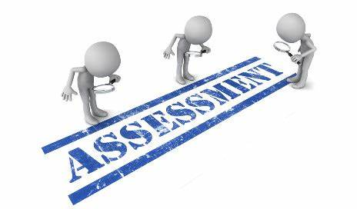

Evaluation is a continuous process comprising of block examination and annual university examination. Students will be evaluated throughout the year. The internal assessment will contribute towards the final examination scores.

Multiple examination methods including MCQs, SAQs, OSPE and viva will be used for assessment. In line with PMC stipulation, the pass/fail marks for the test and examination will be 50%.

There will be a block exam at the end of each block.

**Theory (knowledge):** MCQs (Multiple Choice Questions) and SAQs (Short Answer Questions) are used to assess the theory part for the block exam

**MCQ:**

* A MCQ has a statement or clinical scenario followed by four options (likely answers).
* After reading the statement/scenario student select ONE, the most appropriate answer/response from the given list of options.

### Correct answer carries one mark, and incorrect ‘zero mark’. There is NO negative marking.

**SAQ:**

**OSPE: Objective Structured Practical Examination (See the proposed plan of OSPE)**

* It may comprise between 12- 25 stations.
* The content may assess application of knowledge, or practical skills.
* Student will complete task in define time at one given station.
* All the students are assessed on the same content by the same examiner in the same allocated time.
* A structured examination will have observed, unobserved, interactive and rest stations.

### **Observed and interactive stations:**

They will be assessed by internal or external examiners through the task or viva.

### **Unobserved station:**

It will be static station in which students will have to answer the questions related to the given pictures, models or specimens on the provided response sheet.

### **Rest station:**

It is a station where no task is given, and during this time student can organize his/her thoughts.

**ASSESSMENT PLAN 4th YEAR MBBS**

‘

|  |  |
| --- | --- |
| **LEARNING RESOURCES:** | |
| **SUBJECT** | **RESOURCES** |
| **GNERAL MED** |  |
| **GENERAL SURGERY** |  |
| **PEADS** |  |
| **GYNAE** |  |

|  |  |
| --- | --- |
| **OTHER LEARNING RESOURCES:** | |
| **Hands-on Activities**  **/ Practical** | Students will be involved in Practical sessions and hands-on activities that link with the foundation module to enhance the learning. |
| **Labs** | Utilize the lab to relate the knowledge to the specimens and models available. |
| **Skill Labs** | A skills lab provides the simulators to learn the basic skills and procedures. This helps build the confidence to approach the patients. |
| **Videos** | Video familiarizes the student with the procedures and protocols to assist patients. |
| **Computer Lab / CDs / DVDs / Internet Resources:** | To increase the knowledge students should utilize the available internet resources and CDs/DVDs. This will be an additional advantage to increase learning. |
| **SDL** | SDL is scheduled to search for information to solve cases, read through different resources and discuss among the peers and with the faculty to clarify the concepts. |