GANDHARA UNIVERSITY

|  |
| --- |
| SARDAR BEGUM DENTAL COLLEGE |
| FINAL YEAR BDS 2023-2024 |
|  |
| DEPARTMENT OF MEDICAL EDUCATION | SARDAR BEGUM DENTAL COLLEGE | GANDHARA UNIVERSITY |

**BLOCK 10**

**CLINICAL DENTISTRY III & IV**

**FROM THE DESK OF PRINCIPAL**

Health is a fast-evolving field and with new technologies taking over the traditionally man-dominated fields like radiology and robotic surgical suites assisted by Artificial Intelligence and learning are taking new dimensions with the help of Augmented Reality, we are indeed living in challenging time s. Today's student of Medicine and Dentistry will be in the field a decade from now, up against a disease burden that is as varied as the next strain of the Covid-19 Virus and as complicated as the genetic characteristic of Oral Cancer, the largest cancer amongst both genders in Pakistan and at the same time as unpredictable as the recent Covid-19 Pandemic.

It is therefore imperative that our curricula of the Medical and Dental Colleges be in tandem with the changing times with the ability to evolve with time, measuring up to the challenges thrown at the field of healing from the Ever-evolving diseases.

These Student Guidebooks are reviewed every year with the same concept in mind that our future Physician and Dental Surgeon be ready for the challenges that lie ahead.

In the end, I give you the same prayer as is mentioned in the Quran

Prof. Shaheed Iqbal

BDS, MDS

Oral & Maxillofacial Surgery

Principal Sardar Begum Dental College

Gandhara University,

Peshawar.

2

We extend a warm and enthusiastic welcome as you embark on the final year of your BDS journey! This is an exceptional time for each and every one of you, as it represents the culmination of years of hard work, dedication, and passion for dentistry.

This final year will present you with a multitude of challenges, but it is through these challenges that you will grow and thrive. You will encounter a diverse range of dental cases, each presenting its own unique complexities and intricacies. Embrace these cases with confidence, as they will test your diagnostic abilities, treatment planning skills, and critical thinking capabilities.

In addition to refining your clinical skills, this year will also provide you with invaluable experiences in patient management. You will have the opportunity to engage with patients from all walks of life, ensuring their comfort, providing empathetic care, and delivering comprehensive treatment. Patient management skills are essential to becoming a well-rounded dental professional, and this year will be instrumental in developing these crucial abilities.

While your studies and clinical practice will demand your utmost attention, it is vital to prioritize well-being. Take time for self care, maintain a healthy work life balance and seek support when needed. Your physical and mental well being are integral to your success as a dental professional

Our mission is to provide all educational opportunities to our students. Therefore, on completion of the BDS program graduate will possess an appropriate foundation of knowledge, skills, and attitudes to be well prepared to practice safely and effectively

As a director DME I will be meeting with the facilitators to receive the feedback and will try to resolve any difficulties or problems faced during the block. Please do not hesitate to contact DME for any academic help. I wish you an enjoyable and learning experience with block 10.

**Director DME: Dr. Marina Khan**

|  |
| --- |
| **TABLE OF CONTENTS** |
| **Block Team** |
| **List of abbreviations** |
| **Aims of the study guide** |
| **Modules distribution of Final year BDS** |
| **Introduction of block** |
| **General Outcomes** |
| **Leaning Methodologies** |
| **Rules Regulations** |
| **Learning objectives & Course contents** |
| **Assessment** |
| **Learning Resources** |

**MODULE TEAM**

|  |  |  |
| --- | --- | --- |
| Module Coordinator Dr. Marina Khan  Director (Department of Medical Education)  [marinakahn@hotmail.com](mailto:marinakahn@hotmail.com) | | |
|  |  |  |
| DEPARTMENT OF ORAL & MAXILOFACIAL SURGERY | Prof Dr. Jawad Ahmad Kundi  Prof Dr. Syed Murad Ali Shah  Prof Dr. Shahid Khattak  Assist Prof Dr. Fahad Qiam  Dr. Zeenia |
|  |  |  |
| DEPARTMENT OF OPERATIVE DENTISTRY | Prof. Dr. Shakeel Khattak  Prof Dr. Yasir Khattak  Senior Registrar Dr. Khizar  Dr. Asma  Dr. Sajida |
|  |  |
| DEPARTMENT OF PROSTHODONTICS | Prof Dr Ali Chughtai  Assist Prof. Dr. Marriya Khalid  Assist Prof. Dr. Ehtesham Khan  Dr. Hammad Mian  Dr. Jawad |
|  |  |  |
| DEPARTMENT OF ORTHODONTICS | Prof Dr. Imran Tajik  Prof Dr. Nazir Ahmad  Assistant Prof Dr. Arsalan Hamid  Assistant Prof Dr. Haider Zahid  Senior Registrar Dr. Saira Bilal  Dr. Anam Arbab  Dr. Saman Baseer |
|  |  |
| DEPARTMENT OF  MEDICAL EDUCATION | Assistant Prof Dr. Marina Khan  Assist Prof Dr. Syed Muhammad Junaid  Dr. Aalia Zaib  Dr. Usama Zeb |

**DEPARTMENT OF MEDICAL EDUCATION**

High-quality medical /dental education is a vital prerequisite for high-quality patient care. Dental education’s aim is to supply society with a knowledgeable, skilled, and up-to-date cadre of professionals who put patient care above self-interest, along with developing their expertise over the course of a lifelong career.

The department of Dental Education has expanded beyond the classroom all around the world and quality patient care is learned by the bedside teaching and with the practical introduction of clinical cases in preclinical years. The Dental Education department ensures that the educational content synchronizes with the learning strategies, the assessment tools and provides effective feedback to enhance the learning process. The department of Dental Education at Sardar Begum Dental College is interested in raising the standards of the teaching by continuously developing a pool of trained faculty members. For this purpose, interactive sessions and hands-on workshops are constantly designed, focusing on current and effective modes of evidence-based teaching and assessment tools. It fosters flexible and a learner-centered approach during teaching. Self-reflection and critique of teaching techniques are also vital in propelling an institute towards excellence. Our Dental Education department aims to achieve that and more.

**DEPARTMENT OF ORAL & MAXILLOFACIAL SURGERY**

Welcome to the oral and maxillofacial surgery department, an integral part of your final year BDS clerkship experience! This department plays a vital role in the comprehensive field of dentistry, focusing on the diagnosis and treatment of various diseases, injuries, and deformities of the face, jaws, mouth, and associated structures.

Oral and maxillofacial surgery is a specialized branch that requires a deep understanding of both dentistry and medicine. As you embark on this journey, you will witness the remarkable combination of surgical expertise, dental knowledge, and compassionate patient care.

The primary objective of the oral and maxillofacial surgery department is to equip you with the necessary skills and knowledge to manage a wide range of oral and maxillofacial conditions. Throughout your clerkship, you will have the opportunity to observe, assist, and, in some cases, even perform procedures under the guidance of experienced surgeons.

The oral and maxillofacial surgery department is a multidisciplinary field, closely collaborating with other departments such as prosthodontics, periodontics, orthodontics, and radiology. This collaborative approach ensures a comprehensive and holistic treatment plan for patients, addressing not only their oral and maxillofacial concerns but also considering their overall well-being.

During your time in this department, you will also learn the importance of effective communication and patient management skills. You will witness how oral and maxillofacial surgeons interact with patients, provide pre- and post-operative care, and educate individuals about their treatment options. This aspect of your clerkship will enable you to develop a patient-centered approach and enhance your ability to address their concerns and expectations.

We hope that your time in the oral and maxillofacial surgery department will be enriching and transformative, as you acquire valuable clinical skills, broaden your knowledge base and develop a profound appreciation for the intricacies of this specialized field. Embrace the learning opportunities, engage with experienced faculty, and seize every moment to refine your skills as future dental practitioner

**DEPARTMENT OF PROSTHODONTICS**

Prosthetic dentistry is the branch of dentistry pertaining to the restoration and maintenance of oral functions, comfort, appearance and health of the patient by restoration of teeth and/or replacement of the missing structures with removable and fixed dental prosthesis. It also encompasses the treatment of lost maxillofacial structures as well as management of patients with implant prosthesis. An understanding of the choice of material and technique is crucial in delivering a high standard of prosthetic care.

It is imperative for the student to have knowledge regarding instruments, handling of the patient, clinical and laboratory procedures. It will prepare the students to work independently as competent dental health professionals by imparting basic prosthetic care.

Students will be given academic and clinical training experience of prosthetic clinical procedures pertaining to removable prosthodontics. The knowledge will be built on the previous background understanding of dental materials and laboratory procedures. Fixed Prosthodontics will be taught on simulators to train them to work on live patients in internship. However, teaching of Implantology and Maxillofacial Prosthodontics will be limited to basic clinical principles and techniques

**DEPARTMENT OF ORTHODONTICS**

Welcome to the Orthodontic Department, an exciting part of your final year BDS clerkship experience! This department focuses on the diagnosis, prevention, and treatment of malocclusions and irregularities in dental and facial structures. Orthodontics plays a vital role in enhancing the aesthetics and functionality of the dentition.

During your clerkship, you will explore the fascinating world of orthodontics, learning about the principles, techniques, and appliances used to correct dental and skeletal discrepancies. The Orthodontic Department aims to equip you with a comprehensive understanding of orthodontic diagnosis, treatment planning, and the implementation of various orthodontic interventions.

Orthodontics involves the management of various conditions, including crowded teeth, protruding or retruded jaws, malocclusions, and jaw asymmetry. You will have the opportunity to observe and actively participate in the assessment, treatment planning, and placement of orthodontic appliances such as braces, aligners, and functional appliances.

The primary goal of the Orthodontic Department is to provide you with the knowledge and skills necessary to diagnose and manage malocclusions effectively. You will learn about the different orthodontic techniques and treatment modalities, including fixed orthodontic appliances, removable appliances, and interceptive orthodontics in growing patients.

Throughout your time in this department, you will witness the importance of meticulous records, careful treatment planning, and the monitoring of patients' progress. You will gain insights into the assessment of facial and dental aesthetics, occlusion, and the harmonious relationship between the jaws.

Orthodontics is a dynamic and patient-centered field that requires effective communication and empathy. You will observe how orthodontists establish rapport with patients, understand their concerns, and educate them about the orthodontic process. This aspect of your clerkship will enhance your ability to provide personalized care and ensure that patients are active participants in their treatment journey.

The Orthodontic Department also emphasizes the integration of orthodontic care with other dental disciplines. You will witness how orthodontists collaborate with departments such as prosthodontics, periodontics, oral and maxillofacial surgery, and pediatric dentistry to provide comprehensive and multidisciplinary treatment for complex cases.

**DEPARTMENT OF OPERATIVE DENTISTRY**

Welcome to the Operative Dentistry Department, an essential component of your final year BDS. *This department focuses on the diagnosis, prevention, and treatment of dental caries and other conditions affecting the teeth*. Operative dentistry plays a crucial role in restoring and preserving the functionality and aesthetics of the dentition.

Throughout your clerkship, you will delve into the intricacies of dental restorations, learning the principles, techniques, and materials involved in the art and science of operative dentistry. The Operative Dentistry Department aims to provide you with a comprehensive understanding of the fundamental concepts and practical skills necessary to deliver high-quality dental care.

Operative dentistry encompasses a wide range of procedures, including cavity preparation, restoration placement, direct and indirect restorations, and esthetic dentistry. You will have the opportunity to observe and actively participate in various aspects of operative dentistry, gaining hands-on experience in the use of dental instruments, materials, and modern technologies.

The primary objective of the Operative Dentistry Department is to equip you with the knowledge and skills required to assess and treat dental caries effectively. You will learn how to identify carious lesions, formulate treatment plans, and implement conservative and minimally invasive approaches to restore tooth structure.

During your time in this department, you will witness the importance of attention to detail, precision, and the preservation of healthy tooth structure. You will learn about different restorative materials, adhesive techniques, and the use of dental technologies

Effective communication and patient management skills are integral to operative dentistry. You will witness how operative dentists establish trust, educate patients about oral health, and address their concerns and expectations. Developing these skills will enable you to provide comprehensive care and ensure patient satisfaction.

## 

## LIST OF ABBREVIATIONS

|  |  |
| --- | --- |
| **DME** | Department of Medical Education |
| **LGIS** | Large Group Interactive Session |
| **SDL** | Self-Directed Learning |
| **DSL** | Directed Self Learning |
| **MCQ** | Multiple Choice Question |
| **SAQ** | Short Answer Question |
| **OSCE** | Objective Structured Clinical Exam |

**STUDY GUIDE:**

This study guidebook was designed by combining the efforts of all topics throughout the year to give dentistry students at SBDC a resource material that highlights significant components of the curriculum. By providing students control over their learning, the study guide aims to promote self-regulated lifelong learning.

In regard to the course content, the study guide provides an overview of the anticipated course outcomes and objectives. The assessment approach is also customized to the intuitional strategy.

A successful curriculum has a significant impact on the final product, as well as on society as a whole. This study guide was carefully designed with the PMC curriculum and rules in mind, and Gandhara University stakeholders and faculty members worked hard to personalize it to the needs of students. They are further working to build, implement, and exercise a well-built curriculum in light of changing demographic needs and disease prevalence in our society. Throughout the construction of the study guide, students' feedback was received and included. Curriculum is a living, dynamic entity that is constantly changing. With each passing day, we hope to improve it. This selfless effort on the part of the entire faculty serves as a beacon for our wonderful students.

Each module in this block has been created to cater the gap between basic and clinical subjects through pre-clinical learning. The block is divided into two modules in which the students are exposed to a variety of basic and clinical subjects. The integrated curriculum is enforced through interactive lectures, small group discussion, community outreach programs along with rotations at preclinical laboratory. The course content pertinent to each module will be addressed in problem-based scenarios and student will work collaboratively towards its solution..



**AIMS OF THE STUDY GUIDE**

It is an aid to:

* Inform students how student learning program of the BLOCK-wise module has been organized
* Help students organize and manage their studies throughout the module
* Guide students on assessment methods, rules, and regulations
* Communicates information on organization and management of the module. This will help the student to contact the right person in case of difficulty.
* Defines the objectives which are expected to be achieved at the end of the module.
* Identifies the learning strategies such as lectures, small group teachings, clinical skills and demonstration, tutorial that will be implemented to achieve the module objectives.
* Provides a list of learning resources such as books, computer assisted learning programs, web- links, and journals, for students to consult in order to maximize their learning.
* Highlights information on the contribution of continuous and block examinations on the student's overall performance.
* Includes information on the assessment methods that will be held to determine every student's achievement of objectives.
* Focuses on information pertaining to examination policy, rules, and regulations.

**ORGANIZATION OF MODULAR CURRICULUM**

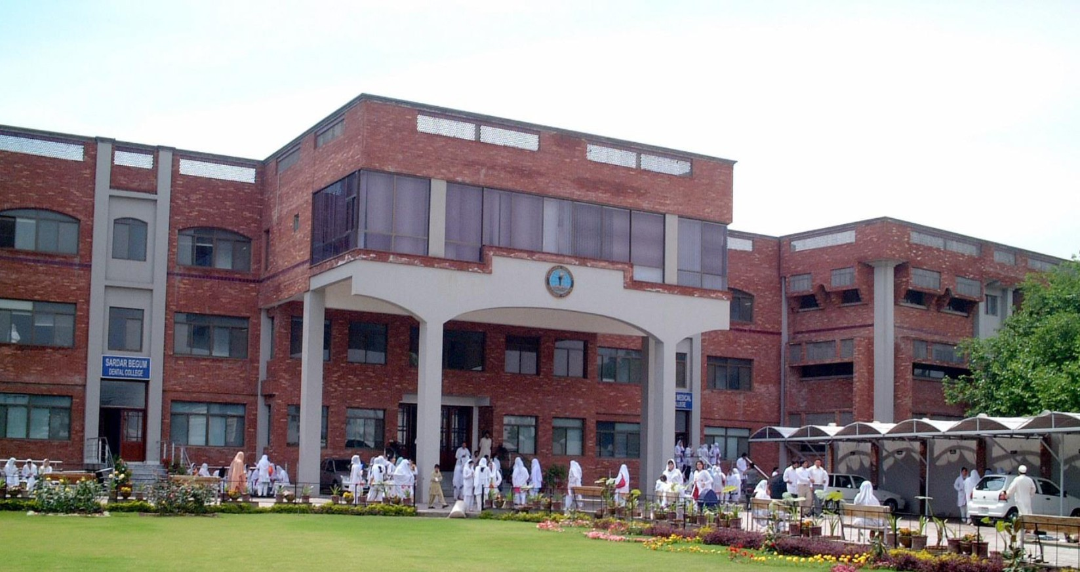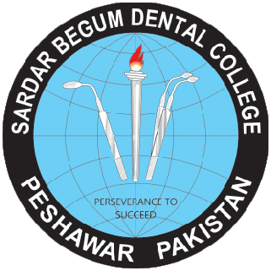

**FINAL YEAR BDS**

|  |  |  |  |  |  |  |  |  |  |
| --- | --- | --- | --- | --- | --- | --- | --- | --- | --- |
| **Block-10** | | **Exam Block 10** | **Block-11** | | **Exam Block11** | **Block-12** | | **Exam Block 12** | **Final Exam** |
| **Module**  **19**  **Clinical Dentistry I** | **Module**  **20**  **Clinical Dentistry II** | **Module**  **21**  **Clinical Dentistry I**II | **Module**  **22**  **Clinical Dentistry I**V | **Module**  **23**  **Clinical Dentistry V** | **Module**  **24**  **Clinical Dentistry VI** |

**BLOCK 11**

**MODULE 21**

**CLINICAL DENTISTRY III**

### **GENERAL OUTCOME**

By end of this block the students of final year BDS will be able to

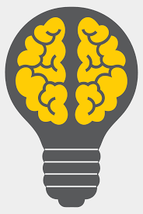

**KNOWLEDGE**

Define an impacted tooth Enlist common impacted teeth and their cause of impaction

Enlist indication and contraindications for removal of impacted teeth NICE guidelines

Classify impacted teeth & determine the level of difficulty for extraction. Describe the management of a patient with an impacted third

Evaluate a patient with an impacted tooth by: history, clinical and radiographic examination

Define Odontogenic infections

evaluate a patient with an odontogenic , maxillofacial infection and order and interpret relevant investigations

Discuss factors (host, micro-organisms, anatomical) that govern the spread of odontogenic infections

Diagnose and differentiate between edema (inoculation), cellulitis and abscess

Understand the pathophysiology of complex odontogenic infections and their potential complications.

Recognize the signs and symptoms of complex odontogenic infections, including cellulitis, abscess formation, and involvement of surrounding structures.

Describe the objectives of pulp protection.

Define cavity liners and bases.

Identify the causes of non-carious lesions.

Discuss the clinical manifestation of non-carious lesion.

Describe physiologic tooth movements

Define Preventive & Interceptive orthodontics

Define Biomechanics

Describe the pathophysiology of neuropathic pain

1. Understand the principles and techniques of radiographic imaging in oral and maxillofacial surgery (OMFS).

Understand the importance of cross infection control in oral and maxillofacial surgery (OMFS) to prevent the transmission of infectious diseases.

Recognize and classify traumatic injuries to the teeth.

Acquire skills in emergency management and first aid for dental trauma.

Recognize and classify traumatic injuries to the teeth.

Acquire skills in emergency management and first aid for dental trauma.

Discuss Periodontal injuries and its management

Enlist the Biological Considerations for Interim Fixed Restorations

Define Major connectors

Enlist the components of dental consent

Discuss the management of flare-ups

Discuss the different types of endodontic infections

Classify removable appliances (RA)

Explain the mechanism of action of RA

Describe indications and contraindications of RA

Classify Functional appliances

Explain the mechanism of action of FnA

Describe indications and contraindications of FnA

Classify Orthopedic Appliances (OA)

Identify different components of OA and their uses

Discuss indications, mechanism of action and effects of Orthopedic Appliances

Describe different orthopedic appliances used for class II and class

Define and classify anchorage

Describe intraoral and extraoral types of anchorage

Identify the anchorage requirements in orthodontics

Understand factors affecting anchorage in orthodontics

lassify dento-alveolar injuries.

Identify the appropriate investigation and radiographs needed for an accurate diagnosis.

### **LEARNING METHODOLOGIES**

The following teaching / learning methods are used to promote better understanding:

* Large Group Interactive Lectures
* Small Group Discussion
* Practical
* Skills session
* E-Learning
* Self-Directed Learning

### LARGE GROUP INTERACTIVE LECTURES (LGIS)

### 

In large group, the lecturer introduces a topic or common clinical conditions and explains the underlying phenomena through questions, pictures, videos of patients'

Case- Based Discussions

Case-Based Discussion is a strategy in which learning is focused around a clinical scenario. List of questions is developed regarding the case under discussion and students are encouraged to discuss their ideas and answer the questions applying relevant basic or clinical knowledge acquired during the course. Usually, common clinical cases are selected for discussions.



Clinical Rotations

Students are assigned 3 months of rotation in department of Oral & Maxillofacial Surgery, Prosthodontics, Operative Dentistry, Orthodontics and Paedodontics. Students are directed to observe patients in orientation week and then perform clinical procedure under supervision of seniors. Students are encouraged to assist

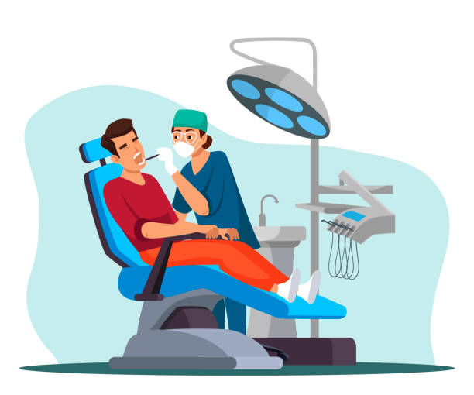

**SELF DIRECTED LEARNING SDL:**

Students assume responsibilities of their own learning through individual study, sharing and discussing with peers, seeking information from Learning Resource Center, teachers, and resource persons within and outside the college. Students can utilize the time within the college scheduled hours of self-study.

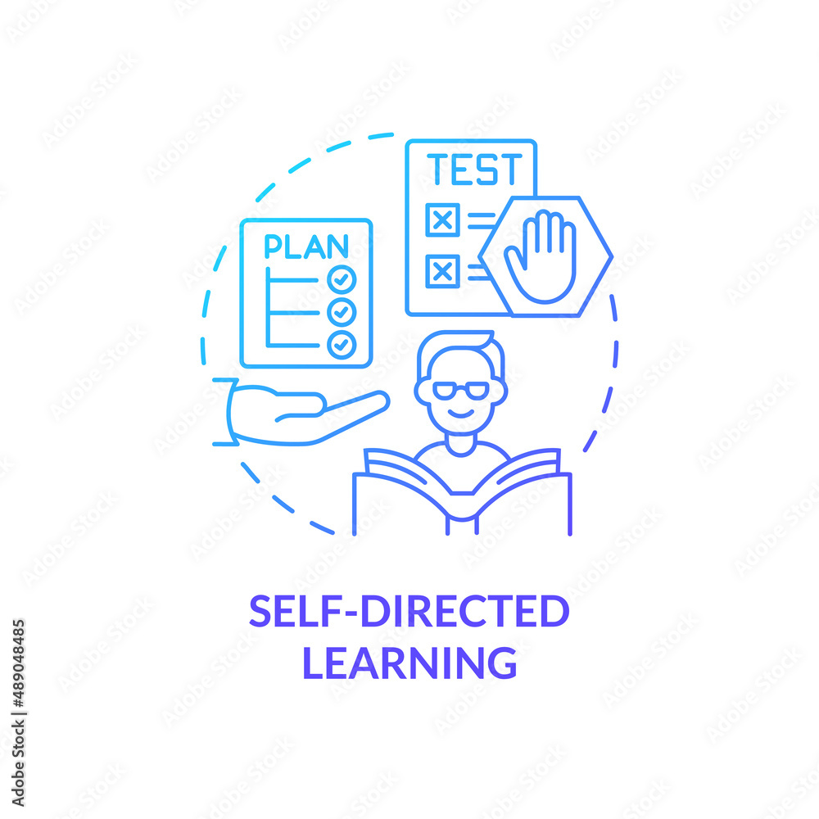

**E-LEARNING:**

E-Learning is a strategy by which learning occurs through the utilization of electronic media, typically the Internet. The basic aspects of medical professionalism and ethics will be addressed through an e-learning course.



**RULES AND REGULATIONS**

We will be making the journey through BLOCK 10 in 12 weeks. Therefore, this course includes an intensive coursework load. Class attendance and participation are extremely important to your learning and are considered in the evaluation of your course grade. If there is anything that the module team can do to assist you during the course, please feel free to contact them. Attendance will be monitored during the different teaching activities. If your attendance is less than 75%, you will not be allowed to sit for both block and annual examination.



All examinations must be taken on the date scheduled. No student will be allowed to enter the examination area after the examination starts. There will be a block exam at the end of each block and each block will cover two modules. There will be a total of 3 block examination and the 30% weightage of these block exam will be added to the 70 % of the annual professional exam as an internal assessment.

**MODULE - 21**

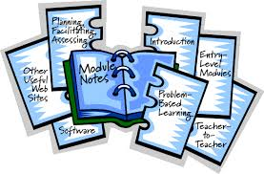

|  |  |  |
| --- | --- | --- |
| **ORAL AND MAXILLOFACIAL SURGERY** | | |
| **S.NO** | **TOPICS** | **LEARNING OBJECTIVE** |
| 1 | Impacted teeth. | Define an impacted tooth Enlist common impacted teeth and their cause of impaction  Enlist indication and contraindications for removal of impacted teeth NICE guidelines  Classify impacted teeth & determine the level of difficulty for extraction. Describe the management of a patient with an impacted third  Evaluate a patient with an impacted tooth by: history, clinical and radiographic examination  Take consent and enlist the potential risks and complications for the removal of impacted teeth. |
| 1. 2   2 | Odontogenic infections | Define Odontogenic infections  evaluate a patient with an odontogenic , maxillofacial infection and order and interpret relevant investigations  discuss factors (host, micro-organisms, anatomical) that govern the spread of odontogenic infections  Diagnose and differentiate between edema (inoculation), cellulitis and abscess  Describe spread and pathophysiology of following infections in head and neck:  odontogenic infection to primary and secondary facial spaces.  • cavernous sinus thrombosis/orbital cellulitis.  • mediastinitis. • Ludwig’s angina. • Osteomyelitis, candidiasis, necrotizing fasciitis, actinomycosis.  Plan management for odontogenic infections.  • Remove the etiology.  • Surgically drain pus and insert drains, if indicated.  • Provide supportive therapy:  select appropriate antibiotic and manage airway, nutrition, hydration.  • Refer, when indicated  • Choose and prescribe appropriate antibiotic(s) for odontogenic infections • justify prophylaxis against infectious endocarditis and total joint replacement  Describe anatomical Facial spaces in head and neck(boundaries and contents) which may get involved by spread of Odontogenic infections |
| 3 | Complex odontogenic infections | Understand the pathophysiology of complex odontogenic infections and their potential complications.  Recognize the signs and symptoms of complex odontogenic infections, including cellulitis, abscess formation, and involvement of surrounding structures.  Learn the principles of obtaining a thorough medical history and performing a comprehensive physical examination in patients with complex odontogenic infections.  Familiarize oneself with the microbiology of complex odontogenic infections, including the common pathogens and their antibiotic susceptibilities.  Understand the diagnostic modalities available for complex odontogenic infections,  Understand the potential complications associated with complex odontogenic infections, including the spread of infection to adjacent structures, systemic complications, or airway compromise.  Learn management strategies for complications related to complex odontogenic infections, including airway management, appropriate antibiotic adjustment, or surgical interventions. |
| 1. 4   4 | Deep facial spaces infections | Understand the anatomy of head and neck region, particularly the deep facial spaces involved in infections  Recognize the signs and symptoms of deep facial spaces infections  Know about the microbiology of deep facial spaces infection including common pathogens and their antibiotic susceptibilities  Knowing the principles of obtaining a thorough medical history and performing a comprehensive physical examination in patients with deep facial infections.  Learning the principles of appropriate antibiotic therapy for deep facial infections, including selection of antibiotics based on the suspected or identified pathogens.  Acquiring the skills to perform incision and drainage procedures for deep facial abscesses, including knowledge of anatomical landmarks and techniques for optimal drainage. |
| 5 | Salivary gland infections, obstructive diseases & tumors | Describe pathophysiology and presentation of obstructive, retentive, infectious and neoplastic salivary gland disease.  • Describe various diagnostic modalities for salivary gland disorders.  • describe the principles of management of the following salivary gland disorders: sialolithiasis,  • Mucocele, ranula, infections, traumatic injuries to salivary glands, pleomorphic adenoma, Warthin’s tumor, mucoepidermoid carcinoma, adenoid cystic carcinoma, adenocarcinoma. |
| 6 | Prosthetic surgery | • Enlist objectives of preprosthetic surgery. •  Identify abnormalities of soft and hard tissues which interfere with denture (partial/complete) construction and formulate a treatment plan  Name and describe ridge extension, augmentation and correction (osteotomies) procedures for mandible and maxilla.  • Discuss complications of preprosthetic surgery.  • Briefly describe the principles of following surgical procedures: ¬ Alveloloplasty simple, intraseptal (Dean’s), ¬ tuberosity reduction, exostosis and undercuts correction, tori removal, ¬ mylohyoid ridge reduction, ¬ genial tubercle reduction, ¬ retromolar pad reduction, ¬ lateral palatal soft tissue excess removal, ¬ unsupported hypermobile tissue removal, ¬ inflammatory fibrous hyperplasia removal, ¬ Labial and lingual frenectomy  • Describe the surgical protocol for immediate denture placement/construction. |

|  |  |  |
| --- | --- | --- |
| **PROSTHODONTICS** | | |
| **S.NO** | **TOPICS** | **LEARNING OBJECTIVE** |
|  | Metal ceramic crowns | Enlist Advantages/ Disadvantages of Metal Ceramic Crown  Enlist Indications/ Contraindications of Metal Ceramic Crown  Know recommended dimensions, Preparation features and steps of Metal Ceramic Crown  Know the Laboratory steps for fabricating Metal Ceramic Crowns |
|  | Dental Surveyor | Explain dental surveyor and its parts  Know purposes of Dental Surveyor  Know the steps for surveying a dental cast |
|  | Articulation | Define articulator  Define articulation  Differentiate between inter occlusal and graphic records  Enlist uses of an articulator  Enlist ideal requirements of an articulator  Enlist advantages of an articulator  Classify articulators  Comprehend programming articulators  Identify parts of semi adjustable articulator  Enlist steps of mounting casts on semi adjustable articulator |
|  | Tooth selection | Understand anterior tooth selection on basis of width, length, thickness, shape and shade.  Understand dentogenic concept.  Understand Leon William theory.  Understand posterior tooth selection on basis of width, length, thickness, cuspal angulation, material. |
|  | All ceramic crowns | Enlist Advantages/ Disadvantages of All Ceramic Crown  Enlist Indications/ Contraindications of All Ceramic Crown  Know recommended dimensions, Preparation features and steps of All Ceramic Crown  Know the Laboratory steps for fabricating All Ceramic Crowns |
|  | Arrangement of artificial | Enlist aims and objectives of artificial teeth  Enlist requirements of artificial teeth  Enlist landmarks to find and use for determining denture tooth positions  Explain concepts of occlusion  Elaborate on bilateral balance occlusion  Classify occlusal schemes  Identify features of Angles class 1 occlusion  Identify arrangement of each tooth |
|  | Partial veneer crowns | Classify types of Partial Veneer Crown  based on extension  Enlist Advantages/ Disadvantages of Partial Veneer Crown  Enlist Indications/ Contraindications of Partial Veneer Crown  Know recommended dimensions, Preparation features and steps of Partial Veneer Crown  Know the Laboratory steps for fabricating Partial Veneer Crown |
|  | Support- | Define Support and its Types  Know the purpose and functions of a dental Rest.  Know the method of preparation of Occlusal, Cingulum and Incisal rests |

|  |  |  |
| --- | --- | --- |
| **OPERATIVE DENTISTRY** | | |
| **S.NO** | **TOPICS** | **LEARNING OBJECTIVE** |
|  | Management of deep carious lesions | Describe the objectives of pulp protection.  Define cavity liners and bases.  Explain the properties of different cavity liners and bases.  Enlist the uses of cavity liners and bases.  Differentiate between cavity liners and bases.  Explain why cavity liners need to be covered by a base |
|  | Non-Carious lesions & their management | Identify the causes of non-carious lesions.  Discuss the clinical manifestation of non-carious lesion.  Discuss the considerations for restorative management of non-carious lesion.  Enlist the restorative material used for restoring non carious lesions. |
|  | Dentine hypersensitivity | Define dentinal hypersensitivity.  Discuss the theories of dentinal hypersensitivity.  Enlist the etiological factors of dentinal hypersensitivity.  Discuss the clinical features of dentinal hypersensitivity.  Enlist the treatment options for dentinal hypersensitivity |
|  | Failure of direct restorations | Discuss the causes of failure of direct restorations.  Illustrate the indications of replacing existing restorations.  Illustrate the indications of replacing tooth-colored restorations. |

|  |  |  |
| --- | --- | --- |
| **PEADODONTICS** | | |
| **S.NO** | **TOPICS** | **LEARNING OBJECTIVE** |
|  | Oral habits in children | Enlist common oral habits in children and their management |

|  |  |  |
| --- | --- | --- |
| **ORTHODONTICS** | | |
| **S.NO** | **TOPICS** | **LEARNING OBJECTIVE** |
|  | Biology of tooth movement | Describe physiologic tooth movements.  Discuss the cellular biology and principals of orthodontic tooth movement.  Explain different phases of orthodontic tooth movement  Discuss different theories of tooth movement  Describe optimum orthodontic force, and the impact of force magnitude, duration and direction on tooth movement.  Describe cellular events associated with use of light and heavy orthodontic forces  Define hyalinization and explain different stages of hyalinization  Understand cellular events of root resorption  Explain the deleterious effects of orthodontic forces  Explain the effects of various drugs on tooth movement |
|  | Orthodontics biomechanics | Define Biomechanics.  Explain the basic principles of biomechanics and their application in orthodontics.  Understand the concept of center of resistance, center of rotation, moment and couple in orthodontics and their clinical implications in orthodontic tooth movement  Describe the types of orthodontic forces  Discuss the types of orthodontics tooth movements |
|  | Preventive &  Interceptive Orthodontics | Define preventive and interceptive orthodontics.  Explain the goals of preventive/interceptive orthodontics.  Discuss the importance of early orthodontic intervention in preventing/ intercepting malocclusions.  Understand different types of preventive and interceptive procedures and their indications.  Illustrate the use of preventive and interceptive orthodontic appliances and techniques, such as space maintainers, expansion appliances and habit breakers.  Interpret the impact of oral habits on dental and skeletal development, and the use of preventive and interceptive techniques to address them.  Understand and apply the basic principles of space supervision in orthodontics  Discuss various types of space maintainers and their uses  Describe the serial extraction and guidance of eruption concepts in orthodontics and their clinical applications  Discuss the role of orthodontics in intercepting or preventing more complex orthodontic problems such as skeletal malocclusions.  Demonstrate communication skills to explain the importance of preventive and interceptive orthodontics to patients and other health care professionals. |

|  |  |  |
| --- | --- | --- |
| **ORAL BIOLOGY** | | |
| **S.NO** | **TOPICS** | **LEARNING OBJECTIVE** |
|  | Physiological tooth movements  Eruption & shedding | Pre eruptive tooth movements  Eruptive movements  Post eruptive movements  Shedding of teeth  Orthodontic tooth movement |

**MODULE 22**

**CLINICAL DENTISTRY IV**



|  |  |  |
| --- | --- | --- |
| **ORAL AND MAXILLOFACIAL SURGERY** | | |
| **S.NO** | **TOPICS** | **LEARNING OBJECTIVE** |
|  | Diagnosis & management of orofacial pain | Describe the pathophysiology of neuropathic pain.  Classify oro-facial pain according to site and etiology.  Differentiate trigeminal neuralgia from pre-trigeminal neuralgia, odontalgia, and post-herpetic neuralgia, neuroma, burning mouth syndrome, glossopharyngeal neuralgia and headaches  Discuss surgical management of trigeminal neuralgia |
|  | Radiography: technique & indication | 1. Understand the principles and techniques of radiographic imaging in oral and maxillofacial surgery (OMFS). 2. Familiarize oneself with the different types of dental radiographs commonly used in OMFS, such as periapical, bitewing, panoramic, and cone beam computed tomography (CBCT) images. 3. Learn the proper positioning and technical factors required for obtaining high-quality radiographic images in OMFS. 4. Understand the indications for various radiographic imaging modalities in OMFS, including assessment of dental and skeletal anatomy, evaluation of pathology, trauma assessment, and treatment planning.   Acquire the skills to interpret radiographic images and identify normal anatomical structures as well as common pathologies and abnormalities relevant to OMFS. |
|  | Cross infection control | Understand the importance of cross infection control in oral and maxillofacial surgery (OMFS) to prevent the transmission of infectious diseases.  Familiarize oneself with the relevant regulations, guidelines, and best practices for cross infection control in OMFS.  Learn the principles of hand hygiene, including proper hand washing techniques and the use of hand sanitizers or antiseptic solutions.  Understand the appropriate use of personal protective equipment (PPE), such as gloves, masks, goggles, and gowns, to minimize the risk of cross infection.  Acquire knowledge of sterilization and disinfection methods for instruments, equipment, and surfaces in OMFS settings.  Learn the proper techniques for instrument processing, including cleaning, packaging, sterilization, and storage.  Understand the importance of aseptic techniques during surgical procedures, including maintaining a sterile field and proper handling of surgical instruments.  Recognize the risk factors and preventive measures for needle stick injuries and sharps-related infections in OMFS. |
|  | BLS ALTS | Understand the importance of BLS and ALS  List steps of ATLS evaluation (primary survey) of patient with maxillofacial trauma  Describe the detailed clinical examination of Maxillofacial trauma patients |
|  | Traumatic injuries to the teeth & management | Recognize and classify traumatic injuries to the teeth.  Acquire skills in emergency management and first aid for dental trauma.  Understand endodontic considerations and techniques for managing dental injuries.  Understand the principles of emergency management and immediate first aid for dental trauma, including control of bleeding, preservation of avulsed teeth, and management of soft tissue injuries.  Learn the techniques for splinting and stabilization of mobile or fractured teeth to promote healing and minimize complications.  Acquire knowledge of endodontic considerations and techniques for managing traumatic dental injuries, such as root canal therapy, apexification, or revascularization.  Understand the indications and techniques for tooth re-implantation, including proper storage media and timing considerations.  Recognize the potential complications associated with dental trauma, such as pulp necrosis, root resorption, or esthetic and functional impairments, and implement appropriate management strategies. |
|  | Periodontal injuries | Discuss periodontal injuries and discuss its management |

|  |  |  |
| --- | --- | --- |
| **PROSTHODONTICS** | | |
| **S.NO** | **TOPICS** | **LEARNING OBJECTIVE** |
|  | Interim fixed restorations | Categorize the considerations for Interim Fixed Restorations  Enlist the Biological Considerations for Interim Fixed Restorations  Enlist the Mechanical Considerations for Interim Fixed Restorations  Enlist the Esthetic Considerations for Interim Fixed Restorations  Know the materials for the fabrication of Interim Fixed Restorations  Know and Classify Procedures for the fabrication of Interim Fixed Prosthesis / Restorations |
|  | Major Connectors | Define Major Connectors and its purpose  Know indications/contraindications, advantages/disadvantages of maxillary major connector  Know indications/contraindications, advantages/disadvantages of mandibular major connectors  Designing of maxillary and mandibular major connectors |
|  | Trial | Define try in denture  Define try in appointment  Understand significance of try in  Enlist armamentarium for try in  Educate patient regarding try in  Compare with previous denture  Enlist and explain try in steps  Verify the try in  Enlist and elaborate remount process for correction  Explain wash impression and marking of posterior palatal seal  Communicate with laboratory |
|  | Dental Consent | Enlist the components of Complete Dental Consent for Dental Treatment particularly Fixed Restorations |
|  | Tissue management & impression making | Define Impressioning  Enlist the Pre requisite for Impressioning for Fixed prosthesis / Restorations  Classify the impression materials for Fixed Prosthesis/ Restorations  Enlist the Advantages/ Disadvantages/ Recommendations and Precautions for different Impression Materials  Evaluate the Impression for Fixed prosthesis/ restorations  Know Impression Disinfection based of different materials |
|  | Types of partial denture | Enlist Advantages/ Disadvantages of different types of Removable partial denture  Enlist Indications/ Contraindications of different types of Removable partial denture |
|  | Fabrication | Enlist and elaborate steps of flasking and dewaxing  Enlist and elaborate steps of packing and curing  Explain steps of rearticulating casts and dentures  Comprehend significance of rearticulation  Elaborate the purpose and process of a facebow transfer jig  Enlist steps of denture finishing and polishing  Explain significance of hydration of dentures  Enlist steps of remount cast fabrication |
|  | Insertion & follow up | Identify errors on fitting surface  Elaborate adjustments to fitting surface  Identify errors on denture borders  Elaborate steps of adjustments to denture borders  Identify errors in occlusion  Elaborate steps of adjustments to occlusal surface  Comprehend details of selective grinding  Educate patient on denture use  Prescribe sequential follow up of denture patients and denture adjustments |
|  | Kennedy classification of partially dentate arches | Classify partially dentate arches |
|  | Relining & rebasing | Define relining  Enlist indications of relining  Enlist contra indication of relining  Classify types of relining  Depict lab reline procedure  Depict chair side reline procedure  Define rebasing  Depict rebasing procedure |

|  |  |  |
| --- | --- | --- |
| **OPERATIVE DENTISTRY** | | |
| **S.NO** | **TOPICS** | **LEARNING OBJECTIVE** |
|  | Pulp & Peri radicular pathosis  ( Pulpal diseases) | Identify etiologic factors causing pulpal inflammation.  Explain the mechanism of spread of inflammation in the pulp.  Explain why it is difficult for the pulp to recover from severe injury.  Classify pulpal diseases and their clinical and histologic features. |
|  | Pulp & Peri radicular pathosis  Periapical disease | Classify periapical lesions and their clinical and radiographic features.  Identify non endodontic pathologic lesions that may mimic endodontic peri radicular pathosis. |
|  | Endodontic microbiology  (Endodontic infection & its pathways) | Recognize the microbial causation of apical periodontitis.  Describe the routes of root canal infection.  Discuss the different types of endodontic infections.  Discuss the ecologic factors that influence the composition of the microbiota within the root canal system. |
|  | Endodontic microbiology  (Microbiota involved & Factors.) | Differentiate the persistent and secondary endodontic infections.  Enlist microbiota in root canal treated teeth.  Describe the factors involved with symptomatic endodontic infections.  Discuss the development of extra radicular infections |
|  | Endodontic emergencies | Define endodontic flare-up.  Explain the causes of -flare-up.  Discuss the management of flare-ups.  Recognize the categories of endodontic emergencies.  Management of Endodontic emergencies. |
|  | Endodontic instruments | Describe the general physical properties of intracanal preparation instruments.  Explain the basis for sizing and taper of endodontic instruments  Differentiate between stainless steel and NiTi intracanal instruments in terms of physical properties and usage characteristics.  Illustrate the working of Niti and Stainless-steel files.  List the instrument used during obturation.  Detect the visible changes in instruments that will predispose to breakage. |
|  | Internal Anatomy | List ways that help to determine the type of pulp canal system.  Illustrate the laws of location of canal orifices.  Discuss the components of the pulp system.  Describe the most common root and pulp anatomy and the more frequent variations in root and pulp anatomy of each tooth.  Recognize the variations of root and pulp anatomy. |

|  |  |  |
| --- | --- | --- |
| **PEADODONTICS** | | |
| **S.NO** | **TOPICS** | **LEARNING OBJECTIVE** |
|  | Pediatric endodontic | Explain the Aims of Pediatric Dentistry  Discuss the outline for treatment planning  Differentiate between the various types of radiographs  Enumerate indications and contraindications for radiographs |
|  | Traumatic injuries to the teeth in children | Classify dento-alveolar injuries.  Identify the appropriate investigation and radiographs needed for an accurate diagnosis.  Describe management of hard tissue injury in the following categories:  Crown Infraction  Uncomplicated crown fracture.  Complicated crown fracture.  Uncomplicated Crown-root fracture.  Complicated Crown-root fracture  Root fracture.  Discuss management of soft tissue and hard tissue injury in following categories:  Concussion.  Subluxation.  Extrusive luxation.  Lateral luxation.  Intrusion.  Avulsion.  Describe the rationale of delayed reimplantation of an avulsed tooth.  Describe the sequelae of injuries to the primary dentition. |

|  |  |  |
| --- | --- | --- |
| **ORTHODONTICS** | | |
| **S.NO** | **TOPICS** | **LEARNING OBJECTIVE** |
|  | Removable orthodontic appliances | Classify removable appliances (RA)  Explain the mechanism of action of RA  Describe indications and contraindications of RA  Enlist advantages & disadvantages of RA  Explain components of the RA and their functions  Gain an understanding of the design, fabrication, insertion and adjustment of removable appliances  Understand limitations of removable appliances |
|  | Functional orthodontic appliances | Define and classify functional appliances (FnA)  Describe the mechanism of action of FnA.  Understand indications and contraindications of FnA  Familiar with the advantages and disadvantages of FnA  Gain an understanding of the design, fabrication, insertion and adjustments of functional appliances  Recognize removable and fixed functional appliance  Identify FnA used for Class II & class III malocclusions  Understand clinical management of FnA |
|  | Fixed Appliances | Describe different types of fixed appliances  Identify various components of the fixed appliances  Gain an understanding of indications and contraindications of fixed appliances  Know advantages and disadvantages of fixed appliance  Have an understanding of different stages of fixed appliance therapy and their goals  Learn the basic principles and techniques in fixed appliance therapy. |
|  | Orthopeadic appliances | Classify Orthopedic Appliances (OA)  Identify different components of OA and their uses  Discuss indications, mechanism of action and effects of Orthopedic Appliances  Describe different orthopedic appliances used for class II and class III management (Head gears, chin cup and face mask)  Gain an understanding of selection of OA for different type of malocclusions and their clinical handling |
|  | Anchorage in Orthodontics | Define and classify anchorage  Describe intraoral and extraoral types of anchorage  Identify the anchorage requirements in orthodontics  Understand factors affecting anchorage in orthodontics  Gain an understanding of the approaches used to reinforce anchorage during orthodontic treatment.  Be familiar with the skeletal anchorage systems in orthodontics (TADs) |

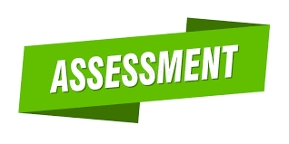

**ASSESSMENT METHODS FOR BLOCK EXAM:**

Evaluation is a continuous process comprising of block examination and annual university examination. Students will be evaluated throughout the year. The internal assessment will contribute towards the ﬁnal examination scores.

Multiple examination methods including MCQs, SAQs, OSPE and viva will be used. In line with PMC stipulation, the pass/fail marks for the test and examination will be 50%.

There will be a block exam at the end of each block.

**Theory (knowledge)**:

MCQs (Multiple Choice Questions) and SAQs (Short Answer Questions) are used to assess the theory part for the block exam.

**MCQ:**

* + - * A MCQ has a statement or clinical scenario followed by four options (likely answers).
      * After reading the statement/scenario student select ONE, the most appropriate answer/response from the given list of options.
      * Correct answer carries one mark, and incorrect ‘zero mark’. There is NO negative marking.

**SAQ:**

SAQ are open ended questions that requires students to create an answer. They are commonly used in examinations to access the basic knowledge and understanding of a topic.

**OSPE**:

Objective Structured Practical Examination (See the proposed plan of OSPE)

It may comprise between 12- 25 stations.

The content may assess application of knowledge, or practical skills.

Student will complete task in deﬁne time at one given station.

All the students are assessed on the same content by the same examiner in the same allocated time.

A structured examination will have observed, unobserved, interactive and rest stations.

**OBSERVED AND INTERACTIVE STATIONS:**

They will be assessed by internal or external examiners through the task or viva.

**UNOBSERVED STATION:**

It will be static station in which students will have to answer the questions related to the given pictures, models or specimens on the provided response sheet.

**REST STATION:**

It is a station where no task is given, and during this time student can organize his/her thoughts.



**ASSESSMENT GRID FOR BLOCK EXAM**

|  |  |  |  |  |  |  |  |  |  |  |  |  |  |  |  |  |  |  |
| --- | --- | --- | --- | --- | --- | --- | --- | --- | --- | --- | --- | --- | --- | --- | --- | --- | --- | --- |
| **Component from BLOCK EXAM= Theory and Practical: 140+140**  **Component from Internal Assessment= Theory and Practical 60+60**  **Theory=600 Marks Practical=600**  **Total Marks: 1200** | | | | | | | | | | | | | | | | | | |
| **MODULE/BLOCK** | | | **BLOCK – X** | | | | | **BLOCK – XI** | | | | | | **BLOCK – XII** | | | | |
| **Module- 19** | | **Module-20** | | | **Module-21** | | | **Module-22** | | | **Module-23** | | | **Module-24** | |
| **Professional Examination** | **Theory Marks** | | **100** | | **100** | | | **100** | | | **100** | | | **100** | | | **100** | |
| **200** | | | | | **200** | | | | | | **200** | | | | |
| **Practical Marks (OSPE)** | | **200** | | | | | **200** | | | | | | **200** | | | | |
| **Internal Assessment-IA** | | **Theory: 60 Practical:60** | | | | | **Theory: 60 Practical:** | | | | | | **Theory: 60 Practical:60** | | | | |
| **Subject wise distribution** | **Subjects** | **MCQ#** | **SAQs#** | **OSCE Stations** | **viva** | | **MCQ#** | **SAQs**  **#** | | **OSPE Stations#** | **viva** | | **MCQs**  **#** | **SAQs**  **#** | | **OSPE Stations** | **viva** |
| **OMFS** | **23** | **3** | **5** | **15** | | **23** | **3** | | **5** | **15** | | **23** | **3** | | **5** | **15** |
| **OPERATIVE** | **23** | **3** | **5** | **15** | | **23** | **3** | | **5** | **15** | | **23** | **3** | | **5** | **15** |
| **ORTHODONTICS** | **23** | **3** | **5** | **15** | | **23** | **3** | | **5** | **15** | | **23** | **3** | | **5** | **15** |
|  | **PROSTHODONTICS** | **23** | **3** | **5** | **15** | | **23** | **3** | | **5** | **15** | | **23** | **3** | | **5** | **15** |
|  | TOTAL# | **92**  **(I mark each)** | **12**  **(4 marks each)** | **20(4 marks each)**  **=80** | 60 | | **92**  **(I mark each**) | **12**  **(4 marks each)** | | **20(4 marks each)=80** | **60** | | **92**  **(I mark each)** | **12**  **(4 marks each)** | | **20**  **(4 marks each)=80** | **60** |
|  | **Total** | **92** | **48** | **140** | | | **92** | **48** | | **140** | | | **92** | **48** | | **140** | |
| **Total(theory+practiacl)** | | **140** | | **140** | | | **140** | | | **140** | | | **140** | | | **140** | |
|  | **Internal Assessment** | | **60** | | **60** | | **60** | | | **60** | | | **60** | | | **60** | | |
| **Total marks** | | **200** | | **200** | | **200** | | | **200** | | | **200** | | | **200** | | |
| **Total Marks** | | **400** | | | | **400** | | | | | | **400** | | | | | |
| **Grand total** | **1200** | | | | | | | | | | | | | | | | | |

|  |  |  |  |  |  |
| --- | --- | --- | --- | --- | --- |
| **THEORY INTERNAL ASSESSMENT**  **15 MARKS** | | | **PRACTICAL INTERNAL ASSESSMENT**  **15 MARKS** | | |
| **ATTENDANCE**  **5 MARKS** | **ASSIGNMENTS AND PRESENTATIONS**  **5 MARKS** | **BEHAVIOUR /DISCIPLINE**  **5 MARKS** | **ATTENDANCE**  **5 MARKS** | **LOGBOOK**  **10 MARKS** | |
| 90 and above  5 marks  B/W 85% to 90%=  4 marks  B/W 80% to 85%=  3 marks  75% to 80%= 2 marks  75%= 1 mark  Below 75 % = 0 marks | Grade A=5 marks  Grade B= 3 marks  Grade C= 1 mark  No assignments or presentations =0 marks | No misbehave or warning in lectures = 5 marks  Written warning given to student = 0 marks | Above 90%=  5 marks  B/W 85% to 90%=  4 marks  B/W 80% to 85%=  3 marks  75% to 80%= 2 marks  Upto 75%= 1 mark  Below 75 % = 0 marks | Complete and timely signed =10 marks  Completed and late submission=5 marks  Incomplete or no logbook =0 marks (additional criteria student will not be allowed to appear for the exam) | |
|  |  |  |  |  |  |

**INTERNAL ASSESSMENT MARKS DISTRIBUTION**

|  |  |
| --- | --- |
| **LEARNING RESOURCES** | |
| **SUBJECT** | **RESOURCES** |
| **Oral & Maxillofacial Surgery** | Contemporary oral & maxillofacial surgery by James hupp, Edward Ellis and Myron Tucker  Fractures of Facial Skeleton by Michaels Perry, Andrew Brown and Peter Bank  Handbook of local anesthesia by Stanley Melamed  Essentials of dental radiography and radiology by Eric Whaites and Nicholas drage |
| **ORTHODONTICS** | **Recommended Textbooks**:  · Contemporary Orthodontics. by William R Profit  · An introduction to Orthodontics. by Laura Mitchells  **Reference Books**:  · Orthodontics: Current Principles and Techniques By Graber  · Esthetics and biomechanics in orthodontics by Nanda  · Textbook of orthodontics by Bishara  · Orthodontic and orthopedics treatment in the mixed dentition By McNamara |
| **OPERATIVE DENTISTRY & ENDODONTICS** | Pathways of the Pulp  Endodontic: Principles and Practice  Sturdevants Art & Science of Operative Dentistry  Fundamentals of Operative Dentistry: a contemporary approach  Pickard’s manual of Operative Dentistry |
| **PROSTHODONTICS** | Mc Cracken Removable Partial Prosthodontics 13th Ed  Stewarts Clinical Removable Partial Prosthodontics 4th Ed  Contemporary Fixed Prosthodontics 6th Ed  Fundamentals of Fixed Prosthodontics 4th Ed  Prosthodontics treatment of edentulous Patient 14th Ed  Complete Denture Prosthodontics by John Joy Manapplil 3rd Ed |
| **PEDIATRIC DENTISTRY** | Recommended text book  A manual of Pediatric Dentistry Andlaw R.J & Rocl W.P  Reference Books  Pediatric Dentistry ( infancy through Adolescence)-Pinkham  Pediatric Dentistry-Welbury  Dentistry for Child & Adolescence- Mc.Donald |

|  |  |
| --- | --- |
| **OTHER LEARNING RESOURCES** | |
| **Hands-on Activities/ Practical** | Students will be involved in Practical sessions and hands-on activities that link with the foundation module to enhance the learning. |
| **Labs** | Utilize the lab to relate the knowledge to the specimens and models available. |

|  |  |
| --- | --- |
| **Skill Labs** | A skills lab provides the simulators to learn the basic skills and procedures. This helps build the confidence to approach the patients. |
| **Videos** | Video familiarize the student with the procedures and protocols to assist patients. |
| **Computer Lab/CDs/DVDs**  **/Internet Resources** | To increase the knowledge students should utilize the available internet resources and CDs/DVDs. This will be an additional advantage to increase learning. |
|  | SDL is scheduled to search for information to solve cases, read through different resources and discuss among the peers and with the faculty to clarify the concepts. |