**GANDHARA UNIVERSITY**

**KABIR MEDICAL COLLEGE**

**URRICULUM**

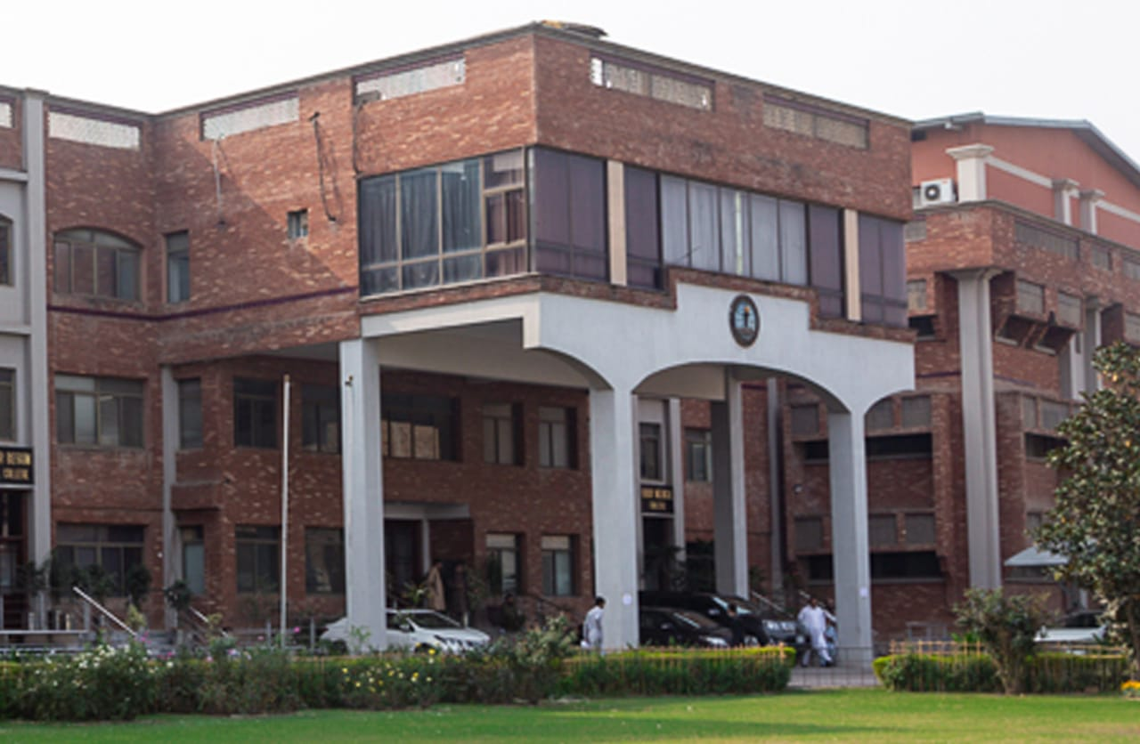

**4TH YEAR MBBS 2023-2024**

**BLOCK 12**

**(MULTISYSTEM II**

**& REPRODUCTION II)**

# FROM THE DESK OF PRINCIPAL

**BRIG AHMAD HUSSAIN MASHWANI(R)**

Kabir Medical College has evolved, since its inception, as an exceptionally outstanding facility to provide quality education to the students.

I must appreciate the hard work of our well experienced and dedicated faculty members and staff in maintaining high standards of medical education and the efforts they have put into Kabir Medical College to be a distinguished center of excellence.

By the grace of Almighty, we are starting the integrated curriculum for 1st year MBBS. We meet international standards of professional education by installing the system of integrated curriculum and system-based teaching of basic medical sciences. We advocate interactive sessions to improve comprehension of students as well as training them with skills of communication and self-expression.

Since the establishment of Kabir Medical College, we have been working constantly to upgrade services and facilities at the campus and the attached Naseer Teaching Hospital for our students and patients.

We would like our graduates to excel as confident, responsible, and self-learning medical practitioners. With a state-of-the-art campus, experienced faculty, an up-to-date digital library, I assure that your decision to study at Kabir Medical College will surely be a wise one, your experience here will be profoundly enriching, and you will become an asset to the nation and international community health care professionals.

Brig Ahmad Hussain Mashwani (R)

MBBS, FCPS(SURGERY)OJT (VASCULAR SURGERY)

CHPE, MHPE(KMU)

Principal

Kabir Medical College

Gandhara University  
 Peshawar

On behalf of the block team, I would like to welcome you to block-11(Renal & Endocrinology modules). As a part of the system-based curriculum, this block is an integrated presentation, comprises system-based modules which link basic science knowledge to clinical problems. Integrated teaching means that subjects are presented as a meaningful whole. Students will be able to have a better understanding of basic sciences when they repeatedly learn in relation to clinical examples. Small group discussions, early exposure to clinics, wards, and skills acquisition in skills lab are characteristics of integrated teaching program.

Our mission is to provide all educational opportunities to our students, therefore on completion of the MBBS program graduates will possess an appropriate foundation of knowledge, skills, and attitudes to be well prepared to practice safely and effectively.

This study guide includes the course contents of the block. The learning objectives, practical, topics of the small group discussions.it also includes the assessment plan for the block exam.

As a director I will be meeting with the facilitators to receive the feedback and will try to resolve any difficulties or problems faced during the block. Please do not hesitate to contact DME for any academic help. I wish you an enjoyable learning experience with block 11.

**Director DME: Dr. Marina Khan**

|  |
| --- |
| **Topic** |
| **Block Team** |
| **List of abbreviations…** |
| **Aims of the study guide…** |
| **Module distribution of 4th year MBBS** |
| **Introduction of block 11…** |
| **General Outcomes…** |
| **Leaning Methodologies…** |
| **Rules Regulations** |
| **Learning objectives & Course contents** |
| **Assessment…………………………………………………………………………………………….** |
| **Learning Resources………………………………………………………………………………** |

**BLOCK TEAM**

|  |  |  |  |
| --- | --- | --- | --- |
|  | **Dr Marina Khan**  **Director of Department of Medical Education** | | **marinakahn@hotmail.com** |
| **DEPARTMENT OF PATHOLOGY** | |  | Prof Dr. Mukhtar  Prof Dr. Ehsan Gul  Prof Dr. Naila  Associate Prof Dr. Shazia  Assist Prof Dr. Ibn-e- Amin  Assist Prof Dr. Ronaq  Dr Alia Banori |
| **DEPARTMENT OF E.N.T** | |  | Prof Dr Amjid Khan  Associate Prof Waqar ud din  Assistant Prof Dr Arif  Dr Shoaib |
| **DEPARTMENT OF OPTHAMOLOGY** | |  | Prof Dr Zafar ul Islam  Prof Dr Zubair Masud  Dr Usman Khan |
| **DEPARTMENT OF COMMUNITY MEDICINE** | |  | Prof Dr Hamid Hussain  Associate Prof Dr Farhana Jabeen  Assist Prof Dr Ghazala Yasmin  Dr Fareeha  Dr Iftikhar Malik |
| **DEPARTMENT OF MEDICAL EDUCATION** | |  | Assist Prof Dr. Marina Khan  Assist Prof Dr. Syed Muhammad Junaid  Dr. Aalia Zaib  Dr. Usama Zeb |

**LIST OF ABBREVIATIONS**

|  |  |
| --- | --- |
| **DME** | Department of Medical Education |
| **CI** | Curriculum integration |
| **Anat** | Anatomy |
| **Physio** | Physiology |
| **Bio** | Biochemistry |
| **Histo** | Histology |
| **Emb** | Embryology |
| **Patho** | Pathology |
| **Pharma** | Pharmacology |
| **OPTH** | Ophthalmology |
| **ENT** | Otorhinolaryngology |
| **GM** | General Medicine |
| **COM** | Community Medicine |
| **LGIS** | Large Group Interactive Session |
| **SGD** | Small Group Discussion |
| **SDL** | Self-Directed Learning |
| **MCQ** | Multiple Choice Question |
| **SAQ** | Short Answer Question |
| **OSPE** | Objective Structured Practical Exam |

**STUDY GUIDE:**

This study guidebook was designed by combining.

the efforts of all topics throughout the year to give medical students at Gandhara University a resource material that highlights significant components of the curriculum. By providing students with control over their learning, the study guide aims to promote self-regulated lifelong learning.

Regarding the course content, the study guide provides an overview of the anticipated course outcomes and objectives. The assessment approach is also customized to the intuitional strategy.

A successful curriculum has a significant impact on the final product, as well as on society. This study guide was carefully designed with the PMC curriculum and rules in mind, and Gandhara University stakeholders and faculty members worked hard to personalize it to the needs of students. They are further working to build, implement, and exercise a well-built curriculum considering changing demographic needs and disease prevalence in our society. Throughout the construction of the study guide, students' feedback was received and included. Curriculum is a living, dynamic entity that is constantly changing. With each passing day, we hope to improve it.

Each module in this block has been created to cater the gap between basic and clinical subjects through pre-clinical learning. The block is divided into two modules in which the students are exposed to a variety of basic and clinical subjects. The integrated curriculum is enforced through interactive lectures, small group discussion, community outreach programs along with rotations at preclinical laboratory. There will be formative as well as summative assessment of the block throughout the modules.

**AIMS OF THE STUDY GUIDE**

It is an aid to:

* Inform students how student learning program of the BLOCK-wise modules has been organized.
* Help students organize and manage their studies throughout the modules.
* Guide students on assessment methods, rules, and regulations.
* Communicates information on organization and management of the modules. This will help the student to contact the right person in case of any difficulty.
* Defines the objectives which are expected to be achieved at the end of each module.
* Identifies the learning strategies such as lectures, small group teachings, clinical skills and demonstration, tutorial that will be implemented to achieve the modules objectives.
* Provides a list of learning resources such as books, computer assisted learning programs, web- links, and journals, for students to consult to maximize their learning.
* Highlights information on the contribution of continuous and block examinations to the student's overall performance.
* Includes information on the assessment methods that will be used to determine every student's achievement of objectives.
* Focuses on information pertaining to examination policy, rules, and regulations.

**ORGANIZATION OF MODULAR CURRICULUM**

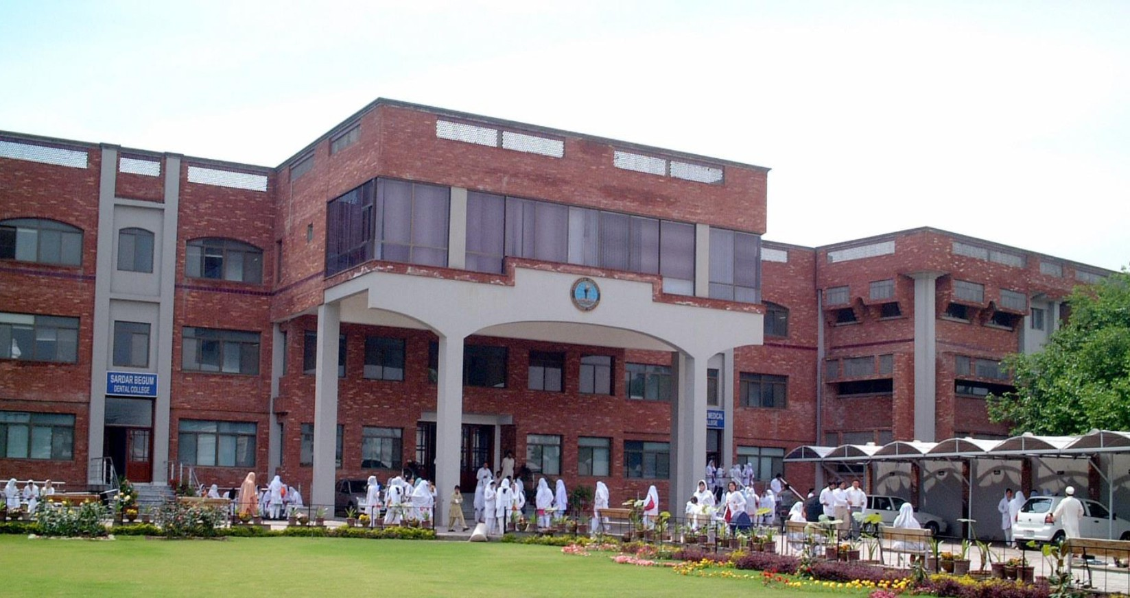

**4th YEAR MBBS**

|  |  |  |  |  |  |  |  |  |  |
| --- | --- | --- | --- | --- | --- | --- | --- | --- | --- |
| **Block-10** | | **Exam Block 10** | **Block-11** | | **Exam Block 11** | **Block-12** | | **Exam Block 12** | **Final Exam** |
| **Module**  **19**  Neurosciences -II | **Module**  **20**  GIT-II | **Module**  **21**  Renal-II | **Module**  **22**  Endocrinology-II | **Module**  **23**  Multisystem-II | **Module**  **24**  Reproduction-II |

**INTRODUCTION TO BLOCK-12:**

Welcome to the 4th Year MBBS Multisystem Module & Reproduction modules.

In the module, you will embark on a comprehensive exploration of multisystem, starting with a detailed examination of anatomy and physiology. You will gain a profound understanding of how the kidneys filter waste and toxins from the blood, maintain fluid and electrolyte balance, and produce hormones crucial for health. Moreover, you will delve into the fascinating realm of blood disorders, where we will uncover the underlying causes, clinical presentations, and diagnostic approaches for a wide spectrum of leukemias. You will develop the skills needed to recognize, evaluate, and manage these conditions effectively.

The reproductive system is made up of glands that produce and secrete hormones, chemical substances produced in the body that regulate the activity of cells or organs. These hormones regulate the body’s growth, metabolism (the physical and chemical processes of the body), and sexual development and function. The hormones are released into the bloodstream and may affect one or several organs throughout the body. Female reproductive system and the hormonal changes that follow will be covered in this module.

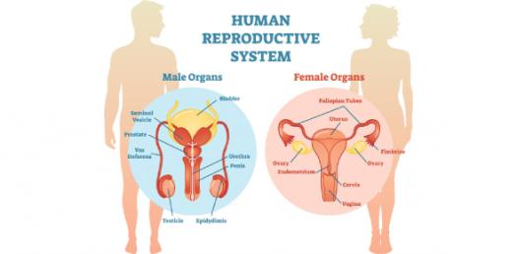 Top of Form

RATIONALE

The Multisystem Module is an essential component of the 4th year MBBS curriculum, reflecting the complexity and integrated nature of human health. It prepares future physicians for the realities of clinical practice, where diseases rarely conform to the boundaries of single organ systems. By fostering a comprehensive and integrated approach to medicine, this module equips medical students with the advanced knowledge, skills, and attitudes necessary for the effective care of patients with complex health needs.  
By the 4th year, MBBS students have a solid foundation in basic sciences. The Reproductive Module serves as a critical bridge to applying this foundational knowledge in clinical settings. It integrates principles of anatomy, physiology, pathology, and pharmacology to understand the complexities of human reproduction, enabling students to apply this knowledge in diagnosing and managing reproductive health issues.

**GENERAL OUTCOMES:**

By the end of this block the students would be able to

**COGNITIVE DOMAIN:**

At the end of block 12, the students of 4th year MBBS will have knowledge about.

1. Describe applied anatomy of Reproduction System
2. Discuss physiology of the Reproduction system
3. Classify the diseases involving the male and female reproduction system.
4. Describe the etiology, pathogenesis, clinical manifestations, diagnosis, and prognosis of the reproductive diseases.
5. Describe the Pharmacology of drugs used in the treatment of reproductive system.
6. Describe the clinical features of reproductive diseases.
7. Management of different Diseases during Pregnancy
8. Enumerate/Describe various diseases.
9. Describe the concept of hospital management, military hygiene and travel health.
10. Describe the prevalence of infectious diseases.
11. Explain the pathology, clinical features, investigations, and treatment of Hyper and hypothyroidism.
12. Describe the classification, pathogenesis, clinical features, investigations, and treatment of Diabetes retinopathy.
13. Describe the pathology, clinical features, investigations, and treatment of laryngeal Carcinoma.

**SKILLS:**

At the end of block 12, the students of 4th year MBBS will be able to perform the following skills



1. Perform various practical’s used in laboratory diagnosis of blood grouping
2. Perform various practical’s used in laboratory diagnosis of hemolytic diseases of new born

**ATTITUDE:**

By the end of this Block, the students will be able to:

* Follow the basic laboratory protocols.
* Participate in class and practical work efficiently.
* Maintain discipline of the college.
* Follow the norms of the college properly.
* Communicate effectively in a team with colleagues and teachers.
* Demonstrate professionalism and ethical values in dealing with patients,

cadavers, colleagues, and teachers.

* Communicate effectively in a team with colleagues and teachers.
* Demonstrate the ability to reflect on the performance.

**LEARNING METHODOLOGIES**

The following teaching / learning methods are used to promote better understanding:

* Large Group Interactive Lectures
* Small Group Discussion
* Practical
* Skills session
* E-Learning
* Self-Directed Learning

**LARGE GROUP INTERACTIVE LECTURES (LGIS)**

In large group, the lecturer introduces a topic or common clinical conditions and explains the underlying phenomena through questions, pictures, videos of, etc. Students are encouraged to actively involve in the learning process.

**SMALL GROUP DISCUSSIONS (SGDs):**

This format helps students to clarify concepts acquire skills or attitudes. Sessions are structured with the help of specific exercises such as patient case, or discussion topics. Students exchange opinions and apply knowledge gained from lectures, tutorials, and self-study. The facilitator role is

to ask probing questions, summarize, or rephrase to help clarify concepts.

Osteology is taught on human bones in small groups so that students can physically learn the bony features and muscle attachments.

**PRACTICAL**

Basic science practical related to Pathology & Community Medicine are scheduled for student learning.

**SELF DIRECTED LEARNING SDL:**

Students assume responsibilities of their own learning through individual study, sharing and discussing with peers, seeking information from Learning Resource Center, teachers, and resource persons within and outside the college. Students can utilize the time within the college scheduled hours of self-study.

**ELEARNING:**

E-Learning is a strategy by which learning occurs through the utilization of electronic media, typically the Internet. The basic aspects of medical professionalism and ethics will be addressed through an e-learning course.

**RULES AND REGULATIONS**

We will be making the journey through Block 12 in 11 weeks. Therefore, this course includes an intensive coursework load. Class attendance and participation are extremely important to learning and are considered in the evaluation of course grades. If there is anything that the module team can do to assist during the course, please feel free to contact them. Attendance will be monitored during the different teaching activities. If the attendance is less than 75%, the student will not be allowed to sit for both block and annual examination.

All examinations must be taken on the date scheduled. There will be a block exam at the end of each block covering two modules. There will be a total of 3 block examinations and the 30% weightage of these block exam will be added to the 70 % of the annual professional exam as an internal assessment. If a student faces any problem related to the block examination marks, he/she has the right to appeal for the rechecking or retotaling of the marks according to the university policy.

**MODULE – 23**

**MULTISYSTEM-II**

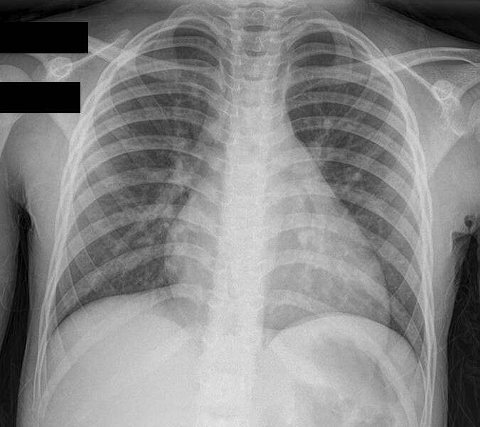

**LEARNING OBJECTIVES & COURSE CONTENTS:**

**At the end of the teaching session the student should be able to achieve the following objectives:**

|  |  |  |
| --- | --- | --- |
| **PATHOLOGY LECTURES** | | |
| **S.NO** | **TOPICS** | **LEARNING OBJECTIVES** |

|  |  |  |
| --- | --- | --- |
|  | Acute Leukemia | Define Acute Leukemia  Explain the types of Leukemia  Explain the clinical features and management of acute leukemia |
|  | Chronic Myeloid Lukemia | Define Chronic myeloid leukemia.  Explain the types of leukemia  Explain the clinical features and management of chronic myeloid leukemia |
|  | Chronic Lymphocytic Lukemia | Define Chronic lymphocytic leukemia.  Explain the types of leukemia  Explain the clinical features and management of chronic lymphocytic leukemia |
|  | Transfusion Reactions | Explain immunological reactions & treatment plan |
|  | Lymphoma | Define Lymphoma  Explain types of lymphoma  Describe the differences between Hodgkin & Non-Hodgkin  lymphoma |

|  |  |  |
| --- | --- | --- |
| **PATHOLOGY PRACTICALS** | | |
| **S.NO** | **TOPICS** | **LEARNING OBJECTIVES** |

|  |  |  |
| --- | --- | --- |
|  | Forward Blood Grouping | Define forward blood grouping   Explain blood groups |
|  | Reverse Blood Grouping | Define Reverse blood grouping  Explain blood groups |

|  |  |  |
| --- | --- | --- |
|  | Hemolytic Disease of Newborn | Explain Rh incompatibility  Describe ABO incompatibility |

|  |  |  |
| --- | --- | --- |
| **PATHOLOGY SGDS** | | |
| **S.NO** | **TOPICS** | **LEARNING OBJECTIVES** |

|  |  |  |
| --- | --- | --- |
| **E.N.T LECTURES** | | |
| **S.NO** | **TOPICS** | **LEARNING OBJECTIVES** |
|  | Laryngeal Carcinoma | Describe cancer of larynx |
|  | Neck Masses | Describe Cervical Lymphadenitis  Explain Tuberculous neck nodes  Elaborate Metastatic Neck Nodes |

|  |  |  |
| --- | --- | --- |
| **COMMUNITY MEDICINE LECTURES** | | |
| **S.NO** | **TOPICS** | **LEARNING OBJECTIVES** |
| 1. | Hospital Management | Describe hospital management  Explain types of hospital management.  Define the principles of hospital management |
| 2. | Military Hygiene | Describe Military hygiene.  Explain types of military hygiene.  Describe the principles of military hygiene |
| 3. | Travel Medicine | Define Travel medicine.  Explain types of travel medicine  Describe the basic principles of travel medicine |
| 4. | Sports Medicine | Define Sports medicine.  Explain types of sports medicine  Describe the basic principles of sports medicine |
| 5. | Hypothesis testing Z-test | Define Hypothesis  Explain the z test for testing of hypothesis |
| 6. | Standard error of Mean | Define standard error of mean  Explain the method of calculating standard error of mean |
| 7. | One sample t-test | Define one sample t test  Explain where should be apply one sample t test. |

|  |  |  |
| --- | --- | --- |
| **COMMUNITY MEDICINE SGDS** | | |
| **S.NO** | **TOPICS** | **LEARNING OBJECTIVES** |
|  | Nutrition | Define macro nutrition  Classify of macro nutrients.  Diseases caused by the deficiency of nutrients   Define micro nutrition  Classify micronutrients   Define food fortification and food adulteration  Define Malnutrition  Explain epidemiology of food borne diseases |
|  | Occupational Health | Define occupational hazards  Epidemiology of occupational diseases. |

|  |  |  |
| --- | --- | --- |
| **COMMUNITY MEDICINE PRACTICALS** | | |
| **S.NO** | **TOPICS** | **LEARNING OBJECTIVES** |
|  | Immunology | Definition of Vaccines   Classify types of Vaccines  Explain Cold Chain  Describe immunization schedule |
|  | Water | Explain the purification of water on large scale  Different methods of water purification |

|  |  |  |
| --- | --- | --- |
| **OPTHAMOLOGY LECTURES** | | |
| **S.NO** | **TOPIC** | **LEARNING OBJECTIVES** |
| 1 | Diabetic Retinopathy | Discuss the effects of diabetes on eye.  Explain the clinical features, investigations and management of diabetic eye disease. |
| 2 | Retinal Vein and Artery Occlusion | Discuss the etiology of CRVO BRVO and CRAO Discuss the clinical features, investigations and management of CRVO BRVO and CRAO |
| 3 | Retinal Detachment | Discuss the etiology of Retinal Detachment. Discuss the clinical features, investigations and management of CRVO BRVO and CRAO |

|  |
| --- |
|  |

|  |  |  |  |
| --- | --- | --- | --- |
| **GENERAL SURGERY LECTURES** | | | |
| **S.No** | **TOPIC** | **LEARNING OBJECTIVES** |
| 1 | Blood Transfusion | Describe the blood product for transfusion.  Explain the indications of blood transfusions.  Enlist the complications of blood transfusions. |
| 2 | Shock | Define Shock Explain Classification of shock Describe the pathophysiology of hypovolemic and septic shock Enumerate the treatment options for hypovolemic and septic shock. |
| 3 | Metabolic Response to Injury and Surgical Trauma | Explain the mediators of metabolic response to injury Describe the metabolic stress response to surgery and surgical trauma Enlist the changes in body composition following injury Enumerate the pathophysiological changes which occurs after trauma and surgical trauma. |
| 4 | Ethics Human Factors Patient Safety Quality Improvement | Explain the importance of autonomy in good surgical practice.  Describe the importance of patient safety, strategies and solutions.  Apply the science of patient safety into clinical practice.  Explain the different kinds of quality measures |

|  |  |  |  |
| --- | --- | --- | --- |
| **GENERAL MEDICINE LECTURES** | | | |
| **S.NO** | **TOPIC** | **LEARNING OBJECTIVES** |
| 1 | Acute Kidney Failure | Define Acute Kidney failure Enumerate the types of kidney failure Explain the clinical manifestations of different types of acute kidney failure Interpret the diagnosis of Acute kidney failure. |

|  |  |  |
| --- | --- | --- |
| PAEDS LECTURES | | |
| S.NO | TOPICS | LEARNING OBJECTIVES |
| 1 | Normal Nutrition | Define principles of feeding in pediatric age group Appraise the role of macronutrients in paediatric age group Discuss the calculation of caloric and water requirements in different age groups. |
| 2 | Breast Feeding | Describe reflexes concerned with breastfeeding.  Enlist 5 steps of breast feeding. Discuss the salient features of initiation and adequacy of breast feeding to an infant.  Explain the advantages of breast feeding. Compare and contrast the constituents of breast milk and cow milk.  Enlist contraindications of breastfeeding |
| 3 | Hyperthyroidism | Define hyperthyroidism Describe the etiology and pathophysiology of hyperthyroidism Discuss Clinical features of hyperthyroidism Describe the management of hyperthyroidism Enlist the complications of hyperthyroidism |
| 4 | Complimentary Feeding | Define weaning Describe the various food that can be given as complementary foods. |
| 5 | Malnutrition | Define malnutrition |

**MODULE – 24**

**REPRODUCTION-II**

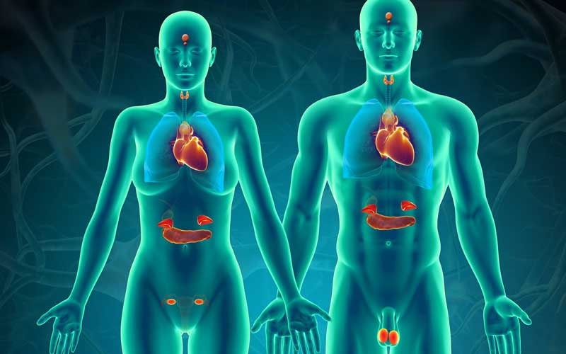

LEARNING OBJECTIVES & COURSE CONTENTS:

**At the end of the teaching session the student should be able to achieve the following objectives:**

|  |  |  |
| --- | --- | --- |
| **PATHOLOGY LECTURES** | | |
| **S.NO** | **TOPICS** | **LEARNING OBJECTIVES** | |
|  | Cervix | Describe Cervix  Differentiate between parts of cervix  Describe the function of Cervix | |
|  | Endometritis & Adenomyosis | Define the types of endometritis  Describe the etiology and morphology  Explain adenomyosis and its types | |
|  | Cervicitis and tumors of cervix | Define Cervicitis and its types  Describe the etiology and morphology Explain the diagnosis of CIN | |
|  | Endometriosis | Define Endometriosis Describe the etiology and morphology of Chocolate cysts Explain the clinical features | |
|  | Endometrial Carcinoma | Define the Epidemiology and types of endometrial carcinoma.  Describe the pathogenesis and morphology of endometrial carcinoma | |
|  | DUB | Define DUB Explain the causes and morphology of DUB | |
|  | Ovarian Tumors | Describe the ovarian tumors. Explain the pathogenesis and morphological features of ovarian tumors. | |
|  | Proliferative and non-proliferative changes in breasts | Explain the changes and morphological features of non-neoplastic breast pathology. | |
|  | Gestational trophoblastic diseases | Describe the etiology of GTD Explain the morphology of H Mole | |
|  | Inflammatory conditions of breasts | Describe mastitis Explain the causes and its morphology | |
|  | Tumors of breasts | Describe the causes and types of breast tumors  Explain the etiology and morphology of carcinoma of breast | |
|  | Urinary bladder cyctisits | Describe the causes of Urinary bladder cyctisits. Explain the etiology and morphology of Urinary bladder cyctisits. | |
|  | Sexually transmitted diseases | Describe Sexually transmitted diseases.  Describe the causes and types of Sexually transmitted diseases. | |
|  | Bladder Neoplasm | Describe the causes and types of Bladder Neoplasm. Explain the etiology and morphology of Bladder Neoplasm. | |
|  | Testicular Diseases Cryptorchidism Testicular atrophy | Describe Testicular Diseases Cryptorchidism Testicular atrophy.  Explain the etiology and morphology of Testicular Diseases Cryptorchidism Testicular atrophy. | |
|  | Testicular Neoplasm | Describe Testicular Neoplasm. Explain the causes and its morphology | |
|  | Carcinoma prostate | Describe Carcinoma prostate Explain the causes and its morphology | |
|  | Benign Prostatic Hyperplasia BPH | Describe Benign Prostatic Hyperplasia BPH. Explain the causes and its morphology. | |

|  |  |  |
| --- | --- | --- |
| **PATHOLOGY SGDs** | | |
| **S.NO** | **TOPICS** | **LEARNING OBJECTIVES** | |
|  | Vulvitis and non-neoplastic epithelial disorders | Describe the Causes  Explain the non-neoplastic epithelial disorders and its etiology | |
|  | Vaginitis and vaginal tumors | Define Vaginitis Explain the features of vaginal intraepithelial neoplasia and its morphology | |
|  | Dysfunctional uterine bleeding | Describe the causes and morphology of DUB | |
|  | Endometrial Hyperplasia | Explain the types and morphology of endometrial hyperplasia. | |
|  | Gestational trophoblastic disease | Describe the features of H mole  Explain the types and features of H mole. | |

|  |  |  |
| --- | --- | --- |
| **PATHOLOGY PRACTICALS** | | |
| **S.NO** | **TOPICS** | **LEARNING OBJECTIVES** | |
|  | Fibroadenoma | Describe the types and morphological features of fibro adenoma | |
|  | Leimyoma | Describe the causes, types and morphology of fibroid uterus | |
|  | Carcinoma of Breast | Explain the causes classification and histopathology of carcinoma | |

|  |  |  |  |
| --- | --- | --- | --- |
| **E.N.T LECTURES** | | | |
| **S.NO** | **TOPICS** | **LEARNING OBJECTIVES** |
| 1 | FB Esophagus | Describe the FB Esophagus |
| 3 | Perforation of Esophagus | Explain the perforation of esophagus Describe the Causes of perforation Enlist treatment options |
| 4 | Throat Disease Scenarios | Explain different throat disease scenarios Enlist the treatment options |

|  |  |  |
| --- | --- | --- |
| **OPTHAMOLOGY LECTURES** | | |
| **S.NO** | **TOPICS** | **LEARNING OBJECTIVES** |
| 1 | White Pupil & retinoblastoma | Describe different causes of white pupil in children  Discuss investigations in white pupil  Discuss the etiology, clinical features, investigations and management of RB |
| 2 | Optic Neuritis | Classify optic neuritis Discuss the etiology, clinical features, investigations and management of optic neuritis |
| 3 | Papillodema | Desrcibe the difference between papiloedema and disc swelling Discuss the etiology, clinical features, investigations and management |
| 4 | Amblyopia and Squint basis | Define amblyopia Discuss the etiology clinical features investigations and management of amblyopia.  Discuss clinical evaluation of squint and principles of management |
| 5 | Concomitant Squint, Esotropia and Exotropia | Define concomitant squint Discuss the etiology, clinical features, investigations and management of esotropia |
| 6 | Diplopia and incomitant squint | Discuss deferential diagnosis/causes of diplopia Define incomitant squint Discuss the etiology clinical features and management of 3rd nerve palsy |
| 7 | Lasers | Discuss various types of lasers and their applications |
| 8 | Ocular Pharmacology | Discuss ocular drugs, actions and indications |
| 9 | Eye Diagnostic Investigations | Describe latest specialized investigative modalities of investigations |
| 10 | Picture and Spot Diagnosis | Identify and spot diagnose ocular pathologies |

|  |  |  |
| --- | --- | --- |
| **COMMUNITY MEDICINE LECTURES** | | |
| **S.NO** | **TOPIC** | **LEARNING OBJECTIVES** | |
|
| 1. | Infectious Diseases Epidemiology | Define infectious diseases  Describe the emerging and reemerging infections  Enlist hospital acquired infections  Explain the visual cycle of chain of infection prevention and control | |
| 2 | Infection and Disinfection | Describe the control of infections | |
| 3 | School Health Services | Define school health services.  Explain the duty of a medical officer  Describe the types of services | |
| 4 | MCH | Describe reproductive health   Explain safe motherhood and its components  Describe maternal mortality and prevention  Describe neonatal care  Enlist neonatal infections  Explain adolescent health problems  Define mother baby package  Describe the strategies to reduce MMR.  Define child care and child health surveillance  Describe the IMNCI program  Enlist Fertility related indicators   Enlist reproductive health indicators | |
| 5 | Biases and confounding | Detect biases and confounding | |
| 6 | Association and Causation estimation of Risk | Evaluate Risk | |
| 7 | Investigation of an outbreak or an epidemic | Conduct outbreak investigation | |

|  |  |  |
| --- | --- | --- |
| **COMMUNITY MEDICINE SGDS** | | |
| **S.NO** | **TOPIC** | **LEARNING OBJECTIVES** | |
|
| 1 | Occupational Health II | Describe Ergonomics   Stress the importance of ergonomics.  Explain the working of ergonomics | |
| 2 | Disaster I | Define Disaster  Explain the types of Disaster  Describe the disaster management cycle | |
| 3 | Disaster II | Define Triage  Explain the importance of Triage.  Describe the role of triage in disaster.  Enumerate the phases of disaster triage | |
| 4 | Disaster III | Explain the importance of pre disaster management.  Enumerate the Steps in pre disaster management  Describe the post disaster management  Enlist the steps in post disaster management. | |

|  |  |  |
| --- | --- | --- |
| **COMMUNITY MEDICINE PRACTICALS** | | |
| **S.NO** | **TOPIC** | **LEARNING OBJECTIVES** | |
|
| 1 | MCH | Define Family Planning  Classify methods and side effects of family planning  Describe the epidemiology of reproductive tract infections   Explain the prevention of RTIs  Enumerate the steps of treatment of RTIs | |
| 2 | Parasitology | Explain the epidemiology of Hook worm diseases, dracunculiasis, Ascariasis, Amoebiasis | |
| 3 | Environment | Describe radiation and light  Explain the types of radiation and light | |
| 4 | Housing | Describe housing   Explain the criteria of health full housing  Enlist the diseases cause by poor quality housing | |
| 5 | Travel Medicine | Define travel medicine  Explain the aims of travel medicine  Enlist the diseases and their prevention  Describe the control diseases | |

|  |  |  |  |
| --- | --- | --- | --- |
| **GENERAL MEDICINE LECTURES** | | | |
| **S.NO** | **TOPIC** | **LEARNING OBJECTIVES** |
| 1 | Diabetes Mellitus | Define Diabetes Mellitus Explain the types of Diabetes Mellitus |
| 2 | Diabetes insipidus | Define Diabetes insipidus.  insipidus. |
| 3 | Cushing syndrome | Define Cushing syndrome.  Enlist the  presentation of Cushing syndrome  Devise the management of Cushing syndrome |
| 4 | Acromegaly | Define acromegaly.  Explain & management of acromegaly |
| 5 | Hypothyroidism | Explain the clinical presentation & management of hypothyroidism |
| 6 | Hyperparathyroidism | Explain the clinical presentation & management of hyperparathyroidism |

|  |  |  |
| --- | --- | --- |
| **GYNAECOLOGY LECTURES** | | |
| **S.NO** | **TOPICS** | **LEARNING OBJECTIVES** |
| 1) | Labour | Define Labour  Explain Stages of Labour  Describe the management of Labour |
| 2 | Mechanisim of Labour | Explain the steps of mechanisim of labour |
| 3 | Prolong labour and Ruptured Uterus | Explain the causes of prolong labour  Describe the diagnosis and treatment plan. |
| 4 | Pain Relief in Labour | Explain the pain relief process in labour  Describe the epidural analgesia |
| 5 | Induction of labour | Enlist the indications of induction  Explain the methods and Complications |
| 6 | Pre-Term Labour | Define pre term labour  Explain the causes of pre term labour  Describe the management of pre term labour |
| 7 | Multiple Pregnancy | Explain the care of women with multiple pregnancies  Describe the complications of multiple pregnancy |
| 8 | Placenta Pervia | Define Placenta Pervia  Explain the types of Placenta Pervia  Describe the clinical presentation, diagnosis and management. |
| 9 | Abruptio Placenta | Define abruptio  Explain the clinical presentation and diagnosis  Describe the management of Abruptio Placenta |
| 10 | Post-Partum Hemorrhage | Define Post Partum hemorrhage  Explain the causes and management |
| 11 | Obstetric Shock | Describe the causes of obstetric shock  Explain the immediate management of obstetric shock |

|  |  |  |  |
| --- | --- | --- | --- |
| **GENERAL SURGERY LECTURES** | | | |
| **S.NO** | **TOPIC** | **LEARNING OBJECTIVES** |
| 1 | Malignant Breast Disease | Define breast malignancies Explain the risk factors, genetic abnormalities, diagnosis and management |
| 2 | Principles of Management of Trauma Patient | Explain triage Define ATLS protocol Describe Maxillofacial trauma and its management Explain types of abdominal trauma and its management |

|  |  |  |
| --- | --- | --- |
| **PHARMACOLOGY LECTURES** | | |
| **S.NO** | **TOPICS** | **LEARNING OBJECTIVES** |
| 1) | Contraception (Male & Female) | Enlist types of contraception  Explain the uses and adverse effects.   Describe drug interactions. |

|  |  |  |
| --- | --- | --- |
| **PEADS LECTURES** | | |
| **S.NO** | **TOPIC** | **LEARNING OBJECTIVES** |
| 1 | Growth | Define growth Describe the factors affecting growth Discuss the anthropometric measures to assess the growth |
| 2 | Development | Define development Describe the developmental milestones including motor skills cognitive/adaptive development, language and communication |
| 3 | Growth Charts | Describe different age and gender appropriate centile charts. Analyze the role of growth charts in different disease affecting growth parameters. |

|  |  |  |
| --- | --- | --- |
| **PHYSIOLOGY LECTURE** | | |
| **S.NO** | **TOPICS** | **LEARNING OBJECTIVES** |
|  |  |  |
| 1) | Review of spermatogenesis and oogenesis | Explain spermatogenesis and oogenesis. |

**ASSESSMENT METHODS FOR BLOCK EXAM:** 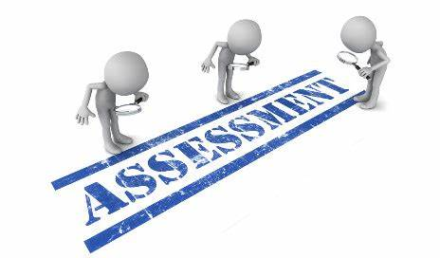

Evaluation is a continuous process comprising of block examination and annual university examination. Students will be evaluated throughout the year. The internal assessment will contribute towards the final examination scores.

Multiple examination methods including MCQs, SAQs, OSPE and viva will be used for assessment. In line with PMC stipulation, the pass/fail marks for the test and examination will be 50%.

There will be a block exam at the end of each block.

**Theory (knowledge):** MCQs (Multiple Choice Questions) and SAQs (Short Answer Questions) are used to assess the theory part for the block exam

**MCQ:**

* A MCQ has a statement or clinical scenario followed by four options (likely answers).
* After reading the statement/scenario student select ONE, the most appropriate answer/response from the given list of options.

### Correct answer carries one mark, and incorrect ‘zero mark’. There is NO negative marking.

**SAQ:**

**OSPE: Objective Structured Practical Examination (See the proposed plan of OSPE)**

* It may comprise between 12- 25 stations.
* The content may assess application of knowledge, or practical skills.
* Student will complete task in define time at one given station.
* All the students are assessed on the same content by the same examiner in the same allocated time.
* A structured examination will have observed, unobserved, interactive and rest stations.

### **Observed and interactive stations:**

They will be assessed by internal or external examiners through the task or viva.

### **Unobserved station:**

It will be static station in which students will have to answer the questions related to the given pictures, models or specimens on the provided response sheet.

### **Rest station:**

It is a station where no task is given, and during this time student can organize his/her thoughts.

**ASSESSMENT PLAN 4th YEAR MBBS**

**MBBS BLOCK EXAMINATION MARKS DISTRIBUTION:**

|  |  |  |  |  |  |  |  |  |  |  |  |  |  |  |  |  |  |  |  |
| --- | --- | --- | --- | --- | --- | --- | --- | --- | --- | --- | --- | --- | --- | --- | --- | --- | --- | --- | --- |
| **Component from BLOCK EXAM= Theory and Practical: 140+140**  **Component from Internal Assessment= Theory and Practical 60+60**  **Theory=600 Marks Practical=600**  **Total Marks: 1200** | | | | | | | | | | | | | | | | | | | |
| **MODULE/BLOCK** | | | **BLOCK – 10** | | | | | **BLOCK – 11** | | | | | | | **BLOCK – 12** | | | | |
| **Module- 19**  **Neurosciences II** | | **Module-20**  **GIT II** | | | **Module-21**  **Renal II** | | | | **Module-22**  **Multisystem II** | | | **Module-23**  **Endocrinology II** | | | **Module-24**  **Reproduction II** | |
|  | **Theory Marks** | | **100** | | **100** | | | **100** | | | | **100** | | | **100** | | | **100** | |
| **200** | | | | | **200** | | | | | | | **200** | | | | |
| **Practical Marks (OSPE)** | | **200** | | | | | **200** | | | | | | | **200** | | | | |
| **Internal Assessment-IA** | | **Theory: 60 Practical:60** | | | | | **Theory: 60 Practical:** | | | | | | | **Theory: 60 Practical:60** | | | | |
| **Subject wise distribution** | **Subjects** | **MCQs** | **SAQs** | **OSPE Stations** | **viva** | | **MCQs** | **SAQs** | | **OSPE Stations** | | **viva** | | **MCQs** | **SAQs** | | **OSPE Stations** | **viva** |
| **ENT** | **23** | **3** | **5** | **15** | | **23** | **3** | | **5** | | **15** | | **23** | **3** | | **5** | **15** |
| **Ophthalmology** | **23** | **3** | **5** | **15** | | **23** | **3** | | **5** | | **15** | | **23** | **3** | | **5** | **15** |
| **Community Medicine** | **23** | **3** | **5** | **15** | | **23** | **3** | | **5** | | **15** | | **23** | **3** | | **5** | **15** |
| **Pathology** | **23** | **3** | **5** | **15** | | **23** | **3** | | **5** | | **15** | | **23** | **3** | | **5** | **15** |
|  | **TOTAL#** | **92**  **(I mark each)** | **12**  **(4 marks each)** | **20 (4 marks each)**  **=80** | **60** | | **92**  **(I mark each)** | **12**  **(4 marks each)** | | **20(4 marks each) =80** | | **60** | | **92**  **(I mark each)** | **12**  **(4 marks each)** | | **20**  **(4 marks each) =80** | **60** |
|  | **Total** | **92** | **48** | **140** | | | **92** | **48** | | **140** | | | | **92** | **48** | | **140** | |
| **Total (theory + practical)** | | **140** | | **140** | | | **140** | | | **140** | | | | **140** | | | **140** | |
|  | **Internal Assessment** | | **60** | | **60** | | **60** | | | **60** | | | | **60** | | | **60** | | |
| **Total marks** | | **200** | | **200** | | **200** | | | **200** | | | | **200** | | | **200** | | |
| **Total Marks** | | **400** | | | | **400** | | | | | | | **400** | | | | | |
| **Grand total** | **1200** | | | | | | | | | | | | | | | | | | |

**INTERNAL ASSESSMENT MARKS DISTRIBUTION:**

**4th YEAR MBBS**

|  |  |  |  |  |  |
| --- | --- | --- | --- | --- | --- |
| **THEORY INTERNAL ASSESSMENT**  **15 MARKS** | | | **PRACTICAL INTERNAL ASSESSMENT**  **15 MARKS** | | |
| **ATTENDANCE**  **5 MARKS** | **ASSIGNMENTS AND PRESENTATIONS**  **5 MARKS** | **BEHAVIOUR /DISCIPLINE**  **5 MARKS** | **ATTENDANCE**  **5 MARKS** | **LOGBOOK**  **5 MARKS** | **BEHAVIOUR**  **5 MARKS** |
| Obtained percentage / 100 x 2 = | Grade A=5 marks  Grade B= 3 marks  Grade C= 1 mark  No assignments or presentations =0 marks | No misbehave or warning in lectures = 5 marks  Written warning given to student = 0 marks | Obtained percentage / 100 x 2 = | Completed and timely signed =5 marks  Completed and late submission=3 marks  Incomplete= 1 mark  No logbook =0 marks | No misbehave or warning in practical class= 5 marks  Written warning given to students= 0 marks |

|  |  |
| --- | --- |
| **LEARNING RESOURCES:** | |
| **SUBJECT** | **RESOURCES** |
| **ENT** | **TEXTBOOKS**  Diseases of Ear, Nose and Throat by P.L. Dhingra, 6th edition |
| **OPTHALMOLOGY** | **TEXTBOOKS**  Shafi and Jatoi  Short Kanski |
| **COMMUNITY MEDICINE** | **TEXTBOOKS**  Fundamentals of community medicine & Public Health (3rd Edition) (Dr. Hayat Muhammad Khan, Dr. Bushra Iftikhar)  Public Health & Community Medicine (latest Edition) (M. Iliyas Ansari  Preventive & social Medicine (Latest Edition) (K. Park) |
| **PATHOLOGY** | . **TEXTBOOKS**  Robbins & Cotran, Pathologic Basis of Disease,9 th edition |

|  |  |
| --- | --- |
| **OTHER LEARNING RESOURCES:** | |
| **Hands-on Activities**  **/ Practical** | Students will be involved in Practical sessions and hands-on activities that link with the foundation module to enhance the learning. |
| **Labs** | Utilize the lab to relate the knowledge to the specimens and models available. |
| **Skill Labs** | A skills lab provides the simulators to learn the basic skills and procedures. This helps build the confidence to approach the patients. |
| **Videos** | Video familiarize the student with the procedures and protocols to assist patients. |
| **Computer Lab / CDs / DVDs / Internet Resources:** | To increase the knowledge students should utilize the available internet resources and CDs/DVDs. This will be an additional advantage to increase learning. |
| **SDL** | SDL is scheduled to search for information to solve cases, read through different resources and discuss among the peers and with the faculty to clarify the concepts. |