**GANDHARA UNIVERSITY**

**KABIR MEDICAL COLLEGE**

**URRICULUM**

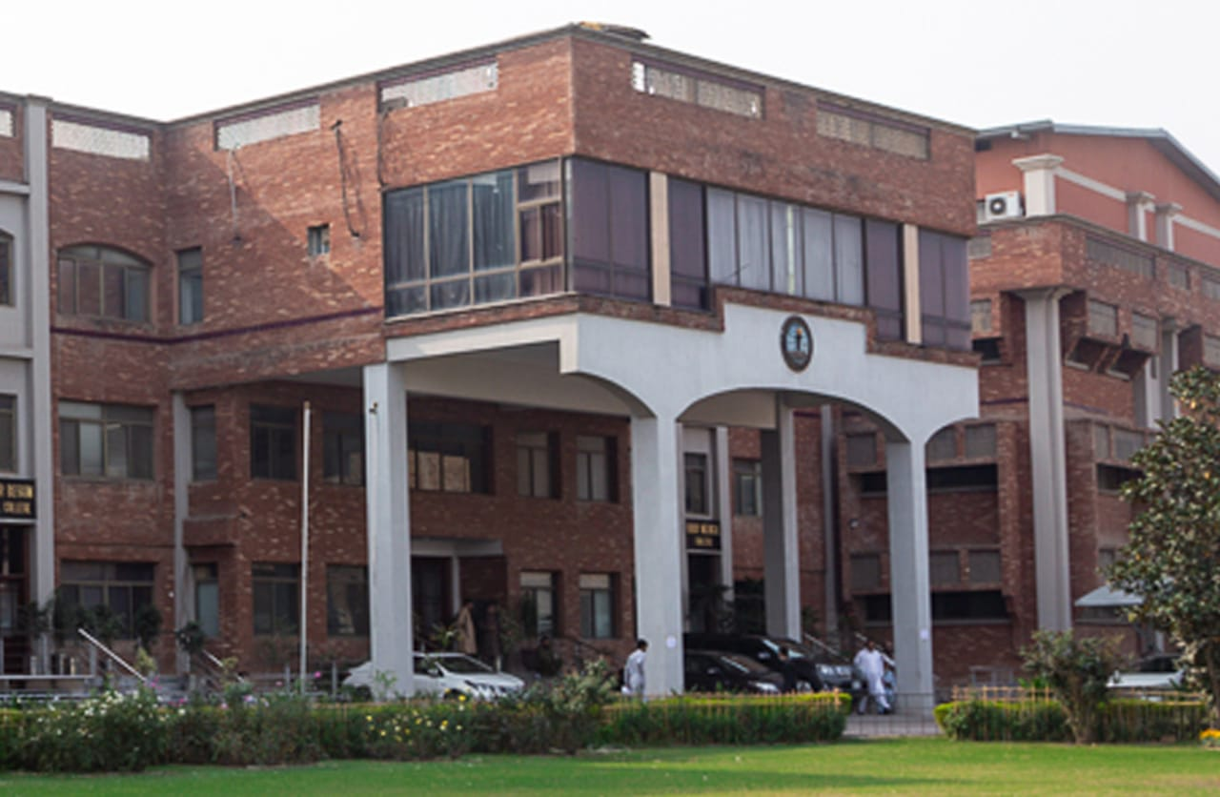

**4TH YEAR MBBS 2024-2025**

**BLOCK 11**

**(RENAL II**

**& ENDOCRINOLOGY II)**

# FROM THE DESK OF PRINCIPAL

**BRIG AHMAD HUSSAIN MASHWANI(R)**

Kabir Medical College has evolved, since its inception, as an exceptionally outstanding facility to provide quality education to the students.

I must appreciate the hard work of our well experienced and dedicated faculty members and staff in maintaining high standards of medical education and the efforts they have put into Kabir Medical College to be a distinguished center of excellence.

By the grace of Almighty, we are starting the integrated curriculum for 1st year MBBS. We meet international standards of professional education by installing the system of integrated curriculum and system-based teaching of basic medical sciences. We advocate interactive sessions to improve comprehension of students as well as training them with skills of communication and self-expression.

Since the establishment of Kabir Medical College, we have been working constantly to upgrade services and facilities at the campus and the attached Naseer Teaching Hospital for our students and patients.

We would like our graduates to excel as confident, responsible, and self-learning medical practitioners. With a state-of-the-art campus, experienced faculty, an up-to-date digital library, I assure that your decision to study at Kabir Medical College will surely be a wise one, your experience here will be profoundly enriching, and you will become an asset to the nation and international community health care professionals.

Brig Ahmad Hussain Mashwani (R)

MBBS, FCPS(SURGERY)OJT (VASCULAR SURGERY)

CHPE, MHPE(KMU)

Principal

Kabir Medical College

Gandhara University  
 Peshawar

On behalf of the block team, I would like to welcome you to block-11(Renal & Endocrinology modules). As a part of the system-based curriculum, this block is an integrated presentation, comprises system-based modules which link basic science knowledge to clinical problems. Integrated teaching means that subjects are presented as a meaningful whole. Students will be able to have a better understanding of basic sciences when they repeatedly learn in relation to clinical examples. Small group discussions, early exposure to clinics, wards, and skills acquisition in skills lab are characteristics of integrated teaching program.

Our mission is to provide all educational opportunities to our students, therefore on completion of the MBBS program graduates will possess an appropriate foundation of knowledge, skills, and attitudes to be well prepared to practice safely and effectively.

This study guide includes the course contents of the block. The learning objectives, practical, topics of the small group discussions.it also includes the assessment plan for the block exam.

As a director I will be meeting with the facilitators to receive the feedback and will try to resolve any difficulties or problems faced during the block. Please do not hesitate to contact DME for any academic help. I wish you an enjoyable learning experience with block 11.

**Director DME: Dr. Marina Khan**

|  |
| --- |
| **Topic** |
| **Block Team** |
| **List of abbreviations…** |
| **Aims of the study guide…** |
| **Module distribution of 4th year MBBS** |
| **Introduction of block 11…** |
| **General Outcomes…** |
| **Leaning Methodologies…** |
| **Rules Regulations** |
| **Learning objectives & Course contents** |
| **Assessment…………………………………………………………………………………………….** |
| **Learning Resources………………………………………………………………………………** |

**BLOCK TEAM**

|  |  |  |  |
| --- | --- | --- | --- |
|  | **Dr Marina Khan**  **Director of Department of Medical Education** | | **marinakahn@hotmail.com** |
| **DEPARTMENT OF PATHOLOGY** | |  | Prof Dr. Mukhtar  Prof Dr. Ehsan Gul  Prof Dr. Naila  Associate Prof Dr. Shazia  Assist Prof Dr. Ibn-e- Amin  Assist Prof Dr. Ronaq  Dr Alia Banori |
| **DEPARTMENT OF E.N.T** | |  | Prof Dr Amjid Khan  Associate Prof Waqar ud din  Assistant Prof Dr Arif  Dr Shoaib |
| **DEPARTMENT OF OPTHAMOLOGY** | |  | Prof Dr Zafar ul Islam  Prof Dr Zubair Masud  Dr Usman Khan |
| **DEPARTMENT OF COMMUNITY MEDICINE** | |  | Prof Dr Hamid Hussain  Associate Prof Dr Farhana Jabeen  Assist Prof Dr Ghazala Yasmin  Dr Fareeha  Dr Iftikhar Malik |
| **DEPARTMENT OF MEDICAL EDUCATION** | |  | Assist Prof Dr. Marina Khan  Assist Prof Dr. Syed Muhammad Junaid  Dr. Aalia Zaib  Dr. Usama Zeb |

**LIST OF ABBREVIATIONS**

|  |  |
| --- | --- |
| **DME** | Department of Medical Education |
| **CI** | Curriculum integration |
| **Anat** | Anatomy |
| **Physio** | Physiology |
| **Bio** | Biochemistry |
| **Histo** | Histology |
| **Emb** | Embryology |
| **Patho** | Pathology |
| **Pharma** | Pharmacology |
| **OPTH** | Ophthalmology |
| **ENT** | Otorhinolaryngology |
| **GM** | General Medicine |
| **COM** | Community Medicine |
| **LGIS** | Large Group Interactive Session |
| **SGD** | Small Group Discussion |
| **SDL** | Self-Directed Learning |
| **MCQ** | Multiple Choice Question |
| **SAQ** | Short Answer Question |
| **OSPE** | Objective Structured Practical Exam |

**STUDY GUIDE:**

This study guidebook was designed by combining.

the efforts of all topics throughout the year to give medical students at Gandhara University a resource material that highlights significant components of the curriculum. By providing students with control over their learning, the study guide aims to promote self-regulated lifelong learning.

Regarding the course content, the study guide provides an overview of the anticipated course outcomes and objectives. The assessment approach is also customized to the intuitional strategy.

A successful curriculum has a significant impact on the final product, as well as on society. This study guide was carefully designed with the PMC curriculum and rules in mind, and Gandhara University stakeholders and faculty members worked hard to personalize it to the needs of students. They are further working to build, implement, and exercise a well-built curriculum considering changing demographic needs and disease prevalence in our society. Throughout the construction of the study guide, students' feedback was received and included. Curriculum is a living, dynamic entity that is constantly changing. With each passing day, we hope to improve it.

Each module in this block has been created to cater the gap between basic and clinical subjects through pre-clinical learning. The block is divided into two modules in which the students are exposed to a variety of basic and clinical subjects. The integrated curriculum is enforced through interactive lectures, small group discussion, community outreach programs along with rotations at preclinical laboratory. There will be formative as well as summative assessment of the block throughout the modules.

**AIMS OF THE STUDY GUIDE**

It is an aid to:

* Inform students how student learning program of the BLOCK-wise modules has been organized.
* Help students organize and manage their studies throughout the modules.
* Guide students on assessment methods, rules, and regulations.
* Communicates information on organization and management of the modules. This will help the student to contact the right person in case of any difficulty.
* Defines the objectives which are expected to be achieved at the end of each module.
* Identifies the learning strategies such as lectures, small group teachings, clinical skills and demonstration, tutorial that will be implemented to achieve the modules objectives.
* Provides a list of learning resources such as books, computer assisted learning programs, web- links, and journals, for students to consult to maximize their learning.
* Highlights information on the contribution of continuous and block examinations to the student's overall performance.
* Includes information on the assessment methods that will be used to determine every student's achievement of objectives.
* Focuses on information pertaining to examination policy, rules, and regulations.

**ORGANIZATION OF MODULAR CURRICULUM**

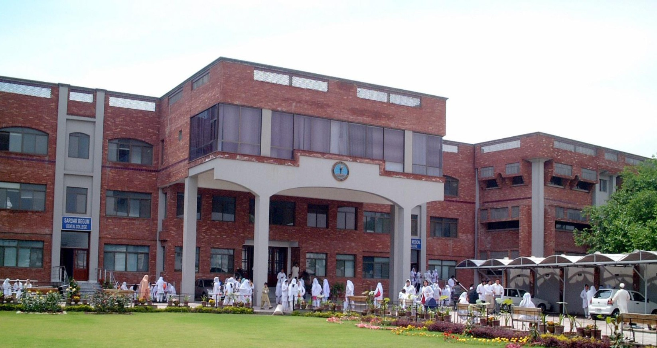

**4th YEAR MBBS**

|  |  |  |  |  |  |  |  |  |  |
| --- | --- | --- | --- | --- | --- | --- | --- | --- | --- |
| **Block-10** | | **Exam Block 10** | **Block-11** | | **Exam Block 11** | **Block-12** | | **Exam Block 12** | **Final Exam** |
| **Module**  **19**  Neurosciences -II | **Module**  **20**  GIT-II | **Module**  **21**  Renal-II | **Module**  **22**  Endocrinology-II | **Module**  **23**  Multisystem-II | **Module**  **24**  Reproduction-II |

**INTRODUCTION TO BLOCK-11:**

Welcome to the 4th Year MBBS Renal Module & Endocrinology modules.

In the Renal module, you will embark on a comprehensive exploration of nephrology, starting with a detailed examination of renal anatomy and physiology. You will gain a profound understanding of how the kidneys filter waste and toxins from the blood, maintain fluid and electrolyte balance, and produce hormones crucial for health. Moreover, you will delve into the fascinating realm of renal pathology, where we will uncover the underlying causes, clinical presentations, and diagnostic approaches for a wide spectrum of renal disorders. From chronic kidney disease to acute kidney injury, glomerulopathies, and electrolyte imbalances, you will develop the skills needed to recognize, evaluate, and manage these conditions effectively.

The endocrine system is made up of glands that produce and secrete hormones, chemical substances produced in the body that regulate the activity of cells or organs. These hormones regulate the body’s growth, metabolism (the physical and chemical processes of the body), and sexual development and function. The hormones are released into the bloodstream and may affect one or several organs throughout the body. The major glands of the endocrine system are the hypothalamus, pituitary, thyroid, parathyroid, adrenals, pineal body, and the reproductive organs (ovaries and testes)

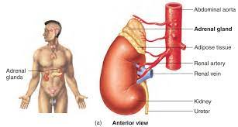

Top of Form

RATIONALE

The rental system is involved in the excretion of waste products, especially nitrogenous end products of protein metabolism. It regulates normal hydrogen ion concentration, pH and acid base balance, maintains sodium and potassium and electrolyte balance of the body also maintains blood pressure, osmotic pressure, water balance, plasma / extra cellular fluid volume. Renal diseases are common in the community and renal failure is a common end stage of most renal disorders. Understanding of the basic anatomy, physiology and biochemical processes is essential for dealing with the disease processes afflicting the renal system. This module provides this basic understanding.

The function of the endocrine system is to coordinate and integrate cellular activity within the whole body by regulating cellular and organ function throughout life and maintaining homeostasis. Homeostasis, or the maintenance of a constant internal environment, is critical to ensuring appropriate cellular function. In this module the anatomy and physiology of the endocrine organs, functional biochemistry of the hormones secreted along with normal physiological changes are taught in integrated fashion with reference to common disease occurring in our community.

**GENERAL OUTCOMES:**

By the end of this block the students would be able to

**COGNITIVE DOMAIN:**

At the end of block 11, the students of 4th year MBBS will have knowledge about.

1. Describe applied anatomy of Urinary & endocrine system.
2. Discuss physiology of the renal & hormonal system
3. Classify the diseases involving glomeruli, tubules, interstitial, renal blood vessels, Chronic nephron loss, Cystic, urine out flow obstruction, congenital-developmental and neoplastic diseases of renal system.
4. Describe the etiology, pathogenesis, clinical manifestations, diagnosis, and prognosis of the renal system diseases.
5. Describe the Pharmacology of drugs used in the treatment of Renal System Diseases.
6. Describe the clinical features of renal diseases.
7. Management of Chronic Kidney Diseases & Renal Transplant patients during Pregnancy
8. Enumerate/Describe various renal diseases primarily affecting pediatrics age group.
9. Describe the concept of occupational health, primary health care.
10. Describe the prevalence of infectious diseases.
11. Explain the pathology, clinical features, investigations, and treatment of Hyper and hypoadrenalism.
12. Describe the classification, pathogenesis, clinical features, investigations, and treatment of Diabetes mellitus.
13. Describe the pathology, clinical features, investigations, and treatment of Hyper and hypopituitarism.
14. Describe the pathology, clinical features, investigations, and treatment of Hyper and hypothyroidism, and hyper and hypoparathyroidism.

**SKILLS:**

At the end of block 11, the students of 4th year MBBS will be able to perform the following skills



1. Perform various practical’s used in laboratory diagnosis of renal diseases
2. Perform various practical’s used in laboratory diagnosis of endocrinal diseases

**ATTITUDE:**

By the end of this Block, the students will be able to:

* Follow the basic laboratory protocols.
* Participate in class and practical work efficiently.
* Maintain discipline of the college.
* Follow the norms of the college properly.
* Communicate effectively in a team with colleagues and teachers.
* Demonstrate professionalism and ethical values in dealing with patients,

cadavers, colleagues, and teachers.

* Communicate effectively in a team with colleagues and teachers.
* Demonstrate the ability to reflect on the performance.

**LEARNING METHODOLOGIES**

The following teaching / learning methods are used to promote better understanding:

* Large Group Interactive Lectures
* Small Group Discussion
* Practical
* Skills session
* E-Learning
* Self-Directed Learning

**LARGE GROUP INTERACTIVE LECTURES (LGIS)**

In large group, the lecturer introduces a topic or common clinical conditions and explains the underlying phenomena through questions, pictures, videos of, etc. Students are encouraged to actively involve in the learning process.

**SMALL GROUP DISCUSSIONS (SGDs):**

This format helps students to clarify concepts acquire skills or attitudes. Sessions are structured with the help of specific exercises such as patient case, or discussion topics. Students exchange opinions and apply knowledge gained from lectures, tutorials, and self-study. The facilitator role is

to ask probing questions, summarize, or rephrase to help clarify concepts.

Osteology is taught on human bones in small groups so that students can physically learn the bony features and muscle attachments.

**PRACTICAL**

Basic science practical related to Pathology & Community Medicine are scheduled for student learning.

**SELF DIRECTED LEARNING SDL:**

Students assume responsibilities of their own learning through individual study, sharing and discussing with peers, seeking information from Learning Resource Center, teachers, and resource persons within and outside the college. Students can utilize the time within the college scheduled hours of self-study.

**ELEARNING:**

E-Learning is a strategy by which learning occurs through the utilization of electronic media, typically the Internet. The basic aspects of medical professionalism and ethics will be addressed through an e-learning course.

**RULES AND REGULATIONS**

We will be making the journey through Block II in 10 weeks. Therefore, this course includes an intensive coursework load. Class attendance and participation are extremely important to learning and are considered in the evaluation of course grades. If there is anything that the module team can do to assist during the course, please feel free to contact them. Attendance will be monitored during the different teaching activities. If the attendance is less than 75%, the student will not be allowed to sit for both block and annual examination.

All examinations must be taken on the date scheduled. There will be a block exam at the end of each block covering two modules. There will be a total of 3 block examinations and the 20% weightage of these block exam will be added to the 70 % of the annual professional exam as an internal assessment. If a student faces any problem related to the block examination marks, he/she has the right to appeal for the rechecking or retotaling of the marks according to the university policy.

**MODULE – 21**

**RENAL-II**

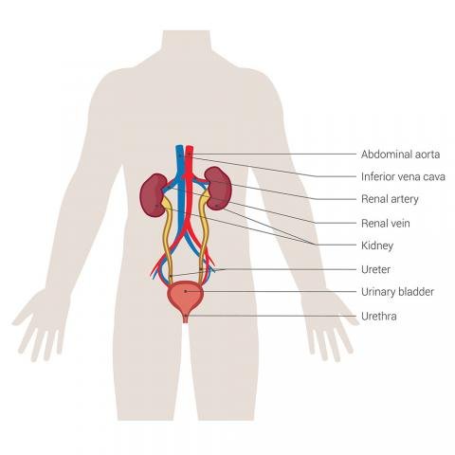

**LEARNING OBJECTIVES & COURSE CONTENTS:**

**At the end of the teaching session the student should be able to achieve the following objectives:**

|  |  |  |
| --- | --- | --- |
| **PATHOLOGY LECTURES** | | |
| **S.NO** | **TOPICS** | **LEARNING OBJECTIVES** |

|  |  |  |
| --- | --- | --- |
|  | Glomerular disease | Describe the pathological responses, pathogenesis and mediators of glomerular injury  Classify Glomerular diseases. Differentiate between major Primary Glomerular diseases in terms of clinicopathological features and different microscopic findings  Discuss the etiologies, clinicopathological features and morphology of the diseases presenting as Nephritic syndrome and Nephrotic syndrome  Explain the pathogenesis and morphology of minimal change disease |
|  | Nephrotic syndrome | Define nephrotic syndrome  Discuss the etiologies, clinicopathological features and morphology of the diseases presenting as Nephrotic syndrome  Explain the pathogenesis and morphology of minimal change disease  Describe the etiology, pathogenesis, morphology and clinical presentation of focal segmental glomerulosclerosis |
|  | Membranous nephropathy | Describe the etiology, pathogenesis, morphology and clinical presentation of membranous |
|  | Nephritic syndrome | Define nephritic syndrome.  Discuss the etiologies, clinicopathological features and morphology of the diseases presenting as Nephritic syndrome  Describe the etiology, pathogenesis, morphology and clinical presentation of IgA nephropathy  Describe the pathogenesis, morphology of diabetic and other types of secondary nephropathies |
|  | Rapidly progressive glomerulonephritis | Describe the etiology, pathogenesis, morphology and clinical presentation of rapidly progressive glomerulonephritis |
|  | Tubulo interstitial disease | Discuss the etiology, clinico-pathological presentation, morphology, and complications of Acute Pyelonephritis,  Discuss the etiology, clinico-pathological presentation, morphology, and complications of chronic Pyelonephritis,  Discuss the etiology, clinico-pathological presentation, morphology, and complications of drug induced nephritis |
|  | Acute tubular injury(ATI)  Ischemic(ATI)  Nephrotoxic (ATI) | Define Acute Tubular Injury (ATI).  Describe the etiology, clinico-pathological features and morphology of ischemic and toxic ATI.  Compare the pattern of tubular damage in ischemic and toxic injury |
|  | Cystic diseases of the kidney  Simple cysts  Acute & childhood polycystic kidney diseases | Classify the cystic diseases of Kidney  Describe the inheritance, Pathological features, Complications, and prognosis of polycystic diseases of Kidneys.  Differentiate between the inheritance, pathological features, typical outcomes and clinical features of Adult and Childhood Polycystic Kidney Diseases  Differentiate between the inheritance, pathological features, typical outcomes, and clinical features of Childhood Polycystic Kidney Diseases |
|  | Renal tumors(Neoplasm)  Benign/Malignant  Renal Cell Carcinoma  Nephroblastoma(Wilms Tumor) | Classify the benign and malignant tumors of the Kidney.  Discuss the etiology, morphology, and prognosis of Renal cell carcinoma  Discuss the genetics, clinico-pathological features, morphology, and prognosis of Wilm’s tumor  Describe the various investigations to diagnose renal tumors albumin/creatinine ratio, urine for micro albumin)  Discuss management of renal tumors  Describe the congenital anomalies of bladder and urethra  Discuss the etiology, morphology clinico-pathological features and complications of Acute & chronic Cystitis. |

|  |  |  |
| --- | --- | --- |
| **PATHOLOGY PRACTICALS** | | |
| **S.NO** | **TOPICS** | **LEARNING OBJECTIVES** |

|  |  |  |
| --- | --- | --- |
|  | Urine Analysis | Demonstrate the procedure of urine collection, physical examination volume, color, appearance, pH of specimen. |
|  | RFT’s · Urea · Creatinine | Perform the physical examination of urine and prepare report of an abnormal urine with pyuria and hematuria Interpret the results  Demonstrate substances for chemical examination and the different procedures of detection of protein & cretanine in urine. |
|  | Specimen examination | Identify the renal specimen for different renal diseases |

|  |  |  |
| --- | --- | --- |
| **PATHOLOGY SGDS** | | |
| **S.NO** | **TOPICS** | **LEARNING OBJECTIVES** |

|  |  |  |
| --- | --- | --- |
|  | Nephrotic Syndrome  Nephritic Syndrome | Define nephrotic & nephritic syndrome.  Discuss the etiologies, clinicopathological features, pathogenesis and morphology of the diseases presenting as Nephrotic & nephritic syndrome |
|  | Acute and Chronic pyelonephritis | Discuss the etiology, clinico-pathological presentation, morphology, and complications of Acute & chronic Pyelonephritis  Discuss the etiology, clinico-pathological presentation, morphology, and complications of acute & chronic pyelonephritis  Discuss the etiology, clinico-pathological presentation, morphology, and complications of drug induced nephritis |
|  | Renal vascular diseases, Nephrosclerosis ,Malignant hypertension, Thrombotic Microangiopathies | Enlist the Types of renal vascular diseases.  Discuss the pathogenesis, morphology of Renal vascular diseases |
|  | Chronic kidney diseases | Explain the etiology, pathogenesis, morphology and clinical presentation and complications of acute kidney diseases |
|  | Renal stones hydronephrosis | Describe etiology, pathogenesis, morphology and management of renal stones |

|  |  |  |
| --- | --- | --- |
| **E.N.T LECTURES** | | |
| **S.NO** | **TOPICS** | **LEARNING OBJECTIVES** |
|  | Congenital lesions of larynx | Enumerate congenital lesions of the larynx.  Discuss congenital lesions of larynx |
|  | otosclerosis | Discuss otosclerosis.  Discuss medical & surgical treatment of otosclerosis. |
|  | Laryngotracheal trauma | Enumerate causes of laryngotracheal trauma and its management |
|  | Meniere's disease | Discuss signs and symptoms of Meniere’s disease.  Discuss the diagnosis and management of Meniere’s disease |
|  | Laryngeal paralysis (RLN) | Discuss laryngeal paralysis or Vocal cord paralysis.  Discuss paralytic causes of hoarseness, its types.  Discuss clinical features, diagnosis, and treatment. |
|  | Facial nerve and its disorders | Discuss facial nerve.  Enumerate facial nerve & its disorders.  Discuss the management of facial nerve & its disorders. |
|  | Pharyngeal pouches | Discuss the Pharyngeal pouch & the predisposing factors, clinical features, and treatment |

|  |  |  |
| --- | --- | --- |
| **COMMUNITY MEDICINE LECTURES** | | |
| **S.NO** | **TOPICS** | **LEARNING OBJECTIVES** |
|  | Food hygiene |  |
|  | Air composition & Air pollution, causes and diseases caused by impurities and their prevention green house effect. |  |
|  | Effective communication |  |
|  | Concept uses & history of statistics | Describe the significance of biostatistics in health and epidemiology.  Application and Interpretation of statistical data |
|  | Common nutritional problems of public health importance, their prevention and control | Discuss common nutritional problems of public health importance, their prevention and control |
|  | Nutritional health programs | Discuss nutritional health programs |
|  | Population and sample, inclusion and exclusion criteria | Define Population and Sample.  Explain the inclusion criteria.  Describe the exclusion criteria |
|  | Noise pollution, definition, causes, hazards and acceptable levels and control | Define noise pollution  Discuss its causes and hazads |
|  | Water related diseases  (infectious type) | Discuss water related diseases and its infectious types |
|  | Practice and methods of health education | Define health education. Explain the stages of health education.  Describe the models in health education.  Enlist the principles of health education. |
|  | Data and its uses | Define data.  Describe types of data |
|  | Water related diseases  Non Infectious types | Discuss water related diseases and its non infectious types |
|  | Concept of communication channels, models and barriers | Explain the different methods of education community.  Define communication.  Enlist the models of health communication.  Describe the barriers to communication. |
|  | Variables + Questionnaire | Define variables  Discuss its types. |

|  |  |  |
| --- | --- | --- |
| **COMMUNITY MEDICINE SGDS** | | |
| **S.NO** | **TOPICS** | **LEARNING OBJECTIVES** |
|  | Injuries and accidents, Definition, classification and prevention | Define Injuries and accidents  Classify injuries and accidents  Discuss its prevention |
|  | Natural Disaster | Definition, classification and types of disaster, natural disaster (earth quake, floods), thermo nuclear war fare, effects of disaster and public health consequence, disaster preparedness |
|  | Metrological environment, Purification of air, climate and weather, effect of extreme temperature, humidity and atmospheric pressure on human health and their prevention | Discuss Metrological environment, Purification of air, climate and weather, effect of extreme temperature, humidity and atmospheric pressure on human health and their prevention |
|  | Radiation, sources, types, causes, hazards and prevention | Discuss Radiation, sources, types, causes, hazards and prevention |

|  |  |  |
| --- | --- | --- |
| **COMMUNITY MEDICINE PRACTICALS** | | |
| **S.NO** | **TOPICS** | **LEARNING OBJECTIVES** |
|  | Food group and its importance and functions in health  Daily requirement of calories  Food pyramid, concept of nutrition, nutrient, food, diet and role of fiber. Requirements of normal human being at different stages of life . | Define undernutrition and its classification.  Discuss protein calorie malnutrition & its causes.  Describe the various classifications for assessment of PEM Discuss control strategies of malnutrition  Discuss Food group and its importance and functions in health  Daily requirement of calories  Food pyramid, concept of nutrition, nutrient, food, diet and role of fiber. Requirements of normal human being at different stages of life . |
|  | Balance diet  Methods of food preservation, food fortification, additive | Discuss balanced diet.  Discuss methods of food preservation, food fortification and additives. |
|  | Preventive Pediatrics | Define Preventive pediatrics.  Discuss the preventive measures for pediatrics disease. |

|  |  |  |
| --- | --- | --- |
| **PHARMACOLOGY LECTURES** | | |
| **S.NO** | **TOPIC** | **LEARNING OBJECTIVES** |
| 1 | Drugs used in the treatment of UTI | Describe the clinical pharmacology of drugs used in the management of acute and chronic UTI (Co-trimoxazole, Nitrofurantoin, Cephalosporins, Amoxacillin-clavulanic acid, etc). |

|  |  |  |
| --- | --- | --- |
| **OPTHAMOLOGY LECTURES** | | |
| **S.NO** | **TOPIC** | **LEARNING OBJECTIVES** |
| 1 | Refractive Surgery | Discuss different modalities of refractive surgical procedures in practice. |
| 2 | Uvea  Anterior  Uveitis | Define anterior uveitis.  Discuss, classify, history & workup of anterior uveitis |
| 3 | Uvea  Posterior  Uveitis | Define posterior uveitis.  Discuss, classify, history & workup of posterior uveitis |

|  |  |  |  |
| --- | --- | --- | --- |
| **ANATOMY LECTURES** | | | |
| **S.No** | **TOPIC** | **LEARNING OBJECTIVES** |
| 1 | Applied anatomy of the renal system | Discuss the gross anatomical features (internal and external) of kidney.  Describe the structures entering and leaving the hilum of kidney along with their relations. |

|  |  |  |  |
| --- | --- | --- | --- |
| **UROLOGY LECTURES** | | | |
| **S.No** | **TOPIC** | **LEARNING OBJECTIVES** |
| 1 | Renal trauma | Describe Initial resuscitation of renal trauma patient.  Classify mechanism and grading of renal trauma.  Discuss clinical and radiological assessment of renal trauma. |

|  |  |  |  |
| --- | --- | --- | --- |
| **PHYSIOLOGY LECTURES** | | | |
| **S.No** | **TOPIC** | **LEARNING OBJECTIVES** |
| 1 | Kidney Stones | Define Kidney Stones  Explain the functions affected by kidney stones.  Describe the formation of kidney stones. |
| 2 | Functions of the Kidney | Enlist the functions of kidney.  Describe glomerular filtration rate (GFR), determinants of GFR and estimation of GFR.  Describe the absorption & secretion of water and solutes along different parts of nephron |

|  |
| --- |
|  |

|  |  |  |  |
| --- | --- | --- | --- |
| **NEPHROLOGY LECTURES** | | | |
| **S.No** | **TOPIC** | **LEARNING OBJECTIVES** |
| 1 | nephritic syndrome | Describe Initial resuscitation of nephrotic & nephritic patient.  Discuss clinical and radiological assessment of nephrotic & nephritic syndrome. |

|  |  |  |  |
| --- | --- | --- | --- |
| **GENERAL MEDICINE LECTURES** | | | |
| **S.NO** | **TOPIC** | **LEARNING OBJECTIVES** |
| 1 | Acute Kidney Failure | Define AKD  Enlist criteria for diagnosing AKD.  Identify important causes of AKD.  Identify symptoms and signs of AKD.  Identify the important complications of AKD.  Enumerate important investigations of AKD.  Discuss the treatment plan of AKD |
| 2 | Chronic Kidney failure | Define CKD  Enlist criteria for diagnosing CKD.  Identify important causes of CKD.  Identify symptoms and signs of CKD.  Identify the important complications of CKD.  Enumerate important investigations of CKD.  Discuss the treatment plan of CKD |
| 3 | Nephrotic Syndrome | Define nephrotic syndrome.  Enlist the basics of nephrotic syndrome.  Explain the clinical presentations of nephrotic syndrome.  Devise the management plan of nephrotic syndrome |
| 4 | Glomerulonephritis | Define Glomerulonephritis  Enumerate the basics of Glomerulonephritis.  Explain the clinical presentations of Glomerulonephritis.  Construct a management plan for a patient with Glomerulonephritis. |
| 5 | Nephritic Syndrome | Define nephritic syndrome.  Enlist the basics of nephritic syndrome.  Explain the clinical presentations of nephritic syndrome.  Devise the management plan of nephritic syndrome |
| 6 | Electrolyte imbalances | Define Hyponatremia  Discuss Types of Hyponatremias  Describe clinical features  Enlist/ interpret the diagnostic lab investigations  Calculate the sodium deficit and free water deficit  Calculate rate of sodium replacement  Discuss complication  Define Hypernatremia  Describe clinical features  Enlist diagnostic lab investigations  Calculate the sodium deficit and free water deficit  Calculate rate of fluid replacement  Describe management plan.  Define Hypokalaemia  Describe clinical features  Interpret diagnostic lab investigations  Discuss complications.  Describe/JUSTIFY management plan  Define Hyperkaliemia  Describe clinical features  Enlist diagnostic lab investigations  Discuss complications Describe management plan |
| 7 | Urinary Tract Infections | Define UTIs.  Enlist the criteria for diagnosing UTIs.  Identify/Differentiate the complicated and uncomplicated UTIs.  Identify symptoms and signs of UTIs.  Identify the important complications.  Enumerate/discuss/ interpret/ important investigations.  Construct a management plan for a patient with UTI. |
| 8 | Acute Polycystic kidney diseases | Define ADPKD.  Enlist/Interpret the criteria for diagnosing ADPKD.  Identify/interpret the genetic causes.  Identify/ symptoms and signs of ADPKD.  Identify/Interpret the important complications. |

|  |  |  |
| --- | --- | --- |
| GYNAECOLOGY / OBSTETRICS LECTURES | | |
| S.NO | TOPICS | LEARNING OBJECTIVES |
| 1 | Chronic Kidney Diseases | Explain the Pregnancy in patients with CKD.  Explain the Effects of CKD on pregnancy outcome |

|  |  |  |
| --- | --- | --- |
| PAEDS LECTURES | | |
| S.NO | TOPICS | LEARNING OBJECTIVES |
| 1 | Acute Kidney Failure | Define ARF  Describe the pathogenesis of ARF  Enlist different pre renal, renal and post renal causes responsible for acute renal failure  Describe approach to a patient with ARF |
| 2 | Hematuria | Define hematuria.  Enlist the causes of hematuria.  Explain the approach to a patient with hematuria |
| 3 | Proteinuria | Define proteinuria.  Enlist the causes of hematuria.  Explain the approach to a patient with hematuria |
| 4 | Urinary Tract Infections | Describe the types of UTI.  Discuss prevention and management of UTI in children. |

|  |  |  |
| --- | --- | --- |
| FAMILY MEDICINE LECTURES | | |
| S.NO | TOPICS | LEARNING OBJECTIVES |
| 1 | Acute renal presentation (Primary care management and red flags) | Explain the etiology, clinical features and presentation of acute renal failure.  Describe the steps of management of a patient with anuria and oliguria.  Identify patients that need urgent and proper referral for specialist care in primary health with anuria and acute renal disease. |

**MODULE – 21**

**ENDOCRINOLOGY**

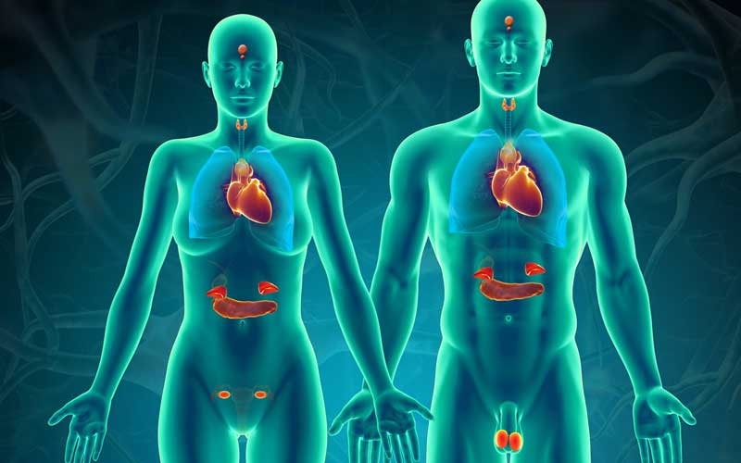

LEARNING OBJECTIVES& COURSE CONTENTS:

**At the end of the teaching session the student should be able to achieve the following objectives:**

|  |  |  |
| --- | --- | --- |
| **PATHOLOGY LECTURES** | | |
| **S.NO** | **TOPICS** | **LEARNING OBJECTIVES** | |
|  | Diabetes mellitus   * Classification * Diagnosis * Insulin resistance * Beta cell dysfunction Complications * Acute & Chronic | Define Diabetes mellitus  Classify Diabetes mellitus  Explain the diagnostic criteria of DM  Explain the mechanisms of insulin resistance  Explain the mechanisms of beta cell dysfunction  Explain the acute and chronic complications of DM | |
|  | Diabetes Insipidus | Define Diabetes Insipidus  Enlist the types of Diabetes Insipidus  Classify Diabetes Insipidus  Explain the diagnostic criteria of Diabetes Insipidus  Explain the exact inter pretention of Diabetes Insipidus | |
|  | Hyperthyroidism | Discuss the etiology of hyperthyroidism.  Enlist & differentiate the different causes, clinical features,clinical presentations algorithms and treatment options of hyperthyroidism.  Discuss pathogenesis and morphology of Hyperthyroidism. | |
|  | Hypothyroidism | Discuss the etiology of hypothyroidism.  Enlist & differentiate the different causes,clinical features,clinical presentations algorithms and treatment options of hypothyroidism.  Discuss pathogenesis and morphology of Hypothyroidism. | |
|  | Cushing syndrome | Discuss the etiology, clinical features, investigations, and treatment of Cushing syndrome | |
|  | Acromegaly | Explain the etiology, clinical features, investigations, treatment, and complications of Acromegaly/gigantism | |
|  | Hirsutism | Explain the etiology, clinical features, investigations, treatment, and complications of Hirsutism | |
|  | Liver | Define hepatitis & liver cirrhosis  Describe the disorders of liver & bilirubin metabolism  Enlist the causes of hyperbilirubinemia ,hepatic & post hepatic diseases  Define jaundice.  Enlist the causes and types of jaundice.  Explain the clinical features, complications, laboratory investigations in suspected liver diseases | |

|  |  |  |
| --- | --- | --- |
| **PATHOLOGY SGDs** | | |
| **S.NO** | **TOPICS** | **LEARNING OBJECTIVES** | |
|  | hyperthyroidism | Discuss the etiology of hypothyroidism.  Enlist & differentiate the different causes, clinical features, clinical presentations algorithms and treatment options of hypothyroidism.  Discuss pathogenesis and morphology of Hypothyroidism. | |
|  | Thyroid function test | Discuss thyroid function test.  Discuss the interpretation & correlate thyroid function test.  Discuss the diagnosis with thyroid diseases | |
|  | Acromegaly | Define acromegaly.  Enlist the causes of acromegaly.  Discuss clinical features of acromegaly. | |
|  | Cushing syndrome | Define Cushing syndrome.  Enumerate the causes of Cushing syndrome.  Discuss the clinical presentation of Cushing syndrome. | |

|  |  |  |
| --- | --- | --- |
| **PATHOLOGY PRACTICALS** | | |
| **S.NO** | **TOPICS** | **LEARNING OBJECTIVES** | |
|  | Benedicts test | Perform Benedict’s test on the beach observing all the precautions & interpretations of the test results | |
|  | Urine for Proteins | Perform urine for protein test on the beach observing all the precautions & interpretations of the test results | |
|  | Urine Microscopy | Identify RBCs, Puss cells & epithelial cells in female crystals and casts under microscope with high power lens | |

|  |  |  |  |
| --- | --- | --- | --- |
| **E.N.T LECTURES** | | | |
| **S.NO** | **TOPICS** | **LEARNING OBJECTIVES** |
| 1 | Laryngeal paralysis  SLN | Discuss laryngeal paralysis.  Enlist & describe the causes, types, clinical features, diagnosis, and treatment of Laryngeal paralysis. |
| 2 | Acoustic neuroma | Discuss acoustic neuroma & the appropriate clinical, audiological, and imaging studies used in diagnosis and treatment of acoustic neuroma. |
| 3 | Benign lesions of vocal cord | Describe the benign lesions of vocal cord  Discuss paralytic causes of hoarseness, its types, clinical features, diagnosis, and treatment |
| 4 | Surgical procedures of ear | Enlist the surgical procedures for external ear  Enumerate the surgical procedure for middle ear  Enumerate the surgical procedure for inner ear  Discuss the procedures of ear |
| 5 | Air way cricothyroidotomy | Describe the air way cricothyrotomy.  Discuss the differential diagnosis of air way cricothyrotomy.  Discuss the medical & surgical treatment of Air way cricothyroidotomy |
| 6 | Assessment of hearing | Enumerate the tests used for hearing.  Describe the tests used for the performance of assessment in hearing |
| 7 | tracheostomy | Describe & demonstrate tracheostomy technique (indications, contraindications, technique and post-procedure care)  Describe & demonstrate suctioning of the tracheostomy tube on the simulator |
| 8 | Hearing loss | Discuss the differential diagnosis of hearing loss & the medical and surgical management of CHL.  Discuss otoscleosis & its medical & surgical treatment of otosclerosis.  Discuss OME & its medical and surgical treatment |

|  |  |  |
| --- | --- | --- |
| **OPTHAMOLOGY LECTURES** | | |
| **S.NO** | **TOPICS** | **LEARNING OBJECTIVES** |
| 1 | Glaucoma  POAG & PACG | Discuss the differences between POAG, NTG and OHT.  Discuss the etiology, clinical features, investigation, and management of POAG.  Discuss the stages of PACG.  Discuss the etiology, clinical features, investigation, and management of Acute angle closure. |
| 2 | Glaucoma Neovascular & lens induced glaucoma | Discuss the etiology, clinical features, investigation, and management of Neovascular glaucoma.  Discuss the etiology, clinical features, investigation, and management of lens induced glaucoma.  Enumerate different treatment options in glaucoma.  Discuss the indications of each treatment option. |
| 3 | Lens cataract | Define cataract.  Describe the types of Age-related cataract.  Describe the pathogenesis and complications of cataract.  Describe the management of cataract |

|  |  |  |
| --- | --- | --- |
| FAMILY MEDICINE LECTURES | | |
| S.NO | TOPICS | LEARNING OBJECTIVES |
| 1 | Common general practice and presentations of endocrine diseases | Explain the etiology, clinical features and presentations of endocrine system.  Describe the steps of management of a patient with endocrine disorders.  Identify patients that need urgent and proper referral for specialist care in primary health with endocrine diseases. |
| 2 | Health Literacy | Explain the role of general practitioner in increasing health literacy. |
| 3 | Opportunistic Screening | Explain the importance of screening in primary cases. |
| 4. | Principles of Family Medicine (The 5 C’s) | Understand the core principles of family medicine  Explain the 5 C’s |

|  |  |  |
| --- | --- | --- |
| **COMMUNITY MEDICINE LECTURES** | | |
| **S.NO** | **TOPIC** | **LEARNING OBJECTIVES** | |
|
|  | Diabetes | Discuss Prevalence of diabetes mellitus globally and in Pakistan  Discuss modifiable and non-modifiable risk factors for diabetes mellitus.  Describe epidemiological determinants of diabetes mellitus  Discuss screening methods for diabetes mellitus Discuss the prevention (Primary, secondary, and tertiary) and care of diabetes mellitus | |
|  | Small scale purification | Discuss small scale purification | |
|  | Techniques of data presentation | Discuss techniques of data presentation | |
|  | Measures of dispersion/ Measure of central tendency | Define the measure of dispersion and collection.  Explain the registration of vital events in Pakistan.  Discuss the method of dispersion and collection. | |
|  | Hardness of water | Discuss hardness of water | |
|  | Obesity | Define obesity.  Discuss the causes of obesity.  Explain the methods of prevention of obesity. | |
|  | ABCD in assessment of nutrition | Discuss ABCD in assessment of nutrition | |
|  | Health Education Programs | Discuss health education programms | |
|  | Normal curve | Define normal curve | |
|  | Malnutrition and its causes | Define malnutrition and its causes | |
|  | Child health problems |  | |
|  | standard errors of mean | Define standard errors of mean | |

|  |  |  |
| --- | --- | --- |
| **COMMUNITY MEDICINE SGDS** | | |
| **S.NO** | **TOPIC** | **LEARNING OBJECTIVES** | |
|
| 1 | Natural purification of water  purification on domestic level | Discuss natural purification of water | |
| 2 | Purification of water on large scale, Swimming pool sanitation and diseases caused by it | Discuss purification of water on large scale | |
| 3 | Development of child 1 – 5 years | Discuss development of child 1-5 years | |
| 4 | Food borne disease | Discuss food borne diseases | |

|  |  |  |
| --- | --- | --- |
| **COMMUNITY MEDICINE PRACTICALS** | | |
| **S.NO** | **TOPIC** | **LEARNING OBJECTIVES** | |
|
| 1 | Well purification  Use of chlorine tablets  Chlorination and super chlorination | Define Preventive pediatrics.  Discuss the preventive measures for pediatrics disease. | |
| 2 | Role of rapid sand filter in water purification | Discuss role of rapid sand filter | |
| 3 | Growth and its parameter Growth chart  BMI | Define growth and its parameter  Define BMI | |
| 4 | Milk borne disease (brucellosis) | Discuss milk borne diseases | |

|  |  |  |  |
| --- | --- | --- | --- |
| **GENERAL MEDICINE LECTURES** | | | |
| **S.NO** | **TOPIC** | **LEARNING OBJECTIVES** |
| 1 | Diabetes Mellitus | Define Diabetes Mellitus  Enlist the differences between type 1 & type 2 diabetes  Describe the clinical presentation, diagnosis & management of Diabetes Mellitus  Explain the complication of Diabetes Mellitus |
| 2 | Diabetes insipidus | Define Diabetes insipidus.  Describe the clinical presentation, diagnosis & management of Diabetes insipidus.  Explain the complication of Diabetes insipidus. |
| 3 | Cushing syndrome | Define Cushing syndrome.  Enlist the types of Cushing syndrome  Describe the clinical presentation of Cushing syndrome  Devise the management of Cushing syndrome |
| 4 | Acromegaly | Define acromegaly.  Explain clinical manifestations & management of acromegaly |
| 5 | Hypothyroidism | Explain the clinical presentation & management of hypothyroidism |
| 6 | Hyperparathyroidism | Explain the clinical presentation & management of hyperparathyroidism |

|  |  |  |
| --- | --- | --- |
| **GYNAECOLOGY LECTURES** | | |
| **S.NO** | **TOPICS** | **LEARNING OBJECTIVES** |
| 1) | Diabetes Mellitus | Explain the management of a pregnant lady with gestational DM and overt DM |

|  |  |  |  |
| --- | --- | --- | --- |
| **FAMILY MEDICINE LECTURES** | | | |
| **S.NO** | **TOPIC** | **LEARNING OBJECTIVES** |
| 1 | Common general practice and presentation of endocrine diseases | Define Diabetes Mellitus  Enlist the differences between type 1 & type 2 diabetes  Describe the clinical presentation, diagnosis & management of Diabetes Mellitus  Explain the complication of Diabetes Mellitus |
| 2 | Health Literacy | Define Diabetes insipidus.  Describe the clinical presentation, diagnosis & management of Diabetes insipidus.  Explain the complication of Diabetes insipidus. |
| 3 | Principles of family medicine the 5C’s | Define Cushing syndrome.  Enlist the types of Cushing syndrome  Describe the clinical presentation of Cushing syndrome  Devise the management of Cushing syndrome |

|  |  |  |  |
| --- | --- | --- | --- |
| **GENERAL SURGERY LECTURES** | | | |
| **S.NO** | **TOPIC** | **LEARNING OBJECTIVES** |
| 1 | Thyroid gland | Describe embryology & surgical anatomy of thyroid gland  Enlist the common diseases of thyroid gland  Describe the presentation,assessment & management of thyroid gland |
| 2 | Parathyroid gland | Describe embryology & surgical anatomy of thyroid gland.  Enlist the types of parathyroid gland  Describe the presentation, recognition, assessment & management of parathyroid gland |

|  |  |  |
| --- | --- | --- |
| **PHARMACOLOGY LECTURES** | | |
| **S.NO** | **TOPICS** | **LEARNING OBJECTIVES** |
| 1) | Insulin | Classify Insulin  Describe the source of insulin.  Describe the mechanism of action and clinical uses of insulin.  Describe the complications of insulin therapy.  Describe the management of hypoglycemia caused by insulin. |
| 2) | Drugs used in thyroid disease | Classify  Describe the mechanism of action, pharmacological effects, clinical uses and adverse effects of Insulin. |
| 3) | Glucocorticoids anabolic steroids | Classify Glucocorticoids  Describe the mechanism of action, pharmacological effects, clinical uses and adverse effects of glucocorticoids. |

|  |  |  |
| --- | --- | --- |
| **PEADS LECTURES** | | |
| **S.NO** | **TOPIC** | **LEARNING OBJECTIVES** |
| 1 | Hypothyroidism hyperthyroidism | Define hyperthyroidism & hypothyroidism  Describe etiology & pathophysiology of hyperthyroidism & hypothyroidism  Enlist the clinical features of hyperthyroidism & hypothyroidism  Describe the complications & management of hyperthyroidism & hypothyroidism |
| 2 | Short stature | Define Short stature  Enlist the causes of Short stature  Devise an assessment plan for a child with short stature |

|  |  |  |
| --- | --- | --- |
| **PHYSIOLOGY LECTURE** | | |
| **S.NO** | **TOPICS** | **LEARNING OBJECTIVES** |
|  |  |  |
| 1) | Hormones Classification/secretion/transport & clearance from blood | Describe the endocrine hormones classification.  Explain the transport and clearance from blood. |

|  |  |  |
| --- | --- | --- |
| **ANATOMY** | | |
| **S.NO** | **TOPICS** | **LEARNING OBJECTIVES** |
|  |  |  |
| 1. | Applied Anatomy of Endocrine System | Describe the gross anatomical features of endocrine system. |

**ASSESSMENT METHODS FOR BLOCK EXAM:** 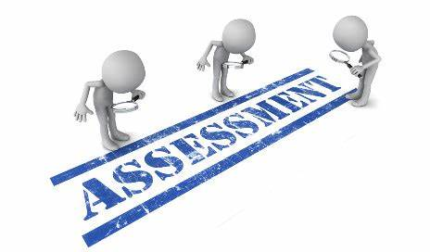

Evaluation is a continuous process comprising of block examination and annual university examination. Students will be evaluated throughout the year. The internal assessment will contribute towards the final examination scores.

Multiple examination methods including MCQs, SAQs, OSPE and viva will be used for assessment. In line with PMC stipulation, the pass/fail marks for the test and examination will be 50%.

There will be a block exam at the end of each block.

**Theory (knowledge):**

MCQs (Multiple Choice Questions) and SAQs (Short Answer Questions) are used to assess the theory part for the block exam

**MCQ:**

* A MCQ has a statement or clinical scenario followed by four options (likely answers).
* After reading the statement/scenario student select ONE, the most appropriate answer/response from the given list of options.

### Correct answer carries one mark, and incorrect ‘zero mark’. There is NO negative marking.

**SAQ:**

**OSPE: Objective Structured Practical Examination (See the proposed plan of OSPE)**

* The content may assess application of knowledge, or practical skills.
* Student will complete task in define time at one given station.
* All the students are assessed on the same content by the same examiner in the same allocated time.
* A structured examination will have observed, unobserved, interactive and rest stations.

### **Observed and interactive stations:**

They will be assessed by internal or external examiners through the task or viva.

### **Unobserved station:**

It will be static station in which students will have to answer the questions related to the given pictures, models or specimens on the provided response sheet.

### **Rest station:**

It is a station where no task is given, and during this time student can organize his/her thoughts.

**ASSESSMENT PLAN 4th YEAR MBBS**

**MBBS BLOCK EXAMINATION MARKS DISTRIBUTION:**

**FOURTH YEAR MBBS BLOCK THEORY FORMAT**

|  |  |  |  |  |
| --- | --- | --- | --- | --- |
| **CLASS ROLL NO** | **BLOCK – (---)** | | | **TOTAL** |
| **MCQs** | **SAQs** | **TOTAL** | **PERCENTAGE** |
|  | **28** | **12** | **40** | **5%** |
| **28 MCQs each subject** | **4 SAQs out of which One is optional i.e., to be attempted 3 SAQs.**  **Each SAQ carries 4 marks.**  **4 x 3 = 12** |  | **MARKS OBTAINED / 40 X 5** |

**FOURTH YEAR MBBS END OF SESSION THEORY FORMAT**

|  |  |  |  |  |  |  |
| --- | --- | --- | --- | --- | --- | --- |
| **CLASS ROLL NO** | **BLOCK X** | **BLOCK XI** | **BLOCK XII** | **ASSIGNMENTS** | **ATTENDANCE** | **TOTAL** |
| **5%** | **5%** | **5%** | **3%** | **2%** | **20%** |
|  |  |  |  | **1 Assignment per subject each block**  **1 mark per Assignment**  **SCORING**  **Assignment submitted on time = 01**  **Late submission / Not Submitted = 0** | **Obtained Attendance % /100 x 2** | **NOTE:**  **FOR PATHO AND COMMUNITY**  **(Marks obtained out of 20 x 1.5 =___)** |

**FOURTH YEAR MBBS BLOCK PRACTICAL FORMAT**

|  |  |  |  |  |  |
| --- | --- | --- | --- | --- | --- |
| **CLASS ROLL NO** | **BLOCK (-----)** | | | | **TOTAL** |
| **DISTRIBUTION** | | | | **5%** |
| **OSPE** | **VIVA** | **PRACTICAL LOGBOOK** | **TOTAL** | **OBATINED MARKS / 40 x 5 = ___%** |
|  | **5 OSPE STATIONS**  **(4 MARKS EACH)**  **= 20 MARKS** | **3 VIVA STATIONS (5 MARKS EACH)**  **= 15 MARKS** | **5 MARKS**  **Complete**  **& timely signed = 5**  **Complete but late submission = 3**  **Incomplete logbook = 1**  **No logbook = 0** | **40 TOTAL MARKS** |

**FOURTH YEAR MBBS END OF SESSION PRACTICAL FORMAT**

|  |  |  |  |  |  |  |
| --- | --- | --- | --- | --- | --- | --- |
| **CLASS ROLL NO** | **BLOCK X** | **BLOCK XI** | **BLOCK XII** | **BEHAVIOUR** | **ATTENDANCE** | **TOTAL** |
| **5%** | **5%** | **5%** | **3%** | **2%** | **20%** |
|  |  |  |  | **No misbehave or written warning = 3**  **Written warning given to student = 0** | **Obtained Attendance % /100 x 2** | **NOTE:**  **FOR PATHO AND COMMUNITY**  **(Marks obtained out of 20 x 1.5 =___)** |

**FOURTH YEAR MBBS FINAL PROF FORMAT (1000 MARKS)**

|  |  |  |  |  |  |  |  |  |  |
| --- | --- | --- | --- | --- | --- | --- | --- | --- | --- |
| **CLASS ROLL NO** | **THEORY (500 MARKS)** | | | | **PRACTICAL (500 MARKS)** | | | | **TOTAL** |
| **MCQs** | **SAQs** | **I.A** | **TOTAL** | **OSPE** | **VIVA** | **I.A** | **TOTAL** | **GRAND TOTAL** |
| **SUBJECT** | **30** | **50**  **/**  **70** | **20 /**  **30** | **100**  **/**  **150** | **40**  **/**  **60** | **40**  **/**  **60** | **20**  **/**  **30** | **100**  **/**  **150** | **200**  **/**  **300** |
| **ENT**  **OPTH** | **30 MCQs**  **each subject** | **7 SAQs out of which TWO will be optional i.e., to be attempted 5 SAQs.**  **Each SAQ carries 10 marks.**  **5 x 10 = 50** | **20** | **100** | **10 OSPE Stations 4 marks each** | **20 MARKS INTERNAL**  **20 MARKS EXTERNAL** | **20** | **100** | **200** |
| **COM**  **PATHO** | **11 SAQs out of which TWO will be optional i.e., to be attempted 9 SAQs.**  **Each SAQ carries 10 marks.**  **9 x 10 = 90** | **30** | **150** | **12 OSPE Stations 5 marks each** | **30 MARKS INTERNAL**  **30 MARKS EXTERNAL** | **30**  **(Marks obtained out of 20 x 1.5 =__)** | **150** | **300** |

|  |  |
| --- | --- |
| **LEARNING RESOURCES:** | |
| **SUBJECT** | **RESOURCES** |
| **ENT** | **TEXTBOOKS**  Diseases of Ear, Nose and Throat by P.L. Dhingra, 6th edition |
| **OPTHALMOLOGY** | **TEXTBOOKS**  Shafi and Jatoi  Short Kanski |
| **COMMUNITY MEDICINE** | **TEXTBOOKS**  Fundamentals of community medicine & Public Health (3rd Edition) (Dr. Hayat Muhammad Khan, Dr. Bushra Iftikhar)  Public Health & Community Medicine (latest Edition) (M. Iliyas Ansari  Preventive & social Medicine (Latest Edition) (K. Park) |
| **PATHOLOGY** | . **TEXTBOOKS**  Robbins & Cotran, Pathologic Basis of Disease,9 th edition |

|  |  |
| --- | --- |
| **OTHER LEARNING RESOURCES:** | |
| **Hands-on Activities**  **/ Practical** | Students will be involved in Practical sessions and hands-on activities that link with the foundation module to enhance the learning. |
| **Labs** | Utilize the lab to relate the knowledge to the specimens and models available. |
| **Skill Labs** | A skills lab provides the simulators to learn the basic skills and procedures. This helps build the confidence to approach the patients. |
| **Videos** | Video familiarize the student with the procedures and protocols to assist patients. |
| **Computer Lab / CDs / DVDs / Internet Resources:** | To increase the knowledge students should utilize the available internet resources and CDs/DVDs. This will be an additional advantage to increase learning. |
| **SDL** | SDL is scheduled to search for information to solve cases, read through different resources and discuss among the peers and with the faculty to clarify the concepts. |