**GANDHARA UNIVERSITY**

**KABIR MEDICAL COLLEGE**

**URRICULUM**

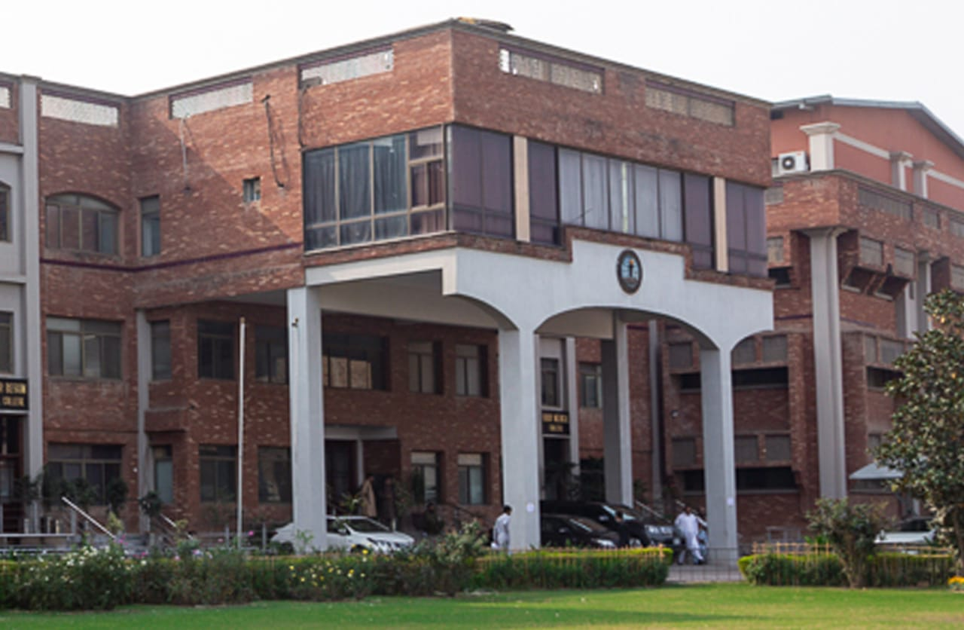

**4TH YEAR MBBS 2024-2025**

**BLOCK 10**

**(NEUROSCIENCES-II & GIT)**

# FROM THE DESK OF PRINCIPAL

**BRIG AHMAD HUSSAIN MASHWANI(R)**

Kabir Medical College has evolved, since its inception, as an exceptionally outstanding facility to provide quality education to the students.

I must appreciate the hard work of our well experienced and dedicated faculty members and staff in maintaining high standards of medical education and the efforts they have put in Kabir Medical College to be a distinguished center of excellence.

By the grace of Almighty, we are starting the integrated curriculum for 1st year MBBS. We meet international standards of professional education by installing the system of integrated curriculum and system-based teaching of basic medical sciences. We advocate interactive sessions to improve comprehension of students as well as training them with skills of communication and self-expression.

Since the establishment of Kabir Medical College, we have been working constantly to upgrade services and facilities at the campus and the attached Naseer Teaching Hospital for our students and patients.

We would like our graduates to excel as confident, responsible, and self-learning medical practitioners. With a state-of-the-art campus, experienced faculty, an up-to-date digital library, I assure that your decision to study at Kabir Medical College will surely be a wise one, your experience here will be profoundly enriching and you will become a valuable asset to the nation and international community health care professionals.

Brig Ahmad Hussain Mashwani (R)

MBBS, FCPS(SURGERY)OJT (VASCULAR SURGERY)

CHPE, MHPE(KMU)

Principal

Kabir Medical College

Gandhara University  
 Peshawar

On behalf of the block team, I would like to welcome you to block-10(Neurosciences & GIT modules). As a part of the system-based curriculum, this block is an integrated presentation, comprises system-based modules which links basic science knowledge to clinical problems. Integrated teaching means that subjects are presented as a meaningful whole. Students will be able to have better understanding of basic sciences when they repeatedly learn in relation to clinical examples. Small group discussions, early exposure to clinics, wards, and skills acquisition in skills lab are characteristics of integrated teaching program.

Our mission is to provide all educational opportunities to our students therefore on completion of the MBBS program graduates will possess an appropriate foundation of knowledge, skills, and attitudes to be well prepared to practice safely and effectively.

This study guide includes the course contents of the block. The learning objectives, practical, topics of the small group discussions.it also includes the assessment plan for the block exam.

As a director I will be meeting with the facilitators to receive the feedback and will try to resolve any difficulties or problems faced during the block. Please do not hesitate to contact DME for any academic help. I wish you an enjoyable and learning experience with block 10.

**Director DME = Dr. Marina Khan**

|  |
| --- |
| **Topic Page Number** |
| **Block Team** |
| **List of abbreviations…** |
| **Aims of the study guide…** |
| **Module distribution of 4th year MBBS** |
| **Introduction of block 10…** |
| **General Outcomes…** |
| **Leaning Methodologies…** |
| **Rules Regulations** |
| **Learning objectives & Course contents** |
| **Assessment…………………………………………………………………………………………….** |
| **Learning Resources………………………………………………………………………………** |

**BLOCK TEAM**

|  |  |  |  |
| --- | --- | --- | --- |
|  | **Dr Marina Khan**  **Director of Department of Medical Education** | | **marinakahn@hotmail.com** |
| **DEPARTMENT OF PATHOLOGY** | |  | Prof Dr. Mukhtar  Prof Dr. Ehsan Gul  Prof Dr. Naila  Prof Dr. Nisar  Associate Prof Dr. Shazia  Assist Prof Dr. Ibn-e- Amin  Assist Prof Dr. Ronaq  Assist Prof Dr. Alia Banori |
| **DEPARTMENT OF E.N.T** | |  | Prof Dr Amjid Khan  Prof. Dr Waqar |
| **DEPARTMENT OF OPTHAMOLOGY** | |  | Prof Dr Zafar ul Islam  Prof Dr Zubair Masud  Dr Usman Khan |
| **DEPARTMENT OF COMMUNITY MEDICINE** | |  | Prof Dr Hamid Hussain  Associate Prof Dr Farhana Jabeen  Assist Prof Dr Ghazala Yasmin  Dr Fareeha  Dr Iftikhar Malik |
| **DEPARTMENT OF MEDICAL EDUCATION** | |  | Assist Prof Dr. Marina Khan  Assist Prof Dr. Syed Muhammad Junaid  Dr. Aalia Zaib  Dr. Usama Zeb |

**LIST OF ABBREVIATIONS**

|  |  |
| --- | --- |
| **DME** | Department of Medical Education |
| **Anat** | Anatomy |
| **Physio** | Physiology |
| **Bio** | Biochemistry |
| **Histo** | Histology |
| **Emb** | Embryology |
| **Patho** | Pathology |
| **Pharma** | Pharmacology |
| **OPTH** | Ophthalmology |
| **ENT** | Otorhinolaryngology |
| **GM** | General Medicine |
| **COM** | Community Medicine |
| **LGIS** | Large Group Interactive Session |
| **SGD** | Small Group Discussion |
| **SDL** | Self-Directed Learning |
| **MCQ** | Multiple Choice Question |
| **SAQ** | Short Answer Question |
| **OSPE** | Objective Structured Practical Exam |

**STUDY GUIDE:**

This study guidebook was designed by combining the efforts of all topics throughout the year to give medical students at Gandhara University a resource material that highlights significant components of the curriculum. By providing students control over their learning, the study guide aims to promote self-regulated lifelong learning.

Regarding the course content, the study guide provides an overview of the anticipated course outcomes and objectives. The assessment approach is also customized to the intuitional strategy.

A successful curriculum has a significant impact on the final product, as well as on society. This study guide was carefully designed with the PMC curriculum and rules in mind, and Gandhara University stakeholders and faculty members worked hard to personalize it to the needs of students. They are further working to build, implement, and exercise a well-built curriculum considering changing demographic needs and disease prevalence in our society. Throughout the construction of the study guide, students' feedback was received and included. Curriculum is a living, dynamic entity that is constantly changing. With each passing day, we hope to improve it.

Each module in this block has been created to cater the gap between basic and clinical subjects through pre-clinical learning. The block is divided into two modules in which the students are exposed to a variety of basic and clinical subjects. The integrated curriculum is enforced through interactive lectures, small group discussion, community outreach programs along with rotations at preclinical laboratory. There will be formative as well as summative assessment of the block throughout the modules.

**AIMS OF THE STUDY GUIDE**

It is an aid to:

* Inform students how student learning program of the BLOCK-wise module has been organized.
* Help students organize and manage their studies throughout the modules.
* Guide students on assessment methods, rules, and regulations.
* Communicates information on organization and management of the modules. This will help the student to contact the right person in case of any difficulty.
* Defines the objectives which are expected to be achieved at the end of each module.
* Identifies the learning strategies such as lectures, small group teachings, clinical skills and demonstration, tutorial that will be implemented to achieve the modules objectives.
* Provides a list of learning resources such as books, computer assisted learning programs, web- links, and journals, for students to consult to maximize their learning.
* Highlights information on the contribution of continuous and block examinations on the student's overall performance.
* Includes information on the assessment methods that will be held to determine every student's achievement of objectives.
* Focuses on information pertaining to examination policy, rules, and regulations.

**ORGANIZATION OF MODULAR CURRICULUM**

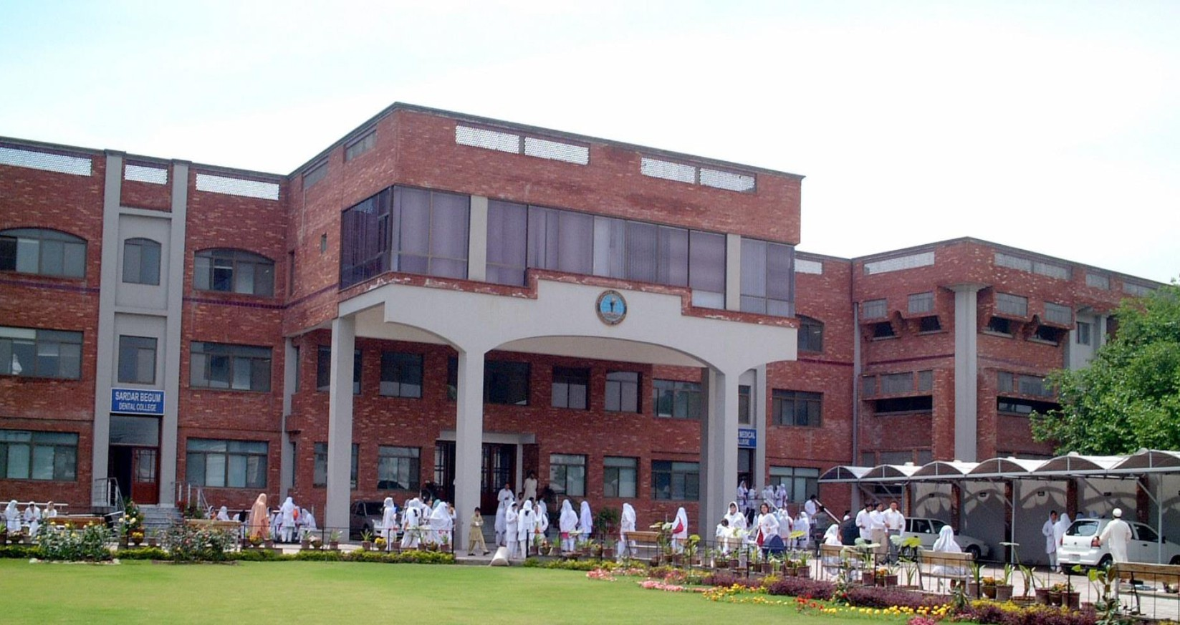

**4th YEAR MBBS**

|  |  |  |  |  |  |  |  |  |  |
| --- | --- | --- | --- | --- | --- | --- | --- | --- | --- |
| **Block-10** | | **Exam Block 10** | **Block-11** | | **Exam Block 11** | **Block-12** | | **Exam Block 12** | **Final Exam** |
| **Module**  **19**  Neurosciences -II | **Module**  **20**  GIT | **Module**  **21**  Renal-II | **Module**  **22**  Endocrinology-II | **Module**  **23**  Multisystem-II | **Module**  **24**  Reproduction-II |

**INTRODUCTION TO BLOCK-10:**

.

Welcome to the 4th Year MBBS Neurosciences Module, a comprehensive exploration of the intricate and captivating world of the nervous system. As you embark on this journey, you are about to delve into the fascinating realm of neuroscience, a field that lies at the intersection of biology, medicine, and the fundamental mysteries of the human mind and body.

The human nervous system is an astonishingly complex network of cells, chemicals, and electrical signals that orchestrates our thoughts, emotions, movements, and sensations. Understanding its intricacies is essential for any medical practitioner, as neurological disorders and diseases pose significant challenges to healthcare professionals worldwide.

Throughout this module, you will gain in-depth knowledge of the structure and function of the nervous system, from the intricacies of neuronal communication to the clinical aspects of diagnosing and treating neurological conditions.

This module will provide students with a multidisciplinary approach to understanding the etiology of neurological and mental disorders. Neurological problems are the leading cause for disability globally. An estimated 1-billion people around the world have a neurological disorder or disease, which is almost 15-percent of the world’s population. According to WHO more than 6 million people die because of stroke each year; over 80% of these deaths take place in low- and middle-income countries. Psychiatric disorders are also major human toll of ill health. According to 2012 WHO data, Neuro-Psychiatric disorders are among 12 leading causes of disability and death in Pakistan. In this module students will learn about the etiology of common disorders encountered by neurologists and psychiatrists and develop a comprehensive understanding of the biological, pathological, psychological and social factors behind these disorders. The basis for pharmacological treatments for conditions such as epilepsy, Parkinson’s disease and schizophrenia will also be discussed.

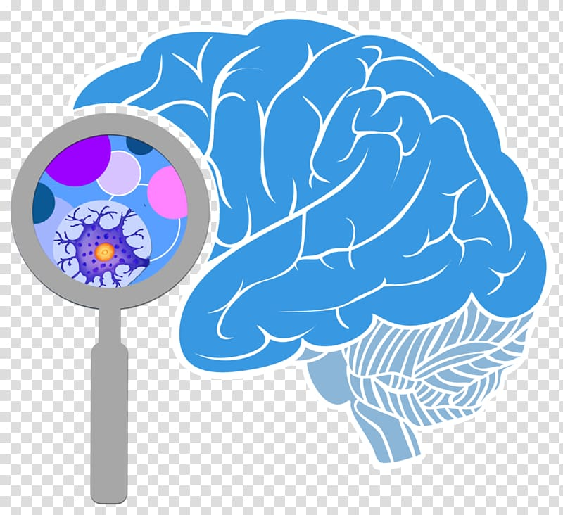Top of Form

**RATIONALE**

The nervous system is the most complex system of the body. A large number of diseases involve the nervous system in their primary pathology, or the nervous system may be secondarily involved in systemic illnesses. Infections like meningitis and encephalitis, movement disorders, demyelinating diseases, epilepsy, and cerebrovascular accidents along with congenital and traumatic disorders are some of the commoner diseases of the nervous system. Timely diagnosis and management prevent high morbidity and mortality. The Neurosciences 1 module in the 2nd Year has already provided a sound basis of the anatomy, physiology, neuropharmacology, and pathologic basis of CNS diseases. In this 4th year, the student will learn the clinical presentation, diagnosis, and management of these diseases.

**GENERAL OUTCOMES:**

By the end of this block the students would be able to

**COGNITIVE DOMAIN:**

1. Enumerate common CNS infection.
2. Define meningitis, enumerate & describe types, etiology & pathogenesis of acute pyogenic & aseptic meningitis.
3. Discuss etiology, pathogenesis of brain abscess viral encephalitis, melanocytic and dysplastic nevi, medulloblastoma, meningioma.
4. Discuss causes, pathogenesis, morphology and clinical presentation of Alzheimer disease and Parkinson disease.
5. Enlist metastatic bone tumor.
6. Discuss the anatomy & physiology of the ear. Discuss the clinical presentations examination, investigations findings and treatment plan for the diseases of external ear.
7. Describe Ulcers, immune disorders, Trauma, Neoplasm, Skin disorder, Blood disorder, Drug Allergy, Vitamin deficiency.
8. Enumerate differential diagnosis of oral ulcers and discuss management of Aphthous ulcers. Classify the premalignant lesions of oral cavity, Differentiate the benign and malignant tumors of oral cavity.
9. Identification of different types of research problems, Devise research and survey methodology, perform different types of research and research introduction methodology, study designs and results discussion, understand and formulate a dissertation.
10. Discuss the concepts of health & disease. Describe health care system of Pakistan using WHO Health system framework.
11. Define epidemiology. Explain the basic concepts of epidemiology.
12. Define, Describe, classify mental health and mental health illnesses. Discuss global perspectives and epidemiology, risk factors, prevention & control of mental health disorders.
13. Describe the role of radiographic imaging studies in diagnosis and management of stroke patients. Differentiate between hemorrhagic and ischemic strokes.
14. Identify Normal cranial and neurological anatomy, Skull fracture, Extra-cerebral blood, Intracranial blood on the following on a CT film.
15. Discuss pathophysiology, clinical presentation, and management of myopia, hypermetropia, astigmatism and presbyopia.
16. Discuss overview of different causes and management of lid bumps.
17. Describe pathophysiology and management of chalazion and stye.
18. Enlist different eyelid tumors and their pathogenesis.
19. Enumerate causes of ptosis, assessment, and their management.
20. Discuss Trichiasis, Entropion and Ectropion, assessment, and their management.
21. Discuss the etiology, clinical features, investigation, and management of congenital, nasolacrimal duct obstruction and dacryocystitis.

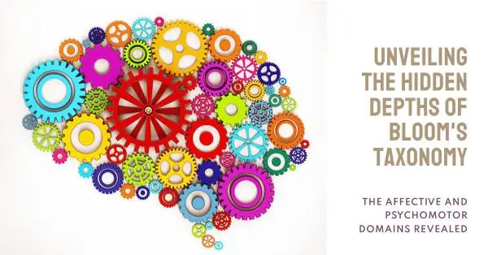**PSYCHOMOTOR DOMAIN:**

1. Identify Normal CSF volume in adults and children.
2. Perform Chemical and cytological analysis of CSF.
3. Perform Laboratory diagnosis of bacterial and viral meningitis.
4. Identify bacterial and viral meningitis.
5. Identify the gross Examination of brain tumor species.
6. Identify the gross & microscopic features of basal cell carcinoma.
7. Identify the gross & microscopic features of Skin tumors.
8. Identify the gross & microscopic features of squamous cell carcinoma skin tumors.
9. Identify the Mosquito, House fly, Sand fly, Tick & Mite, Lice, flea, Aedes egypti with diseases ,Yellow fever ,Dengue

**ATTITUDE:**

By the end of this Block, the students will be able to:

* Follow the basic laboratory protocols.
* Participate in class and practical work efficiently.
* Maintain discipline of the college.
* Follow the norms of the college properly.
* Communicate effectively in a team with colleagues and teachers.
* Demonstrate professionalism and ethical values in dealing with patients,

cadavers, colleagues, and teachers.

* Communicate effectively in a team with colleagues and teachers.
* Demonstrate the ability to reflect on the performance.

**LEARNING METHODOLOGIES**

The following teaching / learning methods are used to promote better understanding:

* Large Group Interactive Lectures
* Small Group Discussion
* Practical
* Skills session
* E-Learning
* Self-Directed Learning

**LARGE GROUP INTERACTIVE LECTURES (LGIS)**

In large group, the lecturer introduces a topic or common clinical conditions and explains the underlying phenomena through questions, pictures, videos of, etc. Students are encouraged to actively involve in the learning process.

**SMALL GROUP DISCUSSIONS (SGD):**

This format helps students to clarify concepts acquire skills or attitudes. Sessions are structured with the help of specific exercises such as patient case, or discussion topics. Students exchange opinions and apply knowledge gained from lectures, tutorials, and self-study. The facilitator role is

to ask probing questions, summarize, or rephrase to help clarify concepts.

Osteology is taught on human bones in small groups so that students can physically learn the bony features and muscle attachments.

**PRACTICAL**

Basic science practical related to Pathology & Community Medicine are scheduled for student learning.

**SELF DIRECTED LEARNING SDL:**

Students assume responsibilities of their own learning through individual study, sharing and discussing with peers, seeking information from Learning Resource Center, teachers, and resource persons within and outside the college. Students can utilize the time within the college scheduled hours of self-study.

**E-LEARNING:**

E-Learning is a strategy by which learning occurs through the utilization of electronic media, typically the Internet. The basic aspects of medical professionalism and ethics will be addressed through an e-learning course.

**RULES AND REGULATIONS**

We will be making the journey through Block I0 in 11 weeks. Therefore, this course includes an intensive coursework load. Class attendance and participation are extremely important to learning and are considered in the evaluation of course grades. If there is anything that the module team can do to assist during the course, please feel free to contact them. Attendance will be monitored during the different teaching activities. If the attendance is less than 75%, the student will not be allowed to sit for both block and annual examination.

All examinations must be taken on the date scheduled. There will be a block exam at the end of each block covering two modules. There will be a total of 3 block examinations and the 30% weightage of these block exam will be added to the 70 % of the annual professional exam as an internal assessment. If a student faces any problem related to the block examination marks, he/she has the right to appeal for the rechecking or retotaling of the marks according to the university policy.

**MODULE – 19**

**NEUROSCIENCES-II**

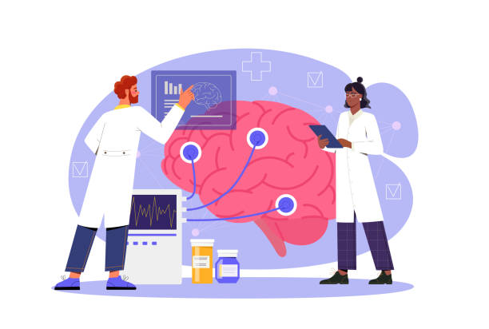

**LEARNING OBJECTIVES & COURSE CONTENTS:**

**At the end of the teaching session the student should be able to achieve the following objectives:**

|  |  |  |
| --- | --- | --- |
| **PATHOLOGY LECTURES** | | |
| **S.NO** | **TOPICS** | **LEARNING OBJECTIVES** |

|  |  |  |
| --- | --- | --- |
|  | Infections of nervous system | Enumerate common CNS infection  Define meningitis, enumerate & describe types,etiology & pathogenesis of acute pyogenic & aseptic meningitis  Differentiate between acute pyogenic & aseptic meningitis |
|  | Parenchymal infections, Brain Abscess, Viral Encephalitis | Enumerate types of parenchymal infections  Discuss etiology, pathogenesis of brain abscess and viral encephalitis |
|  | Neurogenerative Diseases, Alzheimer and Parkinson diseases | Define and enumerate neurodegenerative diseases  Discuss causes, pathogenesis, morphology and clinical presentation of Alzheimer disease and Parkinson disease |
|  | Hemorrhagic & Traumatic disorders of Nervous System | Define and enumerate Hemorrhagic & Traumatic disorders of Nervous System  Discuss causes, pathogenesis, morphology and clinical features |
|  | Skin tumor’s, Nevi Melanoma | Classification of dermal tumors  Melanocytic and dysplastic nevi classify  Epidemiology, etiology, pathogenesis and morphology of melanocytic and dysplastic nevi  Melanoma-epidemiology ,etiology pathogenesis & morphology of melanoma |
|  | Tumors of CNS I Gliomas | Classify CNS tumors  Define Gliomas. Enumerate types of gliomas. Discuss etiology, epidemiology, pathogenesis & morphology of gliomas, gtading of astrocytoma |
|  | Tumors of CNS II | Enumerate types of embryonal tumors  Discuss epidemiology etiology, pathogenesis and morphology of medulloblastoma  Enlist type of meningioma  Discuss epidemiology etiology pathogenesis and morphology of meningioma  Enlist metastatic bone tumor |
|  | Skin Tumor Nevi | Define Skin tumor nevi  Discuss Skin tumor nevi |

|  |  |  |
| --- | --- | --- |
| **PATHOLOGY PRACTICALS** | | |
| **S.NO** | **TOPICS** | **LEARNING OBJECTIVES** |

|  |  |  |
| --- | --- | --- |
|  | CSF | Identify Normal CSF volume in adults and children.  Perform Chemical and cytological analysis of CSF.  Perform Laboratory diagnosis of bacterial and viral meningitis.  Identify and Differentiate between bacterial and viral meningitis |
|  | Brain tumor specie | Identify the gross Examination of brain tumor specie. |
|  | Skin tumors | Identify the gross & microscopic features of basal cell carcinoma.  Identify the gross & microscopic features of Skin tumors. |
|  | Skin tumors | Identify the gross & microscopic features of squamous cell carcinoma skin tumors |

|  |  |  |
| --- | --- | --- |
| **PATHOLOGY SGD** | | |
| **S.NO** | **TOPICS** | **LEARNING OBJECTIVES** |

|  |  |  |
| --- | --- | --- |
|  | neuronal injuries, cerebral edema, hydrocephalus, herniation | Enumerate the types and discuss features of neuronal injuries  Define cerebral edema, hydrocephalus, herniation  Enumerate causes  Discuss types and pathogenesis of cerebral edema hydrocephalus and herniation |
|  | Hydrocephalus and developmental disorders of CNS | Define Hydrocephalus and developmental disorders of CNS  Discuss etiology, pathogenesis Hydrocephalus and developmental disorders of CNS |
|  | CNS trauma, traumatic parenchymal and vascular injury/Disorders of peripheral nerves, pattern of peripheral injury, periapical neuropathies | Discuss etiology types pathogenesis and morphology of traumatic parenchymal injury and traumatic vascular injury |
|  | Peripheral nerve sheath tumors, schwannoma, neurofibroma, neurofibromatosis  Disorders of Neuro muscular junction | Classify peripheral nerve sheath tumors  Discuss etiology types of pathogenesis and morphology of schwannoma.  Neurofibroma and neurofibromatosis  Enumerate disorders of neuromuscular junction  Define myasthenia gravis and Gullian Barre Syndrome. Discuss their causes and pathogenesis |
|  | Skin nomenclature of skin lesion, macroscopic/ microscopic skins, Chronic inflammatory dermatosis | Define macroscopic and microscopic skin lesion  Discuss etiology, pathogenesis and morphology of psoriasis  Enumerate Infectious dermatoses bacterial and fungi |

|  |  |  |
| --- | --- | --- |
| **E.N.T LECTURES** | | |
| **S.NO** | **TOPICS** | **LEARNING OBJECTIVES** |
|  | Anatomy & Physiology of ear | Discuss the anatomy & physiology of ear |
|  | Ulcers of Oral cavity | Describe Ulcers, immune disorders, Trauma, Neoplasm, Skin disorder, Blood disorder, Drug Allergy, Vitamin deficiency.  Enumerate differential diagnosis of oral ulcers and discuss management of Aphthous ulcers |
|  | Diseases of Pinna | Describe the clinical presentation, the examination, the investigations and treatment plan |
|  | Premalignant lesions of oral cavity | Classify the pre malignant lesions of oral cavity |
|  | Tumors of Oral cavity | Differentiate the benign and malignant tumors of oral cavity |
|  | Diseases of external ear | Discuss the clinical presentations examination, investigations findings and treatment plan for the diseases of external ear  Develop management plan for impacted wax & foreign body |
|  | Acute & Chronic tonsilitis | Discuss the etiology clinical presentations examination findings investigations and treatment plan for Acute & Chronic tonsilitis |

|  |  |  |
| --- | --- | --- |
| **COMMUNITY MEDICINE LECTURES** | | |
| **S.NO** | **TOPICS** | **LEARNING OBJECTIVES** |
|  | Changing concepts of health |  |
|  | Research and its components | To understand research process  To know about the research problem  To identify the problems for research |
|  | Development of public health in Pakistan | Definition, importance of Public Health  Overview of Pakistan’s Public Health System and how it developed over the years. Early Development (1947–1970s)  Modern Developments (2000s–Present). Current Challenges in Public Health  Importance of tracking public health progress to understand the challenges and successes in Pakistan |
|  | The role of federal & provincial govt. In health care | Understand the Federal Government's Role:  Describe the federal government's responsibilities in healthcare  And explain how the federal government funds health care programs, such as national immunization campaigns, disease control initiatives, and health education.  Understand the Provincial Government's Role:  Identify the responsibilities of provincial governments in managing and delivering health care services and explain how provincial health departments are responsible for primary and secondary health care services, hospitals, maternal and child health programs, and local health initiatives. |
|  | Research identification, prioritization of research problem, introduction to qualitative research methodology | To prioritize the research problem  To select the most suitable problem for research in the community Writing the title  To Writing the title of research |
|  | Concept of causation | To discuss concept of causation  Germ theory of disease  Epidemiological triad  Multifactorial causation  Web of causation |
|  | Health for all, background, concept and progress | Understand the background of "health for all", origin, and explain the historical context and global health challenges that led to the development of the "health for all" concept. Define "health for all" and explain its fundamental principles, goals and objectives. Evaluate the progress, key challenges and barriers to achieving "health for all. Understand the role of international organizations, governments, civil society, and communities in advancing the "health for all" agenda. Evaluate the role of different stakeholders |
|  | Research, how to write research & survey methodology. Research writing introduction & methodology | To write the introduction  To know about the different parts of the introduction  To write the method material section of thesis |
|  | Prevention and control of stroke | To discuss the prevention and control of stroke |
|  | International health | Define and understand the concept "international health" and distinguish it from related concepts like global health and public health. Explain the importance of international health in addressing health issues that cross national borders and impact populations globally. Recognize the historical development of international health as a field of study and practice. Identify major global health challenges. Understand the impact of social determinants of health, such as poverty, education, gender, and environment, on international health outcomes. Analyse the health effects of global phenomena like climate change, migration, conflict, and pandemics. Describe the roles and responsibilities of key international health organizations |
|  | Spectrum of diseases | Discuss the spectrum of disease. |
|  | District health system in the content of devolution | Explain the concept of devolution in pakistan, including the 18th amendment to the constitution of pakistan. Understand how devolution has transferred responsibilities for health care from the federal government to provincial and district governments. Describe the objectives of devolution, such as promoting local governance, improving service delivery, and ensuring equitable access to health care. Understand the roles and responsibilities of district health managers, such as district health officers (dhos) and their teams. Understand health planning and management at the district level |
|  | Community mental health | To discuss definition of mental health  Causes of mental illness  Application of three levels of prevention. |
|  | Resources for health and community mobilization | Understand the concept of resources for health and define the different types of resources for health, including human, financial, infrastructure, and technological resources. Explain the importance of these resources in achieving effective and equitable health service delivery in pakistan. Understand the challenges related to the availability, allocation, and management of health resources in pakistan. Identify major challenges in mobilizing and managing resources for health in pakistan, such as inadequate funding, human resource shortages, and infrastructure gaps. Define community mobilization and discuss the principles of community mobilization, including participation, empowerment, partnership, and sustainability |
|  | Blindness | Understand the public health significance of blindness: define blindness and visual impairment and distinguish between the two concepts. Explain the global and national burden of blindness, including prevalence rates, demographic trends, and affected populations. Understand the public health importance of blindness, including its impact on quality of life, social participation, productivity, and economic development.  Identify the common causes and risk factors of blindness:  Identify the leading causes of blindness globally and in specific regions, including cataracts, glaucoma, diabetic retinopathy, age-related macular degeneration, and corneal opacities.  Discuss the risk factors associated with blindness. |
|  | Vertical & horizontal program in pakistan (epi & lhw program) | Define vertical and horizontal health programs and explain the key differences between them. Describe the objectives, structure, and scope of the expanded program on immunization (epi) in pakistan and understand the specific diseases targeted by epi. Describe the objectives, structure, and scope of the lady health worker (lhw) program in pakistan. Understand the role of lhws in delivering a broad range of primary health care services, including maternal and child health, family planning, nutrition, and health education. |

|  |  |  |
| --- | --- | --- |
| **COMMUNITY MEDICINE SGD** | | |
| **S.NO** | **TOPICS** | **LEARNING OBJECTIVES** |
|  | Health and its determinants | Define Health  Discuss its determinants |
|  | Health dimension, responsibility of health, positive health, disease, sickness | To define dimension of health  To Discuss & present dimension of health  To Discuss & present determinants of health |
|  | Health indicators (HDI) | To discuss & present human development index  Health indicators  Classification of indicators |
|  | Evaluation of public health & Branches of public health | To discuss public health  To Evaluate public health  To Classify branches of public health |
|  | Partners in health the public and private sector, NGOs and international agencies | To understand the Role of health  To understand Roll of private sector in maintenance of health  To understand NGO’S and other international agencies |
|  | Sustainable development goals | To understand sustainable development goals (SDGs)  To understand Its Background  To understand basic concept of SDG’S |

|  |  |  |
| --- | --- | --- |
| **COMMUNITY MEDICINE PRACTICAL** | | |
| **S.NO** | **TOPICS** | **LEARNING OBJECTIVES** |
|  | Introduction to community Museum | To identify models and images |
|  | Ice berg phenomena and diseases the exhibit the phenomena | To define iceberg phenomena  To explain visible & hidden portion |
|  | Epidemiological triad with examples | To define the components of triad  Interrelation between the components  Application of triad in prevention and control of diseases |
|  | Natural history of disease | To define natural history of disease  Can explain different stages of natural history of disease |
|  | Level of Prevention | To define level of prevention  Can describe each level of prevention  Will be able to apply level of preventions in public health problems |

|  |  |  |
| --- | --- | --- |
| **OPTHAMOLOGY LECTURES** | | |
| **S.NO** | **TOPIC** | **LEARNING OBJECTIVES** |
| 1 | Refractive Error | Discuss pathophysiology and clinical presentation of myopia, hypermetropia, astigmatism and presbyopia  Describe management of myopia, hypermetropia, astigmatism and presbyopia. |
| 2 | Eye lids  (Blephritis, Chalazions and lid tumors, Trichiasis, Entropion and Ectropion, Ptosis) | Discuss overview of different causes of lid bumps.  Describe pathophysiology and management of chalazion and stye.  Enlist different eyelid tumors and its pathogenesis.  Explain management plan of lid bumps.  Enumerate causes of ptosis, assessment and their management.  Discuss Trichiasis, Entropion and Ectropion, assessment and their management.  Describe the etiology, clinical features, investigation and management of proptosis in children and adults |
| 3 | Lacrimals | Discuss the etiology, clinical features, investigation, and management of congenital, nasolacrimal duct obstruction and dacryocystitis  Assess the time of probing in children |
| 4 | Orbit | Discuss the etiology, clinical features, investigation and  management of TED&amp;  Explain Orbital cellulitis |

|  |  |  |
| --- | --- | --- |
| **ANATOMY LECTURES** | | |
| **S.No** | **TOPIC** | **LEARNING OBJECTIVES** |
| 1 | Functional Neuroanatomy of brain | Recall the anatomy of the brain  Describe different parts of the brain  Discuss openings found in the skull  Recognize brain structures on the bases of their anatomical relations |
| 2 | Neuron & Ganglia | Recall the previous knowledge of the nerve cells  Discuss the types of neurons  Describe the parts of neurons  Recall the supporting cell of nervous system, their type and functions |
| 3 | Development of Brain | Explain the origins of nervous system  Describe the Primary and secondary brain vesicles  Discuss the Development of spinal cord and Brain Stem  Review the Development of cerebral hemispheres |

|  |  |  |
| --- | --- | --- |
| **PHYSIOLOGY LECTURES** | | |
| **S.No** | **TOPIC** | **LEARNING OBJECTIVES** |
| 1 | Organization of the nervous  System | Describe the general design of nervous system  Explain the various divisions of nervous system  Discuss the structural and functional unit of CNS |

|  |
| --- |
|  |

|  |  |  |
| --- | --- | --- |
| **NEUROSURGERY LECTURES** | | |
| **S.NO** | **TOPIC** | **LEARNING OBJECTIVES** |
| 1 | Headache Management of head trauma types, diagnosis and management | * Enlist the common pathologies of brain and skull, their assessment and management. * Discuss Head trauma types, diagnosis, management and complications * Describe Brain tumor management and complications |
| 2 | Back Pain/ schiatica neck pain and brachalgia | * Describe Spinal tumor management. * Explain Peripheral neuropathy * Compare Nerve injuries assessment and management |

|  |  |  |
| --- | --- | --- |
| **GENERAL MEDICINE LECTURES** | | |
| **S.NO** | **TOPIC** | **LEARNING OBJECTIVES** |
| 1 | Parkinson Disease | Describe the aetiology,risk factors ,morphology &clinical features of Parkinson diseases |
| 2 | Motor Neuron Disease | Describe the aetiology,risk factors ,morphology &clinical features of motor neuron diseases  Describe the types,clinical presentation and management of motor neuron diseases |
| 3 | Multiple Disease | Explain the pathophysiology clinical features & management of multiple diseases |
| 4 | Stroke CVA | Describe the risk factors of stroke  Explain the types of strokes  Describe the clinical features, radiological features & management of a patient with intracerebral bleed  Describe the clinical features, radiological features & management of a patient with stroke due to infarction |
| 5 | Carpal Tunnel syndrome | Describe the aetiology,risk factors ,morphology &clinical features of management of carpal tunnel syndrome |
| 6 | Meningitis | Describe the aetiology,risk factors ,morphology &clinical features of management of meningitis. |
| 7 | Bells Palsy | Describe the aetiology,risk factors ,morphology &clinical features of management of Bells Palsy |

|  |  |  |
| --- | --- | --- |
| **PSYCHIATRY LECTURES** | | |
|  | Sleep Disorders | Describe the types of sleep disorders  Explain the pharmacological management of sleep disorders  Describe the ways of improving health sleep |
|  | Depressive disorders and atypical depression | Describe the clinical presentation of atypical depression C/F Management Recognize the symptoms of atypical depression  Describe the management of atypical depression and seasonal affective disorders |
|  | Personality disorders | Classify personality disorders  Describe the clinical features, diagnostic criteria and management of personality disorder |
|  | Anxiety dissociative stress somatoform disorders | Classify anxiety disorders  Differentiate between medical and psychiatric causes of anxiety  Differentiate between anxiety and phobia  Explain the different behavioral and neurological presentations of dissociative disorders Types Management Describe the pharmacological and nonpharmacological management of dissociative disorders  Describe the pharmacological and nonpharmacological management of different anxiety disorders including relaxation techniques and breathing exercises  Classify somatoform disorders |
|  | Schizoprenia | Describe the clinical features, diagnostic criteria and management of Schizophrenias  Explain the role of psychotherapy and Electroconvulsive therapy in Schizophrenias  Describe the rehabilitations strategies with patients of Schizophrenias |
|  | Delusional Disorders | Describe the types and management of delusional disorders  Describe the ways of differentiating delusional disorders from Schizophrenias |
|  | Chronic daily headaches | Differentiate between neurological & psychological headaches(chronic tension headaches)  Identify the red signs in patients with headaches  Describe the principles of management of acute & chronic headaches |
|  | Suicide and self harm | Recognize pattern and statistics  Identify triggers of suicide  Describe common predictors of suicide and elaborate management plan for given pathologies |

|  |  |  |
| --- | --- | --- |
| **PHARMACOLOGY** | | |
| **S.NO** | **TOPIC** | **LEARNING OBJECTIVES** |
|  |  |  |
| 1 | Drugs for migraine | Define Migraine  Classify migraine  Identify different treatment options |

|  |  |  |
| --- | --- | --- |
| **PHARMACOLOGY** | | |
| **S.NO** | **TOPIC** | **LEARNING OBJECTIVES** |
|  |  |  |
| 1 | Drugs for migraine | Define Migraine  Classify migraine  Identify different treatment options |

|  |  |  |
| --- | --- | --- |
| **PHARMACOLOGY LECTURES** | | |
| **S.NO** | **TOPIC** | **LEARNING OBJECTIVES** |
| 1 | Drugs for migraine | Define Migraine.  Classify migraine.  Identify different treatment options. |

**MODULE – 20**

**GIT**

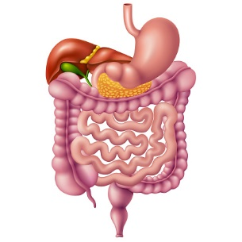

**GENERAL OUTCOMES:**

By the end of this block the students would be able to

**COGNITIVE DOMAIN:**

1. Define, etiology, pathogenesis morphology of premalignant lesions.
2. Enumerate etiology pathogenesis of white lesions of oral cavity.
3. Classification of tumors. Classify tumors of salivary glands
4. Discuss the Epidemiology, etiology, pathogenesis, morphology of squamous cell carcinoma, adenocarcinoma.
5. Enumerate inflammatory lesions.
6. Discuss etiology, pathogenesis, morphology of common tumors, GERD, Barret esophagus, SCC, adenocarcinoma, acute and chronic gastritis, gastric polyps and cancer, ulcerative colitis and Crohn disease, colorectal carcinoma, carcinoid, Cholecystitis, Gall Bladder, pancreas and pancreatitis.
7. Discuss the etiology, clinical presentations, the examination findings and investigations and treatment plan of Acute & Chronic Pharyngitis, H&N infections ludwigs angina and RPS abscess, acute suppurative otitis media, Quingy and PPS abscess, Secretory otitis media.
8. Discuss the Papilloma, hypopharyngeal carcinoma, Oropharyngeal Ca, Lymphoma, syndrome.
9. Define system and health system. Differentiate between Health work force and health units. Recognize Health system stakeholders. Enlist Factor influencing health system.
10. Discuss different descriptive study designs, analytical study designs.
11. Define demography. Explain Different components of demography Cycles with example. Describe Demographic transition and population pyramids.
12. Define water pollution Enlist its Types Explain the Causes of water pollution Discuss the Diseases caused by it.
13. Describe Water related disease. Differentiate between Types of water related diseases.
14. Explain Water purification in small scale. Compare and Contrast Different methods of water purification on small scale.
15. Describe Well purification. Discuss Hardness of water and how to remove it.
16. Explain Swimming pool sanitation and diseases caused by it.
17. Define & discuss cross sectional studies, Case control studies, Cohort study, Randomized control trials.
18. Define & describe & Explain the Effects of air pollution, noise pollution.
19. Define hospital. Describe and classify types of hospitals. Discuss hospital management principles and its types.
20. Classify Hospital wastes. Explain Hospital waste management plan. Discuss Sources of waste in the hospital. Describe the methods of waste disposal.
21. Enumerate causes of red eye. Describe pathophysiology and management of different conjunctival (bacterial /viral/allergic) Inflammations.
22. Describe differences between Pterygium, Pseudo-pterygium, Episcleritis & Scleritis Explain their management.
23. Discuss the etiology, clinical features, investigation, and management of corneal ulcers & keratoconus.

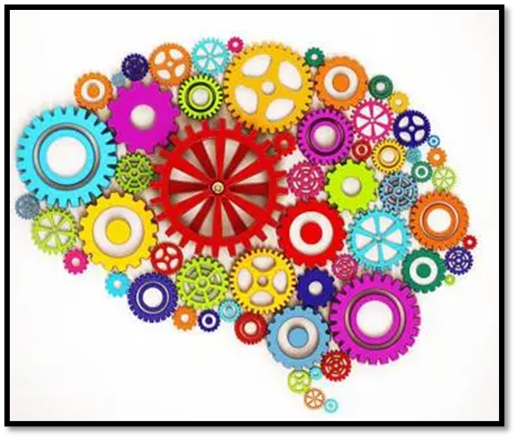

**PSYCHOMOTOR DOMAIN:**

1. Identify GIT specimens.
2. Examine Gross specimen of GIT.
3. Identify Gall Bladder specimens.
4. Examine Gross specimen of Gall Ballder.
5. Identify Pancreas specimens.
6. Examine Gross specimen of Pancreas.

LEARNING OBJECTIVES& COURSE CONTENTS:

**At the end of the teaching session the student should be able to achieve the following objectives:**

|  |  |  |
| --- | --- | --- |
| **PATHOLOGY LECTURES** | | |
| **S.NO** | **TOPICS** | **LEARNING OBJECTIVES** |
|  | Pre-Malignant lesions of oral cavity  (leukoplakia, White lesions of oral cavity) | Define, etiology, pathogenesis morphology of premalignant lesions  Enumerate etiology pathogenesis of white lesions of oral cavity |
|  | Tumors of Oral Cavity | Classification of tumors  Discuss the Epidemiology, etiology, pathogenesis, morphology of squamous cell carcinoma, adenocarcinoma |
|  | Diseases of Salivary Glands  Inflammatory lesions, Tumors | Enumerate inflammatory lesions.  Classify tumors of salivary glands  Discuss etiology, pathogenesis, morphology of common tumors |
|  | Diseases of Esophagus  (GERD, Barrets Esophagus ) | Explain Etiology, pathogenesis, morphology and complications of GERD.  Describe etiology pathogenesis morphology and complications of Barret esophagus |
|  | Tumors of Esophagus | Explain the Classification, epidemiology, etiology pathogenesis, morphology and staging of SCC, adenocarcinoma |
|  | Gastritis Acute/Chronic | Define Gastritis  Explain etiology, pathogenesis morphology and complications of acute and chronic gastritis |
|  | Peptic Ulcer diseases (PUD) Autoimmune Gastritis | Definition, epidemiology etiology pathogenesis morphology and complications of PUD & autoimmune gastritis |
|  | Gastric Polyps and tumors | Classify gastric Polyps and tumors,  Explain the epidemiology, etiology, pathogenesis morphology and complications of gastric polyps and cancer |
|  | Diseases of small/large intestine disease  IBD | Differentiate between ulcerative colitis and Crohn disease,  Explain epidemiology, etiology, pathogenesis, morphology and complications of ulcerative colitis and Crohn disease |
|  | Tumors of small/large intestine  Colorectal Carcinoma | Enlist the tumors of small/large intestine colorectal carcinoma.  Explain epidemiology, etiology, pathogenesis, morphology and complications of colorectal carcinoma, carcinoid |
|  | Cholecystitis | Classify Cholecystitis  Explain epidemiology, etiology, pathogenesis morphology and complications of Cholecystitis |
|  | Gallbladder | Classify diseases of Gall Bladder  Explain epidemiology, etiology, pathogenesis morphology and complications of Gall Bladder |
|  | Pancreas | Classify the diseases of Pancreas.  Explain the epidemiology, etiology, pathogenesis morphology and complications of pancreas |
|  | Pancreatitis | Classify Pancreatitis.  Explain the epidemiology, etiology, pathogenesis morphology and complications of pancreatitis |

|  |  |  |
| --- | --- | --- |
| **PATHOLOGY SGD** | | |
| **S.NO** | **TOPICS** | **LEARNING OBJECTIVES** |
|  | Inflammatory and ulcerative lesions of oral cavity | Explain the pathogenesis morphology of  inflammatory ulcerative  lesions.  Differentiate between inflammatory and ulcerative lesions. |
|  | Esophageal diseases congenital anomalies achalasia and hiatal hernia | Enlist congenital anomalies of esophagus.  Define Achalasia and Hiatal Hernia.  Enlist causes of hiatal hernia.  Discuss pathogenesis and morphology |
|  | Diseases of small and large intestine congenital anomalies and Hirschprung diseases & mickel diverticulum | Enlist congenital anomalies of small & large intestine.  Define Hirschsprung disease.  Discuss causes, pathogenesis, morphology, complications of  Hirschsprung Disease.  Enlist causes of Meckal Diverticulum  Discuss pathogenesis & morphology of Meckal Diverticulum |
|  | Intestinal obstruction and ischemic bowel disease | Define intestinal obstruction and ischemic bowel disease,  Discuss pathogenesis & morphology of Intestinal obstruction and ischemic bowel disease. |
|  | Malabsorption syndrome & celiac Diseases | Define malabsorption syndrome and celiac diseases  Discuss malabsorption syndrome and celiac diseases |
|  | Enterocolitis | Enlist types of diarrheas.  Discuss causes pathogenesis of bacterial,  viral; parasitic  enterocolitis. |
|  | Polyp of small and large intestine | Classify polyps.  Discuss pathogenesis, morphology of non-neoplastic &  neoplastic polyps. |

|  |  |  |
| --- | --- | --- |
| **PATHOLOGY PRACTICALS** | | |
| **S.NO** | **TOPICS** | **LEARNING OBJECTIVES** |
|  | Identification and Gross examination | Identify GIT specimens.  Examine Gross specimen of GIT |
|  | Identification and Gross examination | Identify Gall Bladder specimens.  Examine Gross specimen of Gall Ballder |
|  | Identification and Gross examination | Identify Pancreas specimens.  Examine Gross specimen of Pancreas |

|  |  |  |
| --- | --- | --- |
| **E.N.T LECTURES** | | |
| **S.NO** | **TOPICS** | **LEARNING OBJECTIVES** |
|  | Acute & Chronic Pharyngitis | Discuss the etiology and clinical presentations of Acute & Chronic Pharyngitis  Enlist the examination findings and investigations of Acute and Chronic Pharyngitis  Describe the treatment plan for Acute & Chronic Pharyngitis |
|  | H&N infections ludwigs angina and RPS abscess | Discuss the etiology and clinical presentations of H&N infections ludwigs angina and RPS abscess  Enlist the examination findings and investigations of H&N infections ludwigs angina and RPS abscess  Describe the treatment plan for H&N infections ludwigs angina and RPS abscess |
|  | Acute Suppurative otitis media | Discuss the etiology and clinical presentations for acute suppurative otitis media  Enlist the examination findings and investigations for acute suppurative otitis media  Describe the treatment plan for Acute Suppurative otitis media |
|  | Quingy and PPS Abscess | Discuss the etiology and clinical presentations for Quingy and PPS abscess.  Enlist the examination findings investigations for Quingy and PPS abscess.  Describe the treatment plan for Quingy and PPS abscess |
|  | Secretory Otitis Media | Discuss the etiology and clinical presentations for Secretory otitis media  Enlist the examination findings and investigations for Secretory otitis media  Describe treatment plan for Secretory otitis media |
|  | Chronic Suppurative Otitis media | Discuss the etiology and clinical presentations for Chronic Suppurative otitis media  Enlist the examination findings and investigations for Chronic Suppurative otitis media  Describe the treatment plan for Chronic Suppurative otitis media  Discuss the complications of chronic suppurative otitis media |
|  | Tumors of Oropharynx | Discuss the Papilloma,  Explain the Oropharnygeal Ca,  Describe Lymphoma |
|  | Tumors of Hypopharynx | Discuss the hypopharyngeal carcinoma,  Explain PV syndrome |
|  | Anatomy and Physiology of Larynx  Acute laryngitis | Recall the applied anatomy & physiology of Larynx  Discuss the clinical features and etiology of laryngitis |

|  |  |  |
| --- | --- | --- |
| **OPTHAMOLOGY LECTURES** | | |
| **S.NO** | **TOPICS** | **LEARNING OBJECTIVES** |
| 1 | Ocular Surface | Enumerate causes of red eye.  Describe pathophysiology and management of different conjunctival (bacterial /viral/allergic) Inflammations.  Describe differences between Pterygium, Pseudo-pterygium, Episcleritis & Scleritis  Explain their management. |
| 2 | Cornea | Discuss the etiology, clinical features, investigation, and management of corneal ulcers  Discuss the etiology, clinical features, investigation, and management of corneal ulcers  Discuss the etiology, clinical features, investigation, and management of keratoconus. |

|  |  |  |
| --- | --- | --- |
| **COMMUNITY MEDICINE** | | |
| No. | Lec. Name | Learning Outcomes |
|  | HMIS, concept, uses, data and its types. Collection and registration of vital events in pakistan | Define what a Health Management Information System (HMIS) is and explain its purpose in the context of public health and health care delivery. Understand the components of HMIS, including data collection, storage, processing, analysis, and dissemination. Explain the role of HMIS in supporting evidence-based decision-making, health planning, and resource allocation. Identify the various uses of HMIS in monitoring health programs, improving service delivery, and enhancing health outcomes. Understand how HMIS can be used to track disease patterns, monitor health indicators, and evaluate health program performance. |
|  | Principles of management | * To define principles of management   To discuss principles of management |
|  | Hepatitis A, B, C, D & E | Understand the Public Health Significance of Hepatitis A, B, C, D, & E. Define hepatitis and explain its relevance to public health. Describe the epidemiology of each type of hepatitis virus (A, B, C, D, and E), including prevalence, incidence, and geographic distribution. Understand the impact of hepatitis infections on public health, including morbidity, mortality, and healthcare burden. Identify the Modes of Transmission and Risk Factors. Describe preventive measures. Explore the role of public health policies, vaccination programs, and education campaigns in reducing the burden of hepatitis infections. Analyze the Global and National Burden of Hepatitis. |
|  | Concepts, uses of epidemiology | To understand the background,  To write the objectives  Importance of the objectives |
|  | Typhoid | Understand the Public Health Significance of Typhoid. Define typhoid fever and explain its relevance to public health. Describe the epidemiology of typhoid, including its global and regional prevalence, incidence, and affected populations.  Understand the impact of typhoid on health systems. Identify the Causes, risk factors and routes of transmission. Discuss preventive measures for typhoid fever especially the role of vaccination. Review the global burden. |
|  | Epidemiological method and descriptive study design | To understand define descriptive epidemiology  To classify conduct descriptive epidemiology  To conduct descriptive study designs |
|  | Epidemiological method and analytical study design | To understand define analytical epidemiology  To classify conduct analytical epidemiology  conduct analytical study designs |
|  | Cholera | Define cholera and explain its significance in public health. Describe the global and regional epidemiology of cholera, including its prevalence, incidence, and affected populations.  Understand the impact of cholera on health systems, including morbidity, mortality, and economic costs. Identify the Causes, risk factors and routes of transmission. Discuss the Clinical Presentation and Complications. Explore Public Health Strategies and Policies for Cholera Control |
|  | Elements of Management | To define elements of management  To discuss elements of management |
|  | Cross sectional study and case control study | To understand cross sectional study design  To understand case control study designs  To conduct cross section study design  To conduct case control study design |
|  | Hospital waste | To discuss various types of waste management at hospital |
|  | How to collect Hospital waste | To discuss waste management at hospital  To discuss methods of hospital waste disposal . |
|  | Cohort Study and Randomized Control Trials | To understand cohort study design  To understand cohort study designs  To conduct cohort study design  To conduct RCT |
|  | Principles of Demography | To discuss Principles of demography.  Demographic processes  Determinants of fertility and mortality |
|  | Sampling Techniques | To understand the techniques of sampling  To classify sampling techniques  To use the sampling techniques in their research |
|  | Screening test and Outbreak Investigation | students will be able to identify diseased persons among apparently healthy population  Can conduct the screening test  Can know about the importance of screening test  To investigate an outbreak  can understand the different steps in investigation  To guide the policy maker |
|  | Population pyramids | discuss types of population pyramids  Interpretation of population pyramids  Demographic and social implication of high population growth. |
|  | Demographic cycle | • To discuss demographic cycle  • Demographic transition and trap  • its public health importance |
|  | Health planning and planning cycle | Define health planning and its importance in public health.  Describe the goals and objectives of health planning.  Identify different types of health plans (e.g., strategic, operational, and contingency plans). Explain the stages of the planning cycle. Learn techniques for monitoring and evaluating health plans. |

|  |  |  |
| --- | --- | --- |
| **COMMUNITY MEDICINE SGD** | | |
| **S.NO** | **TOPICS** | **LEARNING OBJECTIVES** |
|  | Food Poisoning | To understand the Concept of food poisoning  To understand prevention of food poisoning |
|  | Cold Chain + Polio | To understand the Role of cold chain  To maintain to optimum temperature of different vaccine |
|  | EPI schedule | To understand the age of the target group for Vaccination schedule  To Present the EPI schedule |
|  | Requirement of healthful housing, urban and rural slums | To understand the concept of health full houses in urban areas  To understand the concept of health full houses in rural slums |
|  | Concept of hospital, services/ functions of hospital | To understand the Function of hospitals  To understand the services of different level s of hospitals |
|  | Social mobility and urbanization in context of demography | To understand Demography  To understand social mobilization  To understand concept of urbanization. |

|  |  |  |
| --- | --- | --- |
| **COMMUNITY MEDICINE PRACTICAL** | | |
| **S.NO** | **TOPICS** | **LEARNING OBJECTIVES** |
|  | Acute diarrheal diseases ORS | To define acute diarrheal disease  Can explain mode of transmission  To understand preparation and indications of ORS |
|  | Introduction to parasitic diseases ,Classification ,Hook worm infection ascariasis, Prevention and control of parasitic diseases | To understand parasitic diseases  To classify the different types of parasites  To understand the life cycle of hook worm and ascriasis  To understand prevention and control of parasitic diseases |
|  | Immunizing agent  (Vaccines) indications, contraindications and side effects | To define the vaccine  Classification of vaccine  Can explain immune response by vaccine |
|  | Poor quality housing and disease caused by it | To understand the impact of poor quality housing on health |
|  | Waste collection team | To understand the role  To understand importance of waste collection teams in public health |
|  | Demography and social implication of high population growth | To understand the demographic trends  To understand and present social implication of population growth. |

|  |  |  |
| --- | --- | --- |
| **GENERAL SURGERY LECTURES** | | |
| **S.NO** | **TOPIC** | **LEARNING OBJECTIVES** |
| 1 | Benign and malignant diseases of salivary glands | Describe Common salivary gland diseases and  Explain their assessment and management |
| 2 | Submandibular & Sublingual glands (Pathology and classification) | Discuss the Pathology of Submandibular & Sublingual glands  Classify the pathologies of submandibular and Sublingual glands |
| 3 | Submandibular & Sublingual glands (Clinical features, investigations & treatment) | Enlist the clinical features of Submandibular & Sublingual glands.  Analyze the investigations of submandibular & Sublingual glands.  Discuss the treatment options |
| 4 | Tongue Ulcers | Describe the Etiology and Pathology of Tongue ulcers  Enlist the Clinical features of tongue ulcers  Discuss the investigations and treatment of tongue ulcers |
| 5 | Thorax, Pneumothorax types & treatment | Define pneumothorax.  Differentiate between the types of pneumothorax.  Discuss the treatment options for pneumothorax |
| 6 | Thorax, Cardiac temponade | Define of cardiac tamponade  Explain cardiac tamponade |
| 7 | Thorax, Carcinoma Lungs | Define carcinoma of lungs  Enlist the treatment options for the carcinoma of lungs |

|  |  |  |
| --- | --- | --- |
| **GENERAL MEDICINE LECTURES** | | |
| **S.NO** | **TOPIC** | **LEARNING OBJECTIVES** |
| 1 | Esophageal Carcinoma | Define the Basics of esophageal carcinoma  Explain the Clinical Features  Discuss the Management |
| 2 | Benign esophageal disease | Define the Basics of Benign Esophageal Diseases  Enlist the Clinical Features  Discuss the Management |
| 3 | Gastric Carcinoma | Explain the Basics of Gastric carcinoma  Enlist the Clinical Features  Discuss the Management |
| 4 | Gastritis | Define the Basics of Gastritis  Enlist the Clinical Features  Discuss the Management |
| 5 | Constipation & IBS | Define the Basics of Constipation & IBS  Enlist the Clinical Features  Discuss the Management |
| 6 | Inflammatory Bowel Syndrome | Define the Basics of IBS  Enlist the Clinical Features  Discuss the Management |
| 7 | Diarrhea | Explain the Basics of Diarrhea  Enlist the Clinical Features  Discuss the Management |
| 8 | Colorectal Carcinoma | Define the Basics of Colorectal carcinoma  Enlist the Clinical Features  Discuss the Management |
| 9 | Acute and chronic pancreatitis | Differentiate between the Basics of acute and chronic pancreatitis  Enlist the Clinical Features  Compare and Contrast the Management of acute and chronic pancreatitis |

|  |  |  |
| --- | --- | --- |
| **FAMILY MEDICINE** | | |
| **S.NO** | **TOPIC** | **LEARNING OBJECTIVES** |
|  | The psychosocial model of health care | Discuss the Influence of psychosocial factors on health care |

|  |  |  |
| --- | --- | --- |
| **PEADS LECTURES** | | |
| **S.NO** | **TOPIC** | **LEARNING OBJECTIVES** |
| 1 | Wilsons Diseases | Define Wilsons Disease  Explain the Pathophysiology of Wilsons Disease  Discuss the Diagnosis & Management of Wilsons Disease |

|  |  |  |
| --- | --- | --- |
| **PHYSIOLOGY LECTURES** | | |
| **S.NO** | **TOPICS** | **LEARNING OBJECTIVES** |
|  |  |  |
| 1) | General Principles of GIT functions motality & nervous control | Describe the primary/basics functions of GIT  Describe the physiological anatomy  Identify the role of nervous system in control of GIT function |

|  |  |  |
| --- | --- | --- |
| **ANATOMY LECTURES** | | |
| **S.NO** | **TOPICS** | **LEARNING OBJECTIVES** |
|  |  |  |
| 1 | Histology of esophagus and stomach | Describe the histology of esophagus and stomach and its clinical co-relations. |

**ASSESSMENT METHODS FOR BLOCK EXAM:** 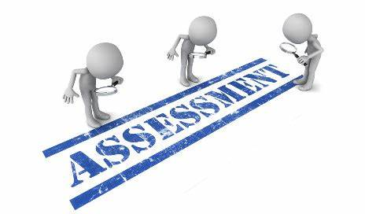

Evaluation is a continuous process comprising of block examination and annual university examination. Students will be evaluated throughout the year. The internal assessment will contribute towards the final examination scores.

Multiple examination methods including MCQs, SAQs, OSPE and viva will be used for assessment. In line with PMC stipulation, the pass/fail marks for the test and examination will be 50%.

There will be a block exam at the end of each block.

**Theory (knowledge):** MCQs (Multiple Choice Questions) and SAQs (Short Answer Questions) are used to assess the theory part for the block exam

**MCQ:**

* A MCQ has a statement or clinical scenario followed by four options (likely answers).
* After reading the statement/scenario student select ONE, the most appropriate answer/response from the given list of options.

### Correct answer carries one mark, and incorrect ‘zero mark’. There is NO negative marking.

**SAQ:**

**OSPE: Objective Structured Practical Examination (See the proposed plan of OSPE)**

* It may comprise between 12- 25 stations.
* The content may assess application of knowledge, or practical skills.
* Student will complete task in define time at one given station.
* All the students are assessed on the same content by the same examiner in the same allocated time.
* A structured examination will have observed, unobserved, interactive and rest stations.

### **Observed and interactive stations:**

They will be assessed by internal or external examiners through the task or viva.

### **Unobserved station:**

It will be static station in which students will have to answer the questions related to the given pictures, models or specimens on the provided response sheet.

### **Rest station:**

It is a station where no task is given, and during this time student can organize his/her thoughts.

**ASSESSMENT PLAN 4th YEAR MBBS**

|  |  |  |  |  |
| --- | --- | --- | --- | --- |
| **BLOCK – 1** | **BLOCK – 2** | **BLOCK - 3** | **ATTENDANCE** | **ASSIGNMENT / PRESENTATION** |
| 5 | 5  Obtained marks / total marks x 5) | 5 | 2  Obtained marks % / 100 x 2 = | 3 |

**20% Internal Assessment**

* **20% Internal Assessment will contribute 20 marks in the final paper (Theory).**
* **15** marks for all the 3 blocks
* **5** marks per block
* (**Obtained marks / total marks x 5)**
* **2 marks** for attendance, which will be calculated by the **end of each year**.
* **3 marks** for continuous Assessment which includes assignments and presentations will also be calculated by the **end of each year.**

|  |  |  |  |  |
| --- | --- | --- | --- | --- |
| **BLOCK (THEORY PAPER) BREAKUP DETAILS** | | | | |
| **BLOCK** | **MCQs** | **SAQs** | **TOTAL MARKS IN EACH BLOCK** |
| **7** | **23** | **12** | **35** |
| **8** | **23** | **12** | **35** |
| **9** | **23** | **12** | **35** |

* Total no of MCQs will be 23. Each will carry one mark
* Total no of SAQs will be 4. Student will attempt 3 SAQs. Each will carry 4 Marks

|  |  |  |  |  |
| --- | --- | --- | --- | --- |
| **BLOCK – 1** | **BLOCK – 2** | **BLOCK - 3** | **ATTENDANCE** | **BEHAVIOUR** |
| 5 | 5  Obtained marks / total marks x 5) | 5 | 2  Obtained marks % / 100 x 2 = | 3 |

**20% Internal Assessment will contribute 20 marks in the final paper (Practical).**

* **15** marks for all the 3 blocks
* **5** marks per block
* (Obtained marks / total marks x 5)
* **2** marks for attendance, which will be calculated by the end of each year.
* **3** marks for behavior / discipline, will also be calculated by the end of each year.

|  |  |  |  |  |
| --- | --- | --- | --- | --- |
| **BLOCK (PRACTICAL) BREAKUP DETAILS** | | | | |
| **BLOCK** | **OSPE STATIONS** | **VIVA** | **TOTAL MARKS IN EACH BLOCK** |
| **7** | **20** | **15** | **35** |
| **8** | **20** | **15** | **35** |
| **9** | **20** | **15** | **35** |

* Total No of OSPE stations: (5) Each will carry 4 marks

**INTERNAL ASSESSMENT MARKS DISTRIBUTION:**

**4th YEAR MBBS**

|  |  |  |  |  |  |
| --- | --- | --- | --- | --- | --- |
| **THEORY INTERNAL ASSESSMENT**  **15 MARKS** | | | **PRACTICAL INTERNAL ASSESSMENT**  **15 MARKS** | | |
| **ATTENDANCE**  **5 MARKS** | **ASSIGNMENTS AND PRESENTATIONS**  **5 MARKS** | **BEHAVIOUR /DISCIPLINE**  **5 MARKS** | **ATTENDANCE**  **5 MARKS** | **LOGBOOK**  **5 MARKS** | **BEHAVIOUR**  **5 MARKS** |
| Obtained percentage / 100 x 2 = | Grade A=5 marks  Grade B= 3 marks  Grade C= 1 mark  No assignments or presentations =0 marks | No misbehave or warning in lectures = 5 marks  Written warning given to student = 0 marks | Obtained percentage / 100 x 2 = | Completed and timely signed =5 marks  Completed and late submission=3 marks  Incomplete= 1 mark  No logbook =0 marks | No misbehave or warning in practical class= 5 marks  Written warning given to students= 0 marks |

|  |  |
| --- | --- |
| **LEARNING RESOURCES:** | |
| **SUBJECT** | **RESOURCES** |
| **ENT** | Dhingra |
| **OPHTHALMOLOGY** | 1. Shafi and Jatoi   1. Short Kanski |
| **SPECIAL PATHOLOGY** | Pathoma |
| **COMMUNITY MEDICINE** | 1) Fundamentals of community medicine & Public Health (3rd Edition) (Dr. Hayat Muhammad Khan, Dr. Bushra Iftikhar)  2) Public Health & Community Medicine (Latest Edition) (M. Ilyas Ansari)  3) Preventive & Social Medicine (Latest Edition) (K. Park) |

|  |  |
| --- | --- |
| **OTHER LEARNING RESOURCES:** | |
| **Hands-on Activities**  **/ Practical** | Students will be involved in Practical sessions and hands-on activities that link with the foundation module to enhance the learning. |
| **Labs** | Utilize the lab to relate the knowledge to the specimens and models available. |
| **Skill Labs** | A skills lab provides the simulators to learn the basic skills and procedures. This helps build the confidence to approach the patients. |
| **Videos** | Video familiarizes the student with the procedures and protocols to assist patients. |
| **Computer Lab / CDs / DVDs / Internet Resources:** | To increase the knowledge students should utilize the available internet resources and CDs/DVDs. This will be an additional advantage to increase learning. |
| **SDL** | SDL is scheduled to search for information to solve cases, read through different resources and discuss among the peers and with the faculty to clarify the concepts. |