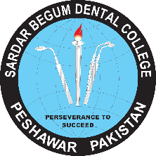**GANDHARA UNIVERSITY**

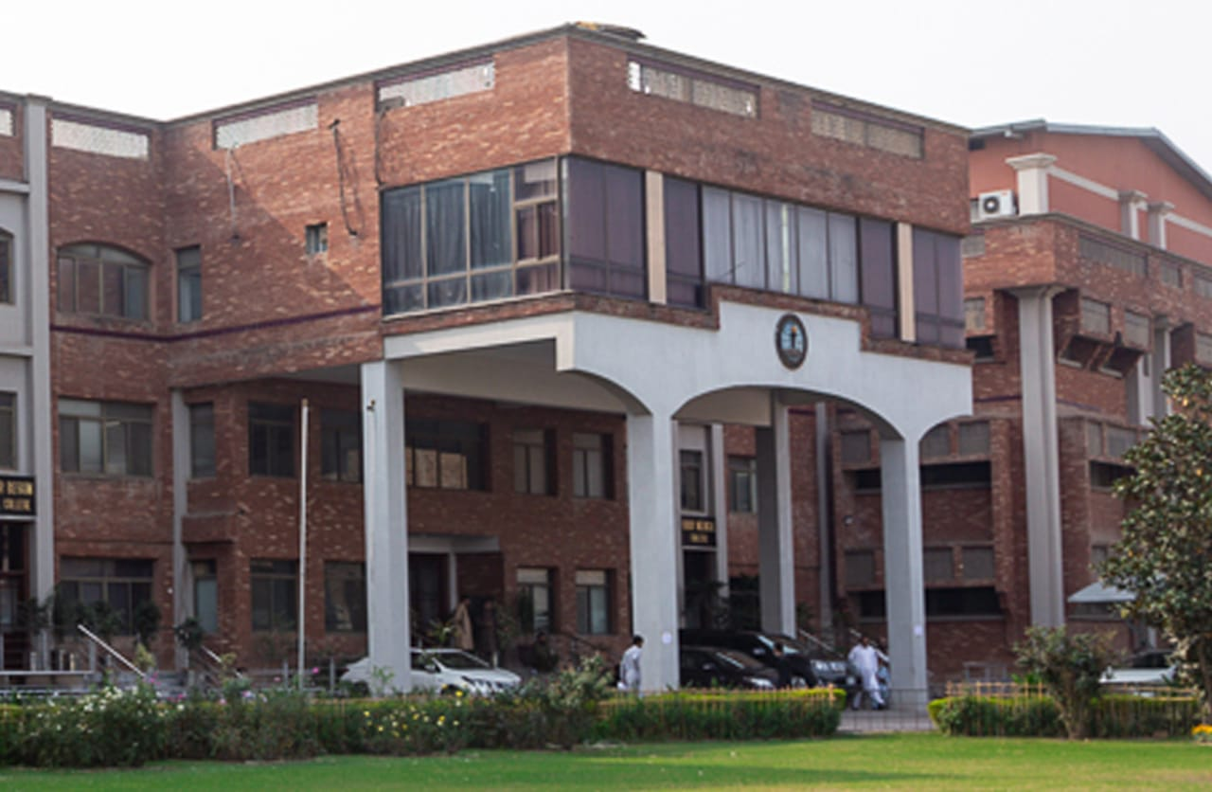 **SARDAR BEGUM DENGTAL COLLEGE**

**THIRD YEAR BDS 2023**

**BLOCK – IX (Module 17 & 18)**

**BONE DISORDERS MUCOCUTANEOUS DISORDERS**

# FROM THE DESK OF PRINCIPAL

Health is a fast-evolving field and with new technologies taking over traditionally man-dominated fields like radiology and robotic surgical suites assisted by Artificial Intelligence and learning taking new dimensions with the help of Augmented Reality, we are indeed living in challenging times. Today's student of Medicine and Dentistry will be in the field a decade from now, up against a disease burden that is as varied as the next strain of the Covid-19 Virus and as complicated as the genetic characteristic of Oral Cancer, the largest cancer amongst both genders in Pakistan and at the same time as unpredictable as the recent Covid-19 Pandemic.  
It is therefore imperative that our curricula of the Medical and Dental Colleges be in tandem with the changing times with ability to evolve with time , measuring up to the challenges thrown at the field of healing from the ever-evolving diseases .  
  
These Student Guidebooks are reviewed every year with the same concept in mind that our future Physician and Dental Surgeon be ready for the challenges that lie ahead.  
  
In the end, I give you the same prayer as is mentioned in the Quran.

# See the source image

# 

# 

Prof. Shaheed Iqbal

BDS, MDS, OMFS

Principal,

Sardar Begum Dental College,

Gandhara University

Peshawar.

On behalf of block team, I would like to welcome you to Block- IX. As a part of the system-based curriculum, this module is an integrated presentation comprises system-based modules which links basic science knowledge to clinical problems. Integrated teaching means that subjects are presented as a meaningful whole. Students will be able to have a better understanding of basic sciences when they repeatedly learn in relation to clinical examples. Small group discussions, early exposure to clinics, wards, and skills acquisition in skills lab are characteristics of integrated teaching program.

Our mission is to provide all educational opportunities to our students therefore on completion of the BDS program graduate will possess an appropriate foundation of knowledge, skills, and attitudes to be well prepared to practice safely and effectively

This study guide includes the course contents, learning objectives, practical & small group discussions topics. It also includes the assessment plan for the block exam.

I will be meeting with the facilitators to receive your feedback and will try to resolve any difficulties or problems faced during the block. Please do not hesitate to contact DME for any academic help. I wish you an enjoyable and learning experience with the block-IX.



**Director DME: Dr. Marina Khan**

|  |
| --- |
| **CONTENT** |
| **Block Team** |
| **List of abbreviations…** |
| **Aims of the study guide…** |
| **Module distribution of 3rd year BDS** |
| **Introduction of Block IX…** |
| **General Outcomes…** |
| **Leaning Methodologies…** |
| **Rules Regulations** |
| **Learning objectives & Course contents** |
| **Assessment** |
| **Learning Resources** |

**MODULE TEAM**

|  |  |  |  |  |
| --- | --- | --- | --- | --- |
|  | **Dr. Marina Khan**  **Director**  **Department of Medical Education** | | [**marinakahn@hotmail.com**](mailto:marinakahn@hotmail.com) | |
| **DEPARTMENT OF PERIODONTOLOGY** | |  | | Associate Prof. Dr. Kawish Syed  Assistant Prof. Dr. Afaq Farooq  Senior Registrar Dr.Abid  Dr. Zain |
| **DEPARTMENT OF ORAL MEDICINE** | |  | | Assistant Prof. Dr. Zafar Iqbal Ahmed  Assistant Prof. Dr. Zainab Shah  Dr. Nafeesa Afridi |
| **DEPARTMENT OF GENERAL SURGERY** | |  | | Associate Prof. Dr.Azhar Shah |
| **DEPARTMENT OF ORAL PATHOLOGY** | |  | | Prof Dr Ahmad Shah  Associate Prof Dr. Sofia Haider Durrani  Assistant Prof. Dr Sana Salam  Dr Rabia |
| **DEPARTMENT OF GENERAL MEDICINE** | |  | | Assistant Prof Dr. Jibran Umar Ayub |
| **DEPARTMENT OF ORAL & MAXILLOFACIAL SURGERY** | |  | | Prof.Dr. Jawad Ahmad Kundi  Prof.Dr. Murad Ali Shah  Prof Dr. Shahid Khattak  Assistant Prof Dr Fahad Qiam  Dr Zeenia |
| **DEPARTMENT OF PROSTHETICS** | |  | | Prof Dr Ali Chughtai  Dr Hammad |
| **DEPARTMENT OF OPERATIVE DENTISTRY** | |  | | Prof Dr Shakeel Khattak  Associate Prof Dr Yasir Khattak  Assistant Prof Dr. Junaid  Dr. Sajida  Dr. Asma |
| **DEPARTMENT OF MEDICAL EDUCATION** | |  | | Assist Prof Dr. Marina Khan  Dr. Aalia Zaib  Dr. Usama Zeb |

**LIST OF ABBREVIATIONS**

|  |  |
| --- | --- |
| **IC** | Integrated Curriculum |
| **DME** | Department of Medical Education |
| MIT | Modes of Information Transfer |
| OPD | Outpatient Department |
| **O.Med** | Oral Medicine |
| **O. Patho** | Oral Pathology |
| **PROSTHO** | Prosthodontics |
| **PERIO** | Periodontology |
| **G.M** | General Medicine |
| **G. S** | General Surgery |
| **ENDO** | Endodontics/ Operative Dentistry |
| **OMFS** | Oral & Maxillofacial Surgery |
| **LGIS** | Large Group Interactive Session |
| **SDL** | Self-Directed Learning |
| **MCQ** | Multiple Choice Question |
| **SAQ** | Short Answer Question |
| **OSPE** | Objective Structured Practical Exam |
| OSCE | Objective Structured Clinical Evaluation |

**STUDY GUIDE:**

This study guidebook was designed by combining

the efforts of all topics throughout the year to give dental students at Sardar Begum Dental College a resource material that highlights significant components of the curriculum. By providing students control over their learning, the study guide aims to promote self-regulated lifelong learning.

Regarding the course content, the study guide provides an overview of the topics, outcomes and objectives. The assessment approach is also customized to the intuitional strategy.

A successful curriculum has a significant impact on the final product, as well as on society. This study guide was carefully designed with the PMC curriculum and rules in mind, and Gandhara University stakeholders and faculty o SBDC worked hard to personalize it to the needs of the students. They are further working to build, implement, and exercise a well-built curriculum considering changing demographic needs and disease prevalence in our society. Throughout the construction of the study guide, students' feedback was received and included. Curriculum is a living, dynamic entity that is constantly changing. With each passing day, we hope to improve it.

Each module in this block has been created to cater for the gap between basic and clinical subjects through pre-clinical learning. The block is divided into two modules in which the students are exposed to a variety of basic and clinical subjects. The integrated curriculum is enforced through interactive lectures, small group discussion along with rotations at preclinical laboratory.

**AIMS OF THE STUDY GUIDE**

It is an aid to:

* **Background pattern

  Description automatically generated**Inform students how student learning program of the BLOCK-wise module has been organized
* Help students organize and manage their studies throughout the block
* Guide students on assessment methods, rules, and regulations
* Communicates information on organization and management of the block. This will help the student to contact the right person in case of any difficulty.
* Defines the objectives which are expected to be achieved at the end of the block.
* Identifies the learning strategies such as lectures, small group teachings, clinical skills, and demonstration, tutorial that will be implemented to achieve the block objectives.
* Provides a list of learning resources such as books, computer assisted learning programs, web- links, and journals, for students to consult to maximize their learning.
* Highlights information on the contribution of continuous and block examinations to the student’s overall performance.
* Includes information on the assessment methods that will be used to determine every student’s achievement of objectives.

**ORGANIZATION OF MODULAR CURRICULUM**

|  |  |  |  |  |  |  |  |  |  |
| --- | --- | --- | --- | --- | --- | --- | --- | --- | --- |
| **Block-VII** | | **Exam Block - 7** | **Block-VIII** | | **Exam Block - 8** | **Block-IX** | | **Exam Block - 9** | **Final Exam** |
| **Module**  **13**  **Oral diseases, etiology & mechanism** | **Module**  **14**  **Oral infections and inflammations** | **Module**  **15**  **Pre-malignant / Malignant Lesions & Salivary Gland disorders** | **Module**  **16**  **Systemic Diseases & Immune Mediated Disorders** | **Module**  **17**  **Bone Disorders** | **Module**  **18**  **Mucocutaneous Disorders** |

**BLOCK – IX**

**BONE DISORDERS AND MUCOCUTANEOUS DISORDERS**

**DEPARTMENT OF ORAL PATHOLOGY**

Oral pathology is a dental specialty that deals with the nature, etiology, basic pathological mechanisms, clinical presentation, histopathological evaluation, diagnosis, and treatment of diseases and disorders that affect the oral and maxillofacial region as well as craniofacial syndromes. The subject of Oral Pathology is aimed to provide a theoretical and practical knowledge of the fundamental concepts of pathological diseases of the oral cavity and orofacial soft and hard tissues for third year BDS students.

At the undergraduate level, oral pathology enables students to understand, recognize and identify disorders of the head and neck region. It includes disease diagnosis via clinical, radiographic, microscopic, biochemical, and other examinations, and patient treatment.

The laboratory of Oral Pathology is well-equipped, and the faculty and staff are fully skilled. Oral pathology is aimed to demonstrate a correlation between subjects in order to establish a deeper approach to studying the underlying concepts of each subject and applying them in clinical encounters in the BDS undergraduate program's future years.

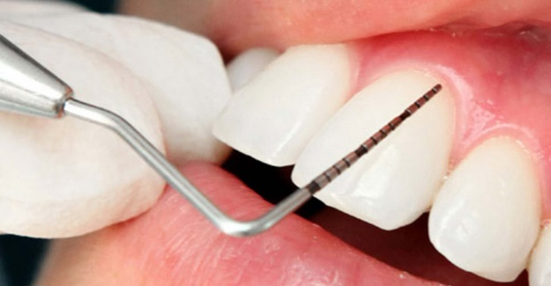

**DEPARTMENT OF PERIODONTOLOGY**

Periodontology is a dental specialty that studies tooth supporting structures as well as diseases and conditions that affect them. The supporting tissues are known as the periodontium and is made up of the gingiva (gums), alveolar bone, cementum, and the periodontal ligament. Periodontology is designed to provide a thorough understanding of the basic principles of periodontal tissue origin, progression, and pathology, as well as the diagnosis and treatment of periodontal disease.

It is essential to provide our students with a broad and complete understanding of periodontology in order to prepare them for the issues they will confront as dentists. This will enable them to perform their professional tasks to a high quality.

The department of periodontology at Sardar Begum Dental College, specializes in diseases of the periodontium, which includes the gums, alveolar bone, and periodontal ligament. Patients with gum and periodontal disorders, as well as those with oral problems, are treated and monitored in the periodontology department.

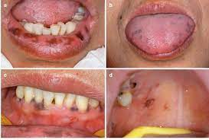

**DEPARTMENT OF ORAL MEDICINE**

Oral medicine is a branch of dentistry that focuses on the diagnosis, investigation, and non-surgical treatment of disorders affecting the oral, perioral structures (such as orofacial pain, oral manifestations of systemic diseases, salivary gland disorders) and medically compromised patients with oral health issues.

The course content in the subject of Oral Medicine at Sardar Begum and Dental College is designed to provide students with extensive diagnostic and therapeutic skills in the diagnosis and nonsurgical treatment of oral and perioral diseases, temporomandibular joint disorders as well as the management of systemic diseases that have a significant impact on oral health. Students will learn how to take a detailed medical history, conduct a thorough physical examination, advise appropriate investigations, and develop a diagnosis and treatment plan.

The overall objective of this subject at the undergraduate level is to emphasize the importance of dental students in obtaining medical and dental histories and doing a full head and neck as well as oral examination is to provide patients with adequate and safe dental care.

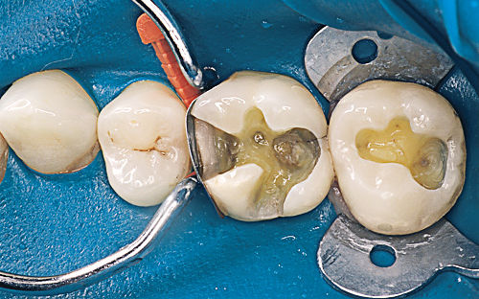**DEPARTMENT OF OPERATIVE DENTISTRY**

Operative dentistry is the practice of restoring normal structure, function, health, and aesthetics of teeth that have been damaged by disease, trauma, wear, or abnormal development. The practice of dentistry in this area requires a wide range of knowledge, from diagnosis, disease processes and prevention, and minimally invasive clinical approaches; to biomaterials and other dental science disciplines as they apply to this distinct and unique interest area limited to the hard calcified tissues of the oral cavity.

The objective of this session is to give basic knowledge of operative instruments, dental terms, principles of cavity preparations, and fundamentals of tooth restorations. The course's major objectives are to introduce students to theoretical topics and to improve their manual dexterity. The use of a hand piece (dental drill) to learn and practice these skills begins during orientation and continues throughout the academic year. During the clerkship programme the students will learn how to assess patient caries risk and implement caries prevention strategies, as well as how to remove or treat carious tooth tissue using techniques that preserve pulp vitality and restore the tooth to form, function, and aesthetics with appropriate materials, as well as how to prevent hard tissue disease and promote soft tissue health.

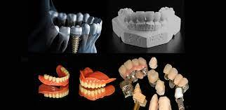

**DEPARTMENT OF PROSTHODONTICS**

Prosthodontic dentistry is a branch of dentistry concerned with the restoration and maintenance of a patient's oral functions, comfort, aesthetics, and health by restoring teeth and/or replacing missing structures with removable and fixed dental prosthesis (artificial prosthesis). this branch of dentistry is one of the most difficult and challenging subjects as it includes both clinical and practical/laboratory work. The main goal of this course is to offer students with the essential information and hands-on experience in complete dentures, partial dentures, crowns, and bridges so that they can become future general dental care professionals.

The department of prosthodontics at SBDC, treats patients with removable complete and partial dentures, fixed prostheses, maxillofacial prostheses, and temporary mandibular problems management. Third year BDS students during their clerkship programme will be taught to design and fabricate removable partial dentures for patients.

**DEPARTMENT OF ORAL & MAXILLOFACIAL SURGERY**

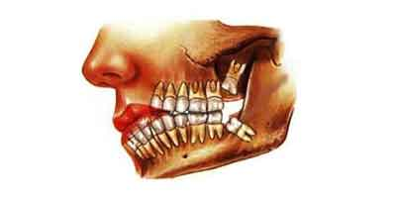Oral surgery is a specialty that deals with the diagnosis and treatment of the pathologies of jaw and oral cavity, that requires surgical intervention. Although tooth extraction is the most common surgery performed by oral surgeons, there is a broad scope to the specialty. This includes managing hard and soft tissue pathologies, oral infections, dentoalveolar trauma, and orofacial pain, as well as providing orthodontic surgery and Osseo integrated implant placement.

**DEPARTMENT OF GENERAL MEDICINE**

General medicine is a course taught at the undergraduate level that allows students to learn clinical medicine and apply their knowledge in clinical dental practice.

The Department of General Medicine contains the following facilities and students will be taught in detail about the relevant subjects: Cardiology, Infectious diseases, Gastro enterology, Hepatology, Nephrology, Pulmonology, Rheumatology, Hematology Dermatology, Psychiatry.

The course is aimed to provide students a touch of the primary areas of General Medicine while remaining mindful of the BDS curriculum's limits and time constraints. This practice will ensure patient safety and provide a better knowledge of the disease's correlation to other dental diseases. For improved learning, the practical component of the course includes structured ward rotations and patient interaction.

**DEPARTMENT OF GENERAL SURGERY**

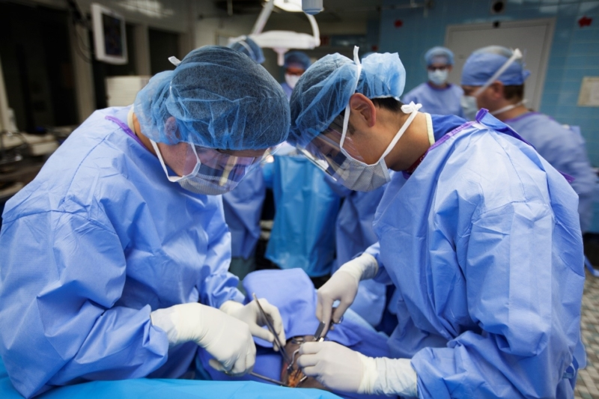General surgery is the science and practice of using operative procedures to treat injury, deformity, and disease. When medication alone is unlikely to relieve discomfort, general surgery is routinely performed. Surgical operational procedures can range from simple procedures conducted in a doctor's office to more complex operations requiring the assistance of a medical team in a hospital setting.

BDS 3rd year Surgery rotation is an essential component of the clerkship curriculum as a student is practically exposed to surgical approaches, its complications and management. The overall purpose of this programme is to educate future dental surgeons to diagnose and manage common surgical problems. Students will rotate through the outpatient department, surgical wards, and operating rooms to learn the fundamentals of clinical reasoning to gain the clinical and procedural skills they require.

**GENERAL OUTCOMES:**

By the end of this block the students would be able to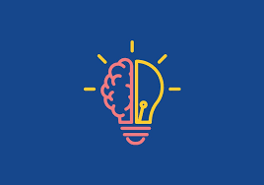

1. **KNOWLEDGE:**
2. Enumerate, Define and explain different types of the mucocutaneous diseases and connective tissue disorders
3. Explain the concept about the periodontal wound healing and Surgical periodontal therapy
4. Describe the guided tissue and bone regeneration and treatment of furcation defects, Periodontal pockets, Bone loss, Trauma from occlusion
5. Describe different periodontal plastic surgeries with emphasis on treatment of recession defects
6. Describe dental implants and its procedure
7. Define and different types of connective tissue disorders, Bone Pathologies, Other disorders of teeth
8. Define and classify odontogenic tumours
9. Define and explain pathophysiology, lab investigations and treatment protocol of different diseases such as acromegaly, hyperthyroidism, hypothyroidism, hyperparathyroidism and hypo parathyroidism, Cushing syndrome, Addison diseases and pheochromocytoma, rheumatoid arthritis, Gout, Systemic Lupus Erythrometosis, Psoriatic arthritis, Ankylosing spondylitis, Osteoporosis and Osteomalacia,Reactive arthritis and Myopathies
10. Define and explain pathophysiology, lab investigations and surgical treatment of Sinus & fistula, Simple goiter, toxic goiter and thyrotoxicosis, carcinoma of thryroid, Parathyroid glands and disorders of parathyroid glands
11. Describe the disease processes in oral cavity and how it leads to the loss of teeth.
12. Enlist Treatment options for the replacement of missing teeth and choose between the alternatives such as no replacements, bridges, dentures or implants by considering the holistic care of individual patients. The laboratory procedures involved in the fabrication of cast partial dentures.
13. Explain Clinical Prosthodontics to the extent that they can take proper consent from the patient and their parents regarding proposed treatment regimen. Incorporation of removable prosthesis in the restorative treatment planning.
14. Recognize the microbial causation of apical periodontitis.
15. Describe the routes of root canal infection and Discuss the different types of endodontic infections
16. Classify and describe the features of different pulpal diseases
17. identify the functions of endodontic instruments and differentiate between Hand and power assisted instruments

**ATTITUDE:**

By the end of the block the students will be able to

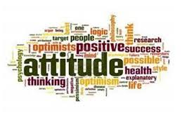

1. Follow the basic laboratory protocols
2. Participate in class and practical work efficiently
3. Maintain discipline of the college.
4. Follow the norms of the college properly.
5. Communicate effectively in a team with colleagues and teachers.
6. Demonstrate professionalism and ethical values in dealing with patients, cadavers,

colleagues, and teachers.

1. Communicate effectively in a team with colleagues and teachers.
2. Demonstrate the ability to reflect on the performance.

**LEARNING METHODOLOGIES**

The following teaching / learning methods are used to promote better understanding:

* Interactive Lectures
* Small Group Discussion
* Practical
* Skills session
* E-Learning
* Self-Directed Learning

**LARGE GROUP INTERACTIVE LECTURES (LGIS)**

In large group, the lecturer introduces a topic or common clinical conditions and explains the underlying phenomena through questions, pictures, videos of patients' interviews, exercises, etc. Students are actively involved in the learning process.

**SMALL GROUP DISCUSSIONS (SGDs):**

This format helps students to clarify concepts acquire skills or attitudes. Sessions are structured with the help of specific exercises such as patient case, interviews, or discussion topics. Students exchange opinions and apply knowledge gained from lectures, tutorials, and self-study. The facilitator role is

to ask probing questions, summarize, or rephrase to help clarify concepts.

**PRACTICAL**

Practical’s & clinical rotations related to General Medicine ,General Surgery, Oral Pathology, Oral Medicine, Periodontology, Oral & Maxillofacial surgery, Operative Dentistry and Prosthodontics are scheduled for student learning.

**SELF DIRECTED LEARNING SDL:**

Students assume responsibilities of their own learning through individual study, sharing and discussing with peers, seeking information from Learning Resource Center, teachers, and resource persons within and outside the college. Students can utilize the time within the college scheduled hours of self-study.

**E-LEARNING:**

E-Learning is a strategy by which learning occurs through the utilization of electronic media, typically the Internet. The basic aspects of medical professionalism and ethics will be addressed through an e-learning course.

1. **Hands on Training**
2. **Oral Pathology, Oral Medicine lab sessions:**

Oral Pathology practical will demonstrate your skills and help in clarifying your concepts practically.

1. **Clinical hands on & Ward Rotation**

Practice of clinical examination on patients in Periodontology, oral medicine, General Medicine, General Surgery, Operative dentistry, Prosthodontics, Oral and maxillofacial surgery wards

**RULES AND REGULATIONS**

We will be making the journey through the Block IX in 8weeks. Therefore, this course includes an intensive coursework load. Class attendance and participation are extremely important to your learning and are considered in the evaluation of the course grade. If there is anything that the block team can do to assist during the course, please feel free to contact DME or concerned department. Attendance will be monitored during the different teaching activities. If the attendance is less than 75%, the student will be not allowed to sit for both block and annual examination.

All examinations must be taken on the date scheduled. Once the exam starts the student will not be allowed to enter the examination Hall. There will be a block exam at the end of each block and each block will cover two modules. There will be a total of 3 block examination and the 30% weightage of these block exam will be added to the 70 % of the annual professional exam as an internal assessment.

**MODULE – XVII**

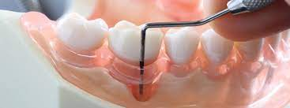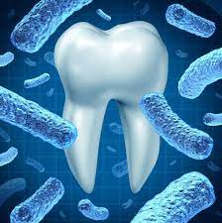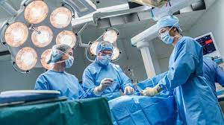

**LEARNING OBJECTIVES & COURSE CONTENTS**

At the end of the teaching session the student should be able to achieve the following objectives

|  |  |  |
| --- | --- | --- |
| **ORAL PATHOLOGY LECTURES** | | |
| **S.NO** | **TOPICS** | **LEARNING OBJECTIVES** |
| 1 | **Bone pathologies**   * Inherited/ Developmental * Metabolic * Hormonal * Inflammatory * Reactive * Fibrosseous * Neoplastic | * Introduction of bone pathologies * Classification of bone pathologies * define, describe and interpret all of the bone disorders. |
| 2 | **TMJ Disorders**   * Developmental * Infective * Inflammatory * Traumatic * Functional * Internal Derangement * Neoplastic | **•** Introduction of TMJ disorders  • Classification of TMJ disorders   * understand, define, describe and diagnose all of the TMJ disorders. |

|  |  |  |
| --- | --- | --- |
| **PERIODONTOLOGY LECTURES** | | |
| **S.NO** | **TOPICS** | **LEARNING OBJECTIVES** |
| 1 | Periodontal pocket | Define periodontal pocket  Classify periodontal pocket  Explain the pathogenesis |
| 2 | Bone loss | Discuss different patterns of bone loss in periodontal disease |
| 3 | Trauma from occlusion | Define and classify TFO  Describe its different stages and management. |

|  |  |  |
| --- | --- | --- |
| **GENERAL SURGERY LECTURES** | | |
| **S.NO** | **TOPICS** | **LEARNING OBJECTIVES** |
| 1 | Sinus and Fistula | Define sinus & fistula  Enlist the Causes of sinus & fistula  Explain the Examination of sinus & fistula  Explain the Technique of sonogram and fistulogram in sinus & fistula  Explain the Treatment of sinus & fistula |

|  |  |  |
| --- | --- | --- |
| **GENERAL MEDICINE LECTURES** | | |
| **S.NO** | **TOPICS** | **LEARNING OBJECTIVES** |
| 1 | Rheumatoid Arthritis | * Define Rheumatoid Arthritis. * Explain the etiology, clinical presentation, diagnosis, and management of Rheumatoid Arthritis. |
| 2 | Gout | * Describe the clinical presentation of Gout. * Discuss the diagnosis and management of Gout |
| 3 | Systemic Lupus  Erythrometosis | * Describe the clinical presentation of SLE. * Discuss the diagnosis and management of SLE. |
| 4 | Psoriatic arthritis  Ankylosing Spondylitis | * Describe the clinical presentation of Psoriatic arthritis * Discuss the diagnosis and management of patient with Psoriatic arthritis * Describe Ankylosing Spondylitis with its clinical presentation, differential diagnosis, and management plan |
| 6 | Osteoporosis and osteomalacia | * Define osteoporosis and osteomalacia. * Enlist the various factors. * Understand their clinical presentation diagnosis and management. |
| 7 | Reactive arthritis | * Define Reactive arthritis * Enlist the risk factors * Explain the clinical features and management of Reactive arthritis |
| 8 | Myopathies | * Define myopathy * Enlist the different types of myopathies. * Explain the clinical presentation and diagnosis of myopathy. |

|  |  |  |
| --- | --- | --- |
| **ORAL MEDICINE LECTURES** | | |
| **S.NO** | **TOPICS** | **LEARNING OBJECTIVES** |
| 1 | Disorders of teeth and bone | 1. Enlist and explain Common dental anomalies  2. Enlist Common bone disorders  3. Explain Its diagnosis and management |
| 2 | TMJ disorders | 1. Classify TMDs.  2. Identify the etiology of TMPDs  3. Describe clinical features and management of TMPDS  4. Establish the D/Ds of trismus and its exact diagnosis and treatment.  5. Neurosensory testing (Discrimination)  6. Radiographic investigation required for TMJ. Investigation of stomatognathic system  7. Internal derangement (Disc displacement with reduction)  8. Relocation of displaced TMJ.  9. Examination of TMJ |

|  |  |  |
| --- | --- | --- |
| **PROSTHODONTICS LECTURES** | | |
| **S.NO** | **TOPICS** | **LEARNING OBJECTIVES** |
|  | Denture base and teeth set up | Describe denture base  Discuss the ideal requirements and functions of different types of denture bases  • Discuss denture base materials including their advantages and disadvantages |
|  | RPD insertion and post insertion care | Justify the management of postinsertion complaints of removable partial denture patients |

|  |  |  |
| --- | --- | --- |
| **OPERATIVE DENTISTRY LECTURES** | | |
| **S.NO** | **TOPICS** | **LEARNING OBJECTIVES** |
| 1 | Periapical Diseases | Explain and classify periapical diseases  Enlist & Describe each feature of the diseases |

|  |  |  |
| --- | --- | --- |
| **ORAL & MAXILLOFACIAL SUGERY LECTURES** | | |
| **S.NO** | **TOPICS** | **LEARNING OBJECTIVES** |
| 1 | Instrumentation for basic oral surgery | Identify and describe the use of different instruments used during basic surgical procedure in dentistry |

**MODULE – XVIII**

**MUCOCUTANEOUS DISORDERS**

|  |  |  |
| --- | --- | --- |
| **GENERAL MEDICINE LECTURES** | | |
| **S.NO** | **TOPICS** | **LEARNING OBJECTIVES** |
| 1 | Acromegaly | * Define Acromegaly. * Explain clinical manifestations and management of acromegaly |
| 2 | Hyperthyroidism | * Define Hyperthyroidism * Explain clinical manifestations and management of hyperthyroidism |
| 3 | Hypothyroidism | * Describe the clinical presentation & management of hypothyroidism |
| 4 | Hyperparathyroidism | * Describe the clinical presentation & management of hyperparathyroidism |
| 5 | Hypoparathyroidism | * Describe the clinical presentation & management of hypoparathyroidism |
| 6 | Cushing Syndrome | * Describe the clinical presentation & management of Cushing Syndrome |
| 7 | Addison Disease  Pheochromocytoma | * Describe the clinical presentation & management of Addison Disease * Describe the clinical presentation & management of pheochromocytoma |

|  |  |  |
| --- | --- | --- |
| **ORAL MEDICINE LECTURES** | | |
| **S.NO** | **TOPICS** | **LEARNING OBJECTIVES** |
| 1 | Mucocutaneous diseases & connective tissue disorders | Discuss lichen planus (LP)and its types  Establish diagnosis of LP & differentiate from lichenoid reaction.  Describe clinical features of vesiculobullous diseases.  Investigate the patient of vesiculobullous diseases and its treatment.  Lupus erythematosus clinical features and Tx |

|  |  |  |
| --- | --- | --- |
| **ORAL PATHOLOGY LECTURES** | | |
| **S.NO** | **TOPICS** | **LEARNING OBJECTIVES** |
| 1 | **Connective tissue disorders**  **Fibrous Tissue Neoplasms** (Benign: Fibromatoses, Nodular Fasciitis, Fibrous Histiocytoma and Malignant: Fibrosarcoma),  2.Vascular Neoplasms (Hemangiomas and Lymphangiomas)  3.Adipose Tissue Neoplasms (Benign: Lipoma and Malignant: Liposarcoma)  **Peripheral Nerves Neoplasms**  (Benign: Neurofibroma, Neurilemmoma (Schwannoma), Granular Cell Tumour and Traumatic Neuroma (Hyperplasia) and Malignant: Malignant Neuromas),  **Lymphomas**  (Hodgkin’s and Non-Hodgkin’s Lymphomas) | * classification, etiology, pathogenesis, clinical features and final diagnosis clinically as well as microscopically of all the neoplasms. * distinguish between the mentioned neoplasms and diagnose them clinically and under the microscope. |
| 2 | Odontogenic Tumors | Introduction  Classification of benign and malignant tumors  Benign tumors classification on the basis of tissue origin i-e epithelial origin, mixed tissue origin and mesenchymal tissue origin  Benign Epithelial origin tumors  ameloblastoma  adenomatoid odontogenic tumor  squamous odontogenic tumor  calcifying epithelial odontogenic tumor  Benign Tumors of mixed tissue origin  **1.**Ameloblastic fibroma  2.Ameloblastic fibrodentinoma  3.Ameloblastic fibroodontoma  4. Odontoameloblastoma  Benign odontogenic mesenchymal origin tumors  1.Odontogenic fibroma  2.Odontogenic myxoma  3.Cementoblastoma  Malignant odontogenic tumors  1.Malignant ameloblastoma  2.Ameloblastic carcinoma  3.Odontogenic carcinoma  4.Primary intraosseous carcinoma  Introduction  Classification of benign and malignant tumors  Benign tumors classification on the basis of tissue origin i-e epithelail origin, mixed tissue origin and mesenchymal tissue origin  Benign Epithelial origin tumors  ameloblastoma  adenomatoid odontogenic tumor  squamous odontogenic tumor  calcifying epithelial odontogenic tumor |

|  |  |  |
| --- | --- | --- |
| **PERIODONTOLOGY LECTURES** | | |
| **S.NO** | **TOPICS** | **LEARNING OBJECTIVES** |
| 1 | Periodontal wound healing | Discuss different mechanisms of healing after various forms of periodontal treatment.  Explain factors that can affect wound healing |
| 2 | Surgical periodontal therapy | Discuss indications of surgical therapy  Describe different periodontal surgical procedures such as  gingivectomy and flap procedures |
| 3 | Guided tissue and bone regeneration | Explain the concept of GTR and GBR  Enlist the indications  Describe grafting materials |
| 4 | Treatment of furcation defects | Classify the grades of FI.  Discuss the management options |
| 5 | Periodontal plastic surgery with emphasis on Treatment of recession defects | Classify the recession defects  Discuss the management options |
| 6 | Dental Implants | Define osseointegration  Define and classify implants  Discuss indications and contraindications  Describe basic steps in the surgical procedure  Enlist differences between an implant ant a tooth |

|  |  |  |
| --- | --- | --- |
| **GENERAL SURGERY LECTURES** | | |
| **S.NO** | **TOPICS** | **LEARNING OBJECTIVES** |
| 1 | **THYROID SWELLING**  Simple Goiter, Toxic Goiter/ Thyrotoxicosis | Simple and toxic goiter  (Anatomical and physiological basis of thyroid gland)  - The diagnostic investigations needed to rule out other thyroid conditions  - Enumerate the Treatment options for goiter  - Propose management plan for goiter and its complications. |
| 2 | Carcinoma of Thyroid | - Classify Ca Thyroid  - List tumor markers for Ca Thyroid  -Diagnose Ca thyroid based on triple assessment.  - Develop management plan for Ca Thyroid and its Complications |
| 3 | Parathyroid glands Disorders of Parathyroid glands | Diagnose disorders of parathyroid based on clinical presentation and  Investigations  - Develop management plan. |

**ASSESSMENT METHODS FOR BLOCK EXAM:**

Evaluation is a continuous process comprising of block examination and annual university examination. Students will be evaluated throughout the year. The internal assessment will contribute towards the ﬁnal examination scores.

Multiple examination methods including MCQs, SAQs, OSPE and viva will be used. In line with PMC stipulation, the pass/fail marks for the test and examination will be 50%.

There will be a block exam at the end of each block.

**Theory (knowledge)**:

MCQs (Multiple Choice Questions) and SAQs (Short Answer Questions) are used to assess the theory part for the block exam.

**MCQ:**

* + - * A MCQ has a statement or clinical scenario followed by four options (likely answers).
      * After reading the statement/scenario student select ONE, the most appropriate answer/response from the given list of options.
      * Correct answer carries one mark, and incorrect ‘zero mark’. There is NO negative marking.

**SAQ:**

SAQ are open ended questions that requires students to create an answer. They are commonly used in examinations to access the basic knowledge and understanding of a topic.

|  |  |  |  |  |  |  |  |  |  |  |  |  |  |  |
| --- | --- | --- | --- | --- | --- | --- | --- | --- | --- | --- | --- | --- | --- | --- |
| **Component from BLOCK EXAM= Theory and Practical:**  **Component from Internal Assessment= Theory and Practical**  **Theory Marks=600 Practical Marks=600**  **Total Marks:1200** | | | | | | | | | | | | | | |
| **MODULE/BLOCK** | **BLOCK – VII** | | | | | **BLOCK – VIII** | | | | | **BLOCK –IX** | | | |
| **Module- 13** | | | **Module-14** | | **Module-15** | | **Module-16** | | | **Module-17** | | **Module-18** | |
| **THEORY MARKS** | **100** | | | **100** | | **100** | | **100** | | | **100** | | **100** | |
| **PRACTICAL MARKS (OSPE)** | **100** | | | **100** | | **100** | | **100** | | | **100** | | **100** | |
| **TOTAL** | **400** | | | | | **400** | | | | | **400** | | | |
| **INTERNAL ASSESSMENT-IA** | **Theory: 50** | | | **Practical:50** | | **Theory:50** | | **Practical:50** | | | **Theory:15** | | **Practical:15** | |
| **SUBJECTS** | **MCQ#** | | **SAQs#** | **OSPE Stations** | **viva** | **MCQ#** | **SAQs**  **#** | **OSPE Stations#** | | **viva** | **MCQs**  **#** | **SAQs**  **#** | **OSPE Stations** | **viva** |
| **GENERAL SURGERY** | **21** | | **3** | **5** | **10** | **21** | **3** | **5** | | **10** | **21** | **3** | **5** | **10** |
| **GENERAL MEDICINE** | **21** | | **3** | **5** | **10** | **21** | **3** | **5** | | **10** | **21** | **3** | **5** | **10** |
| **ORAL PATHOLOGY** | **21** | | **3** | **5** | **10** | **21** | **3** | **5** | | **10** | **21** | **3** | **5** | **10** |
| **ORAL MEDICINE** | **21** | | **3** | **5** | **10** | **21** | **3** | **5** | | **10** | **21** | **3** | **5** | **10** |
| **PERIODONTOLOGY** | **21** | | **3** | **5** | **10** | **21** | **3** | **5** | | **10** | **21** | **3** | **5** | **10** |
| **TOTAL#** | **105** | | **15(3 marks each SAQ)** | **25(4marks each)**  **=100** | **10(marks each station) =50** | **105** | **15(3 marks each SAQ)** | **25(4marks each)**  **=100** | | **10(marks each station) =50** | **105** | **15(3 marks each SAQ)** | **25(4marks each)**  **=100** | **10(marks each station) =50** |
| **TOTAL (THEORY+ PRACTICAL)** | **105+45=150** | | | **100+50=150** | |  | |  | | |  | |  | |
| **INTERNAL ASSESSMENT** |  | **50** | | **50** | |  | | |  | |  | |  | |
| **TOTAL** |  | **200** | | **200** | | **200** | | | **200** | | **200** | | **200** | |
|  | **total Marks** | **400** | | | | **400** | | | | | **400** | | | |
| **GRAND TOTAL** | **1200** | **1200** | | | | | | | | | | | | |

|  |  |  |  |  |
| --- | --- | --- | --- | --- |
| **THEORY INTERNAL ASSESSMENT**  **10 MARKS** | | | **PRACTICAL INTERNAL**  **ASSESSMENT**  **10 MARKS** | |
| **ATTENDANCE**  **5 MARKS** | **ASSIGNMENTS AND PRESENTATIONS**  **2.5 MARKS** | **BEHAVIOUR /DISCIPLINE**  **2.5 MARKS** | **ATTENDANCE**  **5 MARKS** | **LOG BOOK**  **5 MARKS** |
| 91 and above  5 marks  B/W 86% to 90%=  4 marks  B/W 81% to 85%=  3 marks  76% to 80%= 2 marks  75%= 1 mark | Grade A=2.5 marks  Grade B= 2 marks  Grade C= 1 mark  No assignments or presentations =0 marks | No misbehave or warning in lectures = 2.5 marks  Written warning given to student = 0 marks | Above 90%=  5 marks  B/W 85% to 90%=  4 marks  B/W 80% to 85%=  3 marks  75% to 80%= 2 marks  Upto 75%= 1 mark  Below 75 % = 0 marks | Completed and timely signed =5 marks  Completed and late submission=3 marks  Incomplete= 1 mark  No log book =0 marks |
|  |  |  |  |  |

|  |  |
| --- | --- |
| **LEARNING RESOURCES** | |
| **SUBJECT** | **RESOURCES** |
| **GENERAL SURGERY** | **TEXTBOOKS:**   1. Manipal textbook of surgery by Rajagopal Shenoy   **REFERENCE BOOKS:**   1. Bailey & Love’s short practice of surgery by Hamilton bailey. |
| **GENERAL MEDICINE** | **TEXTBOOKS:**   * 1. Current Medical Diagnosis & Treatment (latest edition)   **REFERENCE BOOKS:**   1. Hutchinson’s Clinical methods, 23rd Edition. 2. Macleod’s Clinical Examination 13th Edition. 3. Davidson’s Principles & Practice of Medicine. 4. Kumar and Clark’s Clinical Medicine. 5. HCAI guidelines CDC 6. WHO TB guidelines. |
| **PERIODONTOLOGY** | **TEXTBOOKS**  Carranza’s Clinical Periodontology  **REFERENCE BOOKS**   * 1. Clinical Periodontology & implant dentistry by Jan Lindhe   2. Foundations of periodontics for the dental hygienist   3. Wilikins Clinical Practice of the dental hygienist   4. BSP good practitioners guide |
| **ORAL MEDICINE** | **TEXTBOOKS:**   1. Tyldesley’s Oral Medicine by William. R. Tyldesley   **REFERENCE BOOKS:**   1. Cawson’s Essential of Oral Pathology & Oral Medicine by R.A. Cawson. 2. Burket’s Oral Medicine by Michael Glick. |
| **ORAL PATHOLOGY** | **TEXTBOOKS:**   1. Soame s and Southmans Oral Patology by Max Robinson, Keith Hunton 5th Edition   **REFERENCE BOOKS:**   1. Contemporary Oral and Maxillofacial Pathology by George P. Wysocki, J. Phillip Snapp, Lewis R. Eversole |

|  |  |
| --- | --- |
| **OTHER LEARNING RESOURCES** | |
| **Hands-on Activities/ Practical** | Students will be involved in Practical sessions and hands-on activities that link with the foundation module to enhance the learning. |
| **Labs** | Utilize the lab to relate the knowledge to the specimens and models available. |
| **Videos** | Videos familiarize the student with the procedures and protocols to assist patients. |
| **Computer Lab/CDs/DVDs**  **/Internet Resources** | To increase the knowledge students should utilize the available internet resources and CDs/DVDs. This will be an additional advantage to increase learning. |
| **SDL** | SDL is scheduled to search for information to solve cases, read through different resources and discuss among the peers and with the faculty to clarify the concepts. |