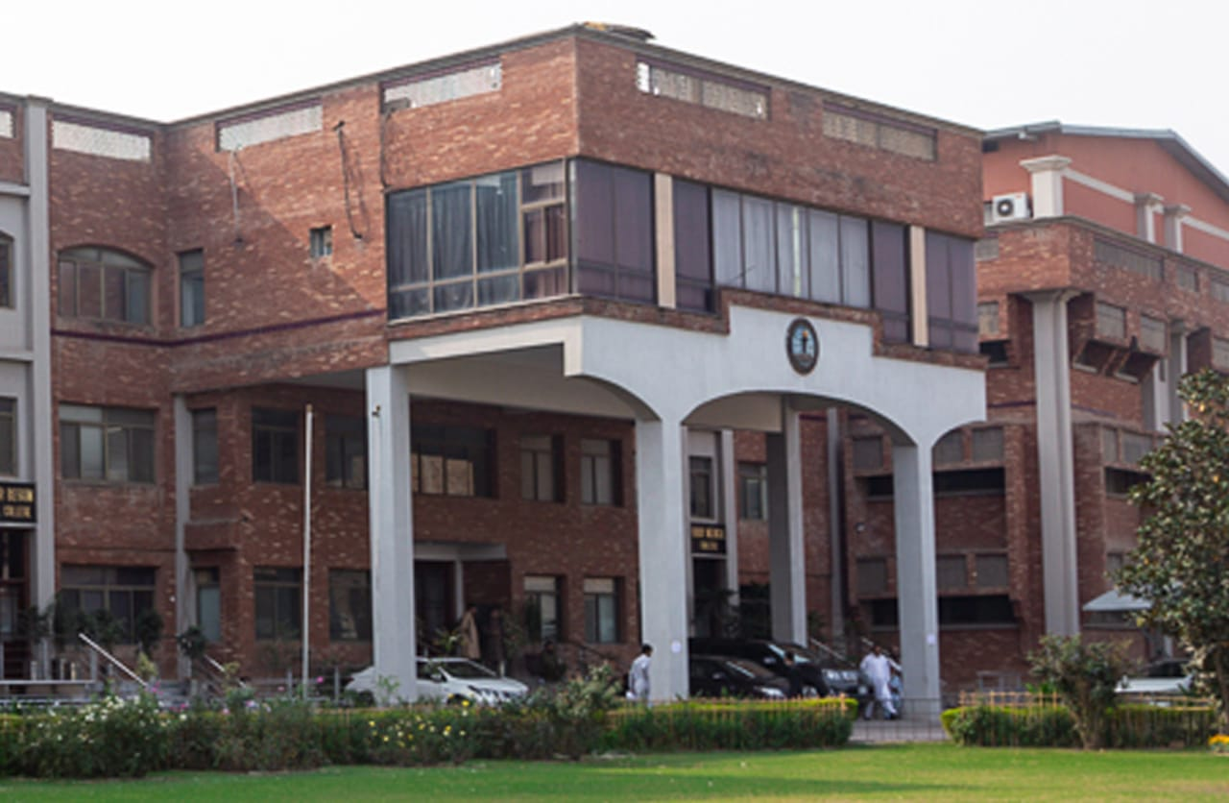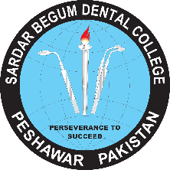**GANDHARA UNIVERSITY**

**SARDAR BEGUM DENTAL COLLEGE**

**URRICULUTHIRD YEAR BDS 2024 - 25**

**BLOCK – VIII**

**(MODULE XV & XVI)**

# FROM THE DESK OF PRINCIPAL

Health is a fast-evolving field and with new technologies taking over traditionally man-dominated fields like radiology and robotic surgical suites assisted by Artificial Intelligence and learning taking new dimensions with the help of Augmented Reality, we are indeed living in challenging times. Today's student of Medicine and Dentistry will be in the field a decade from now, up against a disease burden that is as varied as the next strain of the Covid-19 Virus and as complicated as the genetic characteristic of Oral Cancer, the largest cancer amongst both genders in Pakistan and at the same time as unpredictable as the recent Covid-19 Pandemic.  
It is therefore imperative that our curricula of the Medical and Dental Colleges be in tandem with the changing times with ability to evolve with time , measuring up to the challenges thrown at the field of healing from the ever-evolving diseases .  
  
These Student Guidebooks are reviewed every year with the same concept in mind that our future Physician and Dental Surgeon be ready for the challenges that lie ahead.  
  
In the end, I give you the same prayer as is mentioned in the Quran.

# See the source image

# 

# 

Prof. Shaheed Iqbal

BDS, MDS

Oral & Maxillofacial Surgery

Principal,

Sardar Begum Dental College,

Gandhara University

Peshawar.

I would like to welcome you to Block- VIII on behalf of the block team, As a part of the system-based curriculum, this block is an integrated presentation comprises system-based modules which links basic science knowledge to clinical problems. Integrated teaching means that subjects are presented as a meaningful whole. Students will be able to have a better understanding of basic sciences when they repeatedly learn in relation to clinical examples. early Exposure to clinics, wards for acquisition of skills and knowledge are characteristics of integrated teaching program.

Our mission is to provide all educational opportunities to our students therefore on completion of the BDS program graduate will possess an appropriate foundation of knowledge, skills, and attitudes to be well prepared to practice safely and effectively.

This study guide includes the course contents of the block-VIII. It includes the topics along with learning objectives, practical & assessment plan for the block exam.

As a director I will be meeting with the facilitators to receive the feedback and will try to resolve any difficulties or problems faced during the block. Please do not hesitate to contact DME for any academic help. I wish you an enjoyable and learning experience with the block-VIII.



**Director DME: Dr. Marina Khan**

|  |
| --- |
| **CONTENTS** |
| **Block Team** |
| **List of abbreviations…** |
| **Aims of the study guide…** |
| **Module distribution of 3rd year BDS** |
| **Introduction of Block VIII…** |
| **General Outcomes…** |
| **Leaning Methodologies…** |
| **Rules Regulations** |
| **Learning objectives & Course contents** |
| **Assessment…………………………………………………………………………………………….** |
| **Learning Resources………………………………………………………………………………** |

**MODULE TEAM**

|  |  |  |  |  |
| --- | --- | --- | --- | --- |
|  | **Dr. Marina Khan**  **Director**  **Department of Medical Education** | | [**marinakahn@hotmail.com**](mailto:marinakahn@hotmail.com) | |
| **DEPARTMENT OF PERIODONTOLOGY** | |  | | Associate Prof. Dr. Kawish Syed  Associate Prof. Dr. Afaq Farooq  Senior Registrar : Dr. Wajeeha |
| **DEPARTMENT OF ORAL MEDICINE** | |  | | Assistant Prof. Dr. Zafar Iqbal Ahmed  Assistant Prof. Dr. Zainab Shah  Dr. Maria Nizam |
| **DEPARTMENT OF GENERAL SURGERY** | |  | | Associate Prof. Dr. Azhar Shah |
| **DEPARTMENT OF ORAL PATHOLOGY** | |  | | Prof Dr Ahmad Shah  Associate Prof. Dr. Sofia Haider Durrani  Assistant Prof Dr. Sana Salam  Assistant Prof Dr Rabia |
| **DEPARTMENT OF GENERAL MEDICINE** | |  | | Assistant Prof Dr. Jibran Umar Ayub |
| **DEPARTMENT OF ORAL & MAXILLOFACIAL SURGERY** | |  | | Prof. Dr. Jawad Ahmad Kundi  Prof. Dr. Murad Ali Shah  Prof Dr. Shahid Khattak  Assistant Prof Dr. Fahad Qayam  Senior Registrar Dr. Zenia |
| **DEPARTMENT OF PROSTHETICS** | |  | | Prof Dr. Ali Chughtai  Prof Dr. Mariya Khalid  Assistant Prof Dr. Ehtisham  Dr. Jawwad |
| **DEPARTMENT OF OPERATIVE DENTISTRY** | |  | | Prof Dr. Shakeel Ur Rehman Khattak  Dr. Sajida  Dr. Asma |
| **DEPARTMENT OF MEDICAL EDUCATION** | |  | | Assistant Prof Dr. Syed Muhammad Junaid  Assistant Prof Dr. Aalia Zaib  Lecturer Dr. Usama Zeb |

**LIST OF ABBREVIATIONS**

|  |  |
| --- | --- |
| **IC** | Integrated Curriculum |
| **DME** | Department of Medical Education |
| MIT | Modes of Information Transfer |
| **O.Med** | Oral Medicine |
| **O. Patho** | Oral Pathology |
| **PROSTHO** | Prosthodontics |
| **PERIO** | Periodontology |
| **G.M** | General Medicine |
| **G. S** | General Surgery |
| **ENDO** | Endodontics/ Operative Dentistry |
| **OMFS** | Oral & Maxillofacial Surgery |
| **LGIS** | Large Group Interactive Session |
| **SDL** | Self-Directed Learning |
| **MCQ** | Multiple Choice Question |
| **SAQ** | Short Answer Question |
| **OSPE** | Objective Structured Practical Exam |
| OSCE | Objective Structured Clinical Evaluation |

**STUDY GUIDE:**

This study guidebook was designed by combining.

the efforts of all topics throughout the year to give dental students at Sardar Begum Dental College a resource material that highlights significant components of the curriculum. By providing students control over their learning, the study guide aims to promote self-regulated lifelong learning.

Regarding the course content, the study guide provides an overview of the topics, outcomes, and objectives. The assessment approach is also customized to the intuitional strategy.

A successful curriculum has a significant impact on the final product, as well as on society. This study guide was carefully designed with the PM&DC curriculum and rules in mind, and Gandhara University stakeholders and faculty o SBDC worked hard to personalize it to the needs of the students. They are further working to build, implement, and exercise a well-built curriculum considering changing demographic needs and disease prevalence in our society. Throughout the construction of the study guide, students' feedback was received and included. Curriculum is a living, dynamic entity that is constantly changing. With each passing day, we hope to improve it.

Each module in this block has been created to cater for the gap between basic and clinical subjects through pre-clinical learning. The block is divided into two modules in which the students are exposed to a variety of basic and clinical subjects. The integrated curriculum is enforced through interactive lectures, small group discussion along with rotations at preclinical laboratory.

**AIMS OF THE STUDY GUIDE**

It is an aid to:

* **Background pattern

  Description automatically generated**Inform students how student learning program of the BLOCK-wise module has been organized.
* Help students organize and manage their studies throughout the block.
* Guide students on assessment methods, rules, and regulations.
* Communicates information on organization and management of the block. This will help the student to contact the right person in case of any difficulty.
* Defines the objectives which are expected to be achieved at the end of the block.
* Identifies the learning strategies such as lectures, small group teachings, clinical skills, and demonstration, tutorial that will be implemented to achieve the block objectives.
* Provides a list of learning resources such as books, computer assisted learning programs, web- links, and journals, for students to consult to maximize their learning.
* Highlights information on the contribution of continuous and block examinations to the student’s overall performance.
* Includes information on the assessment methods that will be used to determine every student’s achievement of objectives.

**ORGANIZATION OF 3rd YEAR BDS CURRICULUM**

|  |  |  |  |  |  |  |  |  |  |
| --- | --- | --- | --- | --- | --- | --- | --- | --- | --- |
| **Block-VII** | | **Exam Block - 7** | **Block-VIII** | | **Exam Block - 8** | **Block- IX** | | **Exam Block - 9** | **Final Exam** |
| **Module**  **13**  **Oral diseases, etiology & mechanism** | **Module**  **14**  **Oral infections and inflammations** | **Module**  **15**  **Pre-malignant / Malignant Lesions & Salivary Gland disorders** | **Module**  **16**  **Systemic Diseases & Immune Mediated Disorders** | **Module**  **17**  **Bone Disorders** | **Module**  **18**  **Mucocutaneous Disorders** |

**BLOCK – VIII**

**PRE-MALIGNANT / MALIGNANT LESIONS , SALIVARY GLAND DISORDERS ,** **SYSTEMIC DISEASES & IMMUNE MEDIATED DISORDERS**

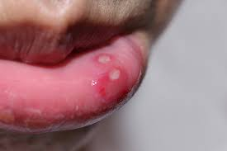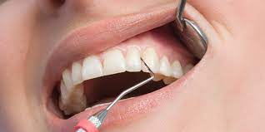

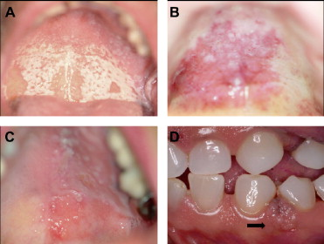**DEPARTMENT OF ORAL PATHOLOGY**

Oral pathology is a dental specialty that deals with the nature, etiology, basic pathological mechanisms, clinical presentation, histopathological evaluation, diagnosis, and treatment of diseases and disorders that affect the oral and maxillofacial region as well as craniofacial syndromes. The subject of Oral Pathology is aimed to provide a theoretical and practical knowledge of the fundamental concepts of pathological diseases of the oral cavity and orofacial soft and hard tissues for third year BDS students.

At the undergraduate level, oral pathology enables students to understand, recognize and identify disorders of the head and neck region. It includes disease diagnosis via clinical, radiographic, microscopic, biochemical, and other examinations, and patient treatment.

The laboratory of Oral Pathology is well-equipped, and the faculty and staff are fully skilled. Oral pathology is aimed to demonstrate a correlation between subjects in order to establish a deeper approach to studying the underlying concepts of each subject and applying them in clinical encounters in the BDS undergraduate program's future years.

**DEPARTMENT OF PERIODONTOLOGY**

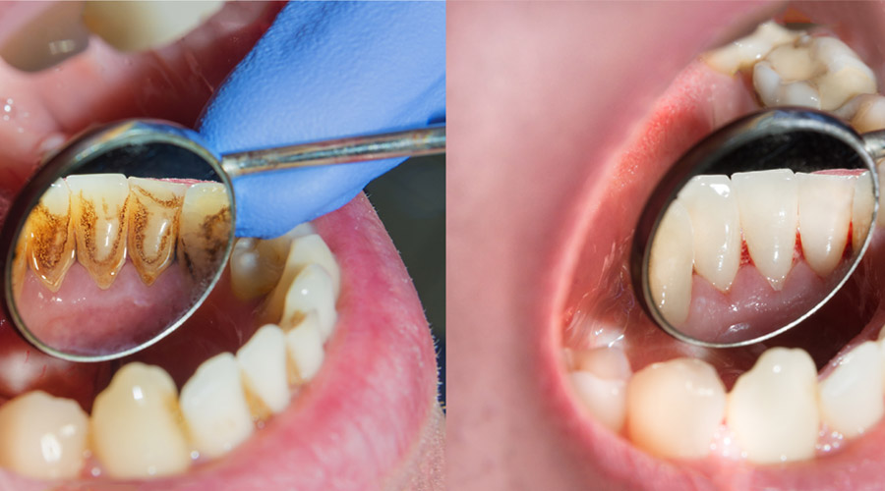Periodontology is a dental specialty that studies tooth supporting structures as well as diseases and conditions that affect them. The supporting tissues are known as the periodontium and is made up of the gingiva (gums), alveolar bone, cementum, and the periodontal ligament. Periodontology is designed to provide a thorough understanding of the basic principles of periodontal tissue origin, progression, and pathology, as well as the diagnosis and treatment of periodontal disease.

It is essential to provide our students with a broad and complete understanding of periodontology in order to prepare them for the issues they will confront as dentists. This will enable them to perform their professional tasks to a high quality.

The department of periodontology at Sardar Begum Dental College, specializes in diseases of the periodontium, which includes the gums, alveolar bone, and periodontal ligament. Patients with gum and periodontal disorders, as well as those with oral problems, are treated and monitored in the periodontology department.

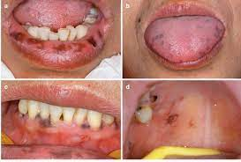

**DEPARTMENT OF ORAL MEDICINE**

Oral medicine is a branch of dentistry that focuses on the diagnosis, investigation, and non-surgical treatment of disorders affecting the oral, perioral structures (such as orofacial pain, oral manifestations of systemic diseases, salivary gland disorders) and medically compromised patients with oral health issues.

The course content in the subject of Oral Medicine at Sardar Begum and Dental College is designed to provide students with extensive diagnostic and therapeutic skills in the diagnosis and nonsurgical treatment of oral and perioral diseases, temporomandibular joint disorders as well as the management of systemic diseases that have a significant impact on oral health. Students will learn how to take a detailed medical history, conduct a thorough physical examination, advise appropriate investigations, and develop a diagnosis and treatment plan.

The overall objective of this subject at the undergraduate level is to emphasize the importance of dental students in obtaining medical and dental histories and doing a full head and neck as well as oral examination is to provide patients with adequate and safe dental care.

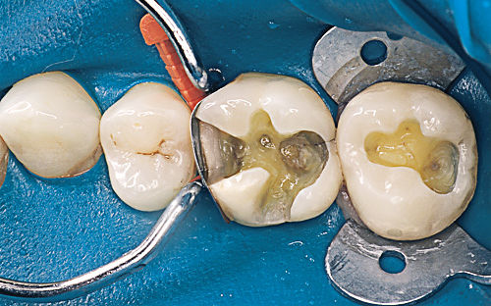**DEPARTMENT OF OPERATIVE DENTISTRY**

Operative dentistry is the practice of restoring normal structure, function, health, and aesthetics of teeth that have been damaged by disease, trauma, wear, or abnormal development. The practice of dentistry in this area requires a wide range of knowledge, from diagnosis, disease processes and prevention, and minimally invasive clinical approaches; to biomaterials and other dental science disciplines as they apply to this distinct and unique interest area limited to the hard calcified tissues of the oral cavity.

The objective of this session is to give basic knowledge of operative instruments, dental terms, principles of cavity preparations, and fundamentals of tooth restorations. The course's major objectives are to introduce students to theoretical topics and to improve their manual dexterity. The use of a hand piece (dental drill) to learn and practice these skills begins during orientation and continues throughout the academic year. During the clerkship programme the students will learn how to assess patient caries risk and implement caries prevention strategies, as well as how to remove or treat carious tooth tissue using techniques that preserve pulp vitality and restore the tooth to form, function, and aesthetics with appropriate materials, as well as how to prevent hard tissue disease and promote soft tissue health.

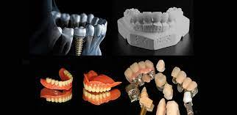

**DEPARTMENT OF PROSTHODONTICS**

Prosthodontic dentistry is a branch of dentistry concerned with the restoration and maintenance of a patient's oral functions, comfort, aesthetics, and health by restoring teeth and/or replacing missing structures with removable and fixed dental prosthesis (artificial prosthesis). this branch of dentistry is one of the most difficult and challenging subjects as it includes both clinical and practical/laboratory work. The main goal of this course is to offer students with the essential information and hands-on experience in complete dentures, partial dentures, crowns, and bridges so that they can become future general dental care professionals.

The department of prosthodontics at SBDC, treats patients with removable complete and partial dentures, fixed prostheses, maxillofacial prostheses, and temporary mandibular problems management. Third year BDS students during their clerkship programme will be taught to design and fabricate removable partial dentures for patients.

**DEPARTMENT OF ORAL & MAXILLOFACIAL SURGERY**

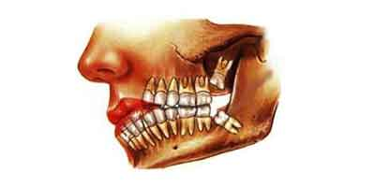Oral surgery is a specialty that deals with the diagnosis and treatment of the pathologies of jaw and oral cavity, that requires surgical intervention. Although tooth extraction is the most common surgery performed by oral surgeons, there is a broad scope to the specialty. This includes managing hard and soft tissue pathologies, oral infections, dentoalveolar trauma, and orofacial pain, as well as providing orthodontic surgery and Osseo integrated implant placement.

**DEPARTMENT OF GENERAL MEDICINE**

General medicine is a course taught at the undergraduate level that allows students to learn clinical medicine and apply their knowledge in clinical dental practice.

The Department of General Medicine contains the following facilities and students will be taught in detail about the relevant subjects: Cardiology, Infectious diseases, Gastro enterology, Hepatology, Nephrology, Pulmonology, Rheumatology, Hematology Dermatology, Psychiatry.

The course is aimed to provide students a touch of the primary areas of General Medicine while remaining mindful of the BDS curriculum's limits and time constraints. This practice will ensure patient safety and provide a better knowledge of the disease's correlation to other dental diseases. For improved learning, the practical component of the course includes structured ward rotations and patient interaction.

**DEPARTMENT OF GENERAL SURGERY**

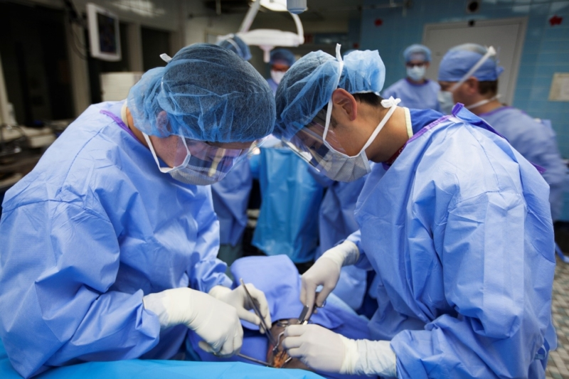General surgery is the science and practice of using operative procedures to treat injury, deformity, and disease. When medication alone is unlikely to relieve discomfort, general surgery is routinely performed. Surgical operational procedures can range from simple procedures conducted in a doctor's office to more complex operations requiring the assistance of a medical team in a hospital setting.

BDS 3rd year Surgery rotation is an essential component of the clerkship curriculum as a student is practically exposed to surgical approaches, its complications and management. The overall purpose of this programme is to educate future dental surgeons to diagnose and manage common surgical problems. Students will rotate through the outpatient department, surgical wards, and operating rooms to learn the fundamentals of clinical reasoning to gain the clinical and procedural skills they require.

**GENERAL OUTCOMES:**

By the end of this block the students of 3rd year BDS will be able to

**KNOWLEDGE:**

1. Describe & classify different types of cysts.
2. Explain clinical, macroscopic as well as microscopic features of the tumor.
3. Classify various types of gingival enlargement & discuss its clinical features and management.
4. Enlist clinical conditions that can cause desquamative gingivitis & discuss their periodontal management.
5. Explain the Clinical features & Conditions Causing Acute Abdomen.
6. Explain the diagnosis & management of Hydatid cyst.
7. Describe acute and chronic cholecystitis its Investigations and Management
8. Describe the Classification & Management of Liver Abscess.
9. Describe the classification, Types, Staging, Investigations, General principles of management of carcinoma of oral cavity / buccal mucosa / tongue / lip.
10. Describe & classify the outline principle of management of cleft lip palate.
11. Explain the clinical presentation and management of GERD, Barret’s esophagus, achalasia, and hiatal hernia
12. Enumerate the causes of esophageal CA, Explain its clinical presentation, diagnosis, and management.
13. Define and classify peptic ulcer / gastritis, enumerate its causes & explain its clinical presentation, diagnosis, and management.
14. Explain the administration of local anesthetics and identify the management of common complications that can occur.
15. Describe the microbial causation of apical periodontitis.
16. Describe the routes and different types of root canal infection.
17. Define acrylic removeable partial denture, enlist its parts & types of acrylic removeable partial denture and explain the principles in designing acrylic removeable partial denture

**ATTITUDE:**

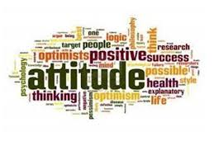

1. Follow the basic laboratory protocols.
2. Participate in class and practical work efficiently.
3. Maintain discipline of the college.
4. Follow the norms of the college properly.
5. Communicate effectively in a team with colleagues and teachers.
6. Demonstrate professionalism and ethical values in dealing with patients, cadavers,

colleagues, and teachers.

1. Communicate effectively in a team with colleagues and teachers.
2. Demonstrate the ability to reflect on the performance.

**LEARNING METHODOLOGIES**

The following teaching / learning methods are used to promote better understanding:

* Interactive Lectures
* Small Group Discussion
* Practical
* Skills session
* E-Learning
* Self-Directed Learning

**LARGE GROUP INTERACTIVE LECTURES (LGIS)**

In large group, the lecturer introduces a topic or common clinical conditions and explains the underlying phenomena through questions, pictures, videos of patients' interviews, exercises, etc. Students are actively involved in the learning process.

**SMALL GROUP DISCUSSIONS (SGDs):**

This format helps students to clarify concepts acquire skills or attitudes. Sessions are structured with the help of specific exercises such as patient case, interviews, or discussion topics. Students exchange opinions and apply knowledge gained from lectures, tutorials, and self-study. The facilitator role is

to ask probing questions, summarize, or rephrase to help clarify concepts.

**SELF DIRECTED LEARNING SDL:**

Students assume responsibilities of their own learning through individual study, sharing and discussing with peers, seeking information from Learning Resource Center, teachers, and resource persons within and outside the college. Students can utilize the time within the college scheduled hours of self-study.

**E-LEARNING:**

E-Learning is a strategy by which learning occurs through the utilization of electronic media, typically the Internet. The basic aspects of medical professionalism and ethics will be addressed through an e-learning course.

1. **Hands on Training**
2. **Oral Pathology, Oral Medicine lab sessions:**

Oral Pathology practical will demonstrate your skills and help in clarifying your concepts practically.

1. **Clinical hands on & Ward Rotation**

Practice of clinical examination on patients in Periodontology, oral medicine, General Medicine, General Surgery, Operative dentistry, Prosthodontics, Oral and maxillofacial surgery wards.

**RULES AND REGULATIONS**

We will be making the journey through the Block VIII in 13 weeks. Therefore, this course includes an intensive coursework load. Class attendance and participation are extremely important to your learning and are considered in the evaluation of the course grade. If there is anything that the block team can do to assist during the course, please feel free to contact DME or concerned department. Attendance will be monitored during the different teaching activities. If the attendance is less than 75%, the student will be not allowed to sit for both block and annual examination.

All examinations must be taken on the date scheduled. Once the exam starts the student will not be allowed to enter the examination Hall. There will be a block exam at the end of each block and each block will cover two modules. There will be a total of 3 block examination and the 30% weightage of these block exam will be added to the 70 % of the annual professional exam as an internal assessment.

**MODULE – XV**

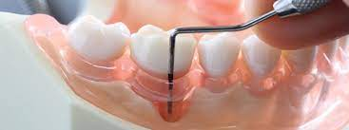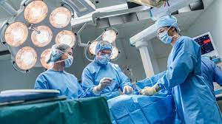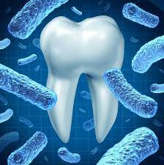 **PRE-MALIGNANT / MALIGNANT LESIONS & SALIVARY GLAND DISORDERS**

**LEARNING OBJECTIVES & COURSE CONTENTS**

At the end of the teaching session the student of 3rd year BDS will be able to achieve the following objectives

|  |  |  |
| --- | --- | --- |
| **ORAL PATHOLOGY LECTURES** | | |
| **S.NO** | **TOPICS** | **LEARNING OBJECTIVES** |
|  | Introduction and classification of cyst  **Odontogenic cysts**   * Classification (odontogenic inflammatory and developmental cyst) * Radicular cyst * Dentigerous Cyst * Odontogenic Keratocyst and NBCC associated with keratocyst   **Non-odontogenic cysts**   * Nasoalveolar * Nasopalatine duct cyst * Idiopathic stafne’s bony cystic cavity * Traumatic cyst * **Non-epithelial (pseudo) cysts** * **Soft tissues cysts and congenital cysts** | * Define and classify the cystic lesion * Describe the signs and symptoms of cyst * Describe the pathogenicity clinical, radiological, histological features of radiological cyst. * Discuss the pathogenicity expansion, clinical, radiological, and histological features of dentigerous cyst. * Discuss the pathogenicity expansion, clinical, radiological, and histological features and manifestations of nbcc associated with keratocyst. * Discuss the pathogenicity expansion, clinical, radiological, and histological features of non-odontogenic cysts. * Discuss the pathological, clinical, radiological and histological features of non- epithelial (pseudo) cysts. * Discuss the clinical, radiological, and histological features of soft tissues cyst and congenital cysts. |
|  | **Epulides**   * Epulis * Fibrous Epulis * Vascular Epulis * Pregnancy Epulis * 5.Peripheral Giant Cell Granuloma * Fibroepithelial Polyp * Denture Irritational Hyperlasia * 7.Papillary Hyperplasia of Palate | * Distinguish between the types of Epulides and diagnose them clinically and under the microscope.   By the end of this lecture students should be able to distinguish between the mentioned lesions and diagnose them clinically and under the microscope. |
|  | **Salivary Gland Diseases (Tumors)**   * Normal salivary gland structure * Classification of salivary gland tumors * Pleomorphic adenoma * Warthins tumor * Oncocytoma * Canalicular adenomas * Basal cell adenomas * Ductal papillomas * Mucoepidermoid carcinoma * Acinic cell carcinoma * Adenoid cystic carcinoma * Polymorphous low grade adenocarcinoma * Carcinoma ex pleomorphic adenoma | * diagnose the mentioned lesions by correlating clinical and histopathological features. * diagnose these lesions if presenting in OPD on basis of the knowledge obtained.   . |

|  |  |  |
| --- | --- | --- |
| **PERIODONTOLOGY LECTURES** | | |
| **S.NO** | **TOPICS** | **LEARNING OBJECTIVES** |
| **1** | Gingival enlargement | Classify various types of gingival enlargement  Discuss clinical features and management of gingival enlargement |
| **2** | Desquamative gingivitis | Enlist clinical conditions that can cause desquamative gingivitis  Discuss their periodontal management |

|  |  |  |
| --- | --- | --- |
| **GENERAL SURGERY LECTURES** | | |
| **S.NO** | **TOPICS** | **LEARNING OBJECTIVES** |
| ***1*** | Causing Acute  Abdomen | * Describe the conditions causing acute abdomen. * Explain the Clinical features & * Management of acute abdomen |
| ***2*** | Hydatid cyst | * Explain the Diagnosis of Hydatid cyst * Explain the Management of Hydatid cyst |
| ***3*** | Cholelithiasis and its  Complications  Acute and chronic cholecystitis | * Explain the Investigations and Management of Cholelithiasis |
| ***4*** | Liver Abscess | * Enlist and describe the Classification & * Management of liver abscess |
| ***5*** | Carcinoma of buccal mucosa | * Describe the Classification Carcinoma of buccal mucosa * Enlist the Types Carcinoma of buccal mucosa * Describe the Staging, Investigations & * General principles of management of Carcinoma of buccal mucosa |
| **6** | Premalignant conditions.  Carcinoma of Oral cavity | * Describe the Classification Carcinoma of Oral cavity * Enlist the Types of Carcinomas of Oral cavity * Describe the Staging of Carcinoma of Oral cavity * Explain the Investigations of Carcinoma of Oral cavity * Enlist and explain the General principles of management Carcinoma of Oral cavity |
| **7** | Carcinoma of lip | * Describe the Classification Carcinoma of lip * Describe the Staging, Investigations & * General principles of management of Carcinoma of lip |
| **8** | Carcinoma of tongue | * Enlist &Describe the Classification of tongue * Enlist the Types Carcinoma of tongue * Describe the Staging, Investigations & * General principles of management of Carcinoma of   tongue |
| **9** | Cleft lip & palate | * Classify and outline principle of management of cleft lip palate. |
| **10** | Salivary glands  (Inflammation,  Calculus, Tumors) | * Enlist the Types of salivary glands * Classify and explain the Abnormalities of salivary glands * Explain the Clinical features & * Management of salivary gland tumors |

|  |  |  |
| --- | --- | --- |
| **GENERAL MEDICINE LECTURES** | | |
| **S.NO** | **TOPICS** | **LEARNING OBJECTIVES** |
|  | **Benign esophageal diseases**   * GERD. * Barret’s Esophagus. * Hiatal Hernia. * Achalasia | 1-Enumerate benign esophageal diseases  2-Explain clinical presentation and management of GERD, Barret’s esophagus, achalasia, and hiatal hernia |
|  | Esophageal carcinoma | 1-Enumerate the causes of esophageal CA  2-Explain its clinical presentation, diagnosis, and management.  . |
|  | Peptic ulcer/Gastritis | 1-Define and classify peptic ulcer.  2- Enumerate its causes.  3- Explain its clinical presentation, diagnosis, and management.  4-Define and classify gastritis.  2- Enumerate its causes.  5- Explain its clinical presentation, diagnosis, and management |
|  | Gastric Carcinoma | 1-Define and classify gastric CA.  2- Enumerate its causes.  3- Explain its clinical presentation, diagnosis, and management |
|  | Irritated bowel syndrome | * Define IBS and its types * Describe clinical presentations of IBS   Explain its diagnosis (Rome’s criteria) and management |
|  | Malabsorption syndrome | * Define malabsorption syndrome and its types * Explain the clinical presentation, diagnosis, and management of celiac disease.   Explain the clinical presentation, diagnosis, and management of Whipple’s disease |
|  | Colorectal carcinoma | * Classify Colorectal Ca (Dukes Classification)   Explain the clinical presentation and management of colorectal Ca. |
|  | Hepatitis & chronic hepatitis | * Define hepatitis. * Explain presentation of acute hepatitis. * Explain its management   Explain presentation & management of chronic hepatitis. |
|  | Liver cirrhosis | * Define liver cirrhosis and enumerate its causes * Explain presentation of liver cirrhosis.   Explain its Management and indications for liver transplant |
|  | Wilson disease& Haemochromatosis | * Explain the clinical presentation and management of Wilson Disease.   Explain the clinical presentation and management of Haemochromatosis. |
|  | Inflammatory Bowel syndrome | * Define IBD and its types * Describe clinical presentations and differences between Crohn’s Disease and Ulcerative Colitis * Explain its diagnosis and management |
|  | Upper GI bleeds | * Enumerate the causes of Upper GI bleed.   Construct the management plan of upper Gastrointestinal bleed. |

|  |  |  |
| --- | --- | --- |
| **ORAL MEDICINE LECTURES** | | |
| **S.NO** | **TOPICS** | **LEARNING OBJECTIVES** |
| **1** | Gastrointestinal diseases | 1. Identify oral manifestations of celiac, Crohn’s diseases and GORD.  2. Describe celiac, Crohn’s, OFG and GORD.  3. Management |
| **2** | Precancerous lesions & conditions oral carcinoma & carcinogenesis | 1. Define precancerous lesion and condition by giving examples. 2. Explain PMDs (Premalignant diseases) 3. Discuss the etiology of oral cancer 4. Clinical features and diagnosis of oral cancer 5. Staging system for oral carcinoma 6. What are the factors which determine the risk in PMDs? 7. Treatment of PMDs. 8. Prevention of oral cancer   Management of patient on Chemo and Radiotherapy |
| **3** | Diseases of lips & tongue  (Disturbance of taste, and  Halitosis) | 1. Enlist classifications & D/Ds of lip swellings 2. Establish diagnosis of lip diseases and initiate proper treatment. 3. Enumerate various disorders of tongue. 4. Identify tongue disorder and its diagnosis and treatment 5. Investigate the cause of taste disturbance and halitosis and its treatment.   Enlist classifications & D/Ds of lip swellings |
| **4** | Salivary glands | 1. Enumerate the major and minor salivary glands, its secretions and functions 2. Describe the salivary gland diseases and establish diagnosis. 3. Determine the causes of disturbance of salivary flow and its management.   Salivary gland examination and its flow from ducts. |

|  |  |  |
| --- | --- | --- |
| **PROSTHODONTICS LECTURES** | | |
| **S.NO** | **TOPICS** | **LEARNING OBJECTIVES** |
| **1** | Dental Surveying | Define dental surveyor.  Describe the purpose of surveying.  Enlist the types and parts of dental surveyor.  Explain the use of dental surveying during designing the prosthesis. |
| **2** | Designing acrylic removeable partial denture | Define acrylic removeable partial denture.  Enlist the types of acrylic removeable partial denture.  Enlist the parts of acrylic removeable partial denture.  Enlist and explain the principles in designing acrylic removeable partial denture |

|  |  |  |
| --- | --- | --- |
| **OPERATIVE DENTISTRY LECTURES** | | |
| **S.NO** | **TOPICS** | **LEARNING OBJECTIVES** |
| **1** | Matrix Systems and wedging techniques | a. Describe various types of matrix systems.  b. Explain the clinical technique for toffelmire matrix band  c. Define wedge  d. Enlist different types of wedging techniques |
| **2** | Introduction of Endodontics | a. Define endodontics  b. Explain the various treatment modalities under endodontics |
| **3** | Indications of Root Canal Treatment | a. Describe the indications for root canal treatment  b. Explain the process of selection of tooth for root canal treatment  c. Enlist the contraindication for root canal treatment |

|  |  |  |
| --- | --- | --- |
| **ORAL & MAXILLOFACIAL SURGERY LECTURES** | | |
| **S.NO** | **TOPICS** | **LEARNING OBJECTIVES** |
| **1** | Types & composition of local anesthesia | Identify & describe the different type of local anesthetics agents working & composition.  Understand how local anesthetics work.  Know the potency, speed of onset & duration of action of common agents |
| **2** | Armamentarium of local anesthesia | Identify the armamentarium required for effective delivery of local anesthesia in dentistry. |
| **3** | Techniques of regional anesthesia in dentistry | Identify the safe dosages of common local anesthetic drugs.  Administer local anesthesia in maxilla & mandibular regions safely & effectively by different techniques. |
| **4** | Complications of local anesthesia | Describe & identify the different reasons for failure of anesthesia.  Identify & manage common complications that can occur. |

**MODULE – XVI**

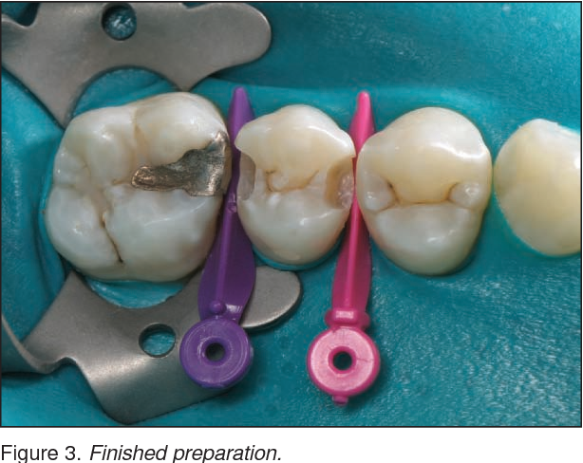**SYSTEMIC DISEASES &**

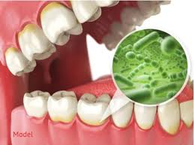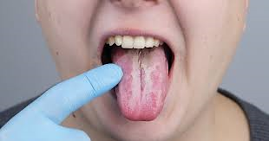**IMMUNE MEDIATED DISORDERS**

|  |  |  |
| --- | --- | --- |
| **GENERAL MEDICINE LECTURES** | | |
| **S.NO** | **TOPICS** | **LEARNING OBJECTIVES** |
|  | Arrythmias | 1-Classify Arrhythmias’ and heart blocks.  2-Explain the etiology and management of atrial fibrillation.  3-Explain Ventricular arrhythmias and their management. |
|  | Congestive heart failure | 1-Define congestive heart failure  2-Enumerate the causes of heart failure.  3-Briefly Explain the clinical presentation and its management. |
|  | Pericarditis/Myocarditis | 1-Define pericarditis and myocarditis.  2-Enumerate its causes.  3- Explain briefly the clinical presentation and their management. |
|  | Rheumatic Heart Diseases | 1. Enlist Rheumatic Heart Diseases.   Describe briefly their clinical presentations and management |
|  | ACS | 1. Define ACS and its types. 2. Describe clinical presentations of MI and diagnostic tests. 3. Enlist the complications of acute MI.   Differentiate between STEMI&STEMI |
|  | Cardiomyopathies | * Define and classify cardiomyopathies.   Explain the clinical presentation and management of hypertrophic cardiomyopathy. |
|  | Anemia  Hemolytic Anemia | * Define Anemia * Classify different types of anemia * Define Hemolytic Anemia. * Classify the different types of hemolytic anemia.   Describe the clinical presentation, Diagnosis, and management of hemolytic anemia. |
|  | Iron Deficiency Anemia  Megaloblastic Anemia | * Describe the clinical presentation & management of Iron Deficiency Anemia   Describe the clinical presentation, diagnosis & management of Megaloblastic Anemia |
|  | Myelodysplastic Syndrome | * Define Myelodysplastic Syndrome   Describe the clinical presentation, diagnosis & management of Megaloblastic Anemia |
|  | Lymphoproliferative disorders | * Classify Lymphoproliferative disorders. * Discuss the clinical presentation, diagnosis, and management of chronic lymphocytic leukemia |
|  | Myeloproliferative disorders | * Classify Myeloproliferative disorders * Discuss the clinical presentation, diagnosis, and management of chronic myeloid leukemia |
|  | Idiopathic thrombocytopenia purpura | Discuss the clinical presentation, diagnosis, and management of Idiopathic thrombocytopenia purpura |
|  | Hodgkin & Non-Hodgkin  Lymphoma | * Define and classify Hodgkin & Non-Hodgkin Lymphoma.   Discuss their clinical presentation, diagnosis, and management |
|  | Parkinson disease  Motor Neuron Disease | * Define Parkinson’s Disease * Enumerate the causes * briefly Explain the clinical presentation and its management. * Construct a management plan for patient of Parkinson * 1-Define MND * 2-Explain its types   Briefly Explain the clinical presentation and its management |
|  | Stroke. CVAs | 1-Define and classify CVAs  2-Explain the etiology and clinical presentation of stoke.  3-Construct the management plan for a patient of CVA. |
|  | Epilepsy | * Define epilepsy and its types. * Explain the clinical presentation and management of epilepsy including status epilepticus |
|  | Multiple Sclerosis | * Define Multiple Sclerosis * Enumerate the causes and types   Briefly Explain the clinical presentation and their management. |
|  | Bells Palsy’s (Facial Nerve)  Myasthenia Gravis | * Enumerate the causes of facial nerve palsy. * Explain the clinical presentation and management of facial nerve palsy * Define Myasthenia Gravis. * Explain its path physiology and clinical presentation.   Explain its management. |
|  | Peripheral neuropathy | * Define peripheral neuropathy and enumerate its causes. * Describe clinical presentations of peripheral neuropathy   Explain its management. |
|  | Meningitis | * Define meningitis and enumerate its causes. * Explain the clinical presentation and management of meningitis. |

|  |  |  |
| --- | --- | --- |
| **ORAL MEDICINE LECTURES** | | |
| **S.NO** | **TOPICS** | **LEARNING OBJECTIVES** |
| **1** | Blood & nutrition  (Endocrine disturbances, and renal diseases Bleeding disorders and patient on anticoagulant therapy) | 1. Enlist hereditary and acquired bleeding hemorrhagic disorders.  2. Diagnosis of each bleeding disorder on result of blood tests.  3. Enumerate causes of post extraction prolong bleeding.  4. Describe anemia and its oral signs  5. Describe leukemia and its oral effects  6. Describe thrombocytopenia and its oral effects  7. Interpretation of various blood tests and their values  8. Identify nutritional and vitamins deficiency and their oral manifestations.  9. Identify Endocrine problems and their oral manifestation.  10. Identify oral signs and symptoms of chronic renal failure and renal transplant patient  11. Management of transplant pt for extraction  12. Hereditary and acquired bleeding disorders  13. Hemostasis  14. Lab tests to assess bleeding disorders patient and their diagnosis  15. Common anticoagulant medication and management of patient on these medications |
| **2** | Immunodeficiency, Hypersensitivity, Autoimmunity & oral reactions to drug therapy | 1. Explain primary and secondary immunodeficiencies, hypersensitivity, angioedema, and autoimmunity.  2. Summarize the effects of immunosuppression in oral cavity.  3. Discuss and identify the adverse oral reactions to drug therapy  4. How to deal and manage with immunosuppressed patient. |
| **3** | Facial Pain & neurological disturbances | 1. Define pain and classification of facial pain.  2. Describe characteristics of odontogenic and neuralgic pain  3. Compare pulpal and periodontal pain.  4. Differentiate between odontogenic, neuralgic.  5. Evaluate patient of facial pain and establish diagnosis and initiate treatment.  6. Diagnose Neuropathic pain (trigeminal neuralgia), glossopharyngeal & post herpetic neuralgia &pain secondary to other  7. Describe bell’s palsy, anesthesia and paresthesia of trigeminal nerve, multiple sclerosis.  8. Atypical facial pain and management  9. Burning mouth syndrome and management.  10. Atypical odontalgia  11. Describe different types of headaches and D/Diagnosis  12. Examination of facial and trigeminal nerve.  13. Triple syringe air blowing test  14. Percussion test  15. Mobility test  16. Examination of maxillary sinus |

|  |  |  |
| --- | --- | --- |
| **ORAL PATHOLOGY LECTURES** | | |
| **S.NO** | **TOPICS** | **LEARNING OBJECTIVES** |
| **1** | **Granulomatous diseases**   * Foreign body granulomas * Chronic granulomatous diseases * Orofacial granulomatosis * Tuberculosis * Sarcoidosis * Wegner’s granulomatosis * Langerhans cell histiocytosis | * Types of granulomatous diseases * classifications, etiology, different tests for diagnosis, pathogenesis, clinical features and final diagnosis clinically as well as microscopically.   distinguish between the mentioned granulomatous diseases and diagnose them clinically as well as under the microscope |
| **2** | * **Immune Mediated Disorders**   1.Recurrent aphthous stomatitis.  a.Associated systemic conditions  b.Aphthous Minor  c.Aphthous Major  d.Herpetiform Ulcers  e.Behcets syndrome  2.Lichen Planus  3. Lichenoid reactions  4. Mucous membrane Pemphigoid  5. Pemphigus Vulgaris  6. Erythema Multiforme  7. Lupus erythematosus  8. Progressive systemic sclerosis   * **Possible immune mediated reactions**   1.Cheilitis glandularis  2.Orofacial granulomatosis | * describe any associated systemic conditions and be able to clinically and histopathologicallly. * identify minor aphthous ulcers based on information provided. * detailed knowledge of etiology, pathogenesis, clinical, histopathological features & diagnosis of lichen planus and lichenoid reactions. * differentiate accurately clinically & histopathologically between all above mentioned   . |

|  |  |  |
| --- | --- | --- |
| **PERIODONTOLOGY LECTURES** | | |
| **S.NO** | **TOPICS** | **LEARNING OBJECTIVES** |
| **1** | Periodontal manifestations of systemic diseases | Discuss systemic conditions that influence periodontium and know clinical features peculiar to each. |

|  |  |  |
| --- | --- | --- |
| **GENERAL SURGERY LECTURES** | | |
| **S.NO** | **TOPICS** | **LEARNING OBJECTIVES** |
|  | Varicose veins | Define varicose veins.  Enlist & describe the Types, Anatomy,  Clinical examination &  Management of varicose veins |
|  | Deep venous  thrombosis | Enlist and describe the Causes, clinical feature,  investigations and treatment of Deep venous  thrombosis |
|  | Chest Trauma  (Flail chest  Pneumothorax  Hemothorax  Surgical emphysema) | Explain the Main aims of resuscitation.  Assessment of injury  Treatment |
|  | Neck Swelling |  |
|  | Blood products and  Blood transfusion | Discuss various types of blood products.  Discuss the protocols of blood transfusion - Elaborate principles of blood transfusion of a surgical patient. |
|  | Neck Trauma |  |
|  | Arterial and Venous Ulcer |  |
|  | General Anesthesia | Differentiate between different techniques of anesthesia and airway maintenance.  - Elaborate the methods of  providing pain relief |
|  | Regional & Spinal Anesthesia | Discuss the local and regional anesthesia.  -Choose appropriate type of anesthesia for various surgical procedures  - pre-anesthesia workup required for regional/spinal anesthesia  - list the complications from regional/spinal anesthesia |

|  |  |  |
| --- | --- | --- |
| **PROSTHODONTIC LECTURES** | | |
| **S.NO** | **TOPICS** | **LEARNING OBJECTIVES** |
| **1** | Retentive Components | Differentiate between types of retentive components which can be utilized for retention in RPD. |

|  |  |  |
| --- | --- | --- |
| 3 | **Nutrition**  Different types,  Enteral feeding (Oral, gastrostomy, jejunotomy) Different modes of enteral feeding Its Advantages and Complications  - Parenteral nutrition  Advantages and its complications –  -Malnutrition in surgical patients - Definition - Assessment - Lab diagnosis - Correction of malnutrition.  Anthropometric measurements | List the physiological effects of malnutrition.  - Identify the different types of nutritional support  – oral, nasogastric, gastro/jejunotomy and parenteral.  - Describe what total parenteral nutrition (TPN) entails, its associated risks, and the additional and parameters of care for these patients. |

|  |  |  |
| --- | --- | --- |
| **OPERATIVE LECTURES** | | |
| **S.NO** | **TOPICS** | **LEARNING OBJECTIVES** |
| **1** | Diagnosis | a. Describe the steps of diagnosis of the tooth  b. Enlist various methods of pulp testing  c. Explain the newer methods of pulp vitality testing |

**ASSESSMENT METHODS FOR BLOCK EXAM:**

Evaluation is a continuous process comprising of block examination and annual university examination. Students will be evaluated throughout the year. The internal assessment will contribute towards the ﬁnal examination scores.

Multiple examination methods including MCQs, SAQs, OSPE and viva will be used. In line with PMC stipulation, the pass/fail marks for the test and examination will be 50%.

There will be a block exam at the end of each block.

**Theory (knowledge)**: MCQs (Multiple Choice Questions) and SAQs (Short Answer Questions) are used to assess the theory part for the block exam.

**MCQ:**

* + - * A MCQ has a statement or clinical scenario followed by four options (likely answers).
      * After reading the statement/scenario student select ONE, the most appropriate answer/response from the given list of options.
      * Correct answer carries one mark, and incorrect ‘zero mark’. There is NO negative marking.

**SAQ:**

SAQ are open ended questions that requires students to create an answer. They are commonly used in examinations to access the basic knowledge and understanding of a topic.

**THEORY**

|  |  |  |  |  |
| --- | --- | --- | --- | --- |
| **CLASS ROLL NO** | **BLOCK – (----)** | | | **TOTAL** |
| **MCQs** | **SAQs** | **TOTAL** | **PERCENTAGE** |
|  | **21** | **09** | **30** | **5%** |
| **21 MCQs each subject** | **4 SAQs out of which One is optional i.e., to be attempted 3 SAQs.**  **Each SAQ carries 3 marks.**  **3 x 3 = 09** |  | **MARKS OBTAINED / 30 X 5** |
|  |  |
|  |  |
|  |  |
|  |  |
|  |  |
|  |  |
|  |  |
|  |  |
|  |  |
|  |  |
|  |  |

**PRACTICAL**

|  |  |  |  |  |  |  |  |
| --- | --- | --- | --- | --- | --- | --- | --- |
| **CLASS ROLL NO** | **BLOCK: VII,VIII, IX** | | | | **BEHAVIOR** | **ATTENDANCE** | **TOTAL**  **(CONTRIBUTION IN FINAL PROF EXAM)** |
| **COMBINED 15%** | | | | **3%** | **2%** | **20%** |
| **OSPE** | **VIVA** | **LOGBOOK** | **TOTAL** | **No misbehave or written warning = 3**  **Written warning given to student = 0** | **Obtained Attendance % /100 x 2** |  |
|  | **15 OSPE STATIONS (4 MARKS EACH)**  **= 60 MARKS** | **3 OSPE STATIONS (15 MARKS EACH)**  **= 45 MARKS** | **15 MARKS**  **Complete**  **& timely signed = 15**  **Complete but late submission = 10**  **Incomplete logbook = 5**  **No logbook = 0** | **120 TOTAL MARKS**  **OBTAINED MARKS / 120 X 15**  **= __%** |  |
|  |  |
|  |  |
|  |  |
|  |  |
|  |  |
|  |  |
|  |  |

|  |  |
| --- | --- |
| **LEARNING RESOURCES** | |
| **SUBJECT** | **RESOURCES** |
| **GENERAL SURGERY** | **TEXTBOOKS:**   1. Manipal textbook of surgery by Rajagopal Shenoy   **REFERENCE BOOKS:**   1. Bailey & Love’s short practice of surgery by Hamilton bailey. |
| **GENERAL MEDICINE** | **TEXTBOOKS:**   * 1. Current Medical Diagnosis & Treatment (latest edition)   **REFERENCE BOOKS:**   1. Hutchinson’s Clinical methods, 23rd Edition. 2. Macleod’s Clinical Examination 13th Edition. 3. Davidson’s Principles & Practice of Medicine. 4. Kumar and Clark’s Clinical Medicine. 5. HCAI guidelines CDC 6. WHO TB guidelines. |
| **PERIODONTOLOGY** | **TEXTBOOKS:**   1. Carranza’s Clinical Periodontology   **REFERENCE BOOKS**   * 1. Clinical periodontology & implant dentistry by Jan lindhe   2. Foundations of periodontics for the dental hygienist   3. Wilikins Clinical practice of the dental hygienist   BSP good practioners guide |
| **ORAL MEDICINE** | **TEXTBOOKS:**   1. Tyldesley’s Oral Medicine by William. R. Tyldesley   **REFERENCE BOOKS:**   1. Cawson’s Essential of Oral Pathology & Oral Medicine by R.A. Cawson.   2.Burket’s Oral Medicine by Michael Glick |
| **ORAL PATHOLOGY** | **TEXTBOOKS:**   1. Soame s and Southmans Oral Patology by Max Robinson, Keith Hunton 5th Edition   **REFERENCE BOOKS:**  1.Contemporary Oral and Maxillofacial Pathology by George P. Wysocki, J. Phillip Snapp, Lewis R. Eversole |

|  |  |
| --- | --- |
| **OTHER LEARNING RESOURCES** | |
| **Hands-on Activities/ Practical** | Students will be involved in Practical sessions and hands-on activities that link with the foundation module to enhance the learning. |
| **Labs** | Utilize the lab to relate the knowledge to the specimens and models available. |
| **Videos** | Videos familiarize the student with the procedures and protocols to assist patients. |
| **Computer Lab/CDs/DVDs**  **/Internet Resources** | To increase the knowledge students should utilize the available internet resources and CDs/DVDs. This will be an additional advantage to increase learning. |
| **SDL** | SDL is scheduled to search for information to solve cases, read through different resources and discuss among the peers and with the faculty to clarify the concepts. |