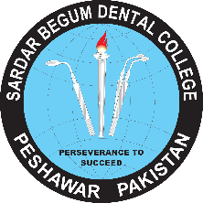 **GANDHARA UNIVERSITY**

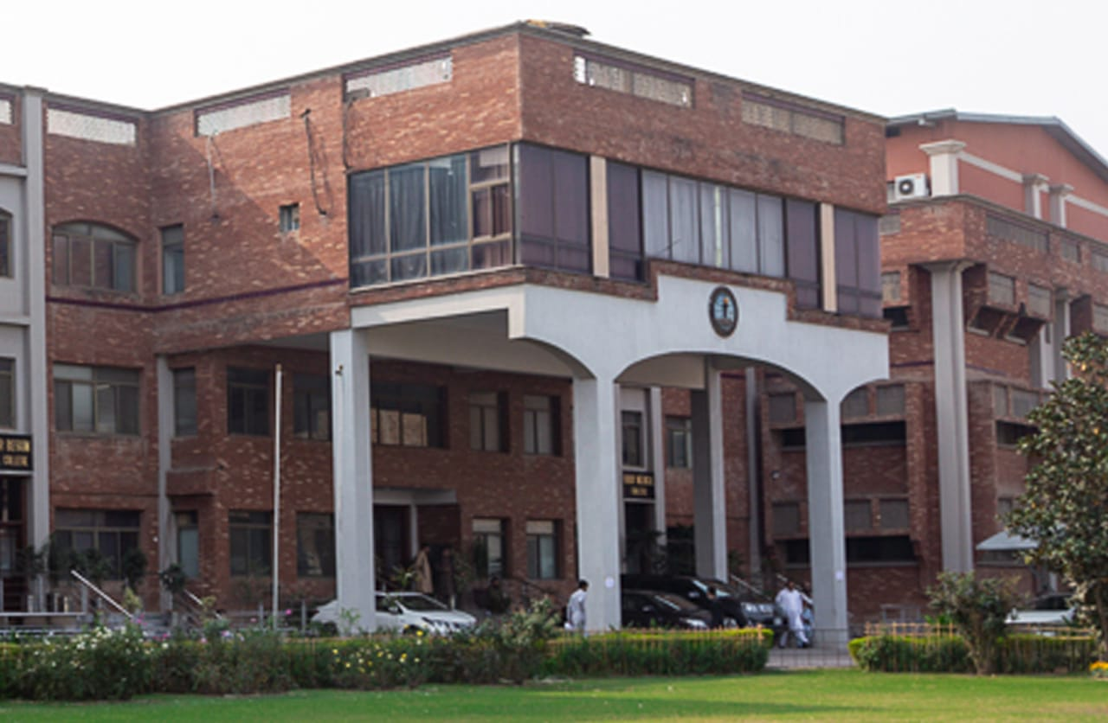**SARDAR BEGUM DENGTAL COLLEGE**

**URRICULUTHIRD YEAR BDS 2024-2025**

**BLOCK – VII**

**(MODULE 13 & 14)**

**(ORAL DISEASES, ETIOLOGY & MECHANISM + ORAL INFECTIONS & INFLAMMATIONS)**

# FROM THE DESK OF PRINCIPAL

Health is a fast-evolving field and with new technologies taking over traditionally man-dominated fields like radiology and robotic surgical suites assisted by Artificial Intelligence and learning taking new dimensions with the help of Augmented Reality, we are indeed living in challenging times. Today's student of Medicine and Dentistry will be in the field a decade from now, up against a disease burden that is as varied as the next strain of the Covid-19 Virus and as complicated as the genetic characteristic of Oral Cancer, the largest cancer amongst both genders in Pakistan and at the same time as unpredictable as the recent Covid-19 Pandemic.  
It is therefore imperative that our curricula of the Medical and Dental Colleges be in tandem with the changing times with ability to evolve with time , measuring up to the challenges thrown at the field of healing from the ever-evolving diseases .  
  
These Student Guidebooks are reviewed every year with the same concept in mind that our future Physician and Dental Surgeon be ready for the challenges that lie ahead.  
  
In the end, I give you the same prayer as is mentioned in the Quran.

# See the source image

# 

# 

Prof. Shaheed Iqbal

BDS, MDS

Oral & Maxillofacial Surgery

Principal,

Sardar Begum Dental College,

Gandhara University

Peshawar.

On behalf of the module team, I would like to welcome you to Block- VII. As a part of the system-based curriculum, this module is an integrated presentation comprises system-based modules which links basic science knowledge to clinical problems. Integrated teaching means that subjects are presented as a meaningful whole. Students will be able to have a better understanding of basic sciences when they repeatedly learn in relation to clinical examples., early exposure to clinics, wards, and skills acquisition in skills lab are characteristics of integrated teaching program.

Our mission is to provide all educational opportunities to our students therefore on completion of the BDS program graduate will possess an appropriate foundation of knowledge, skills, and attitudes to be well prepared to practice safely and effectively.

This study guide includes the course contents of the block-VII. The learning objectives, practical, topics of the small group discussions. It also includes the assessment plan for the block exam.

We will be meeting with the facilitators to receive the feedback and will try to resolve any difficulties or problems faced during the block. Please do not hesitate to contact DME for any academic help. I wish you an enjoyable and learning experience with the block-VII.



**Director DME: Dr. Marina Khan**

|  |
| --- |
| **CONTENTS** |
| **Block Team** |
| **List of abbreviations…** |
| **Aims of the study guide…** |
| **Module distribution of 3rd year BDS** |
| **Introduction of Block VIII…** |
| **General Outcomes…** |
| **Leaning Methodologies…** |
| **Rules Regulations** |
| **Learning objectives & Course contents** |
| **Assessment…………………………………………………………………………………………….** |
| **Learning Resources………………………………………………………………………………** |

**MODULE TEAM**

|  |  |  |  |
| --- | --- | --- | --- |
|  | **Dr. Marina Khan**  **Director**  **Department of Medical Education** | | [**marinakahn@hotmail.com**](mailto:marinakahn@hotmail.com) |
| **DEPARTMENT OF PERIODONTOLOGY** | |  | Associate Prof. Dr. Kawish Syed  Associate Prof. Dr. Afaq Farooq  Assistant Prof. Dr. Abid Rahim  Senior Registrar Dr. Wajiha  Dr. Zain |
| **DEPARTMENT OF ORAL MEDICINE** | |  | Assistant Prof. Dr. Zafar Iqbal Ahmed  Assistant Prof. Dr Zainab Shah  Dr. Maria Nizam |
| **DEPARTMENT OF GENERAL SURGERY** | |  | Prof. Dr. Azhar Ali Shah |
| **DEPARTMENT OF ORAL PATHOLOGY** | |  | Prof Dr. Ahmad Shah  Associate Prof. Dr. Sofia Haider Durrani  Assistant Prof Dr. Sana Salam  Assistant Prof Dr. Rabia |
| **DEPARTMENT OF GENERAL MEDICINE** | |  | Assoc Prof Dr. Jibran Umar Ayyub |
| **DEPARTMENT OF ORAL & MAXILLOFACIAL SURGERY** | |  | Prof Dr. Jawad Ahmad Kundi  Prof Dr. Murad Ali Shah  Prof Dr. Shahid Khattak  Assistant Prof Dr. Fahad Qiam  Dr. Farhan  Dr. Tayyaba |
| **DEPARTMENT OF PROSTHODONTICS** | |  | Prof Dr. Ali Chughtai  Dr. Jawad |
| **DEPARTMENT OF OPERATIVE DENTISTRY** | |  | Prof Dr. Shakeel  Dr. Sajida  Dr. Asma |
| **DEPARTMENT OF MEDICAL EDUCATION** | |  | Assist Prof Dr. Marina Khan  Assist Prof Dr. Syed Muhammad Junaid  Dr. Aalia Zaib  Dr. Usama Zeb |

**LIST OF ABBREVIATIONS**

|  |  |
| --- | --- |
| **IC** | Integrated Curriculum |
| **DME** | Department of Medical Education |
| MIT | Modes of Information Transfer |
| OPD | Outpatient Department |
| **O.MED** | Oral Medicine |
| **O. PATHO** | Oral Pathology |
| **PROSTHO** | Prosthodontics |
| **PERIO** | Periodontology |
| **G.M** | General Medicine |
| **G. S** | General Surgery |
| **ENDO** | Endodontics/ Operative Dentistry |
| **OMFS** | Oral & Maxillofacial Surgery |
| **LGIS** | Large Group Interactive Session |
| **SDL** | Self-Directed Learning |
| **MCQ** | Multiple Choice Question |
| **SAQ** | Short Answer Question |
| **OSPE** | Objective Structured Practical Exam |
| OSCE | Objective Structured Clinical Evaluation |
| RPD | Removeable partial denture |

**STUDY GUIDE:**

This study guidebook was designed by combining

the efforts of all topics throughout the year to give dental students at Sardar Begum Dental College a resource material that highlights significant components of the curriculum. By providing students control over their learning, the study guide aims to promote self-regulated lifelong learning.

Regarding the course content, the study guide provides an overview of the topics, outcomes, and objectives. The assessment approach is also customized to the intuitional strategy.

A successful curriculum has a significant impact on the final product, as well as on society. This study guide was carefully designed with the PMC curriculum and rules in mind, and Gandhara University stakeholders and faculty o SBDC worked hard to personalize it to the needs of the students. They are further working to build, implement, and exercise a well-built curriculum considering changing demographic needs and disease prevalence in our society. Throughout the construction of the study guide, students' feedback was received and included. Curriculum is a living, dynamic entity that is constantly changing. With each passing day, we hope to improve it.

Each module in this block has been created to cater for the gap between basic and clinical subjects through pre-clinical learning. The block is divided into two modules in which the students are exposed to a variety of basic and clinical subjects. The integrated curriculum is enforced through interactive lectures, small group discussion along with rotations at preclinical laboratory. There will be formative as well as summative assessment of the modules throughout the block.

**AIMS OF THE STUDY GUIDE**

It is an aid to:

* **Background pattern

  Description automatically generated**Inform students how student learning program of the BLOCK-wise module has been organized
* Help students organize and manage their studies throughout the block
* Guide students on assessment methods, rules, and regulations
* Communicates information on organization and management of the block. This will help the student to contact the right person in case of any difficulty.
* Defines the objectives which are expected to be achieved at the end of the block.
* Identifies the learning strategies such as lectures, small group teachings, clinical skills, and demonstration, tutorial that will be implemented to achieve the block objectives.
* Provides a list of learning resources such as books, computer assisted learning programs, web- links, and journals, for students to consult to maximize their learning.
* Highlights information on the contribution of continuous and block examinations to the student’s overall performance.
* Includes information on the assessment methods that will be used to determine every student’s achievement of objectives.

**ORGANIZATION OF MODULAR CURRICULUM**

|  |  |  |  |  |  |  |  |  |  |
| --- | --- | --- | --- | --- | --- | --- | --- | --- | --- |
| **Block-VII** | | **Exam Block - 7** | **Block-VIII** | | **Exam Block - 8** | **Block-IX** | | **Exam Block - 9** | **Final Exam** |
| **Module**  **13**  **Oral diseases, etiology & mechanism** | **Module**  **14**  **Oral infections & inflammations** | **Module**  **15**  **Pre-malignant / Malignant Lesions & Salivary Gland disorders** | **Module**  **16**  **Systemic Diseases & Immune Mediated Disorders** | **Module**  **17**  **Bone Disorders** | **Module**  **18**  **Mucocutaneous Disorders** |

**BLOCK – VIII**

**ORAL DISEASES, ETIOLOGY & MECHANISM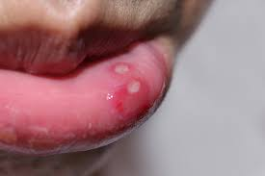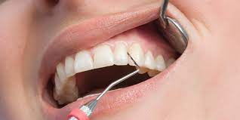 + ORAL INFECTIONS & INFLAMMATIONS**

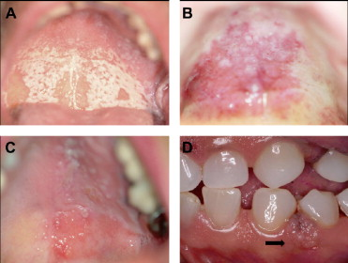**DEPARTMENT OF ORAL PATHOLOGY**

Oral pathology is a dental specialty that deals with the nature, etiology, basic pathological mechanisms, clinical presentation, histopathological evaluation, diagnosis, and treatment of diseases and disorders that affect the oral and maxillofacial region as well as craniofacial syndromes. The subject of Oral Pathology is aimed to provide a theoretical and practical knowledge of the fundamental concepts of pathological diseases of the oral cavity and orofacial soft and hard tissues for third year BDS students.

At the undergraduate level, oral pathology enables students to understand, recognize and identify disorders of the head and neck region. It includes disease diagnosis via clinical, radiographic, microscopic, biochemical, and other examinations, and patient treatment.

The laboratory of Oral Pathology is well-equipped, and the faculty and staff are fully skilled. Oral pathology is aimed to demonstrate a correlation between subjects in order to establish a deeper approach to studying the underlying concepts of each subject and applying them in clinical encounters in the BDS undergraduate program's future years.

**DEPARTMENT OF PERIODONTOLOGY**

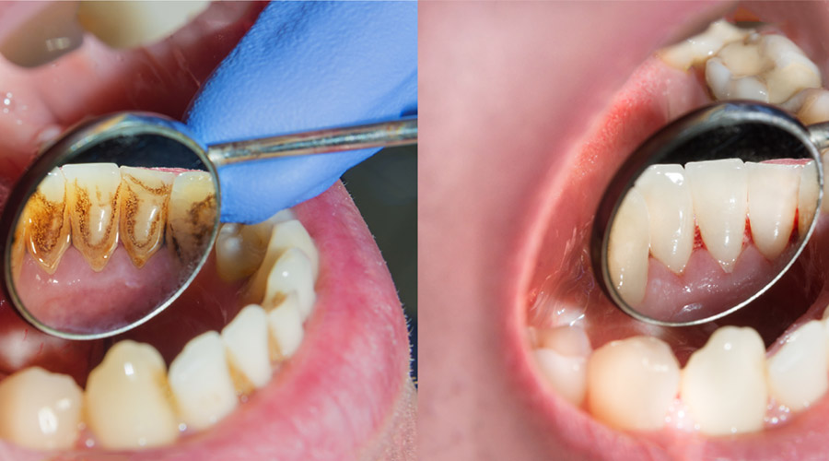Periodontology is a dental specialty that studies tooth supporting structures as well as diseases and conditions that affect them. The supporting tissues are known as the periodontium and is made up of the gingiva (gums), alveolar bone, cementum, and the periodontal ligament. Periodontology is designed to provide a thorough understanding of the basic principles of periodontal tissue origin, progression, and pathology, as well as the diagnosis and treatment of periodontal disease.

It is essential to provide our students with a broad and complete understanding of periodontology to prepare them for the issues they will confront as dentists. This will enable them to perform their professional tasks to a high quality.

The department of periodontology at Sardar Begum Dental College, specializes in diseases of the periodontium, which includes the gums, alveolar bone, and periodontal ligament. Patients with gum and periodontal disorders, as well as those with oral problems, are treated and monitored in the periodontology department.

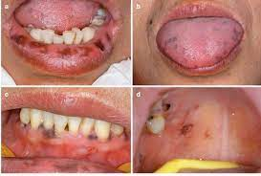

**DEPARTMENT OF ORAL MEDICINE**

Oral medicine is a branch of dentistry that focuses on the diagnosis, investigation, and non-surgical treatment of disorders affecting the oral, perioral structures (such as orofacial pain, oral manifestations of systemic diseases, salivary gland disorders) and medically compromised patients with oral health issues.

The course content in the subject of Oral Medicine at Sardar Begum and Dental College is designed to provide students with extensive diagnostic and therapeutic skills in the diagnosis and nonsurgical treatment of oral and perioral diseases, temporomandibular joint disorders as well as the management of systemic diseases that have a significant impact on oral health. Students will learn how to take a detailed medical history, conduct a thorough physical examination, advise appropriate investigations, and develop a diagnosis and treatment plan.

The overall objective of this subject at the undergraduate level is to emphasize the importance of dental students in obtaining medical and dental histories and doing a full head and neck as well as oral examination is to provide patients with adequate and safe dental care.

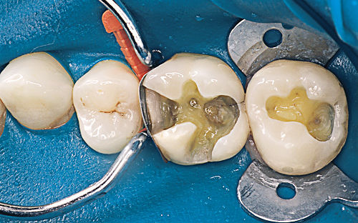**DEPARTMENT OF OPERATIVE DENTISTRY**

Operative dentistry is the practice of restoring normal structure, function, health, and aesthetics of teeth that have been damaged by disease, trauma, wear, or abnormal development. The practice of dentistry in this area requires a wide range of knowledge, from diagnosis, disease processes and prevention, and minimally invasive clinical approaches; to biomaterials and other dental science disciplines as they apply to this distinct and unique interest area limited to the hard calcified tissues of the oral cavity.

The objective of this session is to give basic knowledge of operative instruments, dental terms, principles of cavity preparations, and fundamentals of tooth restorations. The course's major objectives are to introduce students to theoretical topics and to improve their manual dexterity. The use of a hand piece (dental drill) to learn and practice these skills begins during orientation and continues throughout the academic year. During the clerkship programme the students will learn how to assess patient caries risk and implement caries prevention strategies, as well as how to remove or treat carious tooth tissue using techniques that preserve pulp vitality and restore the tooth to form, function, and aesthetics with appropriate materials, as well as how to prevent hard tissue disease and promote soft tissue health.

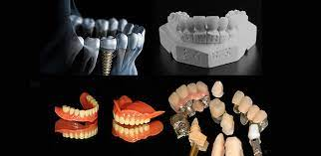

**DEPARTMENT OF PROSTHODONTICS**

Prosthodontic dentistry is a branch of dentistry concerned with the restoration and maintenance of a patient's oral functions, comfort, aesthetics, and health by restoring teeth and/or replacing missing structures with removable and fixed dental prosthesis (artificial prosthesis). this branch of dentistry is one of the most difficult and challenging subjects as it includes both clinical and practical/laboratory work. The main goal of this course is to offer students with the essential information and hands-on experience in complete dentures, partial dentures, crowns, and bridges so that they can become future general dental care professionals.

The department of prosthodontics at SBDC, treats patients with removable complete and partial dentures, fixed prostheses, maxillofacial prostheses, and temporary mandibular problems management. Third year BDS students during their clerkship programme will be taught to design and fabricate removable partial dentures for patients.

**DEPARTMENT OF ORAL & MAXILLOFACIAL SURGERY**

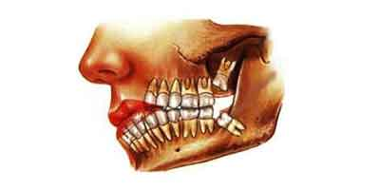Oral surgery is a specialty that deals with the diagnosis and treatment of the pathologies of jaw and oral cavity, that requires surgical intervention. Although tooth extraction is the most common surgery performed by oral surgeons, there is a broad scope to the specialty. This includes managing hard and soft tissue pathologies, oral infections, dentoalveolar trauma, and orofacial pain, as well as providing orthodontic surgery and Osseo integrated implant placement.

**DEPARTMENT OF GENERAL MEDICINE**

General medicine is a course taught at the undergraduate level that allows students to learn clinical medicine and apply their knowledge in clinical dental practice.

The Department of General Medicine contains the following facilities and students will be taught in detail about the relevant subjects: Cardiology, Infectious diseases, Gastro enterology, Hepatology, Nephrology, Pulmonology, Rheumatology, Hematology Dermatology, Psychiatry.

The course is aimed to provide students a touch of the primary areas of General Medicine while remaining mindful of the BDS curriculum's limits and time constraints. This practice will ensure patient safety and provide a better knowledge of the disease's correlation to other dental diseases. For improved learning, the practical component of the course includes structured ward rotations and patient interaction.

**DEPARTMENT OF GENERAL SURGERY**

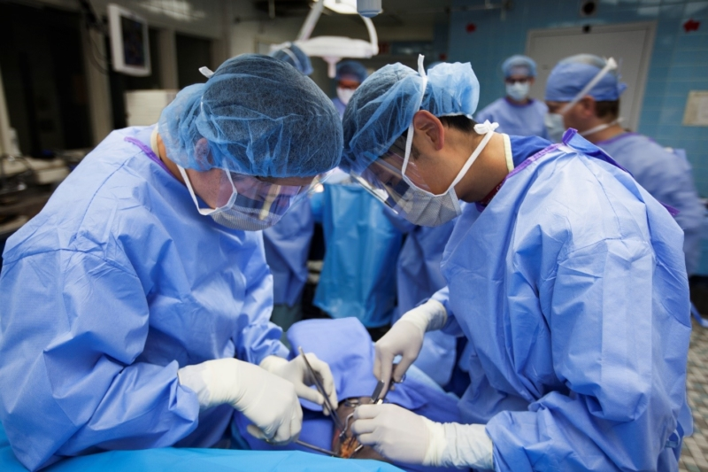General surgery is the science and practice of using operative procedures to treat injury, deformity, and disease. When medication alone is unlikely to relieve discomfort, general surgery is routinely performed. Surgical operational procedures can range from simple procedures conducted in a doctor's office to more complex operations requiring the assistance of a medical team in a hospital setting.

BDS 3rd year Surgery rotation is an essential component of the clerkship curriculum as a student is practically exposed to surgical approaches, its complications and management. The overall purpose of this programme is to educate future dental surgeons to diagnose and manage common surgical problems. Students will rotate through the outpatient department, surgical wards, and operating rooms to learn the fundamentals of clinical reasoning to gain the clinical and procedural skills they require.

**GENERAL OUTCOMES:**

By the end of this block the students would be able to

**KNOWLEDGE:**

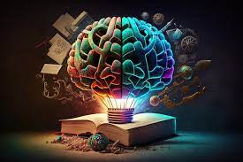

1. Describe histopathology of developmental anomalies, keratosis & related disorders of oral mucosa, oral epithelial in pathology
2. Describe pulpitis, bacterial and viral infection.
3. Describe the normal periodontium, features, classification of periodontal, peri implant diseases and condition staging, grading of periodontal diseases in periodontology.
4. Describe the histopathology of infections of oral cavity.
5. Describe metabolic response to injury, universal precautions, pre & post operative are, shock, trauma care.
6. Tissue repair & management of infectious diseases in general surgery
7. Describe importance, career in medicine and career reasoning in general medicine.
8. Describe the clinical features, investigations and management plan of infectious diseases in general medicine.
9. Describe oral mucosa, principles, universal precautions, professional hazards, and medical emergencies in oral medicine.
10. Describe RPD examination, diagnosis, recording of impression of cast with base & dental surveying in prosthodontics.
11. Describe principals of class II, III & IV cavities in operative dentistry
12. Describe preoperative health status and principles of oral surgery.

**ATTITUDE:**

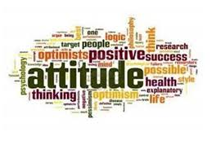

1. Follow the basic laboratory & ward protocols.
2. Participate in class and practical work efficiently.
3. Maintain discipline of the college.
4. Follow the norms of the college properly.
5. Communicate effectively in a team with colleagues and teachers.
6. Demonstrate professionalism and ethical values in dealing with patients, cadavers,

colleagues, and teachers.

1. Communicate effectively in a team with colleagues and teachers.
2. Demonstrate the ability to reflect on the performance.

**LEARNING METHODOLOGIES**

The following teaching / learning methods are used to promote better understanding:

* Interactive Lectures
* Small Group Discussion
* Practical
* Skills session
* E-Learning
* Self-Directed Learning

**LARGE GROUP INTERACTIVE LECTURES (LGIS)**

In large group, the lecturer introduces a topic or common clinical conditions and explains the underlying phenomena through questions, pictures, videos of patients' interviews, exercises, etc. Students are actively involved in the learning process.

**SMALL GROUP DISCUSSIONS (SGDs):**

This format helps students to clarify concepts acquire skills or attitudes. Sessions are structured with the help of specific exercises such as patient case, interviews, or discussion topics. Students exchange opinions and apply knowledge gained from lectures, tutorials, and self-study. The facilitator role is

to ask probing questions, summarize, or rephrase to help clarify concepts.

**PRACTICAL**

Practical’s & clinical rotations related to General Medicine ,General Surgery, Oral Pathology, Oral Medicine, Periodontology, Oral & Maxillofacial surgery, Operative Dentistry and Prosthodontics are scheduled for student learning.

**SELF DIRECTED LEARNING SDL:**

Students assume responsibilities of their own learning through individual study, sharing and discussing with peers, seeking information from Learning Resource Center, teachers, and resource persons within and outside the college. Students can utilize the time within the college scheduled hours of self-study.

**E-LEARNING:**

E-Learning is a strategy by which learning occurs through the utilization of electronic media, typically the Internet. The basic aspects of medical professionalism and ethics will be addressed through an e-learning course.

1. **Hands on Training**
2. **Oral Pathology, Oral Medicine lab sessions:**

Oral Pathology practical will demonstrate your skills and help in clarifying your concepts practically.

1. **Clinical hands on & Ward Rotation**

Practice of clinical examination on patients in Periodontology, oral medicine, General Medicine, General Surgery, Operative dentistry, Prosthodontics, Oral and maxillofacial surgery wards

**RULES AND REGULATIONS**

We will be making the journey through the Block VIII in 13 weeks. Therefore, this course includes an intensive coursework load. Class attendance and participation are extremely important to your learning and are considered in the evaluation of the course grade. If there is anything that the block team can do to assist during the course, please feel free to contact DME or concerned department. Attendance will be monitored during the different teaching activities. If the attendance is less than 75%, the student will be not allowed to sit for both block and annual examination.

All examinations must be taken on the date scheduled. Once the exam starts the student will not be allowed to enter the examination Hall. There will be a block exam at the end of each block and each block will cover two modules. There will be a total of 3 block examination and the 30% weightage of these block exam will be added to the 70 % of the annual professional exam as an internal assessment.

**MODULE – XIII**

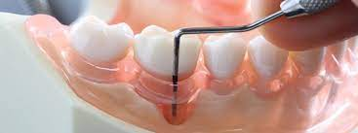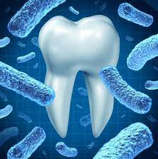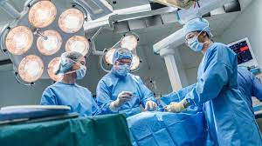

**L**

**LEARNING OBJECTIVES & COURSE CONTENTS**

At the end of 3rd year large group interactive sessions, the students will be able to achieve the following objectives

|  |  |  |
| --- | --- | --- |
| **ORAL PATHOLOGY LECTURES** | | |
| **S.NO** | **TOPICS** | **LEARNING OBJECTIVES** |
| 1 | Introduction to oral pathology | Define oral pathology.  Enlist different terminologies of oral pathology.  Enlist different histopathological terms.  Explain handling of biopsy specimen  Explain tissue processing.  Define & discuss staining |
| 2 | Developmental anomalies of teeth | Define, enlist, and identify clinically and histologically all anomalies i.e., of form, size, shape & structure of teeth.  Clinically identify anomalies of gingiva, jaws & salivary glands.  Describe anomalies of soft tissues i.e., of lip, mucosa & tongue.  Describe congenital, hereditary &acquired developmental head &neck anomalies. |
| 3 | White Lesions | Define white lesions  Classify white lesions.  Discuss Pathophysiology.  Discuss Histopathological & clinical features |
| 4 | Epithelial Pathologies | Definition  Etiology Classification  Pathophysiology  Histopathological features  Clinical features  Diagnosis  Schedule Treatment options |

|  |  |  |
| --- | --- | --- |
| **PERIODONTOLOGY LECTURES** | | |
| **S.NO** | **TOPICS** | **LEARNING OBJECTIVES** |
|  | Normal periodontium | Describe microscopic and macroscopic structures of gingiva, PDL, cementum and alveolar bone. |
|  | Features of a healthy periodontium | Discuss color, contour, texture, and position of healthy periodontal tissues. |
|  | Microbiology of Periodontal diseases | Enumerate microbes in health, gingivitis periodontitis and peri- implantitis.  Discuss periodontal pathogens. |
|  | Dental Calculus | Define calculus.  Classify calculus.  Explain etiologic significance |
|  | Plaque retaining factors | Enumerate anatomic, iatrogenic and habits as plaque retaining factors.  Management of plaque retaining factors |
|  | Epidemiology of periodontal diseases | Enlist different periodontal indices.  And describe their clinical application |
|  | Diagnosis of periodontal diseases (clinical examination of periodontal tissues) | Describe stepwise approach to clinical examination of periodontal tissues.  Differentiate between CAL and PPD |
|  | Radiographic evaluation | Enlist the radiographic features of periodontal diseases.  Enlist and identify the type of bone loss |

|  |  |  |
| --- | --- | --- |
| **GENERAL SURGERY LECTURES** | | |
| **S.NO** | **TOPICS** | **LEARNING OBJECTIVES** |
| 1 | Introduction to General Surgery | Understand and become familiar with  General surgery  • Learn the importance of General surgery |
| 2 | Metabolic response to injury | Discuss metabolic response to injury |
| 3 | **Preoperative Care**  Pre – operative optimization of surgical patients with systemic diseases  - Types of Surgical diseases  - Assessment of patients  - operative care  - Daily assessment of  patient  - Day to day patient care - -Recognition of potential complications  - Diagnosis of complications - Management of post op complications | Explain and justify routine intravenous fluid replacement in surgical  Patients  - Identify the commonly prescribed intravenous fluids.  - Describe important complications of common operations |
| 4 | **Shock**  Classification  Hypovolemic/hemorrhagic Shock | Clinically assess hypovolemia - Identify patients in need of fluid optimization/blood transfusion |
| 5 | **Trauma Care and Tissue response**  -Various types of traumas  -Pathophysiology –  ATLS guidelines  - Definitive  Management  - Complications  - Primary and secondary survey,  - Re- evaluation and monitoring, investigation, and definite treatment | Describe the physiological response to injury.  - State the principles of surgical treatment in an injured patient.  - Assess priorities during all phases of management following ATLS principles.  - Define triage and its importance  - Justify the importance of reassessment of the patient with regards to earlier interventions,  - Discuss issue of missed injuries, management, and documentation.  - Differentiate between  primary and secondary survey.  -Differentiate between blunt, penetrating, crush, blast injuries based on mechanisms of trauma  - List the interventions that may be required for head injury.  – care for the injured patient by a multidisciplinary team - -Explain the role of radiological investigations (FAST, CT scanning) and interventions) |
| 6 | **Postoperative Care** | Demonstrate the ability to write basic postoperative orders and postoperative note in an  organized and comprehensive manner.  Describe principles of monitoring and management of fluid, electrolyte and nutritional  needs of surgical patients, including the calculation of rates for maintenance and replacement fluid.  Apply findings from history, physical exam, and investigations to identify and differentiate  between common postoperative complications |

|  |  |  |
| --- | --- | --- |
| **GENERAL MEDICINE LECTURES** | | |
| **S.NO** | **TOPICS** | **LEARNING OBJECTIVES** |
| 1 | Introduction to General Medicine  History taking in General Medicine | Understand the basics of General Medicine.  Enlist the major subspecialties.  Recognize the importance of a good history.  Enlist the steps of history taking |
| 2 | Career in Medicine  Clinical Reasoning in medicine | Recognize the importance of General Medicine as a career option.  Define clinical reasoning.  Understand the importance of clinical reasoning |

|  |  |  |
| --- | --- | --- |
| **ORAL MEDICINE LECTURES** | | |
| **S.NO** | **TOPICS** | **LEARNING OBJECTIVES** |
| 1 | Oral Mucosa | Describe the structure of oral mucosa.  Enlist the functions of oral mucosa.  Describe age changes and abnormal mucosa.  Describe oral mucosa in generalized diseases. |
| 2 | Principles of Oral Medicine | Define dimensions of oral medicine.  Enumerate the principles of oral medicine.  Enlist the components of patient history.  Enlist different investigations, analyze & interpret different investigations & establish diagnosis.  Discuss the protocols to receive a patient according to society norms & discuss the steps to obtain consent. |
| 3 | Universal Precautions | Enlist the protocols for prevention of cross infection. |
| 4 | Prescription Writing/ Professional Hazards in Dentistry | Constructs correct and legible prescription writing. |
| 5 | Medical emergencies in dental practice | Discuss the prevention of medical emergencies.  Enlist emergency drugs, equipment’s & their uses.  Discuss the diagnosis of medical emergencies including anaphylactic shock and vasovagal syncope.  Discuss management of medical emergencies. |

|  |  |  |
| --- | --- | --- |
| **PROSTHODONTICS LECTURES** | | |
| **S.NO** | **TOPICS** | **LEARNING OBJECTIVES** |
| 1 | Introduction to RPD, Kennedy classification | Define RPD.  Enlist different types of RPDs.  Describe & classify the partially dentate arch based on Kennedy’s classification. |
| 2 | History, Examination, diagnosis, and choice of prosthesis | Taking complete and relevant dental & medical history & examination of the partially dentate patients.  Discuss the treatment options for the replacement of missing teeth. |
| 3 | Recording Impression & Fabrication of Cast with base | Explain the recording of proper impression for further processing the base for RPD.  Describe the laboratory procedures involved in the fabrication of cast partial denture. |

|  |  |  |
| --- | --- | --- |
| **OPERATIVE DENTISTRY LECTURES** | | |
| **S.NO** | **TOPICS** | **LEARNING OBJECTIVES** |
| 1 | Class 2 Cavity Designs | Describe the principles of Class II cavity preparation.  Enlist various Class II cavity preparation designs.  Explain each design in detail. |
| 2 | Class 3 Cavity Designs | Describe the principles of Class III cavity preparation.  Understand the indications & contraindications For Class III composite preparation. |

|  |  |  |
| --- | --- | --- |
| **ORAL & MAXILLOFACIAL SUGERY LECTURES** | | |
| **S.NO** | **TOPICS** | **LEARNING OBJECTIVES** |
| 1 | Preoperative Health Status Evaluation | Take record& interpret an accurate history from patients of any age and communicate effectively.  Work effectively with other healthcare professionals.  Make a differential diagnosis.  Perform relevant diagnostic tests & carry out investigations to establish definitive diagnosis.  Devise strategies & plans based on the likely prognosis & outcomes of the various treatment & establishing a resultant priority & sequence of treatment. |
| 2 | Preventive and management of medical emergencies | Evaluate & identify the medical conditions patients are suffering through history, examination & diagnostics.  Modify dental treatment plan according to medical conditions.  Manage the medical emergencies in dental office.  Work effectively with other healthcare professionals. |
| 3 | Principles of Surgery | Understand & apply basic principles in clinical practice. |

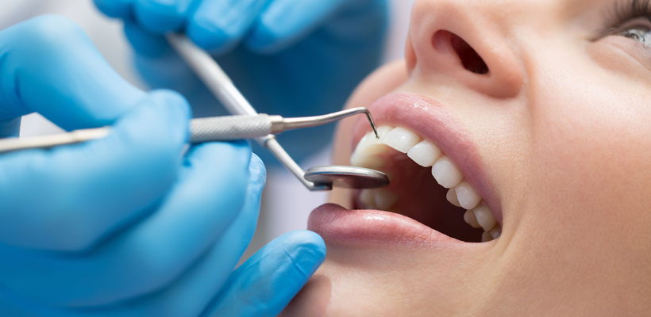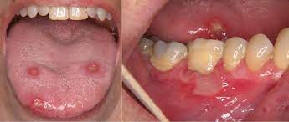**MODULE – XIV**

**ORAL INFECTIONS AND INFLAMMATIONS**

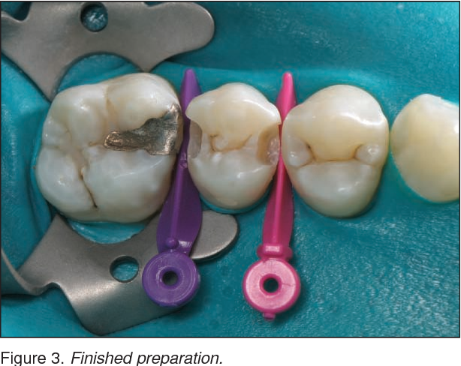

**LEARNING OBJECTIVES & COURSE CONTENTS**

At the end of 3rd year large group interactive sessions, the students will be able to achieve the following objectives

|  |  |  |
| --- | --- | --- |
| **GENERAL MEDICINE LECTURES** | | |
| **S.NO** | **TOPICS** | **LEARNING OBJECTIVES** |
| 1 | Enteric fever | Describe the clinical presentation of enteric fever.  Discuss the diagnosis and management of enteric fever. |
| 2 | Malaria | Describe the clinical presentation of malaria.  Discuss the diagnosis and management of malaria. |
| 3 | Viral hemorrhagic fever (dengue & Congo fever) | Describe the clinical presentation of Viral Hemorrhagic fever  Discuss the diagnosis and management of Viral Hemorrhagic Fever  Enlist the complications of Viral Hemorrhagic Fever. |
| 4 | Infectious diarrhea/HIV | Describe the clinical presentation of Infectious Diarrhea  Discuss the diagnosis and management of patient with diarrhea. |
| 5 | PUO | Define Pyrexia of unknown origin.  Discuss the clinical features of PUO.  Understand its diagnosis and management. |
| 6 | Bacteremia & septicemia | Define Bacteremia & Septicemia  Enlist the risk factors  Explain the clinical features and management of bacteremia & septicemia. |
| 7 | Septic Arthritis | Describe the clinical approach to a patient with septic arthritis.  Enlist the differential diagnosis of patient with septic arthritis.  Explain the management plan of patient with |

|  |  |  |
| --- | --- | --- |
| **ORAL MEDICINE LECTURES** | | |
| **S.NO** | **TOPICS** | **LEARNING OBJECTIVES** |
| 6 | Therapy | Enlist the principles of therapy.  Enlist the various routes of drug administration.  Enlist the various topical & systemic drugs & their uses in oral medicine.  Enlist the limitations of therapy. |
| 1 | Infection of gingiva & oral Mucosa | Enumerate different bacterial, fungal, and viral infections.  Describe the clinical feature of each infection.  Established diagnosis based on clinical features and their investigations.  Identify and describe the oral manifestation of HIV infections.  Communicate and advice to patient for preventing further spread of infection. |
| 2 | Swelling of the face & neck | Summarize the causes of facial swellings and make D/Ds.  Examination of facial swellings and lymph nodes. |
| 3 | Oral ulceration | Classification and etiology of oral ulcerations.  Describe and OSCE. Compare different types of RAS.  Establish diagnosis based on clinical features and investigations.  Describe systemic diseases causing oral ulceration.  Remove the cause of traumatic ulcer.  Know when to take biopsy.  Know the blood investigation needed for patient with RAS its analysis.  Examination of oral ulcer.  Explain treatment and follow up visit if required. |
| 4 | Oral Pigmentation | Define oral pigmentation.  Enlist the causes of oral pigmentation  Enlist the types of oral pigmentation  Devise the management of oral pigmentation |

|  |  |  |
| --- | --- | --- |
| **ORAL PATHOLOGY LECTURES** | | |
| **S.NO** | **TOPICS** | **LEARNING OBJECTIVES** |
| 1 | Pulpitis | Define pulpitis.  Enlist Causes, Classification, and types of pulpitis.  discuss Progression and Sequelae of pulpitis.  explain pulpal calcifications, obliterations, necrosis, and age changes in pulp. |
| 2 | Dental carries | Explain caries and its theories.  Classify caries according to location, rate and spread.  Enlist etiological variables of caries.  Explain role of carbohydrates, bacteria, acids, and plaque.  Discuss histological zones of dentinal and enamel caries. |
| 3 | Periodontitis | Define periodontitis.  Enlist etiology of periodontitis.  Enlist clinical features and histological features of different types of periodontitis.  discuss acute osteomyelitis, cellulitis, Ludwig’s angina, and Sequelae of acute periapical abscess |
| 4 | Viral, Bacterial & fungal infections | **(Viral)**  Explain Herpes simplex 1& 2, Acute herpetic gingivostomatitis, Recurrent herpes & herpetic whitlow, Herpes Zoster (chicken pox & shingles, EBV, Cocksackie A Virus, Cytomegalovirus, Measles stomatitis  **(Bacterial)**  Explain ANUG, Noma, Actinomycosis,  Tuberculosis and Syphilis.  **(Fungal)**  Classify and enumerate all clinical forms of candidiasis. |

|  |  |  |
| --- | --- | --- |
| **PERIODONTOLOGY LECTURES** | | |
| **S.NO** | **TOPICS** | **LEARNING OBJECTIVES** |
|  | Treatment planning | Enlist and  describe the sequence of phases in a treatment plan |
|  | Risk factors for periodontal diseases | Identify modifiable and non-modifiable risk factors for periodontal disease |
|  | Pathogenesis of periodontal diseases | Enumerate immune cells.  Classify different immune responses.  Describe bacterial virulence factors.  Explain the events/ stages in inflammation in periodontal tissues.  Describe role of inflammatory mediators. |
|  | Periodontal Pocket | Define Periodontal pocket.  Types of periodontal pocket  Diagnosis and management of periodontal pocket |
|  | Bone Loss | Define Bone loss.  Types of Bone loss  Diagnosis and management of Bone loss |
|  | Classification of periodontal and peri-implant diseases and conditions | Classify diseases.  Describe the classification aids in clinical diagnosis and treatment planning. |
|  | Clinical features of gingivitis | Describe clinical features of gingivitis.  Discuss management |
|  | Acute periodontal conditions | Identify emergent conditions.  Manage acute periodontal conditions |
|  | Non-Surgical periodontal therapy | Discuss the components of non-surgical phase of periodontal therapy |
|  | Adjunctive therapies | Identify the conditions requiring adjunctive therapy.  Describe the use of antibiotics.  Discuss the role of host modulation. |

|  |  |  |
| --- | --- | --- |
| **GENERAL SURGERY LECTURES** | | |
| **S.NO** | **TOPICS** | **LEARNING OBJECTIVES** |
| 1 | Infection | Define infection.  Enlist the factors that determine wound Infection.  Classify sources of infection.  Enlist indications for and choice of Prophylactic antibiotics.  Describe characteristics of the common surgical pathogens and their Sensitivities.  Explain the spectrum of commonly used antibiotics in surgery and the principles of therapy.  Explain the management of abscesses.  Enlist the importance of aseptic and antiseptic techniques.  Explain Delayed primary or secondary closure in contaminated wounds |
| 2 | Basal Cell Carcinoma | Describe the morphology of basal cell carcinoma.  Formulate a differential diagnosis based on the patient’s history and physical findings.  Identify diagnosis and treatment of basal cell carcinoma as well as characteristics and classification of these carcinomas. |
| 3 | Squamous cell Carcinoma | Describe the morphology of squamous cell carcinoma.  Formulate a differential diagnosis based on the patient’s history and physical findings.  Identify the diagnosis and treatment of squamous cell carcinoma as well as characteristics and classification of these carcinomas. |
| 4 | Sterilization | Define Sterilization.  Enlist the Differences between disinfection and sterilization.  Enlist the Methods of sterilization  Enlist the Scrubbing and gowning Techniques. |
| 5 | Bacterial infections | Classify Bacterial infections.  Describe Clinical presentation  Enlist and explain Diagnosis.  Explain Technique of taking pus sample for culture  Describe Treatment of bacterial infection.  Explain the Technique of incision and drainage Abscess. |
| 6 | Parasitic infection | Explain the Liver Abscess.  Explain the Hydatid cyst |
| 7 | Wound Healing | Define wound healing.  Enlist the types of healing  Describe Pathogenesis of healing process  Enlist Factors affecting healing process  Describe the Examination of wound  Explain the Management of wound  Explain Management of pressure sores  Discuss Scars. |
| 8 | Tetanus | Describe Aetiopathogenesis of Tetanus.  describe Clinical presentation of Tetanus.  identify and Manage tetanus |
| 9 | Gangrene | Describe Aetiology of gangrene.  describe Clinical features of gangrene.  identify and Manage gangrene. |
| 10 | Ulcers | Define ulcer.  Enlist its causes.  Enlist its Clinical features.  Describe Examination of ulcers  Identify and explain its Diagnosis.  identify and describe its Treatment |

|  |  |  |
| --- | --- | --- |
| **PROSTHODONTICS LECTURES** | | |
| **S.NO** | **TOPICS** | **LEARNING OBJECTIVES** |
| 1 | Dental Surveying | Enlist & describe stepwise use of dental surveyor designing the prosthesis. |

|  |  |  |
| --- | --- | --- |
| **OPERATIVE DENTISTRY LECTURES** | | |
| **S.NO** | **TOPICS** | **LEARNING OBJECTIVES** |
| 1 | Class 4 Cavity Designs | Describe the principles of Class IV cavity preparation.  Understand the indications & contraindications For Class IV composite preparation. |

**ASSESSMENT METHODS FOR BLOCK EXAM:**

Evaluation is a continuous process comprising of block examination and annual university examination. Students will be evaluated throughout the year. The internal assessment will contribute towards the ﬁnal examination scores.

Multiple examination methods including MCQs, SAQs, OSPE and viva will be used. In line with PMC stipulation, the pass/fail marks for the test and examination will be 50%.

There will be a block exam at the end of each block.

**Theory (knowledge)**:

MCQs (Multiple Choice Questions) and SAQs (Short Answer Questions) are used to assess the theory part for the block exam.

**MCQ:**

* + - * A MCQ has a statement or clinical scenario followed by four options (likely answers).
      * After reading the statement/scenario student select ONE, the most appropriate answer/response from the given list of options.
      * Correct answer carries one mark, and incorrect ‘zero mark’. There is NO negative marking.

**SAQ:**

SAQ are open ended questions that requires students to create an answer. They are commonly used in examinations to access the basic knowledge and understanding of a topic.

|  |  |  |  |  |
| --- | --- | --- | --- | --- |
| **BLOCK – 1** | **BLOCK – 2** | **BLOCK - 3** | **ATTENDANCE** | **ASSIGNMENT / PRESENTATION** |
| 5 | 5  Obtained marks / total marks x 5) | 5 | 2  Obtained marks % / 100 x 2 = | 3 |

**20% Internal Assessment**

* **20% Internal Assessment will contribute 20 marks in the final paper (Theory).**
* **15** marks for all the 3 blocks
* **5** marks per block
* (**Obtained marks / total marks x 5)**
* **2 marks** for attendance, which will be calculated by the **end of each year**.
* **3 marks** for continuous Assessment which includes assignments and presentations will also be calculated by the **end of each year.**

|  |  |  |  |  |
| --- | --- | --- | --- | --- |
| **BLOCK (THEORY PAPER) BREAKUP DETAILS** | | | | |
| **BLOCK** | **MCQs** | **SAQs** | **TOTAL MARKS IN EACH BLOCK** |
| **7** | **26** | **9** | **35** |
| **8** | **26** | **9** | **35** |
| **9** | **26** | **9** | **35** |

|  |  |  |  |  |
| --- | --- | --- | --- | --- |
| **BLOCK – 1** | **BLOCK – 2** | **BLOCK - 3** | **ATTENDANCE** | **BEHAVIOUR** |
| 5 | 5  Obtained marks / total marks x 5) | 5 | 2  Obtained marks % / 100 x 2 = | 3 |

* **20% Internal Assessment will contribute 20 marks in the final paper (Practical).**
* **15** marks for all the 3 blocks
* **5** marks per block
* (Obtained marks / total marks x 5)
* **2** marks for attendance, which will be calculated by the end of each year.
* **3** marks for behavior / discipline, will also be calculated by the end of each year.

**Practical Assessment for each block**

* OSCE Stations = 20 marks (4 marks each station)
* Viva Stations = 15 marks ( 5 marks each station)
* Practical Logbook = 5 marks
* Total = 40 Marks
* **NOTE:** This all will contribute 5% to the total 20% of internal Assessment.
* **Obtained marks / 40 x 5 =**

|  |  |
| --- | --- |
| **LEARNING RESOURCES** | |
| **SUBJECT** | **RESOURCES** |
| **GENERAL SURGERY** | **TEXTBOOKS:**  **1.**Manipal textbook of surgery by Rajagopal Shenoy  **REFERENCE BOOKS:**  1.Bailey & Love’s short practice of surgery by Hamilton bailey. |
| **GENERAL MEDICINE** | **TEXTBOOKS:**  **1.**Current Medical Diagnosis & Treatment (latest edition)  **REFERENCE BOOKS:**   1. Hutchinson’s Clinical methods, 23rd Edition. 2. Macleod’s Clinical Examination 13th Edition. 3. Davidson’s Principles & Practice of Medicine. 4. Kumar and Clark’s Clinical Medicine. 5. HCAI guidelines CDC 6. WHO TB guidelines. |
| **PERIODONTOLOGY** | **TEXTBOOKS:**  **1.**Carranza’s Clinical Periodontology  **REFERENCE BOOKS**   * 1. Clinical periodontology & implant dentistry by Jan lindhe   2. Foundations of periodontics for the dental hygienist   3. Wilikins Clinical practice of the dental hygienist   BSP good practioners guide |
| **ORAL MEDICINE** | **TEXTBOOKS:**  **1.**Tyldesley’s Oral Medicine by William. R. Tyldesley  **REFERENCE BOOKS:**   1. Cawson’s Essential of Oral Pathology & Oral Medicine by R.A. Cawson. 2. Burket’s Oral Medicine by Michael Glick. |
| **ORAL PATHOLOGY** | **TEXTBOOKS:**   1. Soame s and Southmans Oral Patology by Max Robinson, Keith Hunton 5th Edition   **REFERENCE BOOKS:**   1. Contemporary Oral and Maxillofacial Pathology by George P. Wysocki, J. Phillip Snapp, Lewis R. Eversole |

|  |  |
| --- | --- |
| **OTHER LEARNING RESOURCES** | |
| **Hands-on Activities/ Practical** | Students will be involved in Practical sessions and hands-on activities that link with the foundation module to enhance the learning. |
| **Labs** | Utilize the lab to relate the knowledge to the specimens and models available. |
| **Videos** | Videos familiarize the student with the procedures and protocols to assist patients. |
| **Computer Lab/CDs/DVDs**  **/Internet Resources** | To increase the knowledge students should utilize the available internet resources and CDs/DVDs. This will be an additional advantage to increase learning. |
| **SDL** | SDL is scheduled to search for information to solve cases, read through different resources and discuss among the peers and with the faculty to clarify the concepts. |