.

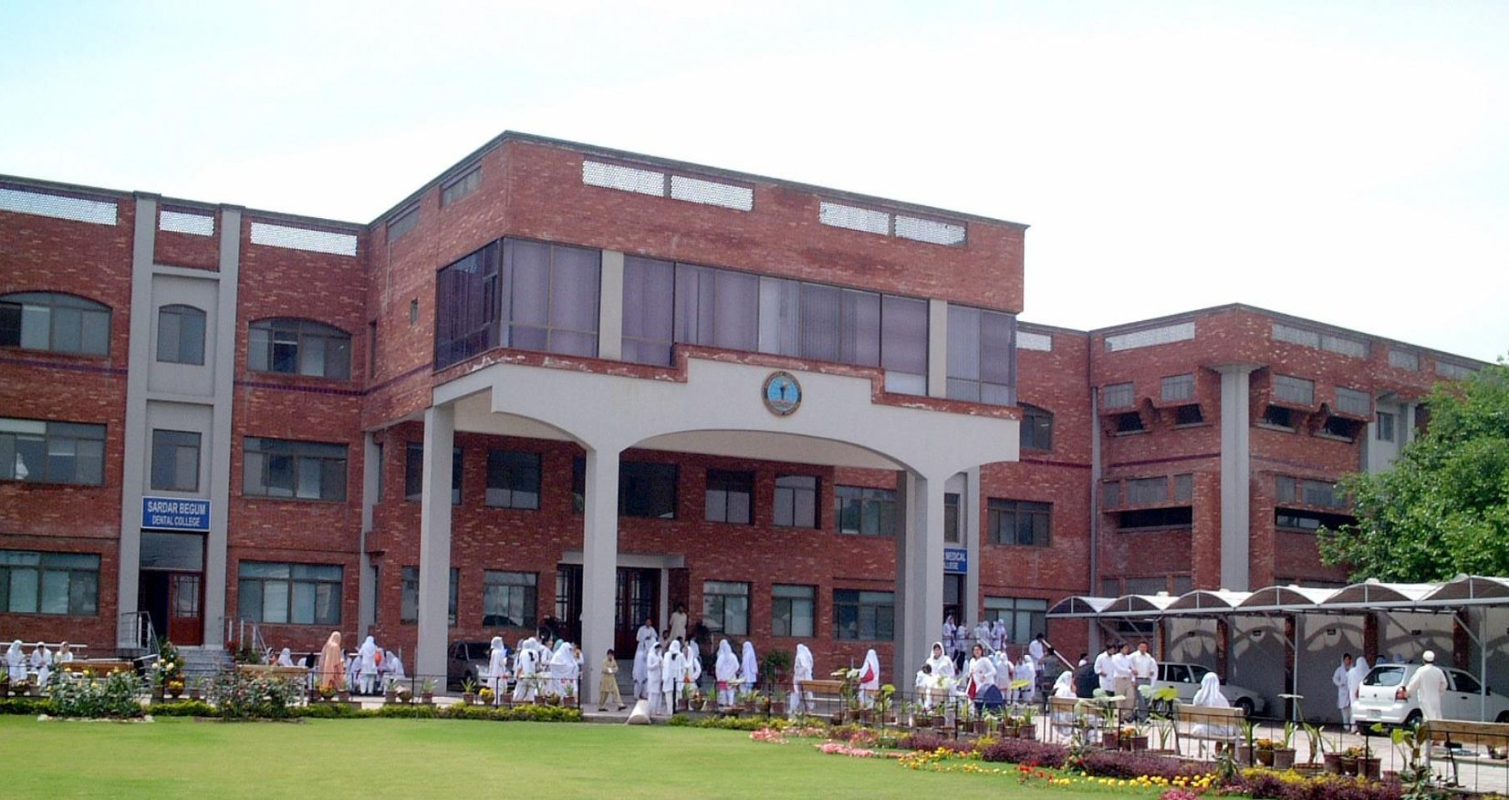

**KABIR MEDICAL COLLEGE** SECOND YEAR MBBS

2023-2024

BLOCK V

MODULE IX AND X

**Department of Medical Education, Gandhara University**

### FROM THE DESK OF PRINCIPAL

Kabir Medical College has evolved, since its inception, as an exceptionally outstanding facility to provide quality education to the students.

I must appreciate the hard work of our well experienced and dedicated faculty members and staﬀ in maintaining high standards of medical education and the eﬀorts they have put in Kabir Medical College to be a distinguished center of excellence.

We meet international standards of professional education by installing the system of integrated curriculum and system-based teaching of basic medical sciences. We advocate interactive sessions to improve comprehension of students as well as training them with skills of communication and self- expression

Since the establishment of Kabir Medical College, we have been working constantly to upgrade services and facilities at the campus and the attached Naseer Teaching Hospital for our students and patients.

We would like our graduates to excel as conﬁdent, responsible and self-learning medical practitioners. With a state-of-the-art campus, experienced faculty, an up-to-date digital library, I assure you that your decision to study at Kabir Medical College will surely be a wise one, your experience here will be profoundly enriching and you will become an asset to the nation and international community health care professionals.

Brig Ahmad Hussain Mishwani(R) MBBS, FCPS (SURGERY) OJT (VASCULARSURGERY) CHPE, MHPE (KMU)

Principal Kabir Medical College Gandhara University, Peshawar



On behalf of the block team, I would like to welcome you to GIT & Renal modules. As a part of the system-based curriculum, this module is an integrated presentation comprises system -based modules which links basic science knowledge to clinical problems. Integrated teaching means that subjects are presented as a meaningful whole. Students will be able to have better understanding of basic sciences when they repeatedly learn it in relation to clinical examples. Small group discussions, early exposure to clinics, wards, and skills acquisition in skills lab are characteristics of integrated teaching program.

Our mission is to provide all educational opportunities to our students. Therefore, on completion of the MBBS program, graduate will possess an appropriate foundation of knowledge, skills and attitudes to be well prepared to practice safely and eﬀectively. This study guide includes the course contents of the module, the learning objectives, practical, topics of the small group discussions. It also includes the assessment plan for the block exam.

As a director I will be meeting with the facilitators to receive timely feedback and will try to resolve any diﬃculties or problems faced during the block. Please do not hesitate to contact DME for any academic help. I wish you an enjoyable and learning experience with block V.



Director DME: Dr. Marina Khan

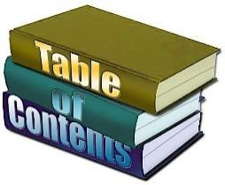

|  |
| --- |
| **Table of Contents** |
| **Block Team.................................................................................................** |
| **List of abbreviations…..................................................................................** |
| **Aims of the study guide.............................................................................** |
| **Module distribution of 2nd year MBBS........................................................** |
| **Introduction of block …..............................................................................** |
| **General Outcomes….....................................................................................** |
| **Learning Methodologies…..........................................................................** |
| **Rules Regulations........................................................................................** |
| **Learning objectives & Course contents....................................................** |
| **Assessment…………………………………………………………………………** |
| **Learning Resources…………………………………………………………** |

**BLOCK TEAM**

|  |  |
| --- | --- |
| **Dr Marina Khan** [**marinakahn@hotmail.com**](mailto:marinakahn@hotmail.com)  **Director Department of Medical Education** | |
| **DEPARTMENT OF ANATOMY** | Prof Dr. Qaisar Inayat  Assoc Prof Dr. Humaira  Assistant Prof Dr. Gul Rukh  Assistant Prof Dr Ibrahim |
| **DEPARTMENT OF PHYSIOLOGY** | Prof Dr. Ghulam Jillani Prof Dr. Anjum Humayun Assist: Prof Dr. Najma  Assistant Prof Dr. Somaya |
| **DEPARTMENT OF BIOCHEMISTRY** | Prof Dr. Mohammad Ahmad Prof Dr. Mudassir Ahmad  Assistant Prof Dr. Inayat  Senior Lecturer Dr. Shahnaz  Lecturer Dr. Asma |
| **DEPARTMENT OF MEDICAL EDUCATION** | Assistant Professor Dr. Marina Khan  Assistant Prof Dr. Syed Muhammad Junaid  Dr. Alia Zaib  Dr. Usama Aurangzeb |

# LIST OF ABBREVIATIONS

|  |  |
| --- | --- |
| **DME** | Department of Medical Education |
| **GIT** | Gastrointestinal |
| **ANAT** | Anatomy |
| **PHYSIO** | Physiology |
| **BIO** | Biochemistry |
| **HISTO** | Histology |
| **EMB** | Embryology |
| **PATHO** | Pathology |
| **PHARMA** | Pharmacology |
| **RADIO** | Radiology |
| **COM** | Community medicine |
| **LGIS** | Large Group Interactive Session |
| **SGD** | Small Group Discussion |
| **SDL** | Self-Directed Learning |
| **MCQ** | Multiple Choice Question |
| **SAQ** | Short Answer Question |
| **OSPE** | Objective Structured Practical Exam |

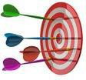

## AIMS OF THE STUDY GUIDE

It is an aid to:

* Inform students that how student learning program of the BLOCK V wise module has been organized
* Help students organize and manage their studies throughout the block.
* Guide students on assessment methods, rules, and regulations
* Communicates information on organization and management of the module. This will help the student to contact the right person in case of any diﬃculty.
* Deﬁnes the objectives which are expected to be achieved at the end of the module.
* Identify the learning strategies such as lectures, small group teachings, clinical skills, and demonstration, tutorial that will be implemented to achieve the block objectives.
* Provides a list of learning resources such as books, computer assisted learning programs, web- links, and journals, for students to consult to maximize their learning.
* Highlights information on the contribution of continuous and block examinations on the student’s overall performance.
* Include information on the assessment methods that will be held to determine every student’s achievement of objectives.
* Focus on information pertaining to examination policy, rules, and regulations

**Exam Block 4**

**Exam Block 5**

**Exam Block 6**

**Final Exam**

## COURSE ORGANIZATION OF

## 2ND YEAR MBBS

|  |  |  |  |  |  |  |  |  |  |  |
| --- | --- | --- | --- | --- | --- | --- | --- | --- | --- | --- |
| **YEAR** | **BLOCK 4** | | **EXAM BLOCK 4** | **BLOCK 5** | | **EXAM BLOCK 5** | **BLOCK 6** | | **EXAM BLOCK 6** | **FINAL EXAM** |
| **2** | **Module**  **7** | **Module**  **8** | **Module**  **9** | **Module**  **10** | **Module**  **11** | **Module**  **12** |
| Neuro  sciences | Special Senses | GIT & Liver | Renal & excretion | Endocrinology | Reproduction |

### LEARNING METHODOLOGIES

The following teaching / learning methods are used to promote better understanding:

* Interactive Lectures
* Small Group Discussion
* Practical
* Skills session
* E-Learning
* Self-Directed Learning

### LARGE GROUP INTERACTIVE LECTURES (LGIS)

In large group, the lecturer introduces a topic or common clinical conditions and explains the underlying phenomena through questions, pictures, videos of patients' interviews, exercises, etc. Students are actively involved in the learning process.

### 

### SMALL GROUP DISCUSSIONS (SGDs):

This format helps students to clarify concepts acquire skills or attitudes. Sessions are structured with the help of specific exercises such as patient case, interviews, or discussion topics. Students exchange opinions and apply knowledge gained from lectures, tutorials, and self-study. The facilitator role is

to ask probing questions, summarize, or rephrase to help clarify concepts.

#### **PRACTICAL**

Basic science practical’s related to Anatomy, Biochemistry and Physiology are scheduled for student learning.

**SELF DIRECTED LEARNING (SDL):**

Students assume responsibilities of their own learning through individual study, sharing and discussing with peers, seeking information from Learning Resource Center, teachers, and resource persons within and outside the college. Students can utilize the time within the college scheduled hours of self-study.

**E-LEARNING:**

E-Learning is a strategy by which learning occurs through the utilization of electronic media, typically the Internet. The basic aspects of medical professionalism and ethics will be addressed through an e-learning course.

1. **HANDS ON TRAINING**
2. **Histology, Biochemistry, Physiology sessions:**

Histology and biochemistry practical will demonstrate your skills and help in clarifying your concepts practically.

1. **Clinical skill lab sessions Hands on**

Practice of clinical examination on mannequins.

**3) Museum Sessions:**

Our museum is equipped with models to help you understand the concepts more clearly.

# RULES AND REGULATIONS

We will be making the journey through Block 5 in 10 weeks. Therefore, this course includes an intensive coursework load. Class attendance and participation are extremely important to learning and are considered in the evaluation of course grade. If there is anything that the block team can do to assist you during the course, please feel free to contact them. Attendance will be monitored during the diﬀerent teaching activities. If the attendance is less than 75%, the student will not be allowed to sit for block and annual examination.

All examinations must be taken on the date scheduled. No student will be allowed to enter the examination area after the examination starts. There will be a block exam covering two modules. There will be 3 block examination and the 30% weightage of these block exam will be added to the 70 % of annual professional examination as an internal assessment.

**MODULE IX**

**GIT & LIVER**

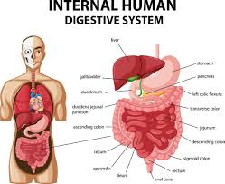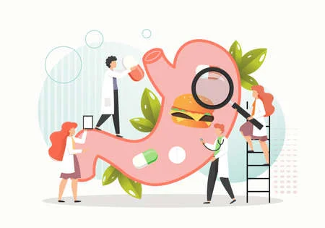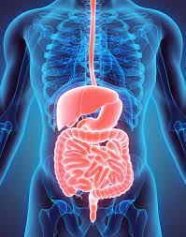

# INTRODUCTION TO GIT & LIVER:

# The gastrointestinal tract also called digestive tract or alimentary canal, consists of a long continuous tube that extends from mouth to the anus. It includes mouth, pharynx, esophagus, stomach, small intestine, and large intestine. Tongue. Teeth, salivary glands, liver, gallbladder, and pancreas are the accessory digestive organs that aid in swallowing, chewing, digestion and breakdown of food. The primary function of GIT is the digestion and absorption of food, including solids and liquids, and the provision of a barrier to many potentially harmful ingested substances. Within GIT, most of the substances are solubilized and further degraded enzymatically to simple molecules, sufficiently small and in form that permits absorption across the mucosal epithelium. This module explains the normal biochemical process of secretion, digestion, absorption along with the functions of saliva and bile. The module explores the important gastrointestinal diseases and the biochemical basis for their diagnosis and treatment.

Learning is best accomplished when information is acquired in meaningfully connected patterns. In recent years, curricula have been developed with integration among basic medical sciences disciplines and between basic and clinical sciences, eliminating sharp discipline boundaries of traditional curriculum. The gastrointestinal is a basic module designed to provide in-depth information about how gastrointestinal system structure (embryology, microscopic anatomy, and gross anatomy) integrates with function (physiologic mechanism of GI motility, digestion, absorption, liver and pancreas function) This module, based on integration will cover the basics of anatomy, physiology, pathology, pharmacology related to GIT and liver. Students will learn about the gross and microscopic structure of liver and GIT and their related functions.

This module will familiarize you with common GIT problems that will be encountered in day-to-day clinical practice in your career. Students will be able to understand the mechanism involved in the development of these pathologies and integrate medical science knowledge to clinical problem-solving. The overall objective of this module is to provide an integrative understanding of the structure, function, and pathologies of gastrointestinal tract.

# CURRICULUM INTEGRATION:

# The term curriculum integration (CI) refers to combining two or more subjects when teaching a topic. Curriculum integration involves integrating the subject concepts, subject content and subject competencies developed in a topic. The goal is to provide an opportunity for deep learning – a wider and deeper understanding of the topic as a whole and more importantly, an understanding of the subject concepts within that topic. The benefits of integrated curriculum both for teaching and learning are endless integrated curriculum allows students to have a deeper understanding of the course subject matter and how to apply the material that they have learned in the classroom in a real-world situation.

# HORIZONTAL INTEGRATION:

# Horizontal integration in a curriculum means that what was once taught in parallel, sequential modules or subjects is taught together in a single module or subject.

# VERTICAL INTEGRATION:

# Vertical integration in curriculum means that foundation sciences are combined with clinical sciences—clinical skills, diagnostic reasoning, differential diagnosis, and management options.

# The various integrating disciplines of neurosciences module are:

**ANATOMY**

**BIOCHEMISTRY**

**PHYSIOLOGY**

**COMMUNITY**

**MEDICINE**

**PEADS**

**GIT**

**BEHAVIORAL**

**SCIENCE**

**PHARMACOLOGY**

**PATHOLOGY**

**MEDICINE**

**RADIOLOGY**

**RIPPLE**

# LEARNING OUTCOMES:

# Logo Description automatically generatedKNOWLEDGE:

# By the end of GIT & liver module, the student will be able to:

# Recognize the gross and microscopic structural and functional features of liver, pancreas, stomach, spleen, and intestines.

# Describe the development of gut, body cavities and biliary apparatus.

# Discuss the mechanism of digestion and absorption of carbohydrates, proteins, and fats.

# Describe different physiologic reflexes occurring upon stimulation of gastrointestinal organs.

# Explain the structure, function and development of hepatobiliary system and explain its role in digestion.

# Discuss the chemistry and functions of gastrointestinal hormones.

# Identify the histological features of liver, intestine, small intestine, large intestine, teeth, and pancreas.

# Discuss the pathogenesis of liver cirrhosis, inflammatory bowel disease, peptic ulcer disease, GERD, and achalasia.

# Discuss gluconeogenesis and glycogenolysis along with its enzymes.

# Discuss pentose phosphate pathway and HMP shunt pathway.

# Describe epidemiology and prevention of polio, enteric fever, food poisoning, amebiasis and giardiasis.

# Discuss the arterial, venous, and lymphatic drainage of gastrointestinal system.

# Describe important landmarks in plain abdominal X ray.

# Logo, company name Description automatically generatedSKILLS:

# By the end of gastrointestinal & liver module, the student would be able to:

1. Identify the histological features of esophagus, stomach, intestines, and liver. Salivary glands, Pancreas gallbladder
2. Determine the blood glucose level and perform oral glucose tolerance test.

3. Identify the microscopic features of kidney, ureter, urinary bladder

4.determine free, total, and combined acidity of gastric juice

**ATTITUDE:**

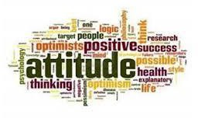By the end of GIT & Renal module, the students of 2nd tear MBBS will be able to:

* Develop respect for the individuality and values of others - (including having respect for oneself) patients, colleagues and other health professionals.
* Organize & distribute tasks.
* Exchange opinion & knowledge.
* Develop communication skills and etiquette with sense of responsibility.
* To equip themselves for teamwork.
* Regularly attend the classes.
* Demonstrate good laboratory practices.
* Carry out practical work as instructed in an organized and safe man
* Make and record observations accurately.
* Develop the ability to give and receive feedback

Respect for self and peers

**COURSE CONTENT AND LEARNING OBJECTIVES**

At the end of the teaching session the student should be able to achieve the following objectives

|  |  |  |  |  |
| --- | --- | --- | --- | --- |
| **EMBRYOLOGY LECTURES** | | | | |
| **S.NO** | **TOPICS** | | **LEARNING OBJECTIVES** |
| 1 | Development of teeth | | Describe the development of teeth.  Describe the development of different parts of teeth |
| 2 | Development of esophagus, stomach, and duodenum | | Describe the development of esophagus, stomach, and duodenum |
| 3 | Development of small & large intestine | | Describe the development of small & large intestine |
| 4 | Development of hindgut | | Describe the development of hindgut |
| 5 | Development of omentum and spleen | | Describe the development of omentum, pancreas, and spleen |
| 6 | Development of liver and extrahepatic biliary apparatus | | Describe the development of liver and extrahepatic biliary apparatus. |
| 7 | Development of body cavities |  | Describe the development of body cavities |
| 8 | Development of pancreas & gall bladder |  | Describe the Development of pancreas & gall bladder |
| 6 | Development of liver and extrahepatic biliary apparatus |  | Describe the development of liver and extrahepatic biliary apparatus. |

|  |  |  |
| --- | --- | --- |
| **ANATOMY LECTURES** | | |
| **S.NO** | **TOPICS** | **TOPIC DETAILS** |
| 1 | Landmarks of abdomen and Teeth | Describe the gastrointestinal tract gross anatomy, general function.  Describe the gross anatomy of teeth. Enumerate the quadrants of the abdomen  Describe the structures located in each quadrant  Describe the landmarks and plans of the abdomen  Describe the importance of landmarks |
| 2 | Structure of anterior abdominal wall | Describe the skin of abdomen  Describe the superficial fascia and deep fascia  Describe the muscle of the anterior abdominal wall  Describe extraperitoneal and parietal peritoneum of the abdomen |
| 3 | Esophagus / Pharynx | Enumerate different parts of pharynx  Describe the boundaries of nasopharynx, laryngopharynx, and oropharynx  Enumerate muscles of pharynx  Describe the origin, insertion, action, and supply of muscles of pharynx |
| 4 | Rectus sheath & Peritoneum | Describe aponeurosis of three muscles  Describe function of anterior abdominal wall  Describe nerve supply and blood supply of the anterior abdominal wall.  Describe parietal peritoneum  Describe visceral peritoneum  Describe ligaments, sac, and pouches  Describe epiploic foramen and recesses  Describe intraperitoneal, retroperitoneal relations  Describe omentum, mesenteries, and transverse section of the peritoneum |
| 8 | Esophagus and stomach | Describe abdominal portion and peritoneum  Describe location, curvatures of the stomach  Describe surfaces of the stomach  Describe orifice and sphincter of the stomach  Blood supply, venous drainage, and nerve supply of the stomach |
| 9 | Small intestine | Enumerate different parts of the small intestine  Describe gross anatomy of small intestine  Describe blood supply venous drainage and nerve supply to small intestine |
| 10 | Large intestine | Enumerate different parts of the large intestine  Describe gross anatomy of large intestine  Describe blood supply venous drainage and nerve supply to large intestine |
| 11 | Blood supply to abdomen | Describe blood supply to abdomen. |
| 12 | Pancrease & gall bladder | Describe gross features of pancreas & gall bladder. |

|  |  |  |  |
| --- | --- | --- | --- |
| **HISTOLOGY LECTURES** | | | |
| **S.NO** | **TOPICS** | **LEARNING OBJECTIVES** | |
| 1 | Lip, Oral cavity & Salivary gland |  | Describe microscopic features of lip and oral cavity.  Describe microscopic structure of different tubular system of salivary glands.  Describe microscopic structures of different types of salivary glands. |
| 2 | Esophagus & Stomach |  | Describe microscopic structure of different layers of esophagus & stomach. |
|  | Teeth |  | Enumerate different parts of teeth  Describe microscopic structure of enamel  Describe microscopic structure of dentin  Describe microscopic structure of cementum |
| 3 | Small intestine |  | Describe microscopic structure of different layers of small intestine. |
| 4 | Large intestine | Describe microscopic structure of different layers of large intestine. | |
| 6 | Liver | Describe microscopic structure of hepatocytes.  Describe the microscopic structure of liver. | |
| 7 | Salivary glands | Describe microscopic structure of different tubular system of salivary gland.  Describe microscopic structure of different types of salivary glands. | |
| 8 | Pancreas | Describe microscopic structure of pancreas. | |
| 9 | Gall bladder | Describe microscopic structure of gall bladder. | |
| 10 | Vermiform appendix | Describe microscopic structure of appendix. | |

|  |  |  |  |  |
| --- | --- | --- | --- | --- |
| **HISTOLOGY PRACTICALS** | | | | |
| **S.NO** | **TOPICS** | **LEARNING OBJECTIVES** | |
| 1 | Teeth |  | Identify and describe the microscopic structure of teeth under a microscope |
| 2 | Esophagus |  | Identify and describe the microscopic structure esophagus under a microscope |
| 3. | Stomach |  | Identify and describe the microscopic structure of stomach under a microscope |
| 4. | Small intestine |  | Identify and describe the microscopic structure of small intestine under a microscope. |
| 5. | Large intestine | Identify and describe the microscopic structure of large intestine under a microscope. | |
| 6 | Liver | Identify and describe the microscopic structure of liver under a microscope. | |
| 7 | Salivary glands | Identify and describe the microscopic structure of salivary glands under a microscope. | |
| 8 | Pancreas | Identify and describe the microscopic structure of pancreas under a microscope. | |
| 9 | Gall bladder | Identify and describe the microscopic structure of gall bladder under a microscope. | |
| 10 | Vermiform appendix | Identify and describe the microscopic structure of vermiform appendix under a microscope. | |

|  |  |  |
| --- | --- | --- |
| **ANATOMY SGDs** | | |
| **S.NO** | **TOPICS** | **LEARNING OBJECTIVES** |
| 1 | Oral cavity, pharynx and esophagus | Describe gross features of oral cavity.  Describe gross features of stomach  Describe and identify different parts of stomach on model  Describe and identify different parts and muscles of pharynx on model |
| 2 | Anterior abdominal wall and duodenum | Describe gross features of esophagus and identify different structures on model |
| 3 | Small intestine and large intestine | Describe gross features of small and large intestine and identify different structures on model |
| 4 | Liver | Describe gross features of liver and identify different structures on model |
| 5 | Pancreas/ gall bladder | Describe gross features of pancreas and gall bladder and identify different structures on model |

|  |  |  |
| --- | --- | --- |
| **PHYSIOLOGY LECTURES** | | |
| **S.NO** | **TOPICS** | **LEARNING OBJECTIVES** |
| 1 | Introduction to G.I. T | Discuss physiological structure of G.I.T  Discuss smooth muscles of G.I.T  Discuss enteric nervous system  Discuss the characteristics of gastrointestinal wall |
| 2 | Intrinsic & Extrinsic nervous system of GIT | Describe the Intrinsic & Extrinsic nervous system of GIT. |
| 3 | Functional movement in the GIT | Describe the functional types of  movements in the gastrointestinal  tract.  Describe law of gut. |
| 4 | GIT blood flow | Describe blood flow through the  villus and its significance |
| 5 | Mastication (saliva) | Discuss composition and secretion of saliva  Enumerate and describe briefly function of saliva |
| 6 | Esophagus | Enumerate the functions of esophagus  Discuss its movements during swallowing  Discuss primary, secondary, and tertiary peristalsis in esophagus |
| 7 | Motor Function of stomach | Describe the motor function of  stomach.  Describe basic electrical rhythm of  the stomach walls  Describe Pyloric pump  Describe role of the pylorus in  controlling stomach emptying  Describe the regulation of gastric  emptying |
| 8 | Gastric Secretions | Describe the secretion, structure,  functions and regulation of Gastrin,  Secretin, Cholecystokinins and other GI  hormones |
| 9 | Small Intestine Movement | Discuss physiology of small intestine  Discuss secretion of small intestine  Discuss mixing and propulsive movements of small intestine  Discuss law of gut |
| 10 | Small intestine  (Digestion and absorption in small intestine) | Discuss digestion and absorption in small intestine  Discuss regulation of chyme flow into the large intestine |
| 11 | Pancreatic Secretion | Discuss role of pancreas in digestion and neutralization of acid chime  Discuss regulation of pancreatic juice secretion |
| 12 | Large intestine Movement & Secretion | Discuss physiology of large intestine  Discuss secretion of mucus and HCO3-  in large intestine  Discuss mixing and propulsive movement of large intestine |
| 13 | Defecation | Discuss fecal mass  Describe flatus  Describe defecation and defecation reflex  Discuss role of rectum in defecation |
| 14 | Functions of Liver | Discuss role of liver in digestion and absorption of fats  Discuss control of bile and pancreatic juice flow into the duodenum  Discuss storage of bile in gall bladder and its empty |
| 15 | G.I.T Hormones | Describe gastrointestinal hormone  actions, stimuli for secretion, and site  of secretion. |
| 16 | Functions of Bile | Describe the function of bile salts in  fat digestion and absorption  Describe functions of the biliary tree  in digestion |
| 17 | Vomiting & Diarrhoea | Describe the mechanisms of Vomiting  and Nausea  Describe Vomiting Act Explain mechanism of diarrhea and its  causes. |

|  |  |  |
| --- | --- | --- |
| **PHYSIOLOGY SGDs** | | |
| **S.NO** | **TOPIC** | **LEARNING OBJECTIVES** |
| 1 | Types of Neurotransmitters secreted by Enteric neurons | Differentiate between mesenteric  and submucosal plexus.  Classify the following enteric nervous  system neurotransmitters as  excitatory or inhibitory:  norepinephrine, acetylcholine, CCK,  VIP, histamine, and somatostatin  Describe the role of autonomic  nervous system in regulation of GIT’s  function  Differentiate between sympathetic  and parasympathetic modulation of  the enteric nervous system and the  effector organs of the GI tract |
| 2 | Disorders of Stomach | Describe the mechanisms of Vomiting  and Nausea  Describe Vomiting Act Explain mechanism of diarrhea and its  causes |
| 3 | Vomiting reflex | Explain vomiting reflex and its causes |
| 4 | Disorders of large Intestine | Describe constipation, megacolon  Explain mechanism of diarrhea and its  causes.  Explain paralysis of defection in spinal  cord injuries |
| 5 | Bile and its regulation | Describe composition of bile and its regulation  Explain conjugation and secretion of bile salts  Explain role of bile acids in fats emulsification  Describe enterohepatic circulation of bile salts |

|  |  |  |
| --- | --- | --- |
| **BIOCHEMISTRY LECTURES** | | |
| **S.NO** | **TOPIC** | **LEARNING OBJECTIVES** |
| 1 | GIT I | Describe the mechanism of digestion and absorption of carbohydrates in the intestines and its disorders |
| 2 | GIT II | Describe the mechanism of digestion and absorption of proteins in the intestines and its disorders |
| 3 | GIT III | Describe the mechanism of digestion and absorption of fats in the intestines and its disorders |
| 4 | Metabolism of Carbohydrates I | Define Glycolysis,  Describe the reactions of glycolysis  Describe the energetics of glycolysis  Describe the types of glycolysis especially the anaerobic glycolysis  Describe the key enzymes and regulation of glycolysis  Discuss the glycolysis in RBC  Describe the biomedical significance and clinical disorders of glycolysis |
| 5 | Metabolism of Carbohydrates II | Describe the fates of pyruvate  Describe the conversion of pyruvate into acetyl CoA  Define citric acid cycle  Describe the sources of acetyl CoA in mitochondria |
| 6 | Metabolism of Carbohydrates III | Describe the reactions of TCA  Discuss the energetics of TCA  Describe the amphibolic nature of TCA  Discuss the regulation of TCA  Enumerate the inhibitors of TCA and their sites of inhibition |
| 7 | Metabolism of Carbohydrates IV | Define Gluconeogenesis  Describe the substrates or precursors of Gluconeogenesis  Describe the Gluconeogenesis from Fatty Acids  Discuss the Cori's cycle  Discuss the regulation of Gluconeogenesis  Name the key enzymes of Gluconeogenesis |
| 8 | Metabolism of Carbohydrates V | Discuss the Role of Pentose Phosphate Pathway  Describe the reactions of the Hexose Mono Phosphate shunt  Discuss the functions of NADPH (produced in Hexose Mono Phosphate shunt) in various tissues and cells  Discuss G6PD deficiency and its effects in various tissues and cells |

|  |  |  |  |
| --- | --- | --- | --- |
| **BIOCHEMISTRY PRACTICALS** | | | |
| **S.NO** | **TOPICS** | **LEARNING OBJECTIVES** | | |
| 1 | free, total, and combined acidity of gastric juice |  | Perform free, total, and combined acidity of gastric juice | |
| 2 | blood glucose |  | Perform blood glucose | |
| 3. | Glucose tolerance test |  | Perform glucose tolerant test | |

|  |  |  |
| --- | --- | --- |
| **BIOCHEMISTRY SGDS** | | |
| **S.NO** | **TOPICS** | **LEARNING OBJECTIVES** |
| 1 | Composition of GIT secretions I | Describe types and composition of G.I.T secretions |
| 2 | Composition of GIT secretions II | Describe types and composition of G.I.T secretions |
| 3 | Mechanism of HCl Secretion | Describe the Mechanism of HCl Secretion |

|  |  |  |
| --- | --- | --- |
| GENERAL MEDICINE LECTURES | | |
| S.NO | TOPICS | **LEARNING OBJECTIVES** |
| 1 | GERD and achalasia | Describe the etiology, clinical features, complications and treatment of GERD and achalasia |
| 2 | Peptic ulcers & Duodenal ulcers | Describe the etiology, clinical features, complications, and management of patient with peptic ulcer and duodenal ulcers |
| 3 | hyperlipidemias | Describe the epidemiology, preventive strategies and diseases associated with hyperlipidemias |
| 4 | Inflammatory bowel disease. | Describe risk for the disease, and predisposing factors  Describe the management of patient with these disease |
| 5 | Liver cirrhosis | Describe the etiology, clinical features, complications, and treatment options of liver cirrhosis |
| 6 | Ulcerative colitis | Identify predisposing factors of the disease  Discuss signs and symptoms of the disease  Determine a proper management plan for the patient  Discuss various clinical complications |

|  |  |  |
| --- | --- | --- |
| **PEADIATRICS LECTURES** | | |
| **S.NO** | **TOPICS** | **LEARNING OBJECTIVES** |
| 1 | Congenital abnormalities of gastrointestinal tract | Discuss congenital abnormalities in gastrointestinal system (gastroschisis vs omphalocele / umbilical hernia) |

|  |  |  |
| --- | --- | --- |
| **COMMUNITY MEDICINE LECTURES** | | |
| **S. No** | **TOPICS** | **LEARNING OBJECTIVES** |
| 1 | Introduction to common prevalent diseases that affect GIT. | Discuss general aspects of common GIT diseases, epidemiology, and prevention. |
| 2 | Acute Diarrheal diseases | Define Acute Diarrheal diseases.  Enlist its types and causes.  Describe the management of acute diarrheal diseases. |
| 3 | Food poisoning | Define food poisoning.  Discuss its epidemiology and prevention. |
| 4 | Cholera | Define Cholera.  Discuss its epidemiology and prevention |
| 5 | Hepatitis A, E | Describe water borne hepatitis  (Hepatitis A and E) viruses and its  control measures. |
| 6 | Hepatitis B, C | Describe the epidemiology of  hepatitis B and C virus infection and  its control measures. |
| 7 | Amebiasis | Define and describe amebiasis.  Discuss its epidemiology and prevention. |
| 8 | Enteric fever | Define enteric fever.  Describe its epidemiology and prevention. |
| 9 | Poliomyelitis | Discuss epidemiology and prevention of polio. |

|  |  |  |
| --- | --- | --- |
| **SURGERY LECTURES** | | |
| **S. NO** | **TOPICS** | **LEARNING OBJECTIVES** |
|  | Intestinal obstruction | Discuss the causes and risk factors of intestinal obstruction  Discuss signs and symptoms of intestinal obstruction.  Discuss the types of bowel obstruction.  Discuss surgical management of bowel obstruction. |
|  | Obstructive jaundice | Define obstructive jaundice.  Describe common symptoms of obstructive jaundice.  Discuss the role of ERCP in management of obstructive jaundice. |
|  | Colorectal carcinoma | Discuss left sided and right sided colorectal cancer.  Describe its signs, symptoms, causes and risk factors.  Discuss colostomy and ileostomy.  Describe side effects of rectal surgery.  Discuss partial and total colectomy. |
|  | Abdomen trauma | Discuss abdominal trauma.  Discuss the role of FAST scan And CT scan in detection of abdominal trauma.  Discuss management of patient with abdominal trauma |

|  |  |  |
| --- | --- | --- |
| **RADIOLOGY LECTURES** | | |
| **S.NO** | **TOPICS** | **LEARNING OBJECTIVES** |
| 1 | Plain abdominal x-ray | Identifying important landmarks  Describe morphologic relationships and discuss their significance. |

|  |  |  |
| --- | --- | --- |
| **PATHOLOGY LECTURES** | | |
| **S.NO** | **TOPICS** | **LEARNING OBJECTIVES** |
| 1 | Oral Ulcers | Discuss etiology, morphology, pathogenesis & Differential diagnosis of oral ulcers. |
| 2 | Peptic Ulcers | Discuss etiology, morphology, pathogenesis & Differential diagnosis of Peptic Ulcers. |
| 3 | Esophagus Achalasia (GERD) | Define Esophagus Achalasia (GERD).  Discuss etiology, pathogenesis, presentation & complication of |
| 4 | Inflammatory Bowel Disease | Define & discuss etiology, morphology, pathogenesis & differences between ulcerative colitis & Crohn’s diseases and its complications. |
| 5 | Pancreatitis | Define acute & chronic pancreatitis.  Classify its types.  Discuss its etiology, pathogenesis, presentation, laboratory diagnosis & complications. |
| 6 | Cholecystitis | Define  Classify its types.  Discuss its etiology, pathogenesis, presentation, laboratory diagnosis & complications. |

|  |  |  |
| --- | --- | --- |
| **SKILL LAB SESSIONS** | | |
| **S. No** | **TOPICS** | **LEARNING OBJECTIVES** |
|  | History taking related in GIT | Demonstrate History taking related in GIT. |
|  | Abdominal Examination | Enlist the steps of examination of abdomen.  Demonstrate correct techniques of auscultation of gut sounds. |
|  | Gut Sounds | Perform examination on simulator to hear gut sounds. |
|  | Nasogastric Tube | Enlist the equipment/material required for NG intubation.  Demonstrate the appropriate technique for insertion of NG Tube. |
|  | Enema administration | Demonstrate the appropriate technique for insertion of enema. |

**MODULE X**

**RENAL & EXCRETION**

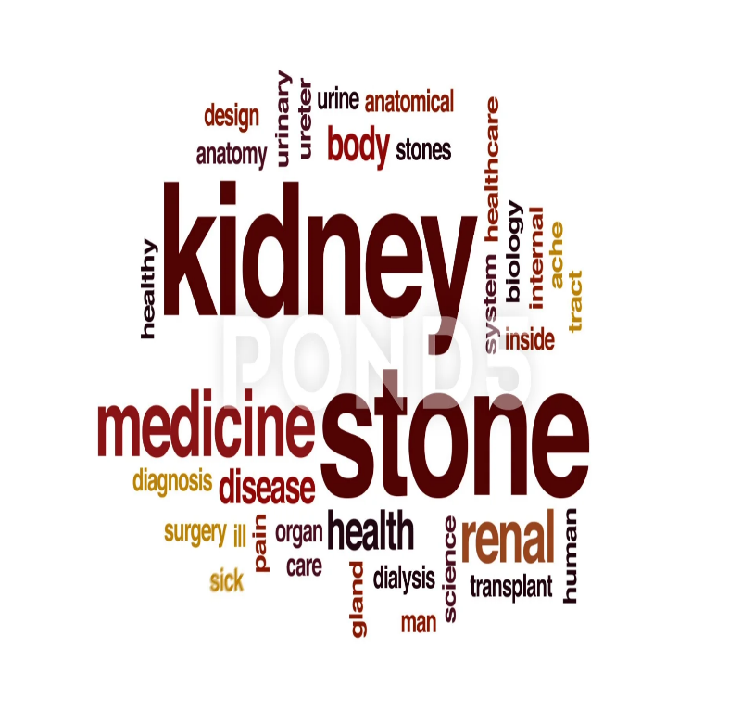

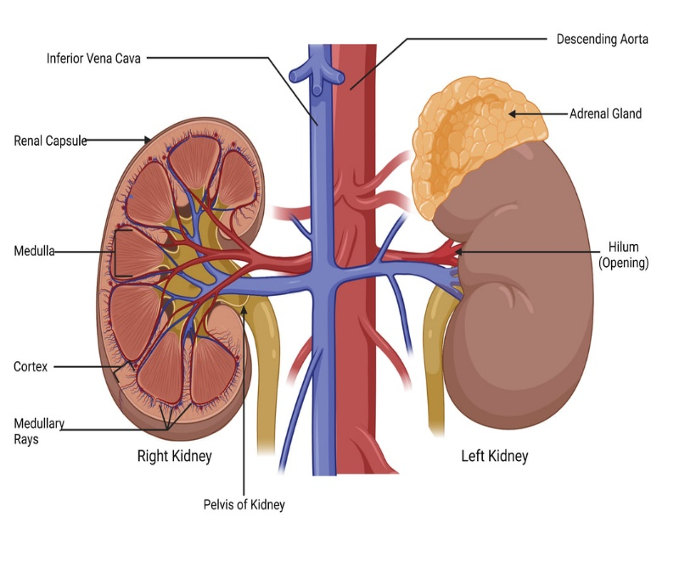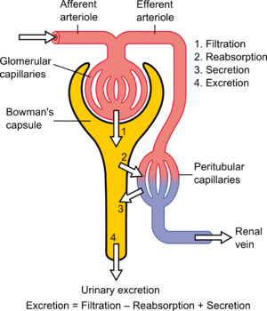

**INTRODUCTION TO RENAL MODULE:**

Renal system is involved in the excretion of waste products especially nitrogenous end products of protein metabolism. It regulates normal hydrogen in concentration, pH, and acid base balance, maintains sodium, potassium, and electrolyte balance of the body. It aids in maintaining blood pressure, osmotic pressure, water balance, plasma/extracellular fluid volume. Kidneys filter fluid from bloodstream and process the filtrate, allowing wastes and excess ions to leave in urine while returning needed substances to the blood. The renal system, controlled by the nervous system, also stores urine until a convenient time for disposal and then provides the anatomical structures to transport this waste liquid to the outside of the body.

Renal diseases are common in the community and renal failure is a common end stage of most renal disorders. Understanding of the basic anatomy, physiology and biochemical processes is essential for dealing with the disease processes afflicting the renal system.

This module focuses on the normal structure and function of renal system

This module will help you to understand the anatomy of the renal system and how it enables the physiologic functions critical to homeostasis. It is best to think of the kidney as a regulator of plasma makeup rather than simply a urine producer.

This module like the previous ones is based on integration of various disciplines that will help students to better understand the structural and functional knowledge of neurosciences. Through this module, you will develop an integrated scientific knowledge that you can put into practice in a clinical setting. These key skills will prepare you for a career helping to progress scientific discovery into clinical and medical practice, ultimately to improve human health

# CURRICULUM INTEGRATION:

# The term curriculum integration (CI) refers to combining two or more subjects when teaching a topic. Curriculum integration involves integrating the subject concepts, subject content and subject competencies developed in a topic. The goal is to provide an opportunity for deep learning – a wider and deeper understanding of the topic as a whole and more importantly, an understanding of the subject concepts within that topic. The benefits of integrated curriculum both for teaching and learning are endless integrated curriculum allows students to have a deeper understanding of the course subject matter and how to apply the material that they have learned in the classroom in a real-world situation.

# HORIZONTAL INTEGRATION:

# Horizontal integration in a curriculum means that what was once taught in parallel, sequential modules or subjects is taught together in a single module or subject.

# VERTICAL INTEGRATION:

# Vertical integration in curriculum means that foundation sciences are combined with clinical sciences—clinical skills, diagnostic reasoning, differential diagnosis, and management options.

# The various integrating disciplines of renal modules are as follows:

**ANATOMY**

**BIOCHEMISTRY**

**PHYSIOLOGY**

**COMMUNITY**

**MEDICINE**

**BEHAVIORAL**

**SCIENCE**

**RENAL MODULE**

**PHARMACOLOGY**

**PATHOLOGY**

**MEDICINE**

**RADIOLOGY**

**RIPPLE**

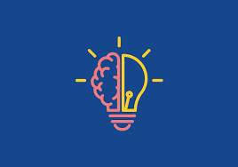**LEARNING OUTCOMES:**

**KNOWLEDGE:**

By the end of renal & excretion module, the student should be able to:

1. Describe the anatomy of structures in posterior abdominal wall in relation to kidneys and ureter.
2. Describe the development, structure, and relations of kidney.
3. Discuss arterial supply, venous drainage, and lymphatic drainage of kidneys.
4. Describe the development, structure, functions and relations of ureters, bladder, and urethra.
5. Discuss acid base balance and its regulation by kidneys and lungs.
6. Draw the relationship between glomerulus, bowmen’s capsule, and proximal tubule.
7. Discuss the buffer systems operating of body and discuss renal regulation of acid base balance in detail.
8. Identify the histological features of kidneys and ureters.
9. Highlight pathologies related to kidneys and their distinctive clinical features.
10. Understand the effect of urinary diseases of different organ systems of the body.
11. Link the structural and functional abnormalities to the clinical signs and symptoms.

**SKILLS:**

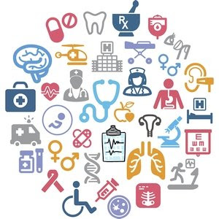

By the end of renal & excretion module the student should be able to:

1.Identify and describe the microscopic structure of kidney,ureter and urinary bladder.

2.Determine the Titratable Acidity of Urine, chloride in urine and serum cholesterol.

# ATTITUDE:

By the end of Renal & excretion module, the students will be able to:

1. Develop respect for the individuality and values of others - (including having respect for oneself) patients, colleagues, and other health professionals.
2. Organize & distribute tasks.
3. Exchange opinion & knowledge.
4. Develop communication skills and etiquette with sense of responsibility.
5. To equip themselves for teamwork.
6. Regularly attend the classes.
7. Demonstrate good laboratory practices.
8. Carry out practical work as instructed in an organized and safe man
9. Make and record observations accurately.
10. Develop the ability to give and receive feedback

|  |  |  |  |
| --- | --- | --- | --- |
| **EMBRYOLOGY LECTURES** | | | |
| **S.NO** | **TOPICS** | **LEARNING OBJECTIVES** | | |
| 1 | Development of kidneys |  | Enlist the stages of development of  Kidneys.  Discuss the stages of development of  Kidneys | |
| 2 | Development of ureters & urinary bladder |  | Enlist & describe the stages of development of Ureters.  Enlist & describe the stages of development of bladder. | |
| 3. | Developmental abnormalities of kidneys |  | Enlist the various types of developmental  anomalies of kidneys along with their  embryological causes. | |
| 4. | Development of urethra & related clinical correlations |  | Describe the development of male urethra& related clinical correlations.  Describe the development of female urethra  & related clinical correlations. | |
| 5. | Developmental abnormalities of urinary bladder & urethra | Discuss the developmental anomalies of  urinary bladder and male and female urethra.  Describe the development of prostate and  bulbourethral glands.  Discuss the developmental anomalies of  urinary bladder and male and female urethra | | |

|  |  |  |  |  |
| --- | --- | --- | --- | --- |
| **HISTOLOGY LECTURES** | | | | |
| **S.NO** | **TOPICS** | **LEARNING OBJECTIVES** | |
| 1 | Kidney |  | Describe the microscopic structure of medulla  Describe the microscopic structure of cortex  Describe the microscopic structure of  Renal columns and medullary rays |
| 2 | Ureter/urinary bladder |  | Describe the microscopic structure of mucosa of the ureter and urinary bladder  Describe the microscopic structure of muscularis of the ureter and urinary bladder  Describe the microscopic structure of adventitia of the ureter and urinary bladder |
| 3 | Urethra |  | Describe the microscopic structure of female urethra  Describe the microscopic structure of female urethra  Describe the microscopic structure of different parts of urethra |
| 4 | Blood supply to the renal system |  | Describe the structures entering and leaving the  hilum of kidney and their relations  Discuss the blood supply of kidney  Describe the relations of right and left kidney. |

|  |  |  |  |
| --- | --- | --- | --- |
| **ANATOMY LECTURES** | | | |
| **S.NO** | **TOPICS** | | **LEARNING OBJECTIVES** |
| 1 | Introduction to module of renal system |  | Describe the surface anatomy of the renal system.  Describe the functions of the renal system.  Describe the biochemistry of renal system. |
| 2 | Posterior abdominal wall |  | Describe the structure of posterior abdominal wall.  Describe the back. |
| 3 | Kidneys |  | Describe the gross anatomy of kidney  Describe different parts of kidney  Describe relations of the kidney |
| 4 | Ureters |  | Describe the gross anatomy of ureter  Describe the function and structure of ureters |
| 5 | Urinary bladder/clinical correlations |  | Describe the gross features of urinary bladder  Describe the parts and relations of urinary bladder |

|  |  |  |  |
| --- | --- | --- | --- |
| **HISTOLOGY PRACTICALS** | | | |
| **S.NO** | **TOPICS** | **LEARNING OBJECTIVES** | | |
| 1 | Kidneys |  | Identify and describe the microscopic structure of kidney under a microscope. | |
| 2 | Ureter |  | Identify and describe the microscopic structure of ureter under a microscope. | |
| 3. | Urinary bladder |  | Identify and describe the microscopic structure of urinary bladder under a microscope. | |
| 4. | Revision (nephrons) |  | Identify and describe the microscopic structure of nephrons under a microscope. | |
| 5. | Revision (all slides) | Revision of all the slides to Identify and describe the microscopic structure of urinary system under a microscope. | | |

|  |  |  |  |
| --- | --- | --- | --- |
| **ANATOMY SGDS** | | | |
| **S.NO** | **TOPICS** | **LEARNING OBJECTIVE** | | |
| 1 | Kidneys  (Models of kidney) |  | Describe the gross features of kidney.  Identify the model of kidney.  Identify different parts of kidney on model.  Describe the histology of kidney. | |
| 2 | Development of kidneys |  | Enlist and Describe the Developmental stages of kidneys. | |
| 3. | Nephron & tubular system |  | Identify and describe the model of nephron.  Define different parts of nephron.  Describe the histology of nephron. | |
| 4. | Urethra (male & female) |  | Identify and describe the gross and microscopic structure of urethra (histology). | |

|  |  |  |  |  |
| --- | --- | --- | --- | --- |
| **PHYSIOLOGY LECTURES** | | | | |
| **S.NO** | **TOPICS** | **LEARNING OBJECTIVE** | |
| 1 | Compartments of Body fluid & its measurement |  | Discuss total body fluids and its distribution in different compartments  Describe concentration of electrolytes in different compartments  Discuss water intake and water loss in 24hours. |
| 2 | Structure of kidney/nephron/general function of nephron |  | Describe the structure of kidney/nephron  Enlist functions of nephron  Blood supply and venous drainage of kidney  Discus different parts of nephrons and their functions |
| 3. | Glomerular filtration rate)- filtration barrier-factors regulating GFR |  | Define glomerular filtration.  Describe filtration barriers.  Describe the determinants of GFR |
| 4. | Auto Regulation of GFR and Renal blood flow |  | Discuss importance of increased blood flow to kidneys  Discuss effects of decrease blood pressure and increase blood pressure on arterial blood flow to kidney |
| 5 | Acid base regulation |  | Describe acid base regulation  Enlist the buffers  Describe the mechanism of acid base regulation |
| 6 | Renal tubular resorption and secretion |  | Describe determinants of reabsorption  What are the different forces that affects reabsorption & secretion?  Discuss role of hormones in resorption control  Discuss sympathetic stimulation affects in reabsorption & secretion |
| 7 | Mechanism of Resorption in different parts of nephron |  | Describe structure of proximal convoluted tubules  Discuss reabsorption of amino acid and glucose from proximal convoluted tubules  Enumerate mechanism of transport in proximal convoluted tubules(pct)  Discuss reabsorption of loop of henle  Discuss the increase in osmolarity in descending limbs of LOH (loop of henle)  Discuss the decrease in osmolarity in ascending limbs |
| 8 | Hormonal control of renal reabsorption |  | Enlist the hormones involve in the control of renal reabsorption.  Describe the mechanism of each hormones |
| 9 | Concentration & Dilution of urine |  | Define specific gravity  Discuss the importance of hyperosmolar medulla for urine concentration  Discuss role of urea in concentration of urine  Discuss role of ADH  Discuss tubular fluid dilution in ascending loop and collecting ducts |
| 10 | Micturition and its abnormalities |  | Discuss filling and emptying of bladder  Describe micturition reflex  Describe facilitation and inhibition of micturition by the brain |

|  |  |  |  |
| --- | --- | --- | --- |
| **PHYSIOLOGY SGDS** | | | |
| **S.NO** | **TOPICS** | **LEARNING OBJECTIVE** | |
| 1 | Clinical abnormalities of fluid volume regulation |  | Describe the clinical abnormalities of fluid volume regulation |
| 2 | Renal function tests |  | Discuss the clinical importance of renal disorders.  Discuss the importance of renal function tests for the diagnosis of renal disorders.  List the renal function tests.  Explain the renal function tests.  Interpret clinical conditions correlated with their laboratory investigations |
| 3. | Renal failure/uremia |  | Discuss the Signs and symptoms of renal failure/uremia |
| 4. | Artificial kidney and dialysis |  | Describe artificial kidney & dialysis |

|  |  |  |  |
| --- | --- | --- | --- |
| **BIOCHEMISTRY LECTURES** | | | |
| **S.NO** | **TOPICS** | **LEARNING OBJECTIVE** |
| 1 | Buffer system | Describe Buffer Systems operating in the Body |
| 2 | Regulation of Acid Base Balance | Describe Respiratory & renal Regulation of Acid Base Balance |
| 3 | Disorders of Acid Base balance | Describe Disorders of Acid Base balance: their causes, mechanisms and compensations of Respiratory and Metabolic Acidosis & Alkalosis |
| 4 | FA synthesis, regulation | Describe the steps of FA synthesis with enzymes  Discuss the regulation of FA synthesis  Describe how fats are mobilized from adipose tissues to the organs where they will be used for oxidation |
| 5 | Methods of oxidation of FA  /Stages of beta oxidation | Enumerate the various methods of oxidation of FA  Discuss the stages of beta oxidation with its reactions  Discuss the oxidation of odd-chain FA |
| 6 | ketone bodies / ketogenesis | Enumerate the ketone bodies  Define ketogenesis &steps of ketogenesis  Discuss the ketoacidosis in diabetes |
| 7 | synthesis of triacylglycerol/synthesis of phosphatidic acid | Describe the synthesis of triacylglycerol  Describe the synthesis of phosphatidic acid  Enumerate the substances formed from phosphatidic acid |
| 8 | Metabolism of VLD/ HDL | Describe metabolism of VLDL.  Describe metabolism of HDL& LDL  Differentiate between hyperlipidaemias & dyslipidaemias.  Enlist and describe the classification of hyperlipidaemia with enzyme deficiency. |
| 9 | synthesis / degradation of glycerophospholipids | Describe the synthesis of glycerophospholipids  Discuss the degradation of glycerophospholipids  Describe the synthesis of ceramide and sphingophospholipids (sphingomyelin)  Discuss the degradation of sphingomyelin |
| 10 | synthesis of glycosphingolipids  and degradation of glycosphingolipids | Discuss Niemann-Pick disease with its cardinal clinical features  Discuss Farber disease with its cardinal C/F  Describe the synthesis of glycosphingolipids  Describe the degradation of glycosphingolipids |
| 11 | synthesis of prostanoids/ lipoxygenase pathway | Describe the abnormalities of phospholipid metabolism  Define eicosanoids  Describe the synthesis of prostanoids by cyclo-oxygenase pathway  Describe the lipoxygenase pathway for synthesis of Leukotrienes and lipoxins |
| 12 | steps of cholesterol synthesis/ regulation of cholesterol | Describe the various steps of cholesterol synthesis  Discuss the regulation of cholesterol synthesis  Enumerate the functions of apolipoproteins  Describe the steps of chylomicrons metabolism |
| 13 | Metabolism of VLDL/HDL | Describe the metabolism of VLDL  Describe the metabolism of LDL  Describe the metabolism of HDL  Differentiate between hyperlipidemias and dyslipidemias.  Describe the classification of hyperlipidemia with enzyme deficiency |

|  |  |  |
| --- | --- | --- |
| **BIOCHEMISTRY SGDS** | | |
| **S.NO** | **TOPICS** | **LEARNING OBJECTIVE** |
| 1 | Sphingolipidosis | Discuss Sphingolipidosis |
| 2 | Hyperlipidemias | Discuss Hyperlipidemias |

|  |  |  |
| --- | --- | --- |
| **BIOCHEMISTRY PRACTICALS** | | |
| **S.NO** | **TOPICS** | **LEARNING OBJECTIVE** |
| 1 | Determination of Titratable Acidity of Urine | Determine the tritable acidity of a given sample of urine.  Explain the conditions in which the tritable acidity increases or decreases. |
| 2 | Determination of chloride in urine | Estimate the concentration of chloride in the given sample of urine.  Describe conditions in which serum chloride increases or decreases. |
| 3 | Determination of serum cholesterol | Estimate the concentration of cholesterol in the given sample of urine.  Describe conditions in which serum cholesterol increases or decreases. |

|  |  |  |
| --- | --- | --- |
| **GENERAL SURGERY LECTURES** | | |
| **S.NO** | **TOPICS** | **LEARNING OBJECTIVE** |
| 1 | Urinary retention | Discuss the causes of urinary retention.  Describe the management of urinary retention. |
| 2 | Renal and ureteric stones | Describe types of renal stones.  Discuss the causes leading to renal stones formation.  Discuss management of renal stones.  Discuss its complications. |
| 3 | Trauma to Urinogenital system | Discuss Trauma to Urinogenital system.  Enlist the different options for the management of trauma to urinogenital system. |
| 4 | Renal tumors | Discuss types of renal tumors.  Discuss surgical management of renal tumors |

|  |  |  |  |
| --- | --- | --- | --- |
| **GENERAL MEDICINE LECTURES** | | | |
| **S.NO** | **TOPICS** | **LEARNING OBJECTIVE** |
| 1 | Renal function tests | list the indication renal function tests list the normal values of renal function tests (RFT) |
| 2 | Glomerular diseases  Acute Nephritic syndrome | Define Acute Nephritic syndrome.  Enlist the types, causes, clinical features & investigations for Acute Nephritic syndrome. |
| 3 | Nephrotic Syndrome | Define Nephrotic Syndrome.  Enlist the causes, clinical features & diagnosis of Nephrotic Syndrome.  Define Nephrotic syndrome.  Enlist and discuss the causes of nephrotic syndrome. |
| 4 | Chronic kidney injury | Define the chronic Kidney Injury  enlist the causes of chronic Kidney Injury Discuss the clinical features, investigations, outline of management plan of chronic kidney injury |
| 5 | Acute renal failure | Describe the etiology, clinical features and investigations of a patient with acute and chronic renal failure  Describe the difference between acute and chronic renal failure |
| 6 | Renal replacement therapy | Define Renal Replacement therapy  Name the techniques included in Renal Replacement Therapy  List the indications & Contraindications of various techniques including Renal Replacement Therapy |

|  |  |  |
| --- | --- | --- |
| **RADIOLOGY LECTURES** | | |
| **S.NO** | **TOPICS** | **LEARNING OBJECTIVE** |
| 1 | Imaging of renal anatomy | Identifying important landmarks  Describe morphologic relationships and discuss their significance |

|  |  |  |
| --- | --- | --- |
| **COMMUNITY MEDICINE LECTURES** | | |
| **S.NO** | **TOPICS** | **LEARNING OBJECTIVE** |
| 1 | Primary Health Care (PHC) | Define PHC.  Discuss the history of PHC.  Enlist & explain the principles of PHC. |

|  |  |  |
| --- | --- | --- |
| **RIPPLE LECTURES** | | |
| **S.NO** | **TOPICS** | **LEARNING OBJECTIVE** |
| 1 | Research problem | Identify a researchable problem and critically review literature |
| 2 | Research objectives | Write research objectives for a research study.  Develop hypothesis for a study.  Select a study design for a study. |

|  |  |  |
| --- | --- | --- |
| **PEADIATRICS LECTURES** | | |
| **S.NO** | **TOPICS** | **LEARNING OBJECTIVE** |
| 1 | Congenital abnormalities | Discuss congenital structural abnormalities in renal system  Renal agenesis / ectopic |
| 2 | Congenital structural abnormalities in renal system | Discuss congenital structural abnormalities in renal system  (PUJ/VUJ obstruction) |

|  |  |  |
| --- | --- | --- |
| **PATHOLOGY LECTURES** | | |
| **S.NO** | **TOPICS** | **LEARNING OBJECTIVE** |
| 1 | Nephritic Syndrome | Define nephritic syndrome.  Enlist the causes and clinical manifestations of nephritic syndrome. |
| 2 | Nephrotic Syndrome | Define nephrotic syndrome.  Enlist the causes and clinical manifestations of nephrotic syndrome. |
| 3 | Acute tubular necrosis | Define Acute tubular necrosis.  Enlist the causes and clinical manifestations of Acute tubular necrosis. |
| 4 | Lower urinary tract infections | Enlist and describe the causes of lower urinary tract infections.  Describe the pathogenesis of lower urinary tract infections. |

|  |  |  |
| --- | --- | --- |
| **SKILL LAB SESSIONS** | | |
| **S. No** | **TOPICS** | **LEARNING OBJECTIVE** |
|  | History taking related to renal diseases | Demonstrate history taking in patients having renal diseases. |
|  | Urinary Catheter male | Perform the administration of urinary catheter in male. |
|  | Urinary catheter female | Perform the administration of urinary catheter in female. |
|  | Taking urine sample for R/E and culture | Demonstration of Taking urine sample for R/E and culture. |

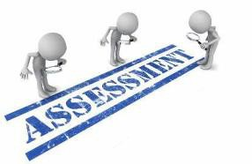

# ASSESSMENT METHODS FOR BLOCK EXAM:

Evaluation is a continuous process comprising of block examination and annual university examination. Students will be evaluated throughout the year. The internal assessment will contribute towards the ﬁnal examination scores.

Multiple examination methods including MCQs, SAQs, OSPE and viva will be for assessment. In line with PMC stipulation, the pass/fail marks for the test and examination will be 50%.

There will be a block exam at the end of each block.

**THEORY (KNOWLEDGE):**

MCQs (Multiple Choice Questions) and SAQs (Short Answer Questions) are used to assess the theory part for the block exam.

### MCQ:

* + A MCQ has a statement or clinical scenario followed by four options (likely answers).
  + After reading the statement/scenario student select ONE, the most appropriate answer/response from the given list of options.
  + Correct answer carries one mark, and incorrect ‘zero mark’. There is NO negative marking.

### SAQ:

### SAQ are open questions that requires student to create as answer. They are commonly used in examinations to access the basic knowledge and understanding of a topic.

**OSPE: OBJECTIVE STRUCTURED PRACTICAL EXAMINATION**

It may comprise between 12- 25 stations.

* + The content may assess application of knowledge, or practical skills.
  + Student will complete task in deﬁne time at one given station.
  + All the students are assessed on the same content by the same examiner in the same allocated time.
  + A structured examination will have observed, unobserved, interactive and rest stations.

### OBSERVED AND INTERACTIVE STATIONS:

They will be assessed by internal or external examiners through the task or viva.

### UNOBSERVED STATION:

It will be static station in which students will have to answer the questions related to the given pictures, models, or specimens on the provided response sheet.

### REST STATION:

It is a station where no task is given, and during this time student can organize his/her thought

**M.B.B.S BLOCK EXAMINATION MARKS DISTRIBUTION:**

|  |  |  |  |  |  |  |  |  |  |  |  |  |  |  |  |  |  |
| --- | --- | --- | --- | --- | --- | --- | --- | --- | --- | --- | --- | --- | --- | --- | --- | --- | --- |
| **Theory marks =140 + Practical marks= 140**  **Theory= 600 Marks Practical: =600**  **Total Marks: 1200** | | | | | | | | | | | | | | | | | |
| **MODULE/BLOCK** | | | | **BLOCK – IV** | | | | **BLOCK – V** | | | | | **BLOCK – VI** | | | | |
| **Module- 7** | | **Module- 8** | | **Module-9** | | | **Module- 10** | | **Module- 11** | | | **Module- 12** | |
| **Neurosciences** | | **Special senses** | | **GIT & Liver** | | | **RENAL & Excretion** | | **Endocrinology** | | | **Reproduction** | |
| **Professional Examination** | **Theory** | | | **100** | | **100** | | **100** | | | **100** | | **100** | | | **100** | |
| **200** | | | | **200** | | | | | **200** | | | | |
| **Practical/ OSPE** | | | **200** | | | | **200** | | | | | **200** | | | | |
| **Int. Assessment-IA**  **(30%)** | | | **Theory: 60 Practical: 60** | | | | **Theory: 60 Practical: 60** | | | | | **Theory: 60 Practical: 60** | | | | |
| **Subject wise distribution** | | **Subjects** | **MCQs** | **SAQs** | **OSPE** | **VIVA** | **MCQs** | **SAQs** | | **OSPE** | **VIVA** | **MCQs** | **SAQs** | | **OSPE** | **VIVA** |
| **Anatomy** | **31** | **4** | **5** | **22** | **31** | **4** | | **5** | **22** | **31** | **4** | | **5** | **22** |
| **Physiology** | **31** | **4** | **5** | **22** | **31** | **4** | | **5** | **22** | **31** | **4** | | **5** | **22** |
| **Biochemistry** | **30** | **4** | **5** | **21** | **30** | **4** | | **5** | **21** | **30** | **4** | | **5** | **21** |
|  | | **TOTAL#** | **92** | **4 SAQs x 4 marks = 16** | **15 (5 marks each station)** | | **92** | **4 SAQs x 4 marks = 16** | | **15 (5 marks each station)** | | **92** | **4 SAQs x 4 marks = 16** | | **15 (5 marks each station)** | |
| **Total** | **92** | **48** | **140** | | **92** | **48** | | **140** | | **92** | **48** | | **140** | |
| **Total**  **(theory + practical)** | | | **140** | | **140** | | **140** | | | **140** | | **140** | | | **140** | |
| **Theory Marks** | | | **140 + 60** | | | | **140 + 60** | | | | | **140 + 60** | | | | |
| **Practical Marks (OSPE)** | | | **140 + 60** | | | | **140 + 60** | | | | | **140 + 60** | | | | |
|  | **Internal Assessment** | | | **60** | | **60** | | **60** | | **60** | | | **60** | | **60** | | |
| **Total marks** | | | **200** | | **200** | | **200** | | **200** | | | **200** | | **200** | | |
| **Total Marks** | | | **400** | | | | **400** | | | | | **400** | | | | |
| **Grand total** | | **1200** | | | | | | | | | | | | | | | |

CRITERIA FOR INTERNAL ASSESSMENT

|  |  |  |  |  |  |  |
| --- | --- | --- | --- | --- | --- | --- |
| **THEORY ASSESSMENT**  **20 MARKS** | | | | **PRACTICAL ASSESSMENT**  **20 MARKS** | | |
| **ATTENDANCE**  **5 MARKS** | **PRESENTATIONS AND ASSIGNMNETS**  **5 MARKS** | **BEHAVIOUR**  **5 MARKS** | **CLASS PERFORMACE**  **SGDS**  **5 MARKS** | **ATTENDANCE**  **5 MARKS** | **BEHAVIOUR**  **5 MARKS** | **LOGBOOK**  **10 MARKS** |
| Above 90%=  5 marks  B/W 85% to 90%=  4 marks  B/W 80% to 85%=  3 marks  75% to 80%= 2 marks  Up to 75%= 1 mark  Below 75 % = 0 marks | Grade A=5 marks  Grade B= 3 marks  Grade C= 1 mark  No assignments or presentations =0 marks | No misbehave or warning in lectures = 5 marks  Written warning given to student = 0 marks | According to performa filled by faculty  Grade A=5 marks  Grade B= 3 marks  Grade C= 1 mark | Above 90%=  5 marks  85% to 90%=  4 marks  80% to 85%=  3 marks  75% to 80%= 2 marks  Up to 75%= 1 mark  Below 75 % = 0 marks | No misbehave or warning in lectures = 5 marks  Written warning given to student = 0 marks | Completed and signed =10 marks  Completed and unsigned=5 marks  Incomplete= 2 marks  No logbook =0 marks |

|  |  |
| --- | --- |
| **LEARNING RESOURCES** | |
| **SUBJECT** | **RESOURCS** |
| **ANATOMY** | **GROSSANATOMY**   1. Clinical Anatomy by Regions, Richard S. Snell 2. Gray’s Anatomy for students 3. Atlas of Human Anatomy, Frank H. Netter   **HISTOLOGY**   1. B. Young J. W. Health Weather’s Functional Histology 2. Histology by Laiq Hussain   **EMBRYOLOGY**   1. Keith L. Moore. The Developing Human 2. Langman’s Medical Embryology |
| **BIOCHEMISTRY** | **TEXTBOOKS**   1. Lippincott’s Illustrated Reviews, Biochemistry 2. Harper’s Illustrated Biochemistry 3. Lehninger Principle of Biochemistry 4. Biochemistry by Devlin |
| **PHYSIOLOGY** | **TEXTBOOKS**   1. Textbook Of Medical Physiology by Guyton and Hall 2. Ganong ‘S Review of Medical Physiology 3. Human Physiology by Lauralee Sherwood 4. Berne & Levy Physiology 5. Best & Taylor Physiological Basis of Medical Practice   **REFERENCEBOOKS**   1. Guyton & Hall Physiological Review 2. Essentials Of Medical Physiology by Jaypee 3. Textbook Of Medical Physiology by InduKhurana 4. Short Textbook of Physiology by Mrthur 5. NMS Physiology |
| **BEHAVIORAL SCIENCE** | 1.A New Intellectual Framework for Psychiatry – group of 12 A  2.ER Kannal– AMERICAN JOURNAL OF PSYCHIATRY,1998– ajp.psychiatryonline.org  3.The Hierarchy of the Sciences-group of 3 A  2000 |

|  |  |
| --- | --- |
| **OTHER LEARNING RESOURCE: S** | |
| **Hands-on Activities**  **/ Practical** | Students will be involved in Practical sessions and hands-on activities that link with the foundation module to enhance the learning. |
| **Labs** | Utilize the lab to relate the knowledge to the specimens and models available. |
| **Skill Labs** | A skills lab provides the simulators to learn the basic skills and procedures. This helps build the conﬁdence to approach the patients. |
| **Videos** | Video familiarize the student with the procedures and protocols to assist patients. |
| **Computer Lab / CDs/ DVDs / Internet**  **Resources:** | To increase the knowledge students should utilize the available internet resources and CDs/DVDs. This will be an additional advantage to increase learning. |
| **SDL** | SDL is scheduled to search for information to solve cases, read through diﬀerent resources and discuss among the peers and with the faculty to clarify the concepts. |

