.

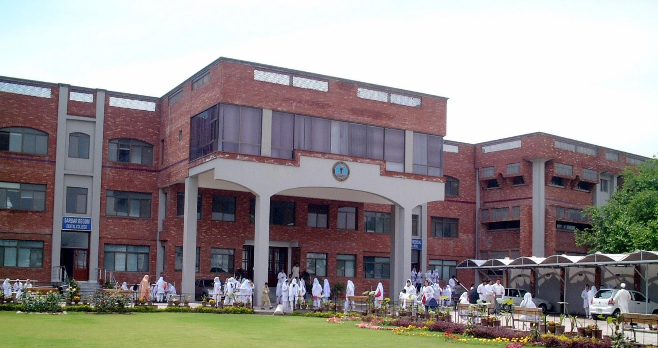

**KABIR MEDICAL COLLEGE**

SECOND YEAR MBBS

2024-2025

BLOCK VI(MODULE XI & XII)

**Department of Medical Education, Gandhara University**

### FROM THE DESK OF PRINCIPAL

Kabir Medical College has evolved, since its inception, as an exceptionally outstanding facility to provide quality education to the students.

I must appreciate the hard work of our well experienced and dedicated faculty members and staﬀ in maintaining high standards of medical education and the eﬀorts they have put in Kabir Medical College to be a distinguished center of excellence.

We meet international standards of professional education by installing the system of integrated curriculum and system-based teaching of basic medical sciences. We advocate interactive sessions to improve comprehension of students as well as training them with skills of communication and self- expression

Since the establishment of Kabir Medical College, we have been working constantly to upgrade services and facilities at the campus and the attached Naseer Teaching Hospital for our students and patients.

We would like our graduates to excel as conﬁdent, responsible and self-learning medical practitioners. With a state-of-the-art campus, experienced faculty, an up-to-date digital library, I assure you that your decision to study at Kabir Medical College will surely be a wise one, your experience here will be profoundly enriching and you will become an asset to the nation and international community health care professionals.

Brig Ahmad Hussain Mishwani (R) MBBS, FCPS (SURGERY) OJT (VASCULARSURGERY)

CHPE, MHPE (KMU)

Principal Kabir Medical College,

Gandhara University

Peshawar.

On behalf of the block team, I would like to welcome you to Block VI (Endocrinology & Reproductive )modules. As a part of the system-based curriculum, these modules are an integrated presentation comprises system -based modules which links basic science knowledge to clinical problems. Integrated teaching means that subjects are presented as a meaningful whole. Students will be able to have better understanding of basic sciences by learning them repeatedly in relation to clinical examples. Small group discussions, early exposure to clinics, wards, and skills acquisition in skills lab are characteristics of integrated teaching program.

Our mission is to provide all educational opportunities to the students. Therefore, on completion of the MBBS program, graduates will possess an appropriate foundation of knowledge, skills, and attitudes to be well prepared to practice safely and eﬀectively. This study guide includes the course contents of the modules, the learning objectives, practical’s, topics of the small group discussions. It also includes the assessment plan for the block exam.

As director DME I will be meeting with the facilitators to receive the feedback and will try to resolve any diﬃculties or problems faced during the block. Please do not hesitate to contact the department for any assistance or academic help. I wish you all an enjoyable and learning experience with Block 6.

**Director DME: Dr. Marina Khan**

|  |
| --- |
| **Table of Contents** |
| **Block Team.................................................................................................................** |
| **List of abbreviations….................................................................................................** |
| **Aims of the study guide… ..........................................................................................** |
| **Modules distribution of 2nd year MBBS......................................................................** |
| **Introduction of Module …...........................................................................................** |
| **General Outcomes…....................................................................................................** |
| **Leaning Methodologies…............................................................................................** |
| **Rules Regulations........................................................................................................** |
| **Learning objectives & Course contents......................................................................** |
| **Assessment……………………………………………………………………………………** |
| **Learning Resources…………………………………………………………………………** |

**BLOCK TEAM**

|  |  |
| --- | --- |
| **Dr. Marina Khan**  **marinakahn@hotmail.com**  **EXT=155**  **Director Department of Medical Education** | |
| **DEPARTMENT OF ANATOMY** | Prof Dr Qaiser Inayat  Assist Prof.Dr Gul Rukh  Assist Prof.Dr Ibrahim  Dr Zakir  Dr Rasheed  D Ayesha |
| **DEPARTMENT OF PHYSIOLOGY** | Prof Dr. Anjum Humayun  Prof Dr. Ghulam Jillani  Assist: Prof Dr. Najma  Assist Prof .Dr Javed  Assist Prof .Dr Somaya  Dr. Rajwali  Dr. Ashfaq |
| **DEPARTMENT OF BIOCHEMISTRY** | Prof Dr. Mohammad Ahmad Prof Dr. Mudassir Ahmad  Assist Prof Dr Ubaid Ullah  Assist Prof Dr Inayat  Dr Shahnaz  Dr Asma  Dr Madiha  Dr Wagma  Dr Kulsoom  Dr Noorain  Dr Abdur Rehman |
| **DEPARTMENT OF MEDICAL EDUCATION** | Assist Prof.Dr. Marina Khan  Assist Prof.Dr. Syed Muhammad Junaid  Assist Prof.Dr. Bakhtiar  Dr Alia Zeb  Dr Usama Aurangzeb |

# LIST OF ABBREVIATIONS

|  |  |
| --- | --- |
| **DME** | Department of Medical Education |
| **CI** | Curriculum integration |
| **ANAT** | Anatomy |
| **PHYSIO** | Physiology |
| **BIO** | Biochemistry |
| **HISTO** | Histology |
| **EMB** | Embryology |
| **PATHO** | Pathology |
| **PHARMA** | Pharmacology |
| **RADIO** | Radiology |
| **COM** | Community medicine |
| **FM** | Forensic Medicine |
| **LGIS** | Large Group Interactive Session |
| **SGD** | Small Group Discussion |
| **SDL** | Self-Directed Learning |
| **MCQ** | Multiple Choice Question |
| **SAQ** | Short Answer Question |
| **OSPE** | Objective Structured Practical Exam |

## AIMS OF THE STUDY GUIDE

It is an aid to:

* Inform students that how student learning program of the BLOCK-wise module has been organized
* Help students organize and manage their studies throughout the modules.
* Guide students on assessment methods, rules, and regulations
* Communicates information on organization and management of the modules. This will help the student to contact the right person in case of any diﬃculty.
* Deﬁnes the objectives which are expected to be achieved at the end of the block.
* Identify the learning strategies such as lectures, small group teachings, clinical skills, and demonstration, tutorial that will be implemented to achieve the modules objectives.
* Provides a list of learning resources such as books, computer assisted learning programs, web- links, and journals, for students to consult to maximize their learning.
* Highlights information on the contribution of continuous and block examinations on the student’s overall performance.
* Focus on information pertaining to examination policy, rules, and regulations

## ORGANIZATION OF MODULAR CURRICULUM:

## 2ND YEAR MBBS

|  |  |  |  |  |  |  |  |  |  |  |
| --- | --- | --- | --- | --- | --- | --- | --- | --- | --- | --- |
| **YEAR** | **BLOCK 4** | | **EXAM BLOCK 4** | **BLOCK 5** | | **EXAM BLOCK 5** | **BLOCK 6** | | **EXAM BLOCK 6** | **FINAL EXAM** |
| **2** | **Module**  **7** | **Module**  **8** | **Module**  **9** | **Module**  **10** | **Module**  **11** | **Module**  **12** |
| Neuro  sciences | Special Senses | GIT & Liver | Renal & excretion Module | Endocrinology | Reproduction |

### LEARNING METHODOLOGIES

The following teaching / learning methods are used to promote better understanding:

* Large Group Interactive Lectures
* Small Group Discussion
* Practical
* Skills session
* E-Learning
* Self-Directed Learning

### LARGE GROUP INTERACTIVE LECTURES (LGIS)

### 

In large group, the lecturer introduces a topic or common clinical conditions and explains the underlying phenomena through questions, pictures, videos of patients' interviews, exercises, etc. Students are actively involved in the learning process.

### SMALL GROUP DISCUSSIONS (SGDs):



This format helps students to clarify concepts acquire skills or attitudes. Sessions are structured with the help of specific exercises such as patient case, interviews, or discussion topics. Students exchange opinions and apply knowledge gained from lectures, tutorials, and self-study. The facilitator role is

to ask probing questions, summarize, or rephrase to help clarify concepts.

#### **PRACTICAL**

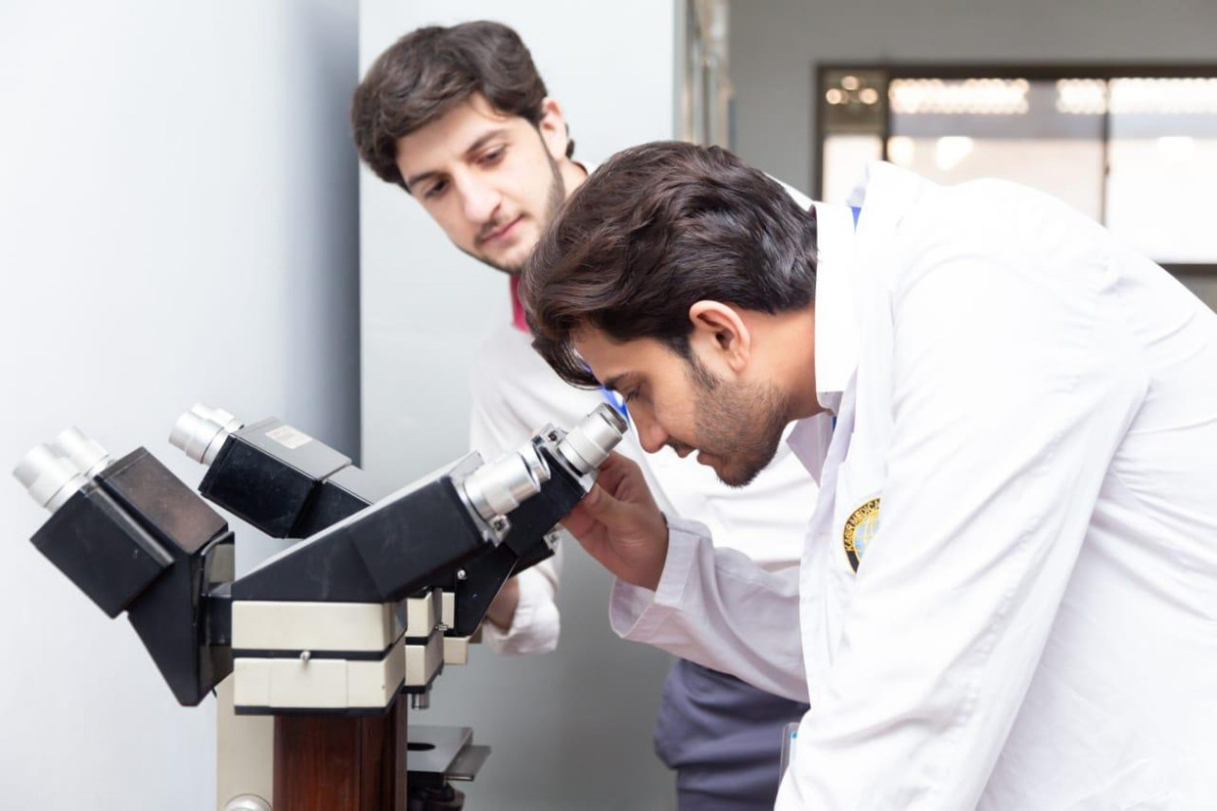

Basic science practical’s related to Anatomy, Biochemistry and Physiology are scheduled for student learning.

**SELF DIRECTED LEARNING (SDL):**

Students assume responsibilities of their own learning through individual study, sharing and discussing with peers, seeking information from Learning Resource Center, teachers, and resource persons within and outside the college. Students can utilize the time within the college scheduled hours of self-study.

**E-LEARNING:**

E-Learning is a strategy by which learning occurs through the utilization of electronic media, typically the Internet. The basic aspects of medical professionalism and ethics will be addressed through an e-learning course.

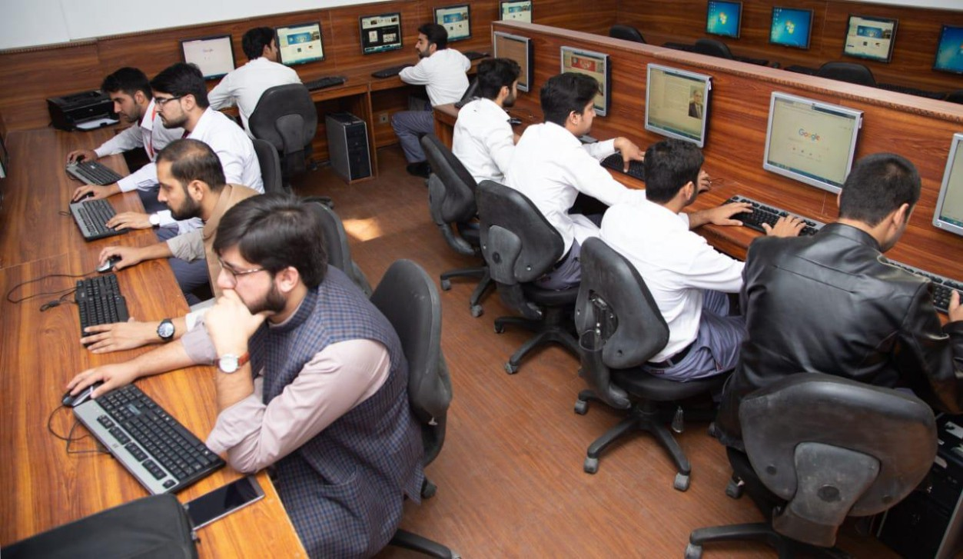

1. **Hands on Training**
2. **Histology, Biochemistry, Physiology sessions:**

Histology and biochemistry practical will demonstrate your skills and help in clarifying your concepts practically.

1. **Clinical skill lab sessions Hands on**

Practice of clinical examination on mannequins.

**3) Museum Sessions:**

Our museum is equipped with models to help you understand the concepts more clearly.

# RULES AND REGULATIONS

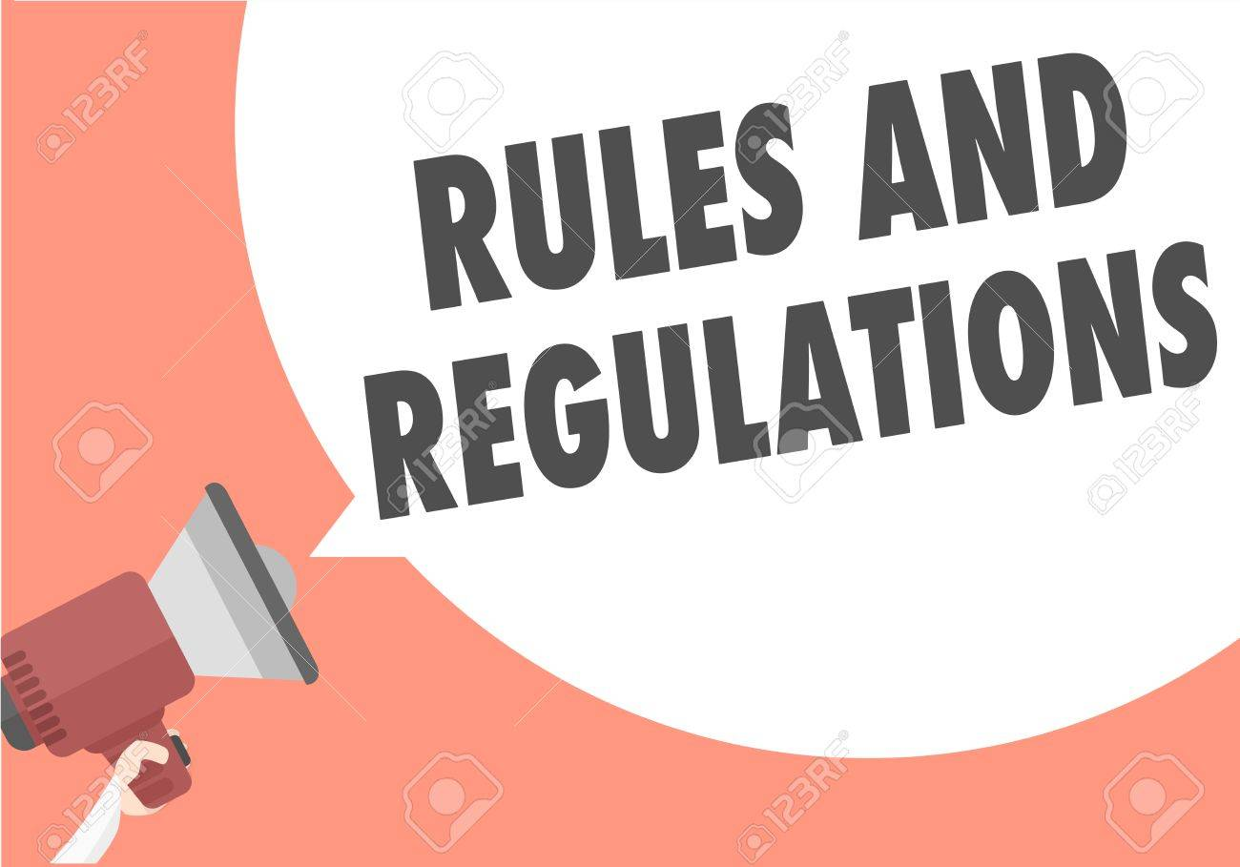

We will be making the journey through Block 6 in 10 weeks. Therefore, this course includes an intensive coursework load. Class attendance and participation are extremely important to learning and are considered in the evaluation of course grade. If there is anything that the block team can do to assist you during the course, please feel free to contact them. Attendance will be monitored during the diﬀerent teaching activities. If the attendance is less than 75%, the student will not be allowed to sit for block and annual examination.



All examinations must be taken on the date scheduled. No student will be allowed to enter the examination area after the examination starts. There will be a block exam covering two modules. There will be 3 block examination and the 20% weightage of these block exam will be added to the annual professional examination as an internal assessment.

# ENDOCRINOLOGY

# MODULE XI

# DURATION: FOUR WEEKS

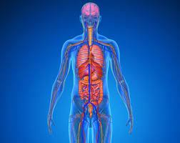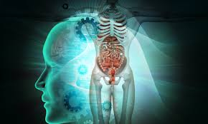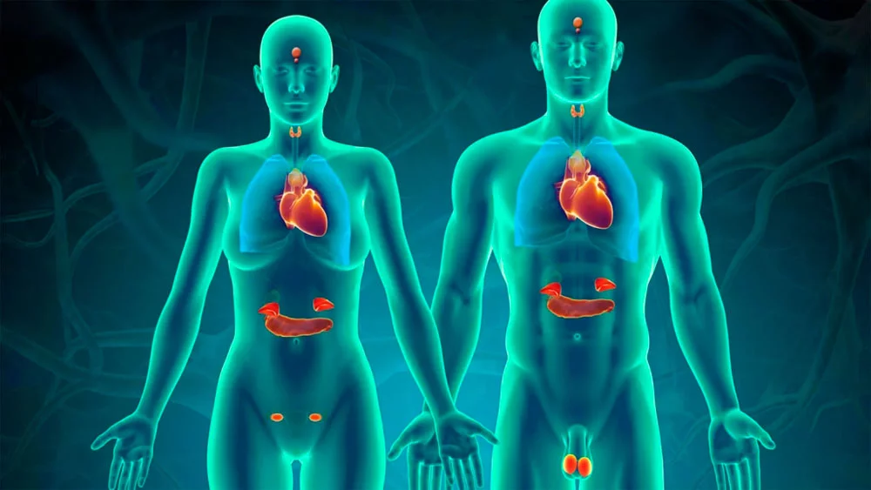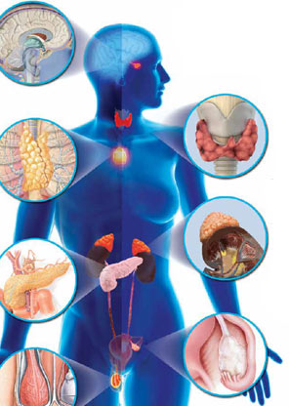

# INTRODUCTION TO ENDOCRINOLOGY

# The Endocrinology & Metabolism module is a 4 weeks’ module consisting of study of synthesis and structure of hormones and regulation of different endocrine glands and the disorders associated with them. The function of the endocrine system is to coordinate and integrate cellular activity within the whole body by regulating cellular and organ function throughout life and maintaining homeostasis. Homeostasis, or the maintenance of a constant internal environment, is critical to ensuring appropriate cellular function. In this module the anatomy and physiology of the endocrine organs along with functional biochemistry of the hormones secreted along with normal physiological changes are taught in integrated fashion with reference to common disease processes occurring in our community.

# The Endocrine system is the collection of glands that produces hormones that regulate metabolism, growth and development, tissue function, sexual function, reproduction, sleep, and mood, among other things. Endocrinology is the study of specific secretions known as hormones and their related effects on the body. This module will build the concepts that will taught in the latter module of Endocrine system -2. This module deals with the normal structure and functions of endocrine glands. At the same time, it helps learners predict endocrine related conditions based on their basic knowledge.

# This module also includes the mechanisms involved in carbohydrates, fats and protein metabolism. The contents of the module will be taught in lectures, SGDs, Practicals and DSLs

# RATIONALE:

# Endocrine disorders like Diabetes Mellitus and Thyroid related diseases are very common in all parts of Pakistan. This module provides the basis on which learners will learn not only knowledge application but also the ability to link normal and the abnormal in the upcoming years of the curriculum.

# CURRICULUM INTEGRATION:

# The term curriculum integration (CI) refers to combining two or more subjects when teaching a topic. Curriculum integration involves integrating the subject concepts, subject content and subject competencies developed in a topic. The goal is to provide an opportunity for deep learning – a wider and deeper understanding of the topic as a whole and more importantly, an understanding of the subject concepts within that topic. The benefits of integrated curriculum both for teaching and learning are endless integrated curriculum allows students to have a deeper understanding of the course subject matter and how to apply the material that they have learned in the classroom in a real-world situation.

# HORIZONTAL INTEGRATION:

# Horizontal integration in a curriculum means that what was once taught in parallel, sequential modules or subjects is taught together in a single module or subject.

# VERTICAL INTEGRATION:

# Vertical integration in curriculum means that foundation sciences are combined with clinical sciences—clinical skills, diagnostic reasoning, differential diagnosis, and management options.

# The various integrating disciplines of the Endocrinology & Metabolism module are:

**ANATOMY**

**BIOCHEMISTRY**

**PHYSIOLOGY**

**COMMUNITY**

**MEDICINE**

**PEADS**

**ENDOCRINOLOGY**

**BEHAVIORAL**

**SCIENCE**

**PHARMACOLOGY**

**SURGERY**

**FORENSIC MEDICINE**

**PATHOLOGY**

**RADIOLOGY**

**RIPPLE**

**MEDICINE**

# LEARNING OUTCOMES:

# KNOWLEDGE:

# By the end of Block 6 (Endocrinology & Reproduction) module, the students will be able to:

# Review the anatomy of endocrine organs (pituitary, thyroid, pancreas, parathyroid and adrenal gland).

# Describe the role of hormones in relation to homeostasis and metabolism.

# Enlist common endocrine related disorders and their pathogenesis

# Recognize various endocrine disorders based on clinical and investigative findings

# Highlight the role of pharmacological agents used to treat endocrine disorders

# Describe the chemistry, biosynthesis, secretion, mechanism of action, regulation, and metabolic effects of Thyroid and Parathyroid hormones with related clinical disorders

# Describe the histological features of pancreas and differentiate between the exocrine and endocrine parts

# Describe the chemistry, biosynthesis, secretion, mechanism of action, regulation, and metabolic effects of Insulin & Glucagon with its related clinical disorders

# Describe the development of adrenal gland and differentiate between the various histological zones of the gland.

1. Describe biosynthesis, secretion, mechanism of action, regulation, and metabolic effects of Adrenal hormones with its related clinical disorders
2. Explain the pathology of hypo and hyperthyroidism, pharmacology of hypo-hyper thyroid drugs and growth chart and malnutrition in pediatrics.
3. Describe the histological features of testes, vas deferens, epididymis, prostate, ovary, mammary gland, and placenta.
4. Describe the gross features of pelvis, sacrum, contents of pelvis, inguinal hernia, and perineum.
5. Describe the development of male and female reproductive system
6. Describe the physiological anatomy of male and female reproductive organs and function of testosterone
7. Describe the female hormone system, menstrual cycle, and placental changes in pregnancy
8. Describe the synthesis of sex hormones
9. Describe the energy requirement and Macronutrient distribution of, carbohydrates, proteins and lipids and their role in human body.
10. Describe the investigation & management of tumor of testis &carcinoma of breast.
11. Describe the psychosocial aspects of reproductive health, sociocultural aspects of sexual dysfunction & inguinoscrotal hernia.
12. Enlist the literature search sources and strategies.
13. Describe safe motherhood its components, common diseases affecting reproductive health
14. Describe pelvimetry, antenatal care, prenatal diagnosis, fetal skull, and congenital anomalies
15. Describe abortion & medicolegal aspects of pregnancy

# SKILLS:

# By the end of block 6 (Endocrinology & Reproduction) modules, the students will be able to:

1. Identify the microscopic structure of thyroid and parathyroid, pituitary, adrenal and pineal gland under a microscope.
2. Determination of serum chloride, serum glucose and alkaline phosphate
3. Identify the microscopic structure of testes, prostrate, ovary, placenta, and mammary gland
4. Determination of creatine, chloride, and serum bilirubin.
5. History and examination of patient with endocrine & reproductive issues
6. Examination of patient with thyroid status, endocrine Rbs monitoring by glucometer
7. Examination of prostate, rectum, and breast on simulator
8. Perform different labs in the endocrine disorders

# ATTITUDE:

By the end of Block 6 (Endocrinology & Reproduction) s module, the students will be able to:

1. Develop respect for the individuality and values of others - (including having respect for oneself) patients, colleagues, and other health professionals.
2. Organize & distribute tasks.
3. Exchange opinion & knowledge.
4. Develop communication skills and etiquette with sense of responsibility.
5. To equip themselves for teamwork.
6. Regularly attend the classes.
7. Demonstrate good laboratory practices.
8. Carry out practical work as instructed in an organized and safe man
9. Make and record observations accurately.
10. Develop the ability to give and receive feedback
11. Respect for self and peers

# LEARNING OBJECTIVES AND COURSE CONTENTS:

At the end of the teaching session the student should be able to achieve the following objectives

# \

|  |  |  |
| --- | --- | --- |
| **GROSS ANATOMY LECTURES** | | |
| **S.NO** | **TOPICS** | **LEARNING OBJECTIVES** |
| 1 | An overview of endocrinology and adrenal gland  And pituitary gland | Define hormones  Classify hormones  Explain the gross features of adrenal gland and pituitary gland |
| 2 | Thyroid and parathyroid gland | Describe the gross anatomy of thyroid gland  Describe the gross anatomy of parathyroid gland |

|  |  |  |  |
| --- | --- | --- | --- |
| **EMBRYOLOGY LECTURES** | | | |
| **S.NO** | **TOPICS** | | **LEARNING OBJECTIVES** |
| 1 | Development of pituitary gland |  | Describe the development of pituitary gland |
| 2 | Development of thyroid and parathyroid gland |  | Describe the development of thyroid and parathyroid gland |
| 3 | Development of adrenal gland |  | Describe development of the adrenal gland |
| 4 | Development of pineal body |  | Describe development of the pineal glandar |

|  |  |  |  |
| --- | --- | --- | --- |
| **HISTOLOGY LECTURES** | | | |
| **S.NO** | **TOPICS** | **LEARNING OBJECTIVES** | |
| 1 | Pituitary gland |  | Describe the histological features of adenohypophysis  Describe the pars tuberalis, pars distalis and pars intermedia  Describe the histological features of neurohypophysis, pars nervosa and infundibulum |
| 2 | Thyroid and parathyroid gland |  | Describe microscopic structure of the thyroid follicles in active and passive phase  Describe the histological features of thyroid gland and para thyroid gland |
| 3 | Adrenal gland |  | Describe the histological features of adrenal gland  Describe the different three zones of the cortex of the adrenal gland  Describe the medulla of the adrenal gland |
| 4 | Pineal gland |  | Describe the histological features of the pineal body |

|  |  |  |  |
| --- | --- | --- | --- |
| **HISTOLOGY PRACTICALS** | | | |
| **S.NO** | **TOPICS** | **LEARNING OBJECTIVES** | |
| 1 | Pituitary gland |  | Identify and describe the microscopic structure of pituitary gland under a microscope |
| 2 | Thyroid and parathyroid gland |  | Identify and describe the microscopic structure of thyroid and parathyroid gland under a microscope |
| 3. | Adrenal gland |  | Identify and describe the microscopic structure of adrenal gland under a microscope |
| 4 | Pineal gland |  | Identify and describe the microscopic structure of pineal gland under a microscope |

|  |  |  |
| --- | --- | --- |
| **ANATOMY SGDS** | | |
| **S.NO** | **TOPIC** | **LEARNING OBJECTIVES** |
| 1 | Pituitary gland | Discuss the gross anatomy and histology of pituitary glands |
| 2 | Thyroid and parathyroid gland | Discuss the histology and gross anatomy of thyroid and para thyroid gland |
| 3 | Adrenal gland | Describe the histological features and gross anatomy of adrenal gland |
| 4 | Pineal body | Discuss the histological features of the pineal body |

|  |  |  |  |
| --- | --- | --- | --- |
| **PHYSIOLOGY LECTURES** | | | |
| **S.NO** | | **TOPICS** | **LEARNING OBJECTIVES** |
| 1 | | Overview of endocrinology | General view of endocrinology and classification of hormones  Explain the mechanism of hormones synthesis transport clearance from blood  Describe the regulation of hormones and measurement of hormone concentration in blood  Explain the mechanism of hormones action  Explain the second messenger mechanisms for mediating intracellular hormonal functions |
| 2 | | Mechanism of action of hormones | Explain mechanisms of Action of Hormones  Describe second messenger mechanisms for mediating intracellular hormonal functions  Describe measurement of Hormone Concentrations in the Blood |
| 3 | Pituitary hormones and control by hypothalamus | | Describe the Physiological anatomy of pituitary gland  Explain the hypothalamic control of pituitary secretion  Explain the Physiological function of growth hormones  Explain the Regulation of growth hormones and physiology of insulin like growth factor  Describe the Physiological function of posterior pituitary gland hormones |
| 4 | Synthesis, Transport & mechanism of thyroid hormone | | Describe formation, Secretion, and transport of thyroid hormones  Explain mechanism of action of thyroid hormones  Explain the actions of thyroid hormones on cellular metabolism |
| 5 | Regulation & function of Thyroid gland | | Explain the Synthesis release and transport of thyroid hormone  Explain the Mechanism of action and metabolic effects of thyroid hormones  Describe the Physiological function of thyroid hormones  And regulation of thyroid hormone |
| 6 | Diseases of thyroid gland & drugs used in its treatment | | Enlist the diseases of thyroid glands and enlist the drugs used for its treatment |
| 7 | synthesis secretion &transport of adreno cortical hormones | | Enumerate the synthesis, secretion, and transport of adrenal cortical hormones  Enlist its Types,  Explain the mechanism of action and physiological effects of mineralocorticoid and regulation  Explain the effects of cortisol on carbohydrate, fat, and protein  Explain the Role of cortisol in inflammation, stress, and allergy  Regulation of cortisol, ACTH secretion and adrenal androgen |
| 8 | Aldosterone physiology (Mineralocorticoids) | | Describe Types, Mechanisms, and regulation of mineralocorticoids  Describe the physiological Effects of Aldosterone (Renal, Circulatory and others) |
| 9 | Glucocorticoids | | Describe Types and Mechanisms of Glucocorticoids actions |
| 10 | Regulation of cortisol | | Describe Effects of Cortisol on Carbohydrate, Proteins and Fat Metabolism  Describe role of Cortisol in Stress, Inflammation and Allergy |
| 11 | Insulin & its metabolic effects synthesis & chemistry | | Explain Mechanism of action of insulin  Describe the Control of Insulin Secretion |
| 12 | Effects of insulin on carbohydrates, protein, and Fats metabolism | | Describe the effects of insulin on carbohydrates, proteins, and Fats metabolism |
| 13 | Mechanism of insulin secretion & its control | | Explain Mechanism of action of insulin  Describe the Control of Insulin Secretion |
| 14 | Glucagon & its function | | Describe regulation of glucagon and its effects |
| 15 | Parathyroid gland | | Describe mechanism of action  Discuss effects of parathyroid hormone and its regulation |
| 16 | Physiological function of calcitonin | | Discuss physiological function of calcitonin |

|  |  |  |
| --- | --- | --- |
| **PHYSIOLOGY SGDs** | | |
| **S.NO** | **TOPIC** | **LEARNING OBJECTIVES** |
| 1 | Diseases of growth hormones | Describe Growth hormone’s effect on growth and metabolism  Explain the structure, mechanism of action and physiological effects of Insulin-Like Growth Factors  Describe regulation of Growth Hormone |
| 2 | Diseases of Adrenal cortex (Cushing syndrome+ Addison disease) | Discuss the diseases of adrenal cortex |
| 3` | Diabetes Mellitus | Describe Effects of hyper glycaemia /hypo glycaemia on body functions |
| 4 | Diseases of parathyroid hormones (Rickets + Osteomalacia) | Discuss the diseases caused by parathyroid hormones |

|  |  |  |
| --- | --- | --- |
| **BIOCHEMISTRY LECTURES** | | |
| **S.NO** | **TOPICS** | **LEARNING OBJECTIVES** |
|  | Hormones | Define hormones  Differentiate between these terms endocrine, paracrine & autocrine.  Classify hormones on various basis  Discuss the mechanism of action of hormones  Define 2nd messengers and their roles |
|  | Anterior pituitary gland | Enumerate the hormones of anterior pituitary gland.  Describe the chemistry, secretion, mechanism of action, regulation, and metabolic effects of Growth hormone with its related clinical disorders |
|  | Posterior pituitary gland | Enumerate the hormones of the posterior pituitary gland. Describe the chemistry, secretion, mechanism of action, regulation, and metabolic effects of the hormones of the posterior pituitary gland with its related clinical disorders |
|  | Parathyroid hormone | Enumerate the hormones secreted from parathyroid gland. Describe the chemistry, biosynthesis, mechanism of action, regulation, and metabolic effects of parathyroid hormone with its related clinical disorders |
|  | Adrenal cortex I | Enumerate the hormones secreted from adrenal cortex. Describe biosynthesis, mechanism of action, regulation, and metabolic effects of Adrenal cortical hormones with its related clinical disorders |
|  | Adrenal cortex II | Enumerate the hormones secreted from adrenal cortex. Describe biosynthesis, mechanism of action, regulation, and metabolic effects of Adrenal cortical hormones with its related clinical disorders |
|  | Adrenal medulla | Enumerate the hormones secreted from adrenal medulla  Describe biosynthesis, mechanism of action, regulation, and metabolic effects of Adrenal medullary hormones with its related clinical disorders |

|  |  |  |
| --- | --- | --- |
| **BIOCHEMISTRY SGDs** | | |
| **S. No** | **TOPICS** | **LEARNING OBJECTIVE** |
| 1 | Diabetes Mellitus | Discuss diabetes mellitus |

|  |  |  |  |
| --- | --- | --- | --- |
| **BIOCHEMISTRY PRACTICAL’s** | | | |
| **S.NO** | **TOPICS** | **LEARNING OBJECTIVES** | |
| 1 | Determination of urine glucose |  | Describe the apparatus, procedure of an experiment How to perform practical |
| 2 | Determination of serum chloride |  | Describe the apparatus, procedure of an experiment How to perform practical |
| 3. | Determination of serum alkaline phosphatase |  | Describe the apparatus, procedure of an experiment How to perform practical |

|  |  |  |  |
| --- | --- | --- | --- |
| **GENERAL MEDICINE LECTURES** | | | |
| **S.NO** | **TOPICS** | | **LEARNING OBJECTIVES** |
| 1 | Acromegaly |  | Describe the pathophysiology, clinical features and investigations of patient with Acromegaly and Gigantism |
| 2 | Hypothyroidism  Hyperthyroidism |  | Describe the clinical features of hyperthyroidism  Describe the investigation and treatment of hyperthyroidism  Describe the clinical features of hypothyroidism  State the investigation and treatment of hypothyroidism |
| 3 | Cushion`s syndrome |  | Enlist the clinical features and complications of Cushion`s syndrome |
| 4 | Addison`s disease |  | Enlist the clinical features and complications of Addison`s disease |

|  |  |  |
| --- | --- | --- |
| **PEADS LECTURES** | | |
| **S.NO** | **TOPIC** | **LEARNING OBJECTIVE** |
| 1 | Growth chart | Discuss growth chart  Discuss growth and development |

|  |  |  |
| --- | --- | --- |
| **SURGERY LECTURES** | | |
| **S.NO** | **TOPIC** | **LEARNING OBJECTIVES** |
|  | Thyrotoxicosis/surgical preparation of toxic patient | Define and discuss thyrotoxicosis Describe clinical features and management of thyrotoxicosis  Discuss surgical preparation of toxic patient |
|  | Investigation and management of thyroid nodules | Define thyroid nodules Classify thyroid nodules |
|  | Tumors of the thyroid gland | Discuss classification of tumors thyroid gland  Discuss etiology and management tumors of thyroid glands  Discuss treatment options for tumor of thyroid gland |
|  | Surgical management of diabetic patient | Describe diabetes Discuss surgical management of diabetic patients |

|  |  |  |
| --- | --- | --- |
| **RADIOLOGY LECTURES** | | |
| **S.NO** | **TOPIC** | **LEARNING OBJECTIVE** |
| 1 | Imaging anatomy of endocrine glands | Identifying important landmarks of endocrine glands  Describe morphologic relationships and discuss the significance of endocrine glands |

|  |  |  |
| --- | --- | --- |
| **RIPPLE LECTURE** | | |
| **S.NO** | **TOPIC** | **LEARNING OBJECTIVE** |
| 1 | Criteria for Prioritization of a Research topic | Discuss criteria for prioritization of a research topic |

|  |  |  |
| --- | --- | --- |
| **COMMUNITY MEDICINE LECTURE** | | |
| **S.NO** | **TOPIC** | **LEARNING OBJECTIVES** |
| 1 | Introduction to common prevalent diseases that affect endocrine system | Discuss the prevelance of Communicable and non-communicable diseases that affect the endocrine system |
| 2 | Obesity | Discuss the effects of obesity on endocrine system, its epidemiology & prevention |
| 3 | Malnutrition | Discuss the effects of malnutrition on the endocrine system its epidemiology and prevention |
| 4 | Communicable diseases that affect endocrine system (mumps, syphilis) | Discuss the Epidemiology & prevention of mumps and syphilis |
| 5 | Epidemiology & prevention of diabetes mellitus | Discuss the epidemiology & prevention and effects an endocrine system of diabetes mellitus |

|  |  |  |
| --- | --- | --- |
| **PATHOLOGY LECTURE** | | |
| **S.NO** | **TOPIC** | **LEARNING OBJECTIVES** |
| 1 | Acromegaly | Define acromegaly  Enumerate causes of acromegaly  Discuss clinical presentation of acromegaly |
| 2 | Hyperthyroidism | Define hyperthyroidism  Enumerate causes of hyperthyroidism Discuss clinical presentation of hyperthyroidism |
| 3 | Hypothyroidism | Define hypothyroidism  Enumerate causes of hypothyroidism  Discuss clinical presentation of hypothyroidism |
| 4 | Thyroid function test | Discuss thyroid function test  Discuss how to interpret and correlate thyroid function test  Discuss how to diagnose the patient with thyroid disease |
| 5 | Cushing’s syndrome | Define Cushing’s syndrome  Enumerate causes of Cushing’s syndrome Discuss clinical presentation of Cushing’s syndrome |
| 6 | Addison’s disease | Define Addison’s disease  Enumerate causes of Addison’s disease Discuss clinical presentation of Addison’s disease |

|  |  |  |
| --- | --- | --- |
| **BEHAVIORIAL SCIENCES LECTURE** | | |
| **S.NO** | **TOPIC** | **LEARNING OBJECTIVE** |
| 1 | Social support treatment stigma | Discuss social support treatment stigma |

|  |  |  |
| --- | --- | --- |
| **PHARMACOLOGY LECTURE** | | |
| **S.NO** | **TOPIC** | **LEARNING OBJECTIVES** |
| 1 | Drugs used in hypo & Hyperthyroidism | Discuss the types, mechanism of action and indications of hypo and hyperthyroidism drugs. |
| 2 | Oral Hypoglycemic Drugs | Discuss the indications and mechanism of action of anti-diabetic drugs. |

**MODULE XII**

**REPRODUCTION**

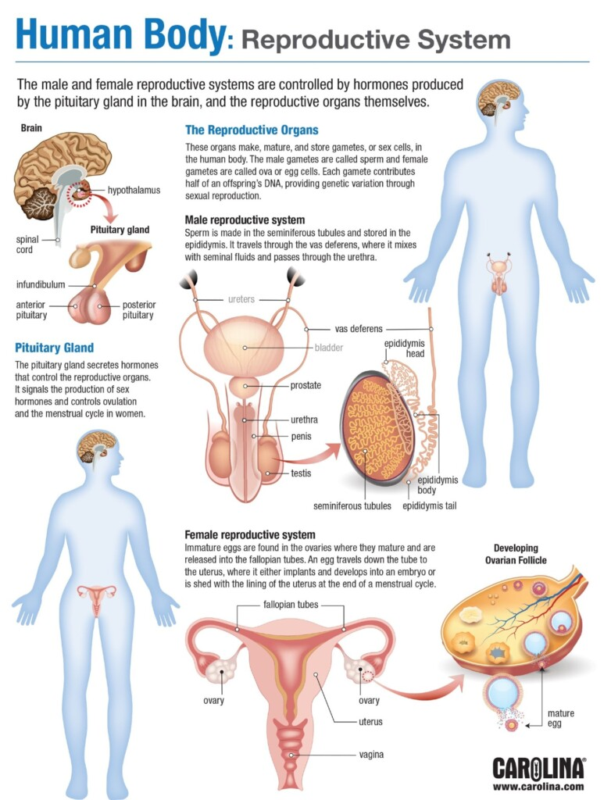

INTRODUCTION TO REPRODUCTION

# REPRODUCTION

# MODULE XII

# The module will explore the normal as well as the abnormal physiology of the male and female reproductive system. Students will be introduced to a variety of pathologies to facilitate a better understanding of how the reproductive system is impacted by diseases. It will give the broad overview of the system. The module will also address reproductive hormonal changes associated with different stages of life correlating pathophysiology with clinical present

# RATIONALE:

# Reproduction module enables students to relate the knowledge of anatomy, physiology, and pathology of the structures of the male and female reproductive system with the clinical presentation of internal and external genital diseases to manage general gynecological problems, sexually transmitted infections, infertility, tumors, breast disorders, pregnancy and related issues in the mother and neonates

**COURSE CONTENTS & LEARNING OBJECTIVES**

|  |  |  |
| --- | --- | --- |
| **GROSS ANATOMY LECTURES** | | |
| **S.NO** | **TOPICS** | **LEARNING OBJECTIVES** |
| 1 | Pelvis /sacrum | Describe landmarks and diameter of bony pelvis  Describe the cavity of the pelvis  Difference between male and female pelvis |
| 2 | Contents of pelvis | Enumerate different contents of pelvis  Describe gross features of each content in detail |
| 3 | Inguinal hernia | Describe inguinal canal  Describe contents of inguinal canal |
| 4 | Overview of perineum | Describe surface anatomy of perineum  Give an overview about structures present in it  Difference between male and female perineum |

|  |  |  |  |
| --- | --- | --- | --- |
| **EMBRYOLOGY LECTURES** | | | |
| **S.NO** | **TOPICS** | **LEARNING OBJECTIVES** | |
| 1 | Development of reproductive system |  | Describe development of reproductive system |
| 2 | Development of genitalia and inguinal canal |  | Describe development of genitalia and inguinal canal |
| 3. | Development of female genital tract |  | Describe development of female genital tract |

|  |  |  |  |
| --- | --- | --- | --- |
| **HISTOLOGY LECTURES** | | | |
| **S.NO** | **TOPICS** | **LEARNING OBJECTIVES** | |
| 1 | Testes /vas deferens/epididymis |  | Describe the histological features of  testes  Describe the histological features of cells of testes |
| 2 | Prostate |  | Describe the histological features of  Prostate gland |
| 3 | Ovary |  | Describe the histological features of medulla of the ovary  Describe the histological features of cortex of the ovary |

|  |  |  |  |
| --- | --- | --- | --- |
| **HISTOLOGY PRACTICALS** | | | |
| **S.NO** | **TOPICS** | **LEARNING OBJECTIVES** | |
| 1 | Testes |  | Identify the microscopic structure of testes under a microscope |
| 2 | Prostate |  | Identify the microscopic structure of prostate under a microscope |
| 3 | Ovary |  | Identify the microscopic structure of ovary under a microscope |
| 4. | Mammary gland |  | Identify the microscopic structure mammary gland under a microscope |
| 5. | Placenta | Identify the microscopic structure of placenta under a microscope | |

|  |  |  |  |
| --- | --- | --- | --- |
| **ANATOMY SGD** | | | |
| **S.NO** | **TOPICS** | **LEARNING OBJECTIVE** | |
| 1 | Bony pelvis |  | Describe landmarks and diameter of bony pelvis  Describe the cavity of the pelvis  Difference between male and female pelvis |
| 2 | Content of pelvis |  | Enumerate different contents of pelvis  Describe gross features of each content in detail |
| 3. | Perineum of male & female perineum |  | Enumerate different contents of perineum  Describe gross features of each content in detail |
| 4 | Male & female reproductive system and differences of their perineum |  | Describe gross features of male and female reproductive system  Enlist the differences between male and female perineum |

|  |  |  |
| --- | --- | --- |
| **PHYSIOLOGY LECTURES** | | |
| **S.NO** | **TOPICS** | **LEARNING OBJECTIVES** |
| 1 | Physiological anatomy of male reproductive organ, Spermatogenesis & its hormonal control | Define different terms and physiology of male reproductive system  Define and discuss Spermatogenesis  Enumerate hormones related to male reproductive system |
| 2 | Prostate gland semen & capacitation of spermatozoa & acrosome | Explain the function of prostate gland  Describe the composition of semen |
| 3 | Function of Testosterone | Relate the functions of testosterone with its secretion and metabolism  Describe the intracellular mechanism of action of testosterone |
| 4 | Regulation of testosterone | Relate the control of secretion of testosterone with its congenital and acquired abnormalities |
| 5 | Physiological anatomy of female organs, gonads & oogenesis | Discuss the anatomy of female organs  Discuss oogenesis & Sexual Cycle  Describe the changes in ovarian follicles in relation to oogenesis. |
| 6 | Female hormonal system | Enumerate ovarian hormones  Relate the mechanism of ovulation including hormonal regulation with its abnormalities. |
| 7 | Menstrual cycle | Define menstrual cycle  Enumerate phases of menstrual cycle  Discuss different phases of menstrual cycle |
| 8 | Puberty & menopause | Define puberty, menarche, and menopause  Enumerate the changes produced in puberty |
| 9 | Physiological changes in pregnancy | Enumerate physiological changes in pregnancy  Discuss physiological changes in pregnancy |
| 10 | Lactation | Describe the development of breast during pregnancy  Explain the functions of prolactin  Explain the composition of milk |
| 11 | Fetal & neonatal physiology | Overview of growth & functional development of fetus  Describe the development of organ system  Describe fetal metabolism  Describe the adjustment of infant and extra uterine life |

|  |  |  |
| --- | --- | --- |
| **PHYSIOLOGY SGDs** | | |
| **S.NO** | **TOPIC** | **LEARNING OBJECTIVES** |
| 1 | Infertility in male | Discuss infertility  Discuss infertility in male |
|  | Prostrate gland abnormalities & hypogonadism in males | Describe prostate gland abnormalities  Discuss hypogonadism in males |
| 2 | Infertility in female | Discuss infertility in female |
| 3 | Preeclampsia & eclampsia | Define preeclampsia & eclampsia  Describe its importance  Enlist the causes & complications of Preeclampsia & eclampsia  Discuss the management of Preeclampsia & eclampsia |

|  |  |  |
| --- | --- | --- |
| **BIOCHEMISTRY LECTURES** | | |
| **S.NO** | **TOPICS** | **LEARNING OBJECTIVES** | |
| 1 | Sex Hormones I | Describe the synthesis of the hormones  Describe the classical and non classical target organs of hormone  Describe the metabolic functions and regulation of hormone  Discuss the manifestations of deficiency and excess of hormone | |
| 2 | Sex Hormones II | Describe the synthesis of the hormones  Describe the classical and non classical target organs of hormone  Describe the metabolic functions and regulation of hormone  Discuss the manifestations of deficiency and excess of hormone | |
| 3 | Nutrition I | Discuss the energy requirements of human body  Balanced diet and basal metabolic rate | |
| 4 | Nutrition II | Explain the Macronutrient distribution and their role in human body. Carbohydrates | |
| 5 | Nutrition III | Explain the Macronutrient distribution and their role in human body. Lipids | |
| 6 | Nutrition IV | Explain the Macronutrient distribution and their role in human body. Proteins | |

|  |  |  |
| --- | --- | --- |
| **PHYSIOLOGY PRACTICAL** | | |
| **S.NO** | **TOPIC** | **LEARNING OBJECTIVE** |
| 1 | Pregnancy | Demonstrate pregnancy test  Perform pregnancy test |

|  |  |  |  |
| --- | --- | --- | --- |
| **BIOCHEMISTRY PRACTICAL’S** | | | |
| **S. NO** | **TOPICS** | **LEARNING OBJECTIVES** | |
| 1 | Determination of creatinine in urine |  | Describe the apparatus, procedure of an experiment  Perform determination of creatinine in urine |
| 2 | Determination of chloride in urine |  | Describe the apparatus, procedure of an experiment  Perform determination of chlorine in urine |
| 3. | Determination of serum bilirubin 1 |  | Describe the apparatus, procedure of an experiment  Perform determination of serum bilirubin |
| 4. | Determination of serum bilirubin 2 |  | Describe the apparatus, procedure of an experiment  Perform determination of serum bilirubin |

|  |  |  |
| --- | --- | --- |
| **BIOCHEMISTRY SGDS** | | |
| **S.NO** | **TOPICS** | **LEARNING OBJECTIVES** |
| 1 | Protein energy malnutrition | Discuss the Protein energy malnutrition and its associated clinical conditions |
| 2 | Obesity and Starvation I | Discuss the Obesity and its effects on human body. |
| 3 | Obesity and Starvation II | Discuss the Obesity and its effects on human body. |
| 4 | Nutritional disorders and protein energy malnutrition | Discuss nutrition disorders and protein energy malnutrition |

|  |  |  |  |
| --- | --- | --- | --- |
| **SURGERY LECTURES** | | | |
| **S. NO** | **TOPICS** | **LEARNING OBJECTIVES** | |
| 1 | Tumor of testis |  | Discuss causes of tumor of testis Describe the etiology, clinical features, and treatment of tumor of testis |
| 2 | Inguinoscrotal Hernia |  | Enumerate causes of Inguinoscrotal Hernia  Describe the etiology,  Enlist the clinical features, and management of Inguinoscrotal Hernia |
| 3 | Carcinoma of breast | Describe the etiology, pathological types, and clinical presentation of carcinoma of breast | |

|  |  |  |  |
| --- | --- | --- | --- |
| **MEDICINE LECTURES** | | | |
| **S.NO** | **TOPICS** | **LEARNING OBJECTIVES** | |
| 1 | Sexually transmitted diseases |  | Enumerate Sexually transmitted diseases  Describe the clinical features of STDS  Enlist the investigation and treatment of STDs |

|  |  |  |  |
| --- | --- | --- | --- |
| **PEADS LECTURES** | | | |
| **S. No** | **TOPICS** | **LEARNING OBJECTIVES** | |
| 1 | Congenital abnormalities in reproductive |  | Discuss congenital abnormalities in reproductive system  Discuss hernia /pyloric stenosis Discuss atresia/HD |
| 2 | Pubertal changes |  | Discuss normal pubertal changes |

|  |  |  |
| --- | --- | --- |
| **GYNAECOLOGY LECTURES** | | |
| **S.NO** | **TOPICS** | **LEARNING OBJECTIVES** |
| 1 | Obstetrics | Define the term Obstetrics  Describe the principles of taking obstetrics history  Demonstrate the key components of history taking |
| 2 | Gynecology | Define the term gynecology  Recall the anatomy of female genital tract  Apply the principles of taking gynecology history  Demonstrate the key components of history taking |
| 3 | Pelvimetry | Describe the gross anatomy of the female pelvic organs (ovaries, uterine tubes, the uterus with its supporting ligaments and the vagina)  Discuss clinical importance of female pelvis  Discuss the importance of pelvimetry |
| 4 | Congenital abnormalities | Classify abnormalities related to reproductive tract  Discuss abnormalities related to reproductive tract |
| 5 | Physiology of normal menstrual cycle, amenorrhea, Ligo | Discuss menstrual cycle Discuss stages of menstrual cycle  Discuss amenorrhea |

|  |  |  |  |
| --- | --- | --- | --- |
| **PATHOLOGY LECTURES** | | | |
| **S. No** | **TOPICS** | **LEARNING OBJECTIVES** | |
| 1 | Male genital system |  | Enumerate different causes of infections Discuss pathogenesis and condition affecting male genital system  Discuss awareness about different diseases affecting male genital system |
| 2 | Prostate |  | Describe prostate  Discuss pathogenesis and symptoms of prostate  Discuss awareness about different diseases affecting male genital system |
| 3 | female genital tract |  | Define Vagina, cervix, tubes, and uterine inflammation  Describe etiology and enlist the symptoms of the different system involved  Review of genital tract infection |
| 4 | Vagina, cervix, tubes, and uterine inflammation |  | Define Vagina, cervix, tubes, and uterine inflammation  Describe etiology and enlist the symptoms of the different system involved Review of genital tract infection |

|  |  |  |  |
| --- | --- | --- | --- |
| **RADIOLOGY LECTURE** | | | |
| **S. No** | **TOPIC** | **LEARNING OBJECTIVES** | |
| 1 | Genital tract |  | Identifying important landmarks of genital tract  Describe morphologic relationships and discuss the significance of genital tract |

|  |  |  |  |
| --- | --- | --- | --- |
| COMMUNITY **MEDICINE LECTURE** | | | |
| **S.NO** | **TOPICS** | **LEARNING OBJECTIVES** | |
| 1 | Reproductive health |  | Define and describe reproductive health and its importance |
|  |
| 2 | Common diseases affecting reproductive tract |  | Explain the General aspects of diseases affecting reproductive health epidemiology and prevention |
| 3 | Safe motherhood |  | Enlist the steps of antenatal and postnatal care, family planning and emergency obstetric care |
| 4 | Maternal mortality |  | Describe the causes, impact, and prevention of maternal mortality in Pakistan |
| 5 | Breast feeding |  | Explain the importance of breast feeding |

|  |  |  |  |
| --- | --- | --- | --- |
| **FORENSIC MEDICINE LECTURE** | | | |
| **S.NO** | **TOPICS** | **LEARNING OBJECTIVES** | |
| 1 | Pregnancy & Medicolegal aspects |  | Define pregnancy  Describe the steps of diagnosis of pregnancy  Explain the medicolegal aspects of pregnancy |

|  |  |  |  |
| --- | --- | --- | --- |
| **BEHAVIORIAL SCIENCES LECTURE** | | | |
| **S.NO** | **TOPICS** | **LEARNING OBJECTIVES** | |
| 1 | Socio-cultural aspects of sexual dysfunction |  | Describe normal sexual response cycle in male and female  Sexual and reproductive dysfunction and it’s management |
| 2 | local Scenario of Reproductive Health |  | Evaluate the local Scenario of Reproductive Health |
| 3 | Psychosocial aspect of reproductive health |  | Introducing the concept of relationship between health, sexual and reproductive health  Clarifying the components of sexual and reproductive individuals |

|  |  |  |  |
| --- | --- | --- | --- |
| **RIPPLE LECTURES** | | | |
| **S. NO** | **TOPICS** | **LEARNING OBJECTIVE** | |
| 1 | Literature Search (Sources)& Search strategy |  | Define literature search  Describe the literature search strategies and sources |

|  |  |  |  |
| --- | --- | --- | --- |
| **PHARMACOLOGY LECTURE** | | | |
| **S. No** | **Topics** | **LEARNING OBJECTIVES** | |
| 1 | Androgens and Anti Androgens |  | Explain the mode of action and side-effects of androgen hormones and anti- androgen drugs.  Describe pharmacological action of androgen hormones and anti- androgen drugs.  Enlist indications, contraindications, interaction of androgen hormones and anti- androgen drugs.  Discuss management of anabolic steroids and androgen inhibitors |

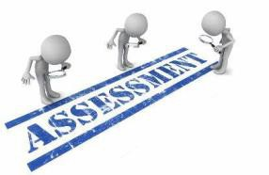

# ASSESSMENT METHODS FOR BLOCK EXAM:

Evaluation is a continuous process comprising of block examination and annual university examination. Students will be evaluated throughout the year. The internal assessment will contribute towards the ﬁnal examination scores.

Multiple examination methods including MCQs, SAQs, OSPE and viva will be for assessment. In line with PMC stipulation, the pass/fail marks for the test and examination will be 50%.

There will be a block exam at the end of each block.

**Theory (knowledge)**: MCQs (Multiple Choice Questions) and SAQs (Short Answer Questions) are used to assess the theory part for the block exam

### MCQ:

* + A MCQ has a statement or clinical scenario followed by four options (likely answers).
  + After reading the statement/scenario student select ONE, the most appropriate answer/response from the given list of options.
  + Correct answer carries one mark, and incorrect ‘zero mark’. There is NO negative marking.

### SAQ:

### SAQ are open questions that requires student to create as answer. They are commonly used in examinations to access the basic knowledge and understanding of a topic.

**OSPE: Objective Structured Practical Examination**

It may comprise between 12- 25 stations.

* + The content may assess application of knowledge, or practical skills.
  + Student will complete task in deﬁne time at one given station.
  + All the students are assessed on the same content by the same examiner in the same allocated time.
  + A structured examination will have observed, unobserved, interactive and rest stations.

### Observed and interactive stations:

They will be assessed by internal or external examiners through the task or viva.

### Unobserved station:

It will be static station in which students will have to answer the questions related to the given pictures, models, or specimens on the provided response sheet.

### Rest station:

It is a station where no task is given, and during this time student can organize his/her thoughts.

**M.B.B.S BLOCK EXAMINATION MARKS DISTRIBUTION:**

|  |  |  |  |  |  |  |  |  |  |  |  |  |  |  |  |  |  |
| --- | --- | --- | --- | --- | --- | --- | --- | --- | --- | --- | --- | --- | --- | --- | --- | --- | --- |
| **Theory marks =140 + Practical marks= 140**  **Theory= 600 Marks Practical: =600**  **Total Marks: 1200** | | | | | | | | | | | | | | | | | |
| **MODULE/BLOCK** | | | | **BLOCK – IV** | | | | **BLOCK – V** | | | | | **BLOCK – VI** | | | | |
| **Module- 7** | | **Module- 8** | | **Module-9** | | | **Module- 10** | | **Module- 11** | | | **Module- 12** | |
| **Neurosciences** | | **Special senses** | | **GIT & Liver** | | | **RENAL & Excretion** | | **Endocrinology** | | | **Reproduction** | |
| **Professional Examination** | **Theory** | | | **100** | | **100** | | **100** | | | **100** | | **100** | | | **100** | |
| **200** | | | | **200** | | | | | **200** | | | | |
| **Practical/ OSPE** | | | **200** | | | | **200** | | | | | **200** | | | | |
| **Int. Assessment-IA**  **(30%)** | | | **Theory: 60 Practical: 60** | | | | **Theory: 60 Practical: 60** | | | | | **Theory: 60 Practical: 60** | | | | |
| **Subject wise distribution** | | **Subjects** | **MCQs** | **SAQs** | **OSPE** | **VIVA** | **MCQs** | **SAQs** | | **OSPE** | **VIVA** | **MCQs** | **SAQs** | | **OSPE** | **VIVA** |
| **Anatomy** | **31** | **4** | **5** | **22** | **31** | **4** | | **5** | **22** | **31** | **4** | | **5** | **22** |
| **Physiology** | **31** | **4** | **5** | **22** | **31** | **4** | | **5** | **22** | **31** | **4** | | **5** | **22** |
| **Biochemistry** | **30** | **4** | **5** | **21** | **30** | **4** | | **5** | **21** | **30** | **4** | | **5** | **21** |
|  | | **TOTAL#** | **92** | **4 SAQs x 4 marks = 16** | **15 (5 marks each station)** | | **92** | **4 SAQs x 4 marks = 16** | | **15 (5 marks each station)** | | **92** | **4 SAQs x 4 marks = 16** | | **15 (5 marks each station)** | |
| **Total** | **92** | **48** | **140** | | **92** | **48** | | **140** | | **92** | **48** | | **140** | |
| **Total**  **(theory + practical)** | | | **140** | | **140** | | **140** | | | **140** | | **140** | | | **140** | |
| **Theory Marks** | | | **140 + 60** | | | | **140 + 60** | | | | | **140 + 60** | | | | |
| **Practical Marks (OSPE)** | | | **140 + 60** | | | | **140 + 60** | | | | | **140 + 60** | | | | |
|  | **Internal Assessment** | | | **60** | | **60** | | **60** | | **60** | | | **60** | | **60** | | |
| **Total marks** | | | **200** | | **200** | | **200** | | **200** | | | **200** | | **200** | | |
| **Total Marks** | | | **400** | | | | **400** | | | | | **400** | | | | |
| **Grand total** | | **1200** | | | | | | | | | | | | | | | |

CRITERIA FOR INTERNAL ASSESSMENT

|  |  |  |  |  |  |  |
| --- | --- | --- | --- | --- | --- | --- |
| **THEORY ASSESSMENT**  **20 MARKS** | | | | **PRACTICAL ASSESSMENT**  **20 MARKS** | | |
| **ATTENDANCE**  **5 MARKS** | **PRESENTATIONS AND ASSIGNMNETS**  **5 MARKS** | **BEHAVIOUR**  **5 MARKS** | **CLASS PERFORMACE**  **SGDS**  **5 MARKS** | **ATTENDANCE**  **5 MARKS** | **BEHAVIOUR**  **5 MARKS** | **LOGBOOK**  **10 MARKS** |
| Above 90%=  5 marks  B/W 85% to 90%=  4 marks  B/W 80% to 85%=  3 marks  75% to 80%= 2 marks  Up to 75%= 1 mark  Below 75 % = 0 marks | Grade A=5 marks  Grade B= 3 marks  Grade C= 1 mark  No assignments or presentations =0 marks | No misbehave or warning in lectures = 5 marks  Written warning given to student = 0 marks | According to performa filled by faculty  Grade A=5 marks  Grade B= 3 marks  Grade C= 1 mark | Above 90%=  5 marks  85% to 90%=  4 marks  80% to 85%=  3 marks  75% to 80%= 2 marks  Up to 75%= 1 mark  Below 75 % = 0 marks | No misbehave or warning in lectures = 5 marks  Written warning given to student = 0 marks | Completed and signed =10 marks  Completed and unsigned=5 marks  Incomplete= 2 marks  No logbook =0 marks |

|  |  |
| --- | --- |
| **LEARNING RESOURCES** | |
| **SUBJECT** | **RESOURCES** |
| **ANATOMY** | **GROSSANATOMY**   1. Clinical Anatomy by Regions, Richard S. Snell 2. Gray’s Anatomy for students 3. Atlas of Human Anatomy, Frank H. Netter   **HISTOLOGY**   1. B. Young J. W. Health Wheather’s Functional Histology 2. Histology by Laiq Hussain   **EMBRYOLOGY**   1. Keith L. Moore. The Developing Human 2. Langman’s Medical Embryology |
| **BIOCHEMISTRY** | **TEXT BOOKS**   1. Lippincott’s Illustrated Reviews, Biochemistry 2. Harper’s Illustrated Biochemistry 3. Leininger Principle of Biochemistry 4. Biochemistry by Devlin |
| **PHYSIOLOGY** | **TEXT BOOKS**   1. Textbook Of Medical Physiology by Guyton and Hall 2. Ganong ‘S Review of Medical Physiology 3. Human Physiology by Lauralee Sherwood 4. Berne & Levy Physiology 5. Best & Taylor Physiological Basis of Medical Practice   **REFERENCE EBOOKS**   1. Guyton & Hall Physiological Review 2. Essentials of Medical Physiology by Jaypee 3. Textbook of Medical Physiology by Indu Khurana 4. Short Textbook of Physiology by Mrthur 5. NMS Physiology |

SCIENCES, 1999 – anomaly

Goldberg – JOURNAL OF APPLIED BEHAVIOURAL

Challenging “Resistance to Change

7. Dent, SG

6. Textbook of Biological Psychiatry ” – group of 2 A EB

5. RW Maris, Al Berman, MM Silve J Panksepp – 2003

4. The Hierarchy of the Sciences? rman – 2000

ER Kand

3. 1998– ajp.psychiatryonline.org – group of 3 A

2. of 12 A el – AMERICAN JOURNAL OF PSYCHIATRY,

1. A New Intellectual Framework for Psychiatry – group

**BEHAVIORAL SCIENCE**

|  |  |
| --- | --- |
| **OTHER LEARNING RESOURCE: S** | |
| **Hands-on Activities**  **/ Practical** | Students will be involved in Practical sessions and hands-on activities that link with the foundation module to enhance the learning. |
| **Labs** | Utilize the lab to relate the knowledge to the specimens and models available. |
| **Skill Labs** | A skills lab provides the simulators to learn the basic skills and procedures. This helps build the conﬁdence to approach the patients. |
| **Videos** | Video familiarize the student with the procedures and protocols to assist patients. |
| **Computer Lab / CDs/ DVDs / Internet**  **Resources:** | To increase the knowledge students should utilize the available internet resources and CDs/DVDs. This will be an additional advantage to increase learning. |
| **SDL** | SDL is scheduled to search for information to solve cases, read through diﬀerent resources and discuss among the peers and with the faculty to clarify the concepts. |

