**SECOND YEAR BDS 2023-2024**

**BLOCK VI ( MODULE XI AND XII)**

**HEALTH PROMOTION & INFECTION CONTROL  
NEOPLASIA & METALLURGY**

**FROM THE DESK OF PRINCIPAL**

Health is a fast-evolving field and with new technologies taking over the traditionally man-dominated fields like radiology and robotic surgical suites assisted by Artificial Intelligence and learning are taking new dimensions with the help of Augmented Reality, we are indeed living in challenging time s. Today's student of Medicine and Dentistry will be in the field a decade from now, up against a disease burden that is as varied as the next strain of the Covid-19 Virus and as complicated as the genetic characteristic of Oral Cancer, the largest cancer amongst both genders in Pakistan and at the same time as unpredictable as the recent Covid-19 Pandemic.

It is therefore imperative that our curricula of the Medical and Dental Colleges be in tandem with the changing times with the ability to evolve with time, measuring up to the challenges thrown at the field of healing from the

Ever-evolving diseases.

These Student Guidebooks are reviewed every year with the same concept in mind that our future Physician and Dental Surgeon be ready for the challenges that lie ahead.

In the end, I give you the same prayer as is mentioned in the Quran



Prof. Shaheed Iqbal

BDS, MDS

Oral & Maxillofacial Surgery

Principal Sardar Begum Dental College

Gandhara University,

Peshawar.

2



On behalf of the block team, I would like to welcome you to Block-VI (Module 11 and 12). As a part of the system-based curriculum, this module is an integrated presentation comprising system-based modules which links basic scientific knowledge to clinical problems. Integrated teaching means that subjects are presented as a meaningful whole. The students will be able to have better understanding of basic sciences when they repeatedly learn it in relation to clinical examples. Small group discussions, early exposure to clinics, wards, and skills acquisition in skills lab are characteristics of integrated teaching program.

The faculty are faced with determining how to present course material so the student not only gain knowledge of the discipline but also become self-directed learners who develop problem solving skills that they can apply in future courses and in their careers.

Our mission is to provide all educational opportunities to our students. Therefore, on completion of the BDS program graduate will possess an appropriate foundation of knowledge, skills, and attitudes to be well prepared to practice safely and effectively

As a director DME I will be meeting with the facilitators to receive the feedback and will try to resolve any difficulties or problems faced during the block. Please do not hesitate to contact DME for any academic help. I wish you an enjoyable and learning experience with block 6.

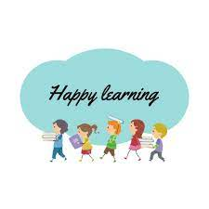

**Director DME: Dr. Marina Khan**

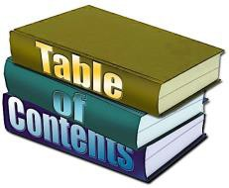

|  |
| --- |
| **TABLE OF CONTENTS** |
| **Block Team** |
| **List of abbreviations** |
| **Aims of the study guide** |
| **Modules distribution of 2nd year BDS** |
| **Introduction of block** |
| **General Outcomes** |
| **Leaning Methodologies** |
| **Rules Regulations** |
| **Learning objectives & Course contents** |
| **Assessment** |
| **Learning Resources** |

**MODULE TEAM**

|  |  |  |
| --- | --- | --- |
| Module Coordinator Dr. Marina Khan  In charge Department of Medical Education  [marinakahn@hotmail.com](mailto:marinakahn@hotmail.com) | | |
|  |  |  |
| DEPARTMENT OF DENTAL MATERIALS | Prof Dr. Tahir Ali Khan  Prof Dr. Amjad Naseer  Assist Prof Dr. Munazza Ijaz  Assistant Prof Dr. Maimona  Assistant Prof Dr. Asad  Dr. Hanan |
|  |  |  |
| DEPARTMENT OF COMMUNITY DENTISTRY | Prof. Dr. Babar Ahad  Prof Dr. Saira Afridi  Prof Dr. Sofia Shehzad  Assist Prof Dr. Sana Ruqayya  Assist Prof Dr Imran Gillani  Lecturer Dr. Aiman |
|  |  |
| DEPARTMENT OF PATHOLOGY | Prof Dr Syed Mukhtiar.Ali.Shah  Prof Dr. Nisar Ahmed  Prof Dr. Ehsan Gul Khattak  Prof Dr. Naila Ismail  Prof Dr. Ibn-e-Amin  Associate Prof Dr. Shazia  Assist Prof. Dr. Ronaq Zaman |
|  |  |  |
| DEPARTMENT OF PHARMACOLOGY | Prof Dr. Iftikhar Ud Din  Associate Prof Dr. Syed Hasnain Ali Shah  Assistant Prof Dr. Saifullah  Lecturer Dr. Ihtesham  Lecturer Dr. Haseeb |
|  |  |
| DEPARTMENT OF  MEDICAL EDUCATION | Assistant Prof Dr. Marina Khan  Assistant Prof Dr. Syed Muhammad Junaid  Lecturer Dr. Aalia Zaib  Lecturer Dr. Usama Zeb |

## 

## LIST OF ABBREVIATIONS

|  |  |
| --- | --- |
| **DME** | Department of Medical Education |
| **ANAT** | Anatomy |
| **PHY** | Physiology |
| **BIO** | Biochemistry |
| **ORAL BIO** | Oral Biology |
| **HISTO** | Histology |
| **EMB** | Embryology |
| **LGIS** | Large Group Interactive Session |
| **SGD** | Small Group Discussion |
| **SDL** | Self-Directed Learning |
| **DSL** | Directed Self Learning |
| **MCQ** | Multiple Choice Question |
| **SAQ** | Short Answer Question |
| **OSPE** | Objective Structured Practical Exam |

**STUDY GUIDE:**

****This study guidebook was designed by combining the efforts of all topics throughout the year to give dentistry students at SBDC a resource material that highlights significant components of the curriculum. By providing students control over their learning, the study guide aims to promote self-regulated lifelong learning.

In regard to the course content, the study guide provides an overview of the anticipated course outcomes and objectives. The assessment approach is also customized to the intuitional strategy.

A successful curriculum has a significant impact on the final product, as well as on society as a whole. This study guide was carefully designed with the PMC curriculum and rules in mind, and Gandhara University stakeholders and faculty members worked hard to personalize it to the needs of students. They are further working to build, implement, and exercise a well-built curriculum in light of changing demographic needs and disease prevalence in our society. Throughout the construction of the study guide, students' feedback was received and included. Curriculum is a living, dynamic entity that is constantly changing. With each passing day, we hope to improve it. This selfless effort on the part of the entire faculty serves as a beacon for our wonderful students.

Each module in this block has been created to cater the gap between basic and clinical subjects through pre-clinical learning. The block is divided into two modules in which the students are exposed to a variety of basic and clinical subjects. The integrated curriculum is enforced through interactive lectures, small group discussion, community outreach programs along with rotations at preclinical laboratory. The course content pertinent to each module will be addressed in problem-based scenarios and student will work collaboratively towards its solution..



**AIMS OF THE STUDY GUIDE**

It is an aid to:

* Inform students how student learning program of the BLOCK-wise module has been organized
* Help students organize and manage their studies throughout the module
* Guide students on assessment methods, rules, and regulations
* Communicates information on organization and management of the module. This will help the student to contact the right person in case of difficulty.
* Defines the objectives which are expected to be achieved at the end of the module.
* Identifies the learning strategies such as lectures, small group teachings, clinical skills and demonstration, tutorial that will be implemented to achieve the module objectives.
* Provides a list of learning resources such as books, computer assisted learning programs, web- links, and journals, for students to consult in order to maximize their learning.
* Highlights information on the contribution of continuous and block examinations on the student's overall performance.
* Includes information on the assessment methods that will be held to determine every student's achievement of objectives.
* Focuses on information pertaining to examination policy, rules, and regulations.

**ORGANIZATION OF MODULAR CURRICULUM**

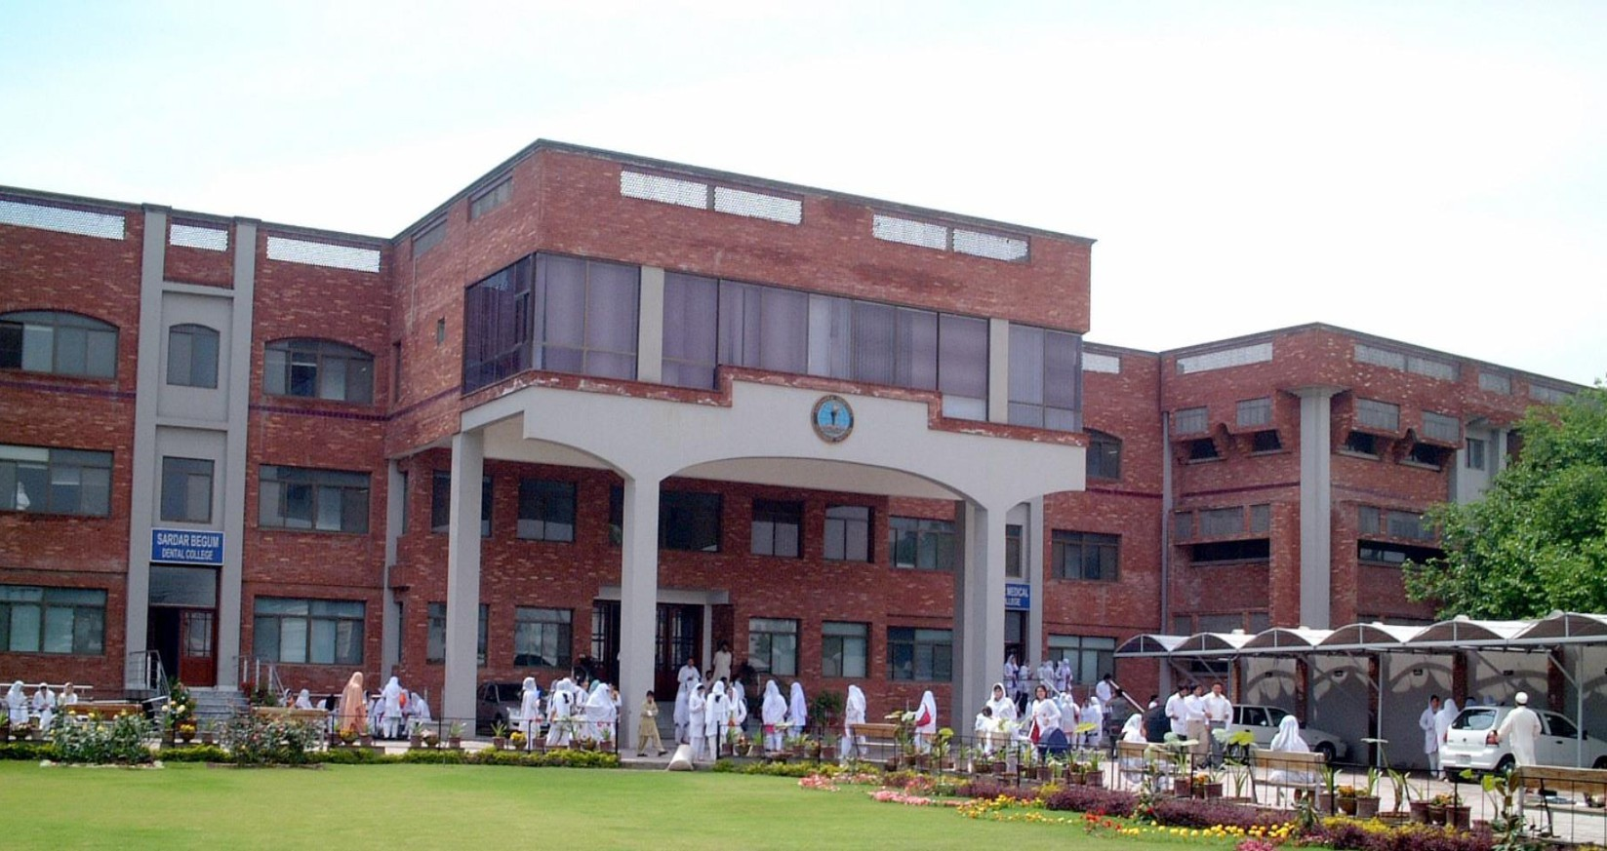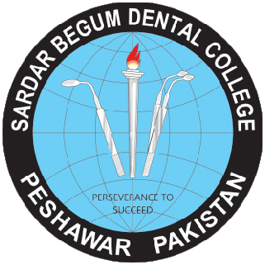

**2nd  YEAR BDS**

|  |  |  |  |  |  |  |  |  |  |
| --- | --- | --- | --- | --- | --- | --- | --- | --- | --- |
| **Block-4** | | **Exam Block 4** | **Block-5** | | **Exam Block 5** | **Block-6** | | **Exam Block 6** | **Final Exam** |
| **Module**  **7**  **Pre and Para-Clinical Dental Sciences** | **Module**  **8**  **Restorative Material**  **and Dental Research** | **Module**  **9**  **Epidemiology of Oral diseases and Auxiliary Materials-I** | **Module**  **10**  **Epidemiology**  **of Oral**  **diseases and Auxiliary Materials-II** | **Module**  **11**  **Health**  **Promotion and Infection Control** | **Module**  **12**  **Neoplasia and Metallurgy** |

### 

### LEARNING METHODOLOGIES

The following teaching / learning methods are used to promote better understanding:

* Large Group Interactive Lectures
* Small Group Discussion
* Practical
* Skills session
* E-Learning
* Self-Directed Learning

### LARGE GROUP INTERACTIVE LECTURES (LGIS)

### 

In large group, the lecturer introduces a topic or common clinical conditions and explains the underlying phenomena through questions, pictures, videos of patients' interviews, exercises, etc. Students are actively involved in the learning process.

### 

### SMALL GROUP DISCUSSIONS (SGDs):



This methodology helps students to clarify concepts acquire skills or attitudes. Sessions are structured with the help of specific exercises such as patient case, interviews, or discussion topics. Students exchange opinions and apply knowledge gained from lectures, tutorials, and self-study. The facilitator role is

to ask probing questions, summarize, or rephrase to help clarify concepts.

#### PRACTICAL

Practical related to Science of Dental Materials, Community & preventive, Dentistry, General Pathology & General Pharmacology are scheduled for student learning.

**SELF DIRECTED LEARNING SDL:**

Students assume responsibilities of their own learning through individual study, sharing and discussing with peers, seeking information from Learning Resource Center, teachers, and resource persons within and outside the college. Students can utilize the time within the college scheduled hours of self-study.

**E-LEARNING:**

E-Learning is a strategy by which learning occurs through the utilization of electronic media, typically the Internet. The basic aspects of medical professionalism and ethics will be addressed through an e-learning course.

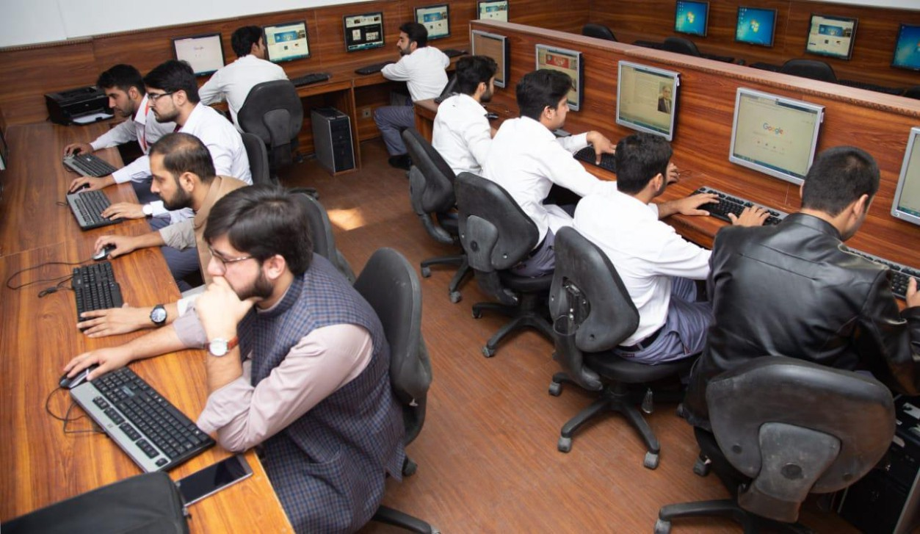

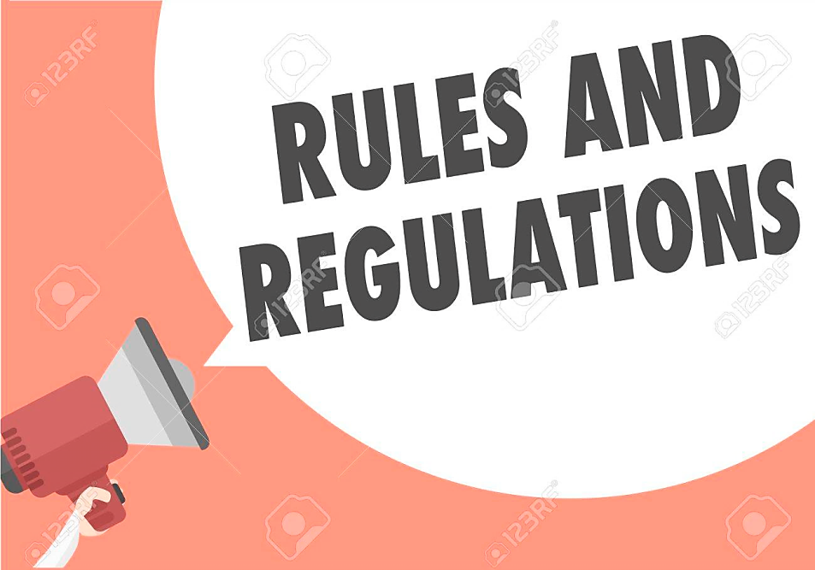

**RULES AND REGULATIONS**

We will be making the journey through BLOCK 6 in 11 weeks. Therefore, this course includes an intensive coursework load. Class attendance and participation are extremely important to your learning and are considered in the evaluation of your course grade. If there is anything that the module team can do to assist you during the course, please feel free to contact them. Attendance will be monitored during the different teaching activities. If your attendance is less than 75%, you will not be allowed to sit for both block and annual examination.

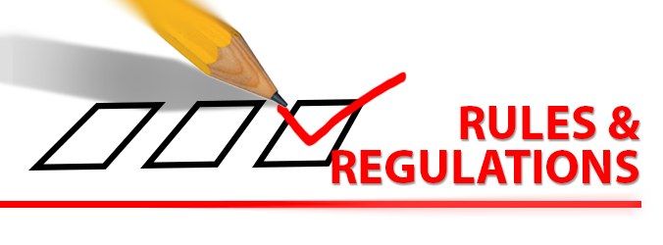

All examinations must be taken on the date scheduled. No student will be allowed to enter the examination area after the examination starts. There will be a block exam at the end of each block and each block will cover two modules. There will be a total of 3 block examination and the 30% weightage of these block exam will be added to the 70 % of the annual professional exam as an internal assessment.

**LEARNING OBJECTIVE & COURSE CONTENTS**

At the end of the teaching session the student should be able to achieve the following objectives

**INTRODUCTION TO BLOCK 6**

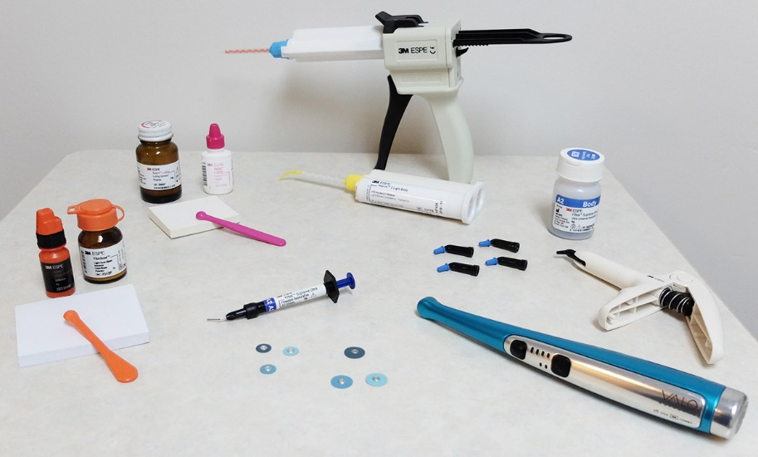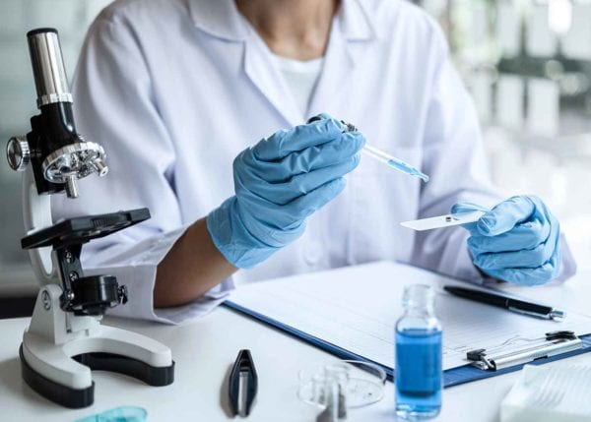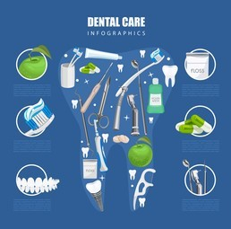

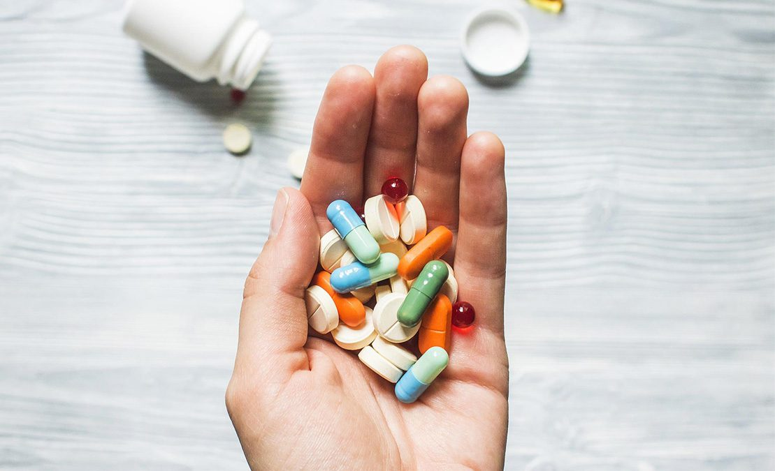

**INTRODUCTION TO BLOCK VI**

Like the previous blocks, Block VI aims to provide students with a theoretical and practical understanding of disease pathology and pharmacology, as well as biomaterials used in dentistry, clinical applications, and community-based dentistry. The block is divided into two modules, each with a theoretical and practical component which is designed in a way so that in module XI, students will learn about health promotion and infection control, while in module XII, they will learn about neoplasia and metallurgy.

Each module in the block is aimed to demonstrate a relationship to other modules in order to create a more in-depth grasp of each subject's key ideas and their application in clinical encounters in the coming years of the BDS undergraduate programme. Each module's course topic will be handled in problem-based scenarios, with students working cooperatively to find a solution. The modules will be assessed in both formative and summative ways throughout the block. Interactive lectures, small group discussions, , community outreach initiatives, and rotations in the preclinical laboratory are all used to reinforce the integrated curriculum.

Block VI aims to introduce students to basic preventive dental materials used in clinical dentistry, as well as various types of endodontic materials classified by their intended clinical uses. It also emphasis’s on the nature of genetic and chromosomal disorders, as well as cancer. A prologue on the pathophysiology of infections involving the blood, urinary tract, cardiovascular system, and central nervous system is provided in this section. Medications that influence the central nervous system, cytotoxic drugs, and those used to treat urinary tract infections, herpes, and toxoplasmosis are also heavily used. This section will also cover indirect restorative materials such as dental ceramics, dental casting alloys (including casting procedures), investment materials, and dental cements. Students will be introduced to behavioral sciences, including sociology and health behaviors, as well as biostatistics.

In block VI, the students will apply what they learned in blocks IV and V regarding the nature, characteristics, and causes of human diseases, as well as pharmacological interactions, to better comprehend how they affect specific organ systems. In Block VI, the preclinical and dental materials laboratory session, the knowledge learned on basic properties and structure of metals and alloys, as well as ceramics, will be used to develop skills for indirect restoration of lost or missing teeth and associated structures.

Students will use what they studied in blocks IV and V on the nature, characteristics, and causes of human diseases, as well as pharmaceutical interactions, to better understand how they influence specific organ systems in block VI. The knowledge gained on the basic properties and structure of metals and alloys, as well as ceramics, will be used to develop skills for indirect restoration of lost or missing teeth and associated structures in Block VI, the preclinical and dental materials laboratory session to develop skills for restoration of cavities and construction of dentures.

Students will gain a better understanding of the pathological basis of common blood infections, UTI, and infections of the CNS and CVS, as well as therapeutics for improved diagnosis and treatment planning of medical and dental patients, after completing block VI. A better understanding of the procedures and biomaterials used for indirect restoration of oral structures will be gained.

**GENERAL OUTCOMES:**

By the end of this block the students would be able to

### KNOWLEDGE:

1. Characteristics, transmission, pathogenesis, clinical findings, and laboratory diagnosis of non-spore forming gram positive rods, gram negative cocci, Entameba & Giardia, Cestodes, Nematodes, trematodes, Treponema pallidum.
2. The students will be able to describe nomenclature of neoplasia and characteristics of benign and malignant neoplasms, epidemiology of neoplasms, Etiology of cancer, Carcinogenic agents, and clinical aspects of Neoplasia.
3. The students will be able to understand the concept of health promotion and its principles and method, explain how to plan a health education campaign, Describe the behavior change models and explain the concepts and types, Explain Individual level behavior change models, Interpersonal level behavior change model / diffusion of innovation, basic concept of community-based behavior change, explain community-based behavior change model/ Precede –Proceed model.
4. The students will be able to describe health care system of Pakistan and Explain levels of health care facilities. They will understand the concept of the vertical and horizontal health care programs, understand the basic concept of infection control and standard/ Universal precautions and the Infection control procedures, Sterilization and Disinfection
5. The students will be able to know about porcelain, its composition, classification and properties, fabrication of porcelain fused to metal crowns, aluminous porcelain, CAD-CAM restorations, and porcelain veneers.
6. The students will know about tooth paste, mouthwash and fluorides use in dentistry, pit and fissure sealant and mouth guards the students will understand the concept of plaque control and different Methods of plaque control, different Oral hygiene aids, Tooth brushing and flossing methods, role of fluoride in dentistry and water fluoridation, Mechanism of action of fluoride and Describe Dental fluorosis in detail, concept behind the use of pits and fissure sealants, its Indications and contraindications for use, and Techniques for sealants application.
7. The students will know about metallurgy, malleability and ductility, different methods for metal shaping in dentistry, structure of metals and alloys, structure and properties of alloys, cooling curves and phase diagrams of alloys and various heat treatments in dental materials, noble and precious metals, properties of pure gold as filling material, composition, properties, and applications of traditional casting gold alloys.
8. The students will be able to know about metal joining procedures like soldering and brazing procedure for noble metals, flux and anti-flux, dental casting alloys, base metal alloys, its classification, composition and requirements, properties of base metal alloys, alloys for porcelain fused to metal restorations, finishing polishing materials, design and characteristics of an abrasives and factors affecting rate of abrasion, classification of abrasives, polishing and polishing agents.
9. The students will be able to describe cell wall synthesis inhibitors, protein synthesis inhibitors, carbonic anhydrase inhibitors, quinolones, Folic Acid Antagonists and Urinary Tract Antiseptics, anti-tuberculosis drugs, antiprotozoal drugs, antifungal drugs, antiviral drugs, and anticancer drugs.
10. The students will be able to describe the drugs which mimic or block the effects of hypothalamic and pituitary hormones, anterior pituitary hormone and their analogs, thyroid, anti-thyroid drugs and hypothyroidism, Iodide salts, iodine and radioactive iodine, glucocorticoid agonists, mineral corticoids, corticosteroid antagonist, describe antidiabetic agents, insulin, insulin secretogogues, biguanides and thiozolidinediones.

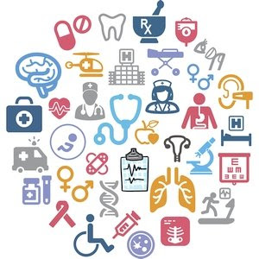

**SKILLS:**

By the end of block- VI, the student should be able to:

1. At the end of this block the students will be able to identify ovum of Ascaris, ovum of Ancylostoma duodenale, ovum of Hymenolepis nana, ovum of Trichuris Trichuria and ovum of Entrobius vermicularis.
2. The students will be able to write prescription for Acute Tonsillitis, rheumatic fever, bronchial asthma, Tuberculosis, amoebic dysentery, bacillary dysentery, Peptic Ulcer and Roundworm Infestation.
3. The students will be able to review and identify all the practicals related to bacteriology, histopathology, and parasitology.
4. Students will learn teeth setup for complete acrylic partial denture

**ATTITUDE:**

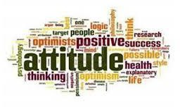

By the end of this block, the students will be able to:

* Develop respect for the individuality and values of others - (including having respect for oneself) patients, colleagues, and other health professionals.
* Organize & distribute tasks.
* Exchange opinion & knowledge.
* Develop communication skills and etiquette with sense of responsibility.
* To equip themselves for teamwork.
* Regularly attend the classes.
* Demonstrate good laboratory practices.
* Carry out practical work as instructed in an organized and safe man
* Make and record observations accurately.
* Develop the ability to give and receive feedback
* Respect for self and peers.

**MODULE - XI**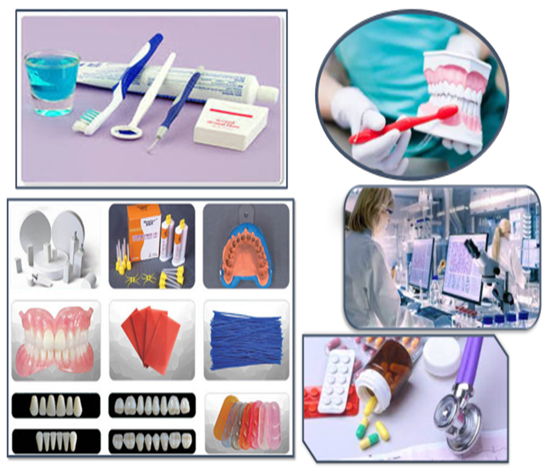

|  |  |  |
| --- | --- | --- |
| **PATHOLOGY LECTURES** | | |
| **S.NO** | **TOPICS** | **LEARNING OBJECTIVE** |
|  | Non spore forming gram positive rods | Describe characteristics, transmission, pathogenesis, clinical findings, and laboratory diagnosis of Non spore forming gram positive rods |
|  | Cestodes I | Describe characteristics, transmission, pathogenesis, clinical findings, and laboratory diagnosis of Cestodes |
|  | Cestodes II | Describe characteristics, transmission, pathogenesis, clinical findings, and laboratory diagnosis of Cestodes |
|  | Diseases Caused by Single-Gene Defects | Describe transmission pattern of diseases caused single gene defects: autosomal dominant, autosomal recessive, X-linked. |
|  | Entamoeba & Giardia | Describe characteristics, transmission, pathogenesis, clinical findings, and laboratory diagnosis of Entameba & Giardia |
|  | Nematodes I | Describe characteristics, transmission, pathogenesis, clinical findings, and laboratory diagnosis of Nematodes |
|  | Nematodes II | Describe characteristics, transmission, pathogenesis, clinical findings, and laboratory diagnosis of Nematodes |
|  | Trematodes I | Describe characteristics, transmission, pathogenesis, clinical findings, and laboratory diagnosis of Trematodes |
|  | Trematodes II | Describe characteristics, transmission, pathogenesis, clinical findings, and laboratory diagnosis of Trematodes |

|  |  |  |  |
| --- | --- | --- | --- |
| **PATHOLOGY PRACTICALS** | | | |
| **S.NO** | TOPICS | LEARNING OBJECTIVE | |
| 1 | Ascaris |  | Identify and describe the microscopic structure of ovum of Ascaris |
| 2 | Ancylostoma duodenale |  | Identify and describe the microscopic structure of ovum of Ancylostoma duodenale |
| 3. | Hymenolepis nana |  | Identify and describe the microscopic structure of ovum of Hymenolepis nana |
| 4. | Trichuris Trichuria |  | Identify and describe the microscopic structure of ovum of Trichuris Trichuria |
| 5. | Entrobius  vermicularis | Identify and describe the microscopic structure of ovum of Entrobius  vermicularis | |

|  |  |  |
| --- | --- | --- |
| **PATHOLOGY SGDs** | | |
| S,NO | TOPIC | LEARNING OBJECTIVE |
| 1 | Meningitis | Describe causative agents & laboratory diagnosis of meningitis |
| 2 | Dengue | Describe causative agent, mode of transmission, prevention & laboratory diagnosis of dengue |
| 3 | Covid | Describe pathogenesis and prevention of Covid |
| 4 | Hepatitis | Describe etiology, prevention, and laboratory diagnosis of hepatitis |
| 5 | Cutaneous & subcutaneous mycosis | Describe Cutaneous & subcutaneous mycosis |

|  |  |  |
| --- | --- | --- |
| **COMMUNITY AND PREVENTIVE DENTISTRY LECTURES** | | |
| **S.NO** | **TOPICS** | **LEARNING OBJECTIVE** |

|  |  |  |
| --- | --- | --- |
|  | Health education 1 | Define health education and health promotion  Describe principles and methods of health education |
|  | Health education 2 | Explain planning of a health education campaign |
|  | Health education 3 | Describe overview of the behavior change models  Explain the concepts and its types |
|  | Health education 4 | Explain Individual level behavior change models HOLC, HBM, transtheoretical model |
|  | Health education 5 | Describe Interpersonal level behavior change model / diffusion of innovation  Describe overview of community-based behavior change  Explain Community based behavior change model/ Precede –Proceed model |
|  | Role of sugar in caries prevention | Describe the role of sugar in causing caries |
|  | Caries Risk assessment | Explain the assessment factors associated with low risk and high risk caries assessment |
|  | Introduction to health care system of Pakistan | Describe health care system of Pakistan  Explain levels of health care facilities  describe vertical and horizontal health care programs |
|  | Infection control 1 | Define infection control  Explain Universal precautions/standard precautions |
|  | Infection control 2 | Describe the Infection control procedures  Explain Sterilization and Disinfection in detail |

|  |  |  |
| --- | --- | --- |
| **COMMUNITY DENTISTRY SGDs** | | |
| **S.No** | **TOPICS** | **LEARNING OBJECTIVE** |
| 1 | Health education /Research work | Discuss different methods of health education  Discuss applied form of behavior change types  Discuss and plan a health education plan for school children |
| 2 | Caries Assessment | Discuss the assessment factors associated with the low risk and high-risk caries assessment |
| 3 | Infection control | Discuss different infection control measures used in hospital |

|  |  |  |
| --- | --- | --- |
| **COMMUNITY DENTISTRY PRACTICALS** | | |
| **S.No** | **TOPICS** | **LEARNING OBJECTIVE** |
|  | Oral Hygiene measures | Discuss different oral hygiene measures |
|  | Flossing | Explain flossing methods |
|  | oral hygiene instructions | explain oral hygiene instructions |
|  | oral hygiene instructions in special groups | explain oral hygiene instructions for general and special groups |
|  | Role of diet and oral health | Explain the role of diet and oral health  Describe dietary chart and record dietary habits of patients |

|  |  |  |
| --- | --- | --- |
| **DENTAL MATERIAL LECTURES** | | |
| **S.NO** | **TOPICS** | **LEARNING OBJECTIVE** |

|  |  |  |
| --- | --- | --- |
| 1 | Ceramics | Describe porcelain, its composition, classification, and properties |
| 2 | Fabrication of porcelain fused to metal crowns | Describe fabrication of porcelain fused to metal crowns |
| 3. | Aluminous porcelain  CAD-CAM restorations  Porcelain veneers | Describe aluminous porcelain, CAD-CAM restorations, and porcelain veneers |
| 4. | Preventive materials l | Define preventive materials  Discuss toothpaste, mouthwash and fluorides use in dentistry |
| 5. | Preventive materials ll | Describe pit fissure sealant and mouth guards |
| 6. | Metallurgy  - Introduction  - Malleability and ductility  - Structure and properties of metals | Give a brief introduction about metallurgy  Describe malleability and ductility, different methods for metal shaping in dentistry  Explain the structure and properties of metals |
| 7. | Metallurgy  - Cold working and annealing  - Structure and properties of alloys | Explain the structure and properties of alloys  Describe the cooling curves and phase diagrams of alloys  Describe various heat treatments in dental materials |
| 8. | Direct gold filling material | Define Noble and Precious metals.  Describe properties of pure gold as filling material |
| 9. | Casting gold alloys | Describe the composition, properties, and applications of traditional casting gold alloys |
| 10. | Wrought alloys  - Steel | Define wrought alloys  Describe steel with its different phases |
| 11 | Wrought alloys  - Stainless steel | Describe the composition and properties of stainless steel |

|  |  |  |  |
| --- | --- | --- | --- |
| **DENTAL MATERIAL PRACTICALS** | | | |
| **S.NO** | **TOPICS** | **LEARNING OBJECTIVE** | |
| 1 | Upper acrylic denture |  | Hands on to make an acrylic partial  denture on upper models |

|  |  |  |  |
| --- | --- | --- | --- |
| **DENTAL MATERIAL SGD’s** | | | |
| **S.NO** | **TOPICS** | **LEARNING OBJECTIVE** | |
| 1 | Artificial teeth |  | Define artificial teeth  Discuss acrylic and porcelain teeth |
| 2 | Ceramics |  | Define porcelain, its composition,  classification  and properties  Discuss fabrication of porcelain fused to metal  crowns |
| 3 | Aluminous porcelain  CAD-CAM restorations  Porcelain veneers |  | Discuss aluminous porcelain, CAD-CAM  restorations and porcelain veneers |
| 4 | Preventive materials |  | Define preventive materials  Discuss toothpaste, mouthwash and fluoride use in dentistry  Discuss pit fissure sealant and mouth guards |
| 5 | Metallurgy  - Introduction  - Malleability and ductility  - Structure and properties of  metals |  | Give a brief introduction about metallurgy  Discuss malleability and ductility, different  methods for metal shaping in dentistry  Explain the structure and properties of metals |
| 6 | Metallurgy  - Cold working and annealing  - Structure and properties of  alloys |  | Explain the structure and properties of alloys  Describe the cooling curves and phase diagrams of alloys  Discuss various heat treatments in dental  materials |
| 7 | Direct gold filling material |  | Define Noble and Precious metals.  Discuss properties of pure gold as filling material |
| 8 | Wrought alloys  - Steel |  | Define wrought alloys  Discuss steel with its different phases |
| 9 | Casting gold alloy |  | Discuss the composition, properties, and applications of traditional casting gold alloys |

|  |  |  |
| --- | --- | --- |
| **GENERAL PHARMACOLOGY LECTURES** | | |
| **S.No** | **TOPIC** | **LEARNING OBJECTIVE** |

|  |  |  |
| --- | --- | --- |
| 1 | Cell wall synthesis inhibitors | Classify penicillin  Describe pharmacokinetics, mechanism of action, clinical uses, and adverse effects of penicillin  Classify cephalosporin  Describe pharmacokinetics, mechanism of action, clinical uses, and adverse effects of cephalosporin |
| 2 | Protein synthesis inhibitors | Enumerate tetracyclines  Describe pharmacokinetics, mechanism of action, clinical uses, and adverse effects of tetracyclines  Enumerate aminoglycosides  Describe pharmacokinetics, mechanism of action, clinical uses, and adverse effects of aminoglycosides  Enumerate macrolides  Describe pharmacokinetics, mechanism of action, clinical uses, and adverse effects of macrolides |
| 3 | Quinolones, Folic  Acid Antagonists,  and Urinary Tract  Antiseptics | Classify quinolones, Folic  Acid Antagonists,  and Urinary Tract Antiseptics  Describe pharmacokinetics, mechanism of action, clinical uses and adverse effects of quinolones, Folic Acid Antagonists and Urinary Tract Antiseptics |
| 4 | Antimycobacterial drugs | Classify 1st and 2nd line anti-tuberculous drugs  Describe pharmacokinetics, mechanism of action, clinical uses, and adverse effects of anti-mycobacterial drugs |
| 5 | Antiprotozoal drugs | Enumerate drugs for amebiasis and malaria  Describe pharmacokinetics, mechanism of action, clinical uses, and adverse effects of amebiasis and malaria |
| 6. | Antifungal drugs | Classify antifungal drugs  Application of antifungal drugs  Describe pharmacokinetic and pharmacodynamics of antifungal drugs |
| 7 | Antiviral drugs | Classification of antiviral drugs, targets, pharmacokinetics, pharmacodynamics, and drug interaction of antiviral drugs |
| 8 | Anticancer drugs | Classify anticancer drugs  Describe pharmacokinetics, mechanism of action, clinical uses, and adverse effects of methotrexate  Describe pharmacokinetics, mechanism of action, clinical uses, and adverse effects of cyclophosphamide |
| 9 | Urine regulation  Carbonic anhydrase inhibitors  Loop and thiazide diuretics  Potassium sparing and osmotic diuretics | Describe normal urine formation Classify diuretics  Describe basic pharmacology, mechanism of action, pharmacokinetics, therapeutic uses, and side effects of carbonic anhydrase inhibitors  Describe basic pharmacology, mechanism of action, pharmacokinetics, therapeutic uses and side effects of loop and thiazide diuretics  Describe basic pharmacology, mechanism of action, pharmacokinetics, therapeutic uses, and adverse effects of Potassium sparing and osmotic diuretics and drug interaction of potassium sparing diuretics. |
| 10 | Anti-asthmatic and drugs for COPD | Discuss the treatment of asthma  Explain the Clinical significance of anti-asthmatics  Discuss the drugs used for COPD |

|  |  |  |
| --- | --- | --- |
| **PHARMACOLOGY PRACTICLES** | | |
| **S.No** | **TOPICS** | **LEARNING OBJECTIVE** |
|  | Acute Tonsillitis  (Prescription) | Describe clinical features of acute tonsillitis  Write a complete prescription for acute tonsillitis |
|  | | Rheumatic Fever  (Prescription) | Describe clinical features of rheumatic fever  Write a complete prescription for rheumatic fever |
|  | | 40ml of turpentine liniment | Enumerate ingredients of turpentine liniment  To prepare and dispense 40ml of turpentine liniment  Enumerate uses of turpentine liniment |
|  | | Bronchial Asthma  (Prescription) | Define bronchial asthma  Enumerate cause of bronchial asthma  Describe clinical features of bronchial asthma  Write a complete prescription for bronchial asthma |
|  | | Tuberculosis  (Prescription) | Define tuberculosis  Enumerate causes of tuberculosis  Describe clinical features of tuberculosis  Write a complete prescription for tuberculosis |

|  |  |  |
| --- | --- | --- |
| **PHARMACOLOGY SGDs** | | |
| S.NO | TOPICS | LEARNING OBJECTIVES |
|  | Vitamins (B1-B12) | Describe sources, uses, mechanism of action and diseases caused by their deficiency  Describe pharmacokinetics of vitamin (B1 –B12) |
|  | Iron & Folic Acid | Describe sources, uses, mechanism of action and diseases caused by their deficiency  Describe pharmacokinetics of iron and folic acid |
|  | Drug reactions | Describe early drug reactions  Describe late drug reactions  Describe vivo drug reactions  Describe vitro drug reactions  Describe pharmacokinetic drug reactions  Describe pharmacodynamics drug reactions |
| 4 | Autacoids | Describe basic pharmacology of histamine  Describe clinical pharmacology of histamine  Describe basic pharmacology of serotonin  Describe clinical pharmacology of serotonin |
| 5 | Drugs for obesity | Classify drugs for obesity  Describe pharmacokinetics and pharmacodynamics of drugs for obesity |

|  |  |  |
| --- | --- | --- |
| **BEHAVIORAL SCIENCES LECTURE** | | |
| **S.NO** | **TOPICS** | **LEARNING OBJECTIVE** | |
| 1 | Anxiety and fear management  In dentistry | Define & Describe dental anxiety and fear  Enlist the Causes of Dental Anxiety  Enlist the symptoms of dental anxiety  Discuss the Management of dental anxiety and fear. | |

|  |  |  |
| --- | --- | --- |
| **JUNIOR PROSTHETICS LECTURE** | | |
| **S.NO** | **TOPICS** | **LEARNING OBJECTIVE** | |
| 1 | Impressioning during partial denture fabrication | Enlist and discuss steps of Impressioning during partial denture fabrication | |
| 2 | Steps and importance of Maxillomandibular relationship recording | Discuss maxillomandibular relations in detail  Vertical relations  Centric relations  Jaw record relations  Difference between centric occlusion and centric relation | |

|  |  |  |
| --- | --- | --- |
| **JUNIOR PROSTHETIC PRACTICALS** | | |
| **S.NO** | **TOPICS** | **LEARNING OBJECTIVE** | |
| 1 | Teeth setup | Perform the arrangement of artificial teeth stepwise on a denture | |

|  |  |  |
| --- | --- | --- |
| **JUNIOR OPERATIVE LECTURE** | | |
| **S.NO** | **TOPICS** | **LEARNING OBJECTIVE** | |
| 1 | Introduction to Amalgam | Define dental amalgam  Enlist the classification, composition of amalgam and manufacturing of alloy powder  Explain setting reaction of dental amalgam  Explain material related variables of dental amalgam  Explain manipulation of dental amalgam | |

|  |  |  |
| --- | --- | --- |
| **JUNIOR OPERATIVE PRACTICALS** | | |
| **S.No** | **TOPICS** | **LEARNING OBJECTIVE** |
| 1 | Class 1, Class 4, and Class 5 restoration | Recall principles and steps of cavity preparation for direct restorations  Describe factors affecting the cavity preparation  Demonstrate outline, resistance, retention, and convenience form on typodont  Apply principles of preparation on a typodont for direct restoration  Implement the filling techniques in restoring the typodont |

**MODULE - XII**

**Duration: 5 weeks**

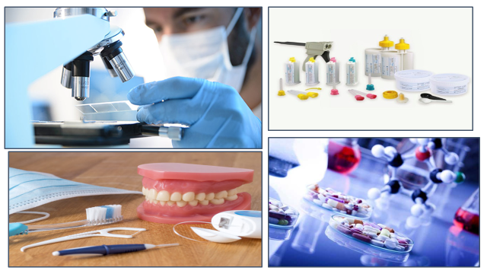

|  |  |  |
| --- | --- | --- |
| **PATHOLOGY LECTURES** | | |
| **S.NO** | **TOPICS** | **LEARNING OBJECTIVE** |
| 1 | Gram negative cocci | Describe characteristics, transmission, pathogenesis, clinical findings, and laboratory diagnosis of gram-negative cocci |
| 2 | syphilis | Describe characteristics, transmission, pathogenesis, clinical findings, and laboratory diagnosis of Treponema pallidum |
| 3 | Nomenclature of neoplasia Characteristics of benign and  Malignant neoplasms | Describe nomenclature of neoplasia Characteristics of benign and  malignant neoplasms |
| 4 | Epidemiology of neoplasms | Describe epidemiology of neoplasms |
| 5 | Etiology of cancer:  Carcinogenic agents | Describe etiology of cancer and  carcinogenic agents |
| 6 | Clinical Aspects of Neoplasia | Describe clinical Aspects of Neoplasia |

|  |  |  |  |
| --- | --- | --- | --- |
| **PATHOLOGY PRACTICALS** | | | |
| **S.NO** | **TOPICS** | **LEARNING OBJECTIVE** | |
| 1 | Review bacteriology |  | Review all the practical related to bacteriology |
| 2 | Review bacteriology |  | Review all the practical related to bacteriology |
| 3. | Review histopathology |  | Review and identify all the slides related to histopathology |
| 4. | Review histopathology |  | Review and identify all the slides related to histopathology |
| 5. | Review parasitology | Review all the practical related to parasitology. | |

|  |  |  |
| --- | --- | --- |
| **PATHOLOGY SGDs** | | |
| **S.NO** | **TOPIC** | **LEARNING OBJECTIVE** |
| 1 | Cell cycle of growth | Describe cell cycle of growth |
| 2 | STDs | Describe etiology &prevention of STDs |
| 3 | Chlamydia & Mycoplasma | Describe characteristics, transmission, pathogenesis, clinical findings, and laboratory diagnosis of Chlamydia & Mycoplasma |
| 4 | Actinomycetes | Describe characteristics, transmission, pathogenesis, clinical findings, and laboratory diagnosis of Actinomycetes |
| 5 | Staging & grading of tumors | Describe staging & grading of tumors |

|  |  |  |
| --- | --- | --- |
| **COMMUNITY AND PREVENTIVE DENTISTRY LECTURES** | | |
| **S.NO** | **TOPIC** | **LEARNING OBJECTIVE** |
| 1 | Plaque control 1 | Define plaque control  Describe Methods of plaque control |
| 2 | Plaque control 2 | Explain Oral hygiene aids  Describe Tooth brushing and flossing methods |
| 3 | Fluoride-1 | Explain role of fluoride in dentistry  Describe Water fluoridation |
| 4 | Fluoride-2 | Explain Mechanism of action of fluoride  Describe Dental fluorosis |
| 5 | Occupational hazards | Define Occupational hazards in dentistry  Describe the Disorders of musculoskeletal and peripheral nervous system |
| 6 | Atraumatic restorative treatment | Define Atraumatic restorative dentistry  Describe the Principles and steps of using Atraumatic restorative treatment. |

|  |  |  |
| --- | --- | --- |
| **COMMUNITY AND PREVENTIVE DENTISTRY SGDs** | | |
| **S.No** | **TOPICS** | **LEARNING OBJECTIVE** |
| 1 | Plaque control 1/Research work | Discuss different brushing techniques for different groups |
| 2 | Fluoride-1 | Discuss role fluoride in dentistry |
| 3 | Occupational hazards\Research work | Discuss most common occupational hazards in dentistry |
| 4 | Pits and fissure sealants | Discuss practical application of sealants |

|  |  |  |
| --- | --- | --- |
| **COMMUNITY AND PREVENTIVE DENTISTRY PRACTICALS** | | |
| **S. No** | **TOPICS** | **LEARNING OBJECTIVE** |
|  | infection control in dentistry/Presentation | Define infection control in dentistry  explain standard precautions |
|  | Chair side preventive procedure- Fluoride application | Explain role of fluoride in dentistry and steps in performing this procedure |

|  |  |  |  |
| --- | --- | --- | --- |
| **DENTAL MATERIALS** | | | |
| **S.NO** | **TOPIC** | **LEARNING OBJECTIVE** |

|  |  |  |
| --- | --- | --- |
| 1 | Metal joining processes  - Soldering  - Brazing  - Welding | Define metal joining procedures  Explain soldering and brazing procedure for noble metals |
| 2 | Flux and antiflux | Explain flux and antiflux |
| 3 | Dental casting alloys | Brief introduction, classification & requirements of base metal alloys |
| 4 | Base metal alloys - I | Brief introduction to base metal alloys, its classification, composition, and requirements |
| 5 | Base metal alloys - II | Describe properties of base metal alloys |
| 6 | Alloys for porcelain fused to metal restorations | Describe about alloys for porcelain fused to metal restorations |
| 7 | Finishing and polishing materials- I | Brief introduction to finishing polishing materials  Describe design and characteristics of an abrasives  and factors affecting rate of abrasion |
| 8 | Finishing and polishing materials- II | Describe classification of abrasives  Describe classification of abrasives, polishing and polishing agents |

|  |  |  |
| --- | --- | --- |
| **DENTAL MATERIAL PRACTICALS** | | |
| **S.No** | **TOPIC** | **SKILL DETAILS** |
| 1 | Submission of upper lower denture | Perform hands on practice to make an acrylic denture on upper and lower models |

|  |  |  |
| --- | --- | --- |
| **DENTAL MATERIAL SGDs** | | |
| **S.No** | **TOPIC** | **LEARNING OBJECTIVE** |
| 1 | Metal joining processes  - Soldering  - Brazing  - Welding | Define metal joining procedures  Explain soldering and brazing procedure for  noble metals |
| 2 | Flux and anti-flux | Explain flux and anti-flux |
| 3 | Dental casting alloys | Brief introduction, classification &amp; requirements of base metal alloys |
| 4 | Base metal alloys | Brief introduction to base metal alloys, its  classification, composition, requirements and  properties of base metal alloys |
| 5 | Finishing and polishing  materials | Brief introduction to finishing polishing materials  Discuss design and characteristics of an abrasives  and factors affecting rate of abrasion  Discuss classification of abrasives, polishing and  polishing agents |

|  |  |  |
| --- | --- | --- |
| **PHARMACOLOGY LECTURES** | | |
| **S. NO** | **TOPIC** | **LEARNING OBJECTIVE** |
| 1 | Introduction to endocrine system, Growth hormone agonist & antagonist | Classification of drugs which mimic or block the effects of hypothalamic and pituitary hormones  Describe mechanism of action, pharmacological effects, clinical uses & adverse effects drugs which mimic or block the effects of hypothalamic and pituitary hormones  Describe pharmacokinetics of drugs which mimic or block the effects of hypothalamic and pituitary hormones |
| 2 | Anterior pituitary hormone and their analogs | Classify anterior pituitary hormone and their analogues  Describe mechanism of action, pharmacological effects, clinical uses, adverse effects and contraindications of anterior pituitary hormone and their analogues  Describe pharmacokinetics of anterior pituitary hormone and their analogues |
| 3 | Thyroid, antithyroid drugs and hypothyroidism  Antithyroid drugs  Iodide salts, iodine, and radioactive iodine | Enumerate hormones of thyroid gland  Describe synthesis and transport of thyroid hormones.  Classification of drugs used in thyroid diseases.  Describe mechanism of action of T4 & T3.  Describe effects of thyroid hormones, clinical uses of synthetic T4 & T3 and toxicity.  Classify anti-thyroid drugs  Describe mechanism of action, pharmacological effects, clinical uses & adverse effects of thioamides  Describe pharmacokinetics of thioamides  Describe mechanism of action, effects, uses & toxicity of Iodide salts, iodine, and radioactive iodine |
| 4 | Corticosteroids, Glucocorticoid agonists  Mineral corticoids  Corticosteroid antagonist | Describe adrenal gland and its hormones  Classification of hormone  Describe mechanism of action, organ & tissue effects of glucocorticoid agonists  Describe pharmacokinetics of glucocorticoids  Describe mechanism of action, organ & tissue effects of mineral corticoids  Describe pharmacokinetics of mineral corticoids  Classification  Describe mechanism of action, effects, uses & adverse effects corticosteroids antagonist  Describe pharmacokinetics of corticosteroids antagonist |
| 5 | Antidiabetic agents | Introduction to pancreatic hormones  Introduction to diabetes mellitus  Classification of drugs for diabetes mellitus |
| 6 | Insulin  Non-insulin antidiabetic drugs | Physiology and effects of insulin.  Classification of insulin preparation.  Uses of different preparations  Insulin delivery system  Hazards of insulin uses  Insulin induced hypoglycaemia treatment  Classify non-insulin antidiabetic drugs  Describe insulin secretogogues mechanism of action, clinical uses & adverse effects |
| 7 | Biguanides and thiozolidinediones  α-glucosidase inhibitors and Glucagon | Enumerate drugs of biguanides  Describe mechanism of action, clinical uses & toxicities of biguanides  Enumerate thiozolidinediones  Describe mechanism of action, clinical uses & toxicities of thiozolidinediones  Describe amylin analog and incretin modulator  Describe mechanism of action, effects, uses & α-glucosidase inhibitors and adverse effects of glucagon  Describe pharmacokinetic of α-glucosidase inhibitors and glucagon |
| 8 | Drugs that affect bone mineral homeostasis  Non hormonal bone mineral homeostasis regulators | Introduction to parathyroid hormone  Regulators of bone mineral homeostasis  Hormonal regulators.  Describe mechanism of action, effects, uses & adverse effects  Classification of non-hormonal bone homeostasis regulators  Describe effects, uses & adverse effects of non-hormonal bone homeostasis regulators  Describe pharmacokinetics of non-hormonal bone homeostasis regulators |

|  |  |  |
| --- | --- | --- |
| **PHARMACOLOGY SGDs** | | |
| **S.No** | **TOPIC** | **LEARNING OBJECTIVE** |
| 1 | Posterior pituitary hormones | Discuss the posterior pituitary hormones  Discuss pharmacological effects, clinical uses, adverse effects, and contraindication |
| 2 | Gonadal hormone | Introduction to gonadal hormone and their effects.  Agonist classification.  Describe estrogens & progesterone’s, effects, clinical uses & toxicity |
| 3 | Drugs in GIT | Classify drugs for peptic ulcer,  explain the pharmacokinetics and pharmacodynamics of drugs used for peptic ulcer  Enumerate drugs for diarrhea,  describe drugs used to treat diarrhea  Enumerate antiemetic drugs,  describe antiemetic agents  Enumerate laxatives  Describe the uses of laxatives |

|  |  |  |
| --- | --- | --- |
| **PHARMACOLOGY PRACTICALS** | | |
| **S.NO** | **TOPIC** | **LEARNING OBJECTIVE** |
|  | Amoebic Dysentery (Prescription) | Construct a complete prescription for Amoebic Dysentery. |
|  | Bacillary Dysentery (Prescription) | Construct a complete prescription for Bacillary Dysentery. |
|  | Peptic Ulcer (Prescription) | Construct a complete prescription for Peptic Ulcer. |
|  | Aqueous Iodine Solution | Demonstrate ingredients of aqueous iodine solution.  To prepare & dispense 20ml of aqueous iodine solution.  Enumerate its uses. |
|  | Roundworm Infestation (Prescription) | Construct a complete prescription for Roundworm Infestation. |

|  |  |  |
| --- | --- | --- |
|  | **ORAL PATHOLOGY LECTURE** | |
| **S.NO** | **TOPIC** | **LEARNING OBJECTIVE** |
| 1 | Squamous Cell Carcinoma | Explain squamous cell carcinoma  Discuss its pathogenesis  Enumerate Clinical Features  Explain its pathology  Discuss Diagnosis  Discuss Treatment |
| 2 | Squamous Papilloma | Explain squamous cell carcinoma  Discuss its pathogenesis  Enumerate Clinical Features  Explain its pathology  Discuss Diagnosis  Discuss Treatment |

|  |  |  |
| --- | --- | --- |
| **BEHAVIORAL SCIENCES LECTURE** | | |
| **S.NO** | **TOPICS** | **LEARNING OBJECTIVE** |
|  | Dentist Patient Communication | Define communication  Explain patient communication in dentistry  Explain Importance of communication in dentistry  Enlist pathways of communication  Enlist the types of skills necessary to be a good communicator |
|  | Application of psychological principles in pediatric dental care. | Understand the psychological factors that influence children behavior during dental treatment |
|  | Dental Stress and anxiety | Define dental stress and anxiety  Enlist causes of dental stress and anxiety  Enlist dental stress & anxiety symptoms  Explain management of dental stress and anxiety |
|  | Behaviour Learning theories | Explain behavior learning theories  Discuss the goals of behavior learning theories |

|  |  |  |
| --- | --- | --- |
| **JUNIOR PROSTHETIC LECTURES** | | |
| **S.NO** | **TOPICS** | **LEARNING OBJECTIVES** |
| 1 | Flasking, dewaxing, packing, curing and finishing partial dentures | Discuss Flasking, dewaxing, packing, curing and finishing partial dentures |
|  | Removable partial denture insertion and post op maintenance | Discuss Removable partial denture insertion and post op maintenance |

|  |  |  |
| --- | --- | --- |
| **JUNIOR PROSTHETIC PRACTICALS** | | |
| **S.NO** | **TOPICS** | **LEARNING OBJECTIVE** | |
| 1 | Teeth setup | Perform the arrangement of artificial teeth stepwise on a denture | |

|  |  |  |
| --- | --- | --- |
| **JUNIOR OPERATIVE LECTURE** | | |
| **S.NO** | **TOPICS** | **LEARNING OBJECTIVE** | |
| 1 | Class 5 cavity design | Enlist the instruments used in preparation of class 5 cavity design  Enlist and discuss the steps of preparation class 5 cavity design | |

|  |  |  |
| --- | --- | --- |
| **JUNIOR OPERATIVE PRACTICALS** | | |
| **S.No** | **TOPICS** | **LEARNING OBJECTIVE** |
| 1 | Class 1, Class 4, and Class 5 restoration | Recall principles and steps of cavity preparation for direct restorations  Describe factors affecting the cavity preparation  Demonstrate outline, resistance, retention, and convenience form on typodont  Apply principles of preparation on a typodont for direct restoration  Implement the filling techniques in restoring the typodont |

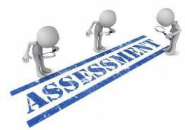

**ASSESSMENT METHODS FOR BLOCK EXAM:**

Evaluation is a continuous process comprising of block examination and annual university examination. Students will be evaluated throughout the year. The internal assessment will contribute towards the ﬁnal examination scores.

Multiple examination methods including MCQs, SAQs, OSPE and viva will be used. In line with PMC stipulation, the pass/fail marks for the test and examination will be 50%.

There will be a block exam at the end of each block.

**Theory (knowledge)**:

MCQs (Multiple Choice Questions) and SAQs (Short Answer Questions) are used to assess the theory part for the block exam.

**MCQ:**

* + - * A MCQ has a statement or clinical scenario followed by four options (likely answers).
      * After reading the statement/scenario student select ONE, the most appropriate answer/response from the given list of options.
      * Correct answer carries one mark, and incorrect ‘zero mark’. There is NO negative marking.

**SAQ:**

SAQ are open ended questions that requires students to create an answer. They are commonly used in examinations to access the basic knowledge and understanding of a topic.

**OSPE**:

Objective Structured Practical Examination (See the proposed plan of OSPE)

* It may comprise between 12- 25 stations.
* The content may assess application of knowledge, or practical skills.
  + Student will complete task in deﬁne time at one given station.
  + All the students are assessed on the same content by the same examiner in the same allocated time.
  + A structured examination will have observed, unobserved, interactive and rest stations.

**OBSERVED AND INTERACTIVE STATIONS:**

They will be assessed by internal or external examiners through the task or viva.

**UNOBSERVED STATION:**

It will be static station in which students will have to answer the questions related to the given pictures, models or specimens on the provided response sheet.

**REST STATION:**

It is a station where no task is given, and during this time student can organize his/her thoughts.

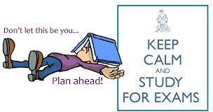

**BLUEPRINT OF THE ASSESSMENT FOR BLOCK EXAM**

**2ND YEAR BDS**

|  |  |  |  |  |  |  |  |  |  |  |  |  |  |  |  |  |  |  |
| --- | --- | --- | --- | --- | --- | --- | --- | --- | --- | --- | --- | --- | --- | --- | --- | --- | --- | --- |
| **Component from BLOCK EXAM= Theory and Practical: 140+140**  **Component from Internal Assessment= Theory and Practical 60+60**  **Theory=600 Marks Practical=600**  **Total Marks: 1200** | | | | | | | | | | | | | | | | | | |
| **MODULE/BLOCK** | | | **BLOCK – IV** | | | | | **BLOCK – V** | | | | | | **BLOCK – VI** | | | | |
| **Module- 7** | | **Module-8** | | | **Module-9** | | | **Module-10** | | | **Module-11** | | | **Module-12** | |
| **PROFESSIONAL EXAMINATION** | **Theory Marks** | | **100** | | **100** | | | **100** | | | **100** | | | **100** | | | **100** | |
| **200** | | | | | **200** | | | | | | **200** | | | | |
| **Practical Marks (OSPE)** | | **200** | | | | | **200** | | | | | | **200** | | | | |
| **Internal Assessment-IA** | | **Theory: 60 Practical:60** | | | | | **Theory: 60 Practical:** | | | | | | **Theory: 60 Practical:60** | | | | |
| **Subject wise distribution** | **Subjects** | **MCQs** | **SAQs** | **OSPE Stations** | **viva** | | **MCQs** | **SAQs** | | **OSPE Stations** | **viva** | | **MCQs** | **SAQs** | | **OSPE Stations** | **viva** |
| **Community Dentistry** | **23** | **3** | **5** | **15** | | **23** | **3** | | **5** | **15** | | **23** | **3** | | **5** | **15** |
| **Dental Materials** | **23** | **3** | **5** | **15** | | **23** | **3** | | **5** | **15** | | **23** | **3** | | **5** | **15** |
| **Pharmacology** | **23** | **3** | **5** | **15** | | **23** | **3** | | **5** | **15** | | **23** | **3** | | **5** | **15** |
|  | **Pathology** | **23** | **3** | **5** | **15** | | **23** | **3** | | **5** | **15** | | **23** | **3** | | **5** | **15** |
|  | **TOTAL#** | **92**  **(I mark each)** | **12**  **(4 marks each)** | **20 (4 marks each)**  **=80** | **60** | | **92**  **(I mark each)** | **12**  **(4 marks each)** | | **20(4 marks each) =80** | **60** | | **92**  **(I mark each)** | **12**  **(4 marks each)** | | **20**  **(4 marks each) =80** | **60** |
|  | **Total** | **92** | **48** | **140** | | | **92** | **48** | | **140** | | | **92** | **48** | | **140** | |
| **Total (theory + practical)** | | **140** | | **140** | | | **140** | | | **140** | | | **140** | | | **140** | |
|  | **Internal Assessment** | | **60** | | **60** | | **60** | | | **60** | | | **60** | | | **60** | | |
| **Total marks** | | **200** | | **200** | | **200** | | | **200** | | | **200** | | | **200** | | |
| **Total Marks** | | **400** | | | | **400** | | | | | | **400** | | | | | |
| **Grand total** | **1200** | | | | | | | | | | | | | | | | | |

**INTERNAL ASSESSMENT DISTRIBUTION**

**SECOND YEAR BDS**

|  |  |  |  |  |  |
| --- | --- | --- | --- | --- | --- |
| **THEORY INTERNAL ASSESSMENT**  **15 MARKS** | | | **PRACTICAL INTERNAL ASSESSMENT**  **15 MARKS** | | |
| **ATTENDANCE**  **5 MARKS** | **ASSIGNMENTS AND PRESENTATIONS**  **5 MARKS** | **BEHAVIOUR /DISCIPLINE**  **5 MARKS** | **ATTENDANCE**  **5 MARKS** | **LOGBOOK**  **5 MARKS** | **BEHAVIOUR**  **5 MARKS** |
| 91 and above  5 marks  B/W 86% to 90%=  4 marks  B/W 81% to 85%=  3 marks  76% to 80%= 2 marks  75%= 1 mark | Grade A=5 marks  Grade B= 3 marks  Grade C= 1 mark  No assignments or presentations =0 marks | No misbehave or warning in lectures = 5 marks  Written warning given to student = 0 marks | Above 90%=  5 marks  B/W 85% to 90%=  4 marks  B/W 80% to 85%=  3 marks  75% to 80%= 2 marks  Up to 75%= 1 mark  Below 75 % = 0 marks | Completed and timely signed =5 marks  Completed and late submission=3 marks  Incomplete= 1 mark  No logbook =0 marks | No misbehave or warning in practical class= 5 marks  Written warning given to students= 0 marks |

|  |  |
| --- | --- |
| **LEARNING RESOURCES** | |
| **SUBJECT** | **RESOURCES** |
| **PATHOLOGY** | **Textbook:**  Robbins Pathology  **Reference book :**  Levinson |
| **PHARMACOLOGY** | **Text Book:**  Basic and Clinical Pharmacology, Katzung  **Reference Books:**   1. Lippincott Illustrated Reviews. 2. Rand and Dale’s Pharmacology |
| **COMMUNITY & PREVENTIVE DENTISTRY** | **Textbook :**  S.S Hiremath, Textbook of Preventive and Community Dentistry.  **Reference Book:**   1. Blainaid Daly, Richard Watt, Essentials of Dental Public Health. 2. Jong’s Community Dental Health, George M.Gluck 3. Joseph John, Preventive and Community Dentistry 4. Community Oral Health, Cynthia Pine, Rebecca Harris |
| **DENTAL MATERIALS** | **Textbook:**  Easy Approach Text by Dr. Tahir Khan and Dr. Amjid Naseer  **Reference Book:**   1. Philips 11th edition 2. Mccabe |

|  |  |
| --- | --- |
| **OTHER LEARNING RESOURCES** | |
| **Hands-on Activities/ Practical** | Students will be involved in Practical sessions and hands-on activities that link with the foundation module to enhance the learning. |
| **Labs** | Utilize the lab to relate the knowledge to the specimens and models available. |

|  |  |
| --- | --- |
| **Skill Labs** | A skills lab provides the simulators to learn the basic skills and procedures. This helps build the confidence to approach the patients. |
| **Videos** | Video familiarize the student with the procedures and protocols to assist patients. |
| **Computer Lab/CDs/DVDs**  **/Internet Resources** | To increase the knowledge students should utilize the available internet resources and CDs/DVDs. This will be an additional advantage to increase learning. |
|  | SDL is scheduled to search for information to solve cases, read through different resources and discuss among the peers and with the faculty to clarify the concepts. |

