.

**SECOND YEAR BDS 2024-25**

**BLOCK IV (MODULE VII & VIII)**

**FROM THE DESK OF PRINCIPAL**

Health is a fast-evolving field and with new technologies taking over the traditionally man-dominated fields like radiology and robotic surgical suites assisted by Artificial Intelligence and learning are taking new dimensions with the help of Augmented Reality, we are indeed living in challenging time s. Today's student of Medicine and Dentistry will be in the field a decade from now, up against a disease burden that is as varied as the next strain of the Covid-19 Virus and as complicated as the genetic characteristic of Oral Cancer, the largest cancer amongst both genders in Pakistan and at the same time as unpredictable as the recent Covid-19 Pandemic.

It is therefore imperative that our curricula of the Medical and Dental Colleges be in tandem with the changing times with the ability to evolve with time, measuring up to the challenges thrown at the field of healing from the

Ever-evolving diseases.

These Student Guidebooks are reviewed every year with the same concept in mind that our future Physician and Dental Surgeon be ready for the challenges that lie ahead.

In the end, I give you the same prayer as is mentioned in the Quran



Prof. Shaheed Iqbal

BDS, MDS

Oral & Maxillofacial Surgery

Principal Sardar Begum Dental College

Gandhara University,

Peshawar.

2



On behalf of the Block team, I would like to welcome you to Block-IV (Module 7 and 8). As a part of the system-based curriculum, this block is an integrated presentation comprising system-based modules which links basic scientific knowledge to clinical problems. Integrated teaching means that subjects are presented as a meaningful whole. The students will be able to have better understanding of basic sciences when they repeatedly learn it in relation to clinical examples. Small group discussions, early exposure to clinics, wards, and skills acquisition in skills lab are characteristics of integrated teaching program.

The faculty are faced with determining how to present course material so the student not only gain knowledge of the discipline but also become self-directed learners who develop problem solving skills that they can apply in future courses and in their careers.

Our mission is to provide all educational opportunities to our students. Therefore, on completion of the BDS program graduate will possess an appropriate foundation of knowledge, skills and attitudes to be well prepared to practice safely and effectively

As director Medical Education I will be meeting with the facilitators to receive feedback and will try to resolve any difficulties or problems faced during the block. Pl ease do not hesitate to contact the department for any academic help. I wish you an enjoyable and learning experience with Block 4.



**Director Medical Education: Dr. Marina Khan**



|  |
| --- |
| **Topic** |
| **Block Team.................................................................................................................** |
| **List of abbreviations….................................................................................................** |
| **Aims of the study guide… ..........................................................................................** |
| **Course distribution of 2ND year BDS......................................................................** |
| **Introduction of block …...........................................................................................** |
| **General Outcomes…....................................................................................................** |
| **Leaning Methodologies…............................................................................................** |
| **Rules Regulations........................................................................................................** |
| **Course contents & Learning Outcomes......................................................................** |
| **Assessment……………………………………………………………………………………** |
| **Learning Resources…………………………………………………………………………** |

**BLOCK TEAM**

|  |  |  |
| --- | --- | --- |
| Dr. Marina Khan  Director Department of Medical Education  [marinakahn@hotmail.com](mailto:marinakahn@hotmail.com)  Ext=155 | | |
|  |  |  |
| DEPARTMENT OF DENTAL MATERIALS | Prof Dr. Tahir Ali Khan  Prof Dr. Amjad Naseer  Assist Prof Dr. Munazza Ijaz  Assistant Prof Dr. Asad  Dr. Hanan |
|  |  |  |
| DEPARTMENT OF COMMUNITY DENTISTRY | Prof. Dr. Babar Ahad  Prof Dr. Saira Afridi  Prof Dr. Sofia Shehzad  Assist Prof Dr. Sana Ruqayya  Assist Prof Dr Imran Gillani |
|  |  |
| DEPARTMENT OF PATHOLOGY | Prof Dr Syed Mukhtiar.Ali.Shah  Prof Dr. Nisar Ahmed  Prof Dr. Ehsan Gul Khattak  Prof Dr. Naila Ismail  Prof Dr. Ibn-e-Amin  Associate Prof Dr. Shazia  Assist Prof. Dr. Ronaq Zaman |
|  |  |  |
| DEPARTMENT OF PHARMACOLOGY | Prof Dr. Iftikhar Ud Din  Associate Prof Dr. Syed Hasnain Ali Shah  Assistant Prof Dr. Saifullah  Dr. Ihtesham  Dr. Haseeb |
|  |  |
| DEPARTMENT OF MEDICAL EDUCATION | Assistant Prof Dr. Marina Khan  Assistant Prof Dr. Syed Muhammad Junaid  Dr. Aalia Zaib  Dr. Usama Zeb |

## 

## LIST OF ABBREVIATIONS

|  |  |
| --- | --- |
| **DME** | Department of Medical Education |
| **PATHO** | Pathology |
| **PHARMA** | Pharmacology |
| **DM** | Dental Material |
| **CD** | Community Dentistry |
| **J.PROS** | Junior Prosthetics |
| **J.OPER** | Junior Operative |
| **LGIS** | Large Group Interactive Session |
| **SGD** | Small Group Discussion |
| **SDL** | Self-Directed Learning |
| **DSL** | Directed Self Learning |
| **MCQ** | Multiple Choice Question |
| **SAQ** | Short Answer Question |
| **OSPE** | Objective Structured Practical Exam |

**STUDY GUIDE:**

****This study guidebook was designed by combining the efforts of all topics throughout the year to give dentistry students at SBDC a resource material that highlights significant components of the curriculum. By providing students control over their learning, the study guide aims to promote self-regulated lifelong learning.

Regarding the course content, the study guide provides an overview of the anticipated course outcomes and objectives. The assessment approach is also customized to the intuitional strategy.

A successful curriculum has a significant impact on the final product, as well as on society. This study guide was carefully designed with the PMC curriculum and rules in mind, and Gandhara University stakeholders and faculty members worked hard to personalize it to the needs of students. They are further working to build, implement, and exercise a well-built curriculum in light of changing demographic needs and disease prevalence in our society. Throughout the construction of the study guide, students' feedback was received and included. Curriculum is a living, dynamic entity that is constantly changing. With each passing day, we hope to improve it. This selfless effort on the part of the entire faculty serves as a beacon for our wonderful students.

Each module in this block has been created to cater the gap between basic and clinical subjects through pre-clinical learning. The block is divided into two modules in which the students are exposed to a variety of basic and clinical subjects. The integrated curriculum is enforced through interactive lectures, small group discussion, community outreach programs along with rotations at preclinical laboratory. The course content pertinent to each module will be addressed in problem-based scenarios and student will work collaboratively towards its solution.



**AIMS OF THE STUDY GUIDE**

It is an aid to:

* Inform students how student learning program of the BLOCK-wise module has been organized
* Help students organize and manage their studies throughout the
* Guide students on assessment methods, rules and regulations
* Communicates information on organization and management of the modules. This will help the student to contact the right person in case of difficulty.
* Defines the objectives which are expected to be achieved at the end of each module.
* Identifies the learning strategies such as lectures, small group teachings, clinical skills and demonstration, tutorial that will be implemented to achieve the modules objectives.
* Provides a list of learning resources such as books, computer assisted learning programs, web- links, and journals, for students to consult to maximize their learning.
* Highlights information on the contribution of continuous and block examinations on the student's overall performance.
* Includes information on the assessment methods that will be held to determine every student's achievement of objectives.

**ORGANIZATION OF MODULAR CURRICULUM**

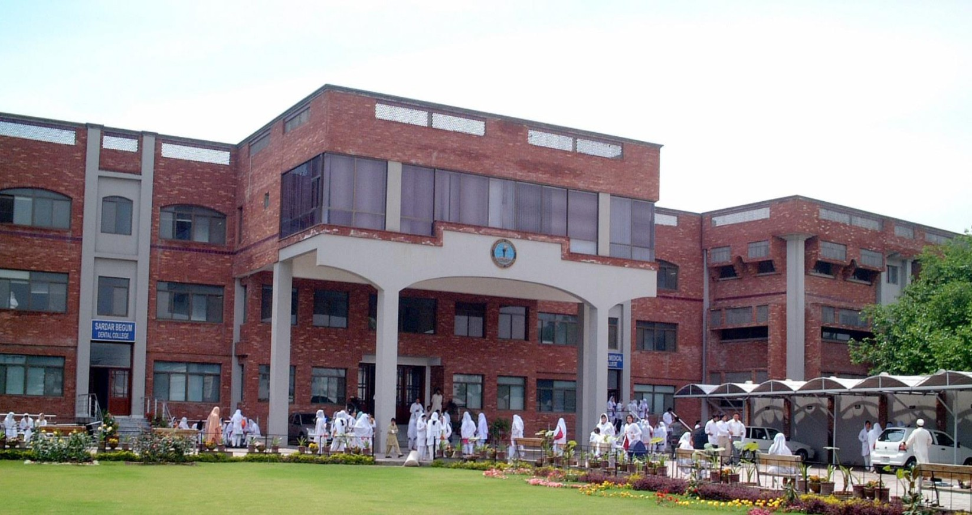

**2nd  YEAR BDS**

|  |  |  |  |  |  |  |  |  |  |
| --- | --- | --- | --- | --- | --- | --- | --- | --- | --- |
| **Block-4** | | **Exam Block 4** | **Block-5** | | **Exam Block 5** | **Block-6** | | **Exam Block 6** | **Final Exam** |
| **Module**  **7**  **Pre and Para-Clinical Dental Sciences** | **Module**  **8**  **Restorative Material**  **and Dental Research** | **Module**  **9**  **Epidemiology of Oral diseases and Auxiliary Materials-I** | **Module**  **10**  **Epidemiology**  **of Oral**  **diseases and Auxiliary Materials-II** | **Module**  **11**  **Health**  **Promotion and Infection Control** | **Module**  **12**  **Neoplasia and Metallurgy** |

### 

### LEARNING METHODOLOGIES

The following teaching / learning methods are used to promote better understanding:

* Interactive Lectures
* Small Group Discussion
* Practical
* Skills session
* E-Learning
* Self-Directed Learning

### LARGE GROUP INTERACTIVE LECTURES (LGIS)

### 

In large group, the lecturer introduces a topic or common clinical conditions and explains the underlying phenomena through questions, pictures, videos of patients' interviews, exercises, etc. Students are actively involved in the learning process.

### 

### SMALL CROUP DISCUSSIONS (SGDs):



This format helps students to clarify concepts acquire skills or attitudes. Sessions are structured with the help of specific exercises such as patient case, interviews or discussion topics. Students exchange opinions and apply knowledge gained from lectures, tutorials and self-study. The facilitator role is

to ask probing questions, summarize, or rephrase to help clarify concepts.

#### PRACTICAL

Basic science practical related to Dental Materials, Community & Preventive Dentistry, Pathology and Pharmacology are scheduled for student learning.

**SELF DIRECTED LEARNING SDL:**

Students assume responsibilities of their own learning through individual study, sharing and discussing with peers, seeking information from Learning Resource Center, teachers, and resource persons within and outside the college. Students can utilize the time within the college scheduled hours of self-study.

**E-LEARNING:**

E-Learning is a strategy by which learning occurs through the utilization of electronic media, typically the Internet. The basic aspects of medical professionalism and ethics will be addressed through an e-learning course.

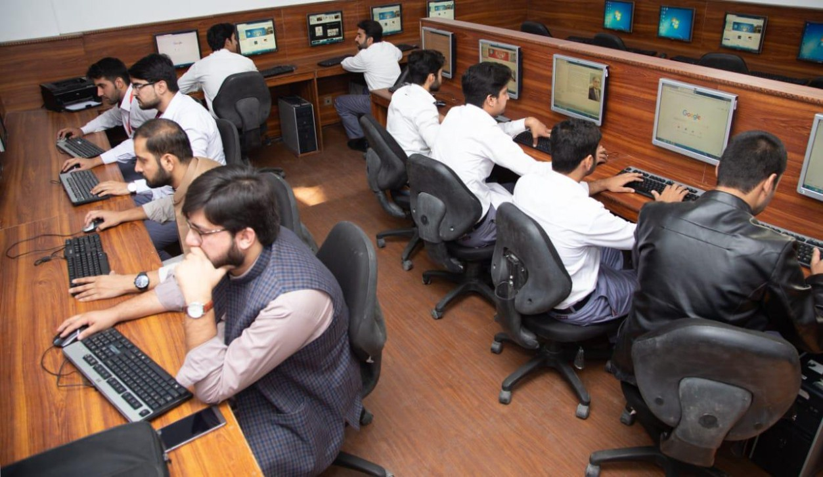

1. **Hands on Training**
2. **Dental Material, Community & Preventive Dentistry ,Pathology & Pharmacology lab sessions:**

All practical’s will demonstrate your skills and help in clarifying your concepts practically.

2. **Clinical skill lab sessions**

Hands on Practice of clinical examination.

.

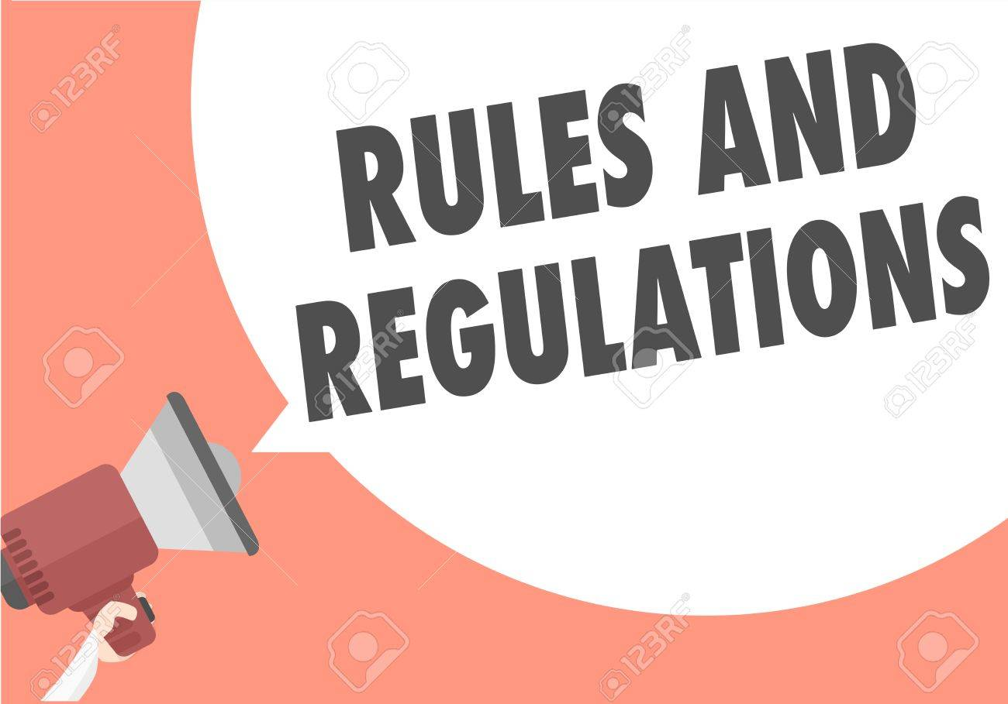

**RULES AND REGULATIONS**

We will be making the journey through block 4 in 11 weeks. Therefore, this course includes an intensive coursework load. Class attendance and participation are extremely important to learning and are considered in the evaluation of course grade. If there is anything that the module team can do to assist during the course, please feel free to contact. Attendance will be monitored during the different teaching activities. If the attendance is less than 75%, student will not be allowed to sit for both block and annual examination.



All examinations must be taken on the date scheduled. Student will be not allowed to enter the examination area after the examination starts. There will be a block exam at the end of each block covering two modules. There will be a total of 3 block examination and the 30% weightage of these block exam will be added to the 70 % of the annual professional exam as an internal assessment.

**INTRODUCTION TO BLOCK-4**

This block is aimed to give students a theoretical and practical grasp of the pathological and pharmacological elements of disease, as well as biomaterials used in dentistry, clinical applications, and community-based dentistry. The block is divided into two modules in which the students are exposed to a variety of basic and clinical subjects. Every module in the block is designed to demonstrate a link to other modules in order to foster a more in-depth understanding of each subject's core principles and their application in clinical encounters in the coming years of the BDS undergraduate programme. There will be formative as well as summative assessment of the modules throughout the block. The integrated curriculum is enforced through interactive lectures, small group discussion, and community outreach programs along with rotations at preclinical laboratory. Block IV also emphasizes on fundamental knowledge about the nature and causes of human body disorders in order to improve medical diagnosis and provides an introduction to microbiology. It also strongly relies on pharmacological interactions, as well as their biochemical and physiological effects on cells, tissues, and organ systems specifically on autonomic nervous system. This block will serve as a prelude to learning about the chemical, biological, and physical nature of biomaterials/therapeutics in preparation for their application in various pathological conditions in blocks V and VI. The epidemiology, philosophy, and practice of dental public health will be taught to the students as well. Students will have a better understanding of the pathological foundation of disease as well as treatments for better dental patient diagnosis and treatment planning. A greater insight of the procedures and biomaterials used for the prevention and restoration of oral structures will be gained. The undergraduate training provided during these blocks, which includes lecture - based and laboratory-based methods under supervision, will help produce confident and competent dentists ready to serve the community as soon as they graduate from dental school.

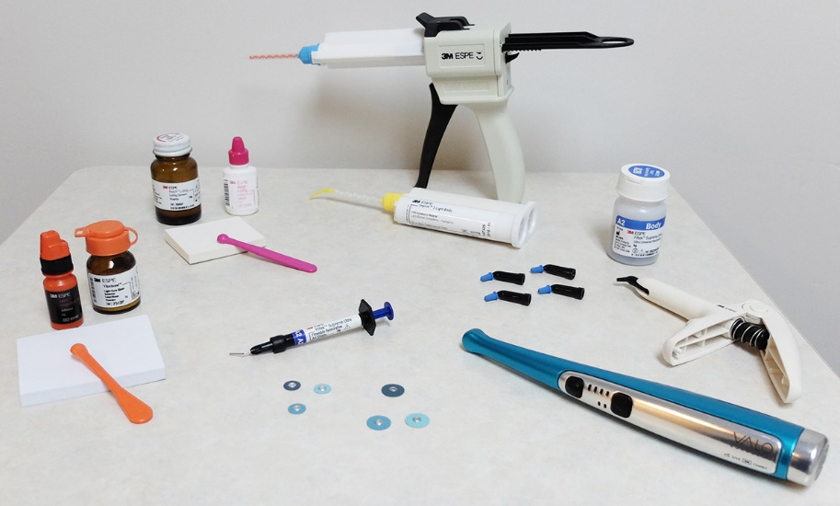

**Dental Materials**

is defined as the study and science of the development, properties, manipulation, care, evolution, and evaluation of materials used in the treatment and prevention of dental disease. The subject of science of dental materials at undergraduate level enables the students to recognize the clinical, technical and scientific rationale for the use of materials in clinical dental practice. This module curriculum is designed so which will help the students learn about optimal selection of materials, understand recognition, physical / mechanical / thermal properties, Stress-strain relationship, elasticity / viscoelasticity, behavior, use, handling, manipulation, safety consideration of materials and patient education regarding dental restoratives. The practical component of the course involves hands-on experience of the materials and their manipulation in the laboratory.

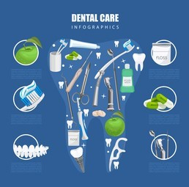**Community & Preventive Dentistry**

is the dynamic field of dentistry which provides basic & advanced health knowledge to an individual and group of people, prevention of oral/dental diseases & awareness of oral hygiene in any population. The main purpose of the subject is to achieve good oral hygiene, Principals and functions of primary health care and to spread health awareness in the public through organized community efforts. The curriculum provides the student with a broad range of knowledge and practical experience in the philosophy and basis of dental public health, primary health care approach, and an introduction to epidemiology of oral diseases as it relates to dental research, behavioral sciences, biostatistics and oral health services.

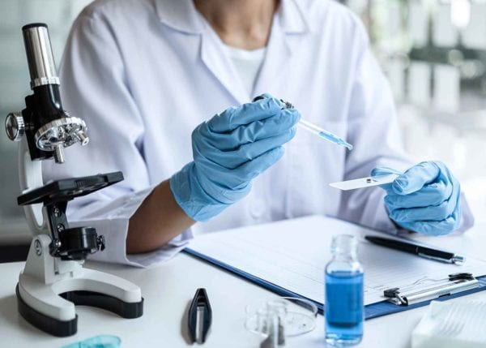

**Pathology**

is the “scientific study of disease”. It is the “scientific study of the molecular, cellular, tissue, or organ system response to injurious agents.” It “is the foundation of medical science and practice. The subject of General Pathology and Microbiology at an undergraduate level enables the students to recognize the structural and functional causes of human disease. This module will help the student to understand the mechanisms of injury to cells and tissues, as well as the body’s means of responding to and repairing injury. Areas of study include cellular adaptation to injury, necrosis, inflammation, wound healing and neoplasia. It forms the foundation of pathology, the application of this knowledge to diagnose diseases in humans and animals.

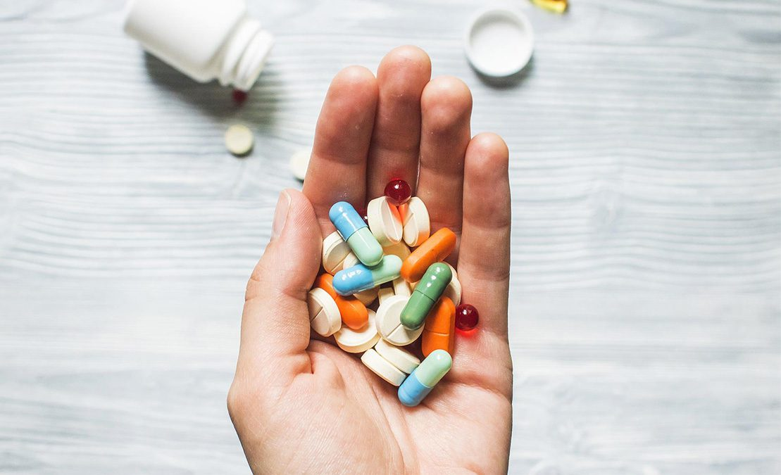

**Pharmacology**

is the science dealing with actions of drugs on the body (pharmacodynamics) and the fate of drugs in the body (pharmacokinetics). This course in this module will provide students with an understanding of the scientific foundations of the study of pharmacology. This includes the basic principles of drug dose, permeation, interaction, metabolism, absorption, and excretion of drugs.

**GENERAL OUTCOMES:**

 By the end of this block the students of 2nd year BDS will be able to

### KNOWLEDGE:

1. describe tooth structure and dental materials
2. Describe the Properties of dental material i.e. Physical properties

Mechanical properties: Stress and strain

1. know about introduction, history classification, chemistry, applications and powder liquid ratio system of dental cements
2. Know about introduction to restorative materials and explain requirements of direct restorative materials
3. Know about history & introduction of dental amalgam, classification, composition of amalgam and manufacturing of alloy powder
4. Differentiate between glass ionomer cements,zinc cements,zinc oxide eugenol cements,pulp protection cements, restorative materials and composite impression materials
5. Describe the core functions of dental public health, key principles of public health, Scope of public health, wider social and environmental influences on health and health economics.
6. have a clear understanding about Changing concepts of health, and its Dimensions.
7. recognize, the concepts of primary health care and understand the Alma Ata declaration, understand the principles and functions of primary health care
8. describe cohort study,case control study ,randomized control trails and biostatistics
9. describe the shape & size of bacteria, medical importance of different cell components and difference between cell wall of G+ & G- bacteria, Stages of bacterial pathogenesis.
10. describe atrophy, hypertrophy, hyperplasia &metaplasia with clinical examples, describe mechanism of reversible cell injury ( free radicals), describe the mechanism of irreversible cell injury & its Clinicopathological correlation, types and morphology of necrosis & its Clinicopathological correlation
11. describe acute and chronic inflammation, tissue repair, sterilization disinfection, host defense and inflammation
12. describe agonist, and antagonist,describe Autonomic nervous system ,sympathetic and asympathetic nervous system
13. Describe about dose, loading, maintenance and pediatric dose, permeation of drug, pharmacokinetic and pharmacodynamics drug interaction.
14. describe drug metabolism, absorption of drug, distribution of drug, excretion of drug, different routes of excretion of drugs, first and zero order kinetics
15. describe the protocols for Examination and treatment planning
16. Describe removable partial denture and complete partial denture

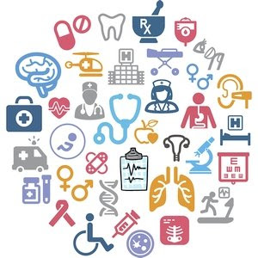

**SKILLS:**

By the end of block- IV, the student of 2nd year BDS will be able to:

1. follow lab protocols, prepare 5% dextrose solution, and prepare 50ml of 0.1% potassium permanganate solution (Kmno4) solution, dispense two doses (60ml) of 12.5% castor oil emulsion, prepare and dispense two doses (60ml) of kaolin suspension
2. preparation and administration of pilocarpine, atropine, ephedrine and unknown drugs on rabbit eye
3. identify media and describe inoculation, composition and uses of media, identify testicular atrophy under a microscope, identify BPH under a microscope, identify and describe the microscopic features of fatty liver under a microscope
4. identify inflammatory cells, acute, appendix lymph nodes under a microscope
5. handle, bend and use a stainless-steel wire, which will facilitate them in future, while making a C-clasp, Identify, handle and manipulate dental amalgam, zinc oxide eugenol cement, calcium hydroxide cement, composite resin, plaster of Paris.
6. understand the basic concept behind the community dentistry in practical life and its uses in general, understand different tooth notation systems take proper history, perform FDI system on models and patients.
7. Fabricate denture base plate and wax pattern instrument examination
8. Preparation of class I,II,III,IV and V cavities

**ATTITUDE:**

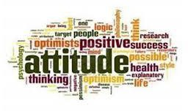

By the end of this block, the students of 2nd tear BDS will be able to:

* Develop respect for the individuality and values of others - (including having respect for oneself) patients, colleagues and other health professionals.
* Organize & distribute tasks.
* Exchange opinion & knowledge.
* Develop communication skills and etiquette with sense of responsibility.
* To equip themselves for teamwork.
* Regularly attend the classes.
* Demonstrate good laboratory practices.
* Carry out practical work as instructed in an organized and safe man
* Make and record observations accurately.
* Develop the ability to give and receive feedback
* Respect for self and peers

**MODULE – 7**

**PRE AND PARA-CLINICAL DENTAL SCIENCES**

**Duration: 5 Weeks**

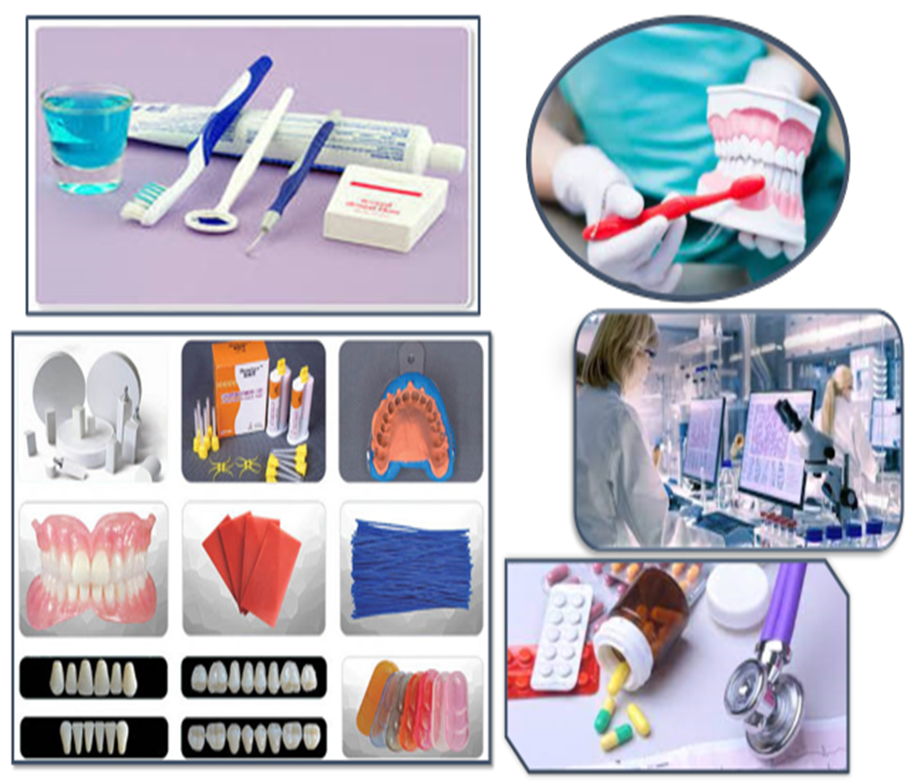

|  |  |  |
| --- | --- | --- |
| **PATHOLOGY LECTURES** | | |
| **S.NO** | **TOPICS** | **LEARNING OBJECTIVES** |
| 1 | Bacterial cell | Describe shape & size of bacteria, Discuss the medical importance of different cell components  Enlist the difference between cell wall of G+ & G- bacteria |
| 2 | Bacterial Growth  Classification of Bacteria  Normal Flora | Describe Growth cycle, Aerobic & Anaerobic growth and classification based on different criteria.  Describe members of normal flora, their anatomic locations& benefits of normal flora |
| 3 | Pathogenesis | Enlist the Stages of bacterial pathogenesis |
| 4 | Cellular adaptation to stress | Describe atrophy, hypertrophy hyperplasia and metaplasia with clinical examples |
| 5 | Reversible cell injury | Enlist the cause & mechanism of reversible cell injury (hypoxic injury) |
| 6 | Irreversible cell injury | Explain the mechanism of irreversible cell injury (free radical injury, chemical & ischemic reperfusion injury) |
| 7 | Necrosis | Enlist the types and morphology of necrosis & its Clinicopathological correlation |
| 8 | Apoptosis I | Explain the mechanisms of Apoptosis |
| 9 | Apoptosis II | Explain mechanisms and Clinicopathological correlation of apoptosis |

|  |  |  |  |
| --- | --- | --- | --- |
| **PATHOLOGY PRACTICALS** | | | |
| **S.NO** | **TOPICS** | **LEARNING OBJECTIVES** | | |
| 1 | Gram staining |  | Identify and perform gram staining | |
| 2 | Culture media |  | Identify media inoculation and composition culture media | |
| 3. | Testicular atrophy |  | Identify the microscopic features of testicular atrophy under a microscope | |
| 4. | Benign prostatic hyperplasia (BPH) |  | Identify the microscopic features of BPH under a microscope | |
| 5. | Fatty liver | Identify the microscopic features of fatty liver under the microscope | | |

|  |  |  |
| --- | --- | --- |
| **PATHOLOGY SGDs** | | |
| **S.NO** | **TOPIC** | **LEARNING OBJECTIVES** |
| 1 | Biosafety | Discuss biosafety procedures and precautions taken in microbiology lab |
| 2 | Intracellular accumulations | Discuss accumulation of lipids, proteins, glycogen & pigments |
| 3 | Pathological calcifications/ Clinicopathological correlation of necrosis & Apoptosis | . Discuss Pathological calcifications  . Enumerate the types of Pathological calcifications  . Discuss the mechanism of pathological calcification  Differentiate between necrosis & Apoptosis.  Enlist & explain Clinicopathological correlation of necrosis & Apoptosis |
| 4 | Basic Mycology | Discuss Structure, growth & Laboratory diagnosis of fungi |
| 5 | Basic virology | Discuss structure and classification of virus |

|  |  |  |  |
| --- | --- | --- | --- |
| **COMMUNITY AND PREVENTIVE DENTISTRY LECTURES** | | | |
| **S.NO** | **TOPICS** | | **LEARNING OBJECTIVES** | |
|  | Orientation to Community Dentistry |  | Define dental public health  Explain its Aims and objectives  Discuss its Contributions to society | |
|  | Principals of public health |  | Describe the Basic/key principles of public health  Explain the Principals applied to public health practice and its Impact on population health  Explain the concept of public health problems | |
|  | Concepts of health and disease & prevention-1 |  | Describe the Changing concepts of health, along with the Dimensions and | |
|  | Primary Health Care-2 |  | Describe the Principals and functions of primary health care | |
|  | Introduction to principles of epidemiology |  | Define the principles of epidemiology and the epidemiological triad  Describe the Measurements of epidemiology | |
|  | Morbidity and mortality |  | Enlist the Measures of mortality and morbidity | |
|  | General Epidemiology: |  | Describe Epidemiological study designs  Describe descriptive and analytical study designs | |
|  | Screening |  | Define screening  Describe the Criteria for screening  Enlist the types of screening  Explain the concept of predictive values | |
| 9 | General epidemiology: Descriptive study-1 |  | Define descriptive study designs (cross sectional study designs)  Enlist the uses of descriptive epidemiology | |
| 10 | descriptive study -2 |  | Enlist the Steps in conducting descriptive study | |

|  |  |  |
| --- | --- | --- |
| Concepts of health and disease & prevention-2 |  | Explain determinants of health  Describe the Natural history of disease |
| Primary Health Care-1 |  |  |

|  |  |  |
| --- | --- | --- |
|  | **COMMUNITY DENTISTRY PRACTICALS** | |
| **S.No** | **TOPIC** | **SKILL DETAILS** |
| 1 | Introduction to Community Dentistry | Explain an overview of basic concept of community dentistry in practical life |
| 2 | Tooth notation | Identify tooth notations on models |
| 3 | universal tooth numbering system | Identify universal tooth notation on models and patients |
| 4 | Palmer tooth notation | Identify and perform palmer tooth notation on models and patients |
| 5 | FDI system | Perform FDI tooth numbering system on models & patients |

|  |  |  |
| --- | --- | --- |
|  | **COMMUNITY DENTISTRY SGDs** | |
| **S.No** | **TOPIC** | **LEARNING OBJECTIVES** | |
|  | Principals of public health | Discuss the Basic/key principles of public health  Discuss the Principals applied to public health practice and its Impact on population health | |
|  | Concepts of health and disease & prevention | Discuss the Changing concepts of health, and disease.  Discuss the determinants of health | |
|  | Primary Health Care | Discuss the primary health care  Discuss the Alma-Ata declaration  Discuss the Principles and functions of primary health care | |
|  | Introduction to principles of epidemiology  Morbidity and mortality  General Epidemiology | Discuss the principles of epidemiology and the epidemiological triad  Discuss the Measurements of epidemiology  Discuss the Measures of mortality and morbidity  Discuss the Epidemiological study designs  Discuss the descriptive and analytical study designs | |
|
|  | General epidemiology: Descriptive study | Discuss the descriptive study designs (cross sectional study designs)  Discuss the uses of descriptive epidemiology.  Discuss and enlist the Steps in conducting descriptive study | |

|  |  |  |
| --- | --- | --- |
| **DENTAL MATERIAL LECTURES** | | |
| **S.NO** | **TOPICS** | **LEARNING OBJECTIVES** | |
| 1. | Introduction to tooth structure  Introduction to dental materials | Enlist parts, structure, and functions of tooth.  Explain dental materials and science of dental material  Classify dental materials  Explain selection and evaluation of dental material | |
| 2. | Properties of dental material  - Introduction  - Physical properties  - Mechanical properties: Stress and strain | Describe the properties of unmixed, mixed and set material.  Enlist the physical properties  In stress and strain | |
| 3. | Stress-strain relationship  Fracture toughness | Describe the stress and strain relationship  Explain the fracture toughness | |
| 4. | Impact strength  Fatigue properties  Wear  Hardness | Describe impact strength, fatigue properties, wear and hardness | |
| 5. | Elasticity, viscoelasticity, creep, and flow  Rheological properties | Describe elasticity, viscoelasticity, creep, and flow  Explain rheological properties | |
| 6. | Thermal properties  Biological properties  Adhesion | Enlist the thermal properties, biological properties, and adhesion | |
| 7. | Adhesion  Miscellaneous physical properties | Explain adhesion and miscellaneous physical properties | |
| 8. | Miscellaneous physical properties  Chemical properties | Enlist the chemical and miscellaneous properties | |
| 9. | Dental cements | Define dental cements  Describe chemistry, applications, and powder liquid ratio system of dental cements | |
| 10. | Restorative materials | Describe restorative materials and requirements of direct restorative materials | |
| 11. | Dental Amalgam | Define dental amalgam  Enlist the classification, composition of amalgam and manufacturing of alloy powder  Explain setting reaction of dental amalgam  Explain material related variables of dental amalgam  Explain manipulation of dental amalgam | |

|  |  |  |
| --- | --- | --- |
| **DENTAL MATERIAL PRACTICALS** | | |
| **S.NO** | **TOPICS** | **SKILL DETAILS** | |
| 1 | Wire Work | Perform the wire bending exercise to make the various alphabets (A-Z) from stainless steel wire | |

|  |  |  |  |
| --- | --- | --- | --- |
| **DENTAL MATERIAL SGD’s** | | | |
| **S.NO** | **TOPICS** | **LEARNING OBJECTIVES** | |
| 1 | Introduction to tooth structure  Introduction to dental  Materials  Properties of dental material  - Introduction  - Physical properties  - Mechanical properties: |  | Discuss parts, structure and functions of tooth.  Explain dental materials and science of dental material  Classify dental materials  Discuss selection and evaluation of dental material.  Discuss the properties of unmixed, mixed and  set material. |
| 2 | Stress  and strain  Stress-strain relationship  Fracture toughness |  | Discuss the physical properties  Discuss stress and strain  Discuss the stress and strain relationship  Describe fracture toughness |
|  |
| 4 | Impact strength  Fatigue properties  Wear  Hardness |  | Discuss impact strength, fatigue properties,  wear and hardness |
| 5 | Elasticity, viscoelasticity, creep and flow  Rheological properties |  | Discuss elasticity, viscoelasticity, creep and  flow  Discuss rheological properties |
| 6 | Thermal properties  Biological properties  Adhesion |  | Discuss thermal properties, biological properties and adhesion |
| 7 | Adhesion  Miscellaneous physical  properties |  | Discuss adhesion and miscellaneous physical  Properties |
| 8 | Miscellaneous physical  properties  Chemical properties |  | Discuss the chemical and miscellaneous properties |
| 9 | Dental cements |  | Discuss the dental cements  Discuss the chemistry, applications and powder liquid ratio system of dental cements |
| 10 | Restorative materials |  | Discuss the restorative materials and requirements of direct restorative materials |
| 11 | Dental Amalgam |  | Discuss dental amalgam |

|  |  |  |  |
| --- | --- | --- | --- |
| **GENERAL PHARMACOLOGY** | | | |
| **S.No** | **TOPIC** | **LEARNING OBJECTIVES** |
|  | Introduction to pharmacology  Agonist & Antagonist | Define pharmacology and drug Describe its importance  Describe optimum pharmacokinetic and pharmacodynamic of drug  Describe agonist  Classification and clinical uses of agonist  Describe antagonist  Classification and enlist the clinical uses of antagonist |
|  | Dose, classification of dose  Loading, maintenance and paediatric dose | Define dose  Describe its significance  Classification of dose  Describe loading dose  Describe significance of loading dose  Describe the calculation of loading dose  Describe maintenance dose  Describe significance of maintenance dose  Describe the calculation of maintenance dose  Describe paediatric dose  Describe significance of paediatric dose  Describe the calculation of pediatric dose |
|  | Permeation of drug | Describe active and passive diffusion of drug  Describe ion trapping  Describe Fick’s law of diffusion  Describe Handerson Hasselbalch equation |
|  | Pharmacokinetic Drug interaction  Pharmacodynamic drug interaction | Describe pharmacokinetic drug interaction  Give examples of absorption, distribution, metabolism and excretion drug interactions  Describe How to avoid pharmacokinetic drug interaction  Describe pharmacodynamic drug interaction  Enlist the examples of drugs which are involve in enhancing or reducing the effects of other drugs  Describe to avoid pharmacodynamic drug interaction |
|  | Drug metabolism | Define drug biotransformation  Explain Where does it occur  Outcomes of biotransformation  Explain   * Phase I reactions * Phase II reactions |
|  | Absorption of drug  Distribution of drug | Define drug absorption  Enlist the different routes effects on absorption of drug  Enlist the factors affecting absorption of drug:   * Factors relating to drug * Route of administration * Factors relating to sits of absorption   Define volume of distribution  Explain How volume of distribution affects plasma concentration of a drug  Describe factors affecting distribution of drug  Describe role of physiological barriers  Enumerate drugs with large volume of distribution  Enumerate drugs with small volume of distribution |
|  | Excretion of drug  Renal excretion of drug  Biliary excretion, lung excretion, drug excreted in milk and saliva | Define excretion of drug  Differentiate between clearance, elimination and excretion  Enumerate different routes of excretion of drugs  Describe different drugs excreted renally  Process involve in renal excretion:   * Glomerular filtration * Active tubular secretion * Passive tubular secretion   Enlist the different routes of excretion of drugs  Describe first and zero order kinetics  Enumerate drugs eliminated through first order kinetics  Enumerate drugs eliminated through zero order kinetics |
|  | Quantal dose response curve, Sigmoid dose response curve and grade response curve | Define dose response curve  Describe with the help of graph Explain how dose of drug show affects  Describe the importance of dose response curve |

|  |  |  |  |
| --- | --- | --- | --- |
| **PHARMACOLOGY PRACTICALS** | | | |
| **S.NO** | **TOPIC** | **SKILL DETAILS** |
| 1 | Lab protocols | Identify the general protocols for working safely and efficiently in pharmacology lab  Identify the common apparatus used in laboratory |
| 2 | 5% dextrose solution | Identify the ingredients of dextrose solution  Prepare and dispense 50ml of 5% dextrose solution  Describe its uses |
| 3 | 0.1% potassium permanganate (Kmno4) solution | Identify the ingredients of potassium permanganate (Kmno4) solution  Prepare and dispense 50ml of 0.1% potassium permanganate (Kmno4) solution  Describe its uses |
| 4 | Two doses (60ml) of 12.5% castor oil emulsion | Identify the ingredients of castor oil emulsion  Prepare and dispense two doses (60ml) of 12.5% castor oil emulsion  Describe its uses |
| 5 | Two doses (60ml) of kaolin suspension | Identify the ingredients of kaolin suspension  Prepare and dispense two doses (60ml) of kaolin suspension  Describe its uses |

|  |  |  |
| --- | --- | --- |
| **PHARMACOLOGY SGDs** | | |
| **S.No** | **TOPIC** | **LEARNING OBJECTIVES** |
| 1 | Branches of Pharmacology | Enlist the different branches of pharmacology e.g. clinical pharmacology, pharmacotherapeutics, pharmacy, pharmacognosy, pharmacogenetics, chemotherapy, toxicology, posology, pharmacokinetics and pharmacodynamics  Enlist the branches of pharmacology with examples |
| 2 | Routes of drug administration | Discuss and enlist the different routes of drug administration e.g. oral, sublingual, rectal, parenteral, inhalational, topical Describe their merits and demerits  Enumerate dosage forms used through different routes |
| 3 | Half-life and bioavailability of drug | Discuss half-life and bioavailability of drug  Discuss the significance of half-life of drug  Enumerate and discuss the factors affecting half-life of dug  Discuss the bioavailability and factors affecting it |
| 4 | Tolerance, tachyphylaxis, up regulation and down regulation of receptors | Discuss tolerance, tachyphylaxis, Up regulation and down regulation of receptors and their significance |
| 5 | Potency, efficacy, affinity, spare receptors, therapeutic index and therapeutic window | Discuss potency, efficacy, affinity, spare receptors, therapeutic index and therapeutic window with graph  Discuss the calculation of therapeutic index  Enumerate drugs with narrow therapeutic index |

|  |  |  |
| --- | --- | --- |
| **JUNIOR PROSTHETICS LECTURES** | | |
| **S.No** | **TOPICS** | **LEARNING OBJECTIVES** | |
| 1 | Introduction to Removable and Fixed Prosthodontics and its Relevance to Science of Dental Materials | Define prosthodontics,  Define prosthetics and prosthesis  Discuss the Aims of Prosthesis  Subdivisions of prosthodontics and define each division  Differentiate between fixed and removable type of prosthesis  Define RPD  Enlist Components of RPD  Indications of RPD  Differentiate between Removable and fixed partial denture | |
| 2 | Introduction to Complete Denture and its use | Define CD  Enlist Components of CP  Indications of CD  Differentiate between Partial and complete denture. | |
| 3 | Steps and Importance of History and examination before Prosthodontic procedure | Enlist Steps of History and examination before Prosthodontic procedure.  Explain Importance of History and examination before Prosthodontic procedure | |

|  |  |  |
| --- | --- | --- |
| **JUNIOR PROSTHETIC PRACTICALS** | | |
| **S.No** | **TOPICS** | **SKILL DETAILS** |
| 1 | Wax Pattern for Denture Base | 1. Define wax pattern Introduction 2. Enlist the Methods of dental wax pattern 3. Enlist the Types of waxes 4. Identify the Instruments used for wax pattern 5. Identify fabrication for wax pattern |

|  |  |  |
| --- | --- | --- |
| **JUNIOR PROSTHETICS SGDs** | | |
| **S.No** | **TOPICS** | **LEARNING OBJECTIVES** |
| 1 | Introduction to prosthodontics | Discuss prosthodontics, prosthetics, and prosthesis  Discuss the Aims of Prosthesis  Subdivisions of prosthodontics and define each division  Discuss and enlist the differences between fixed and removable type of prosthesis |
| 2 | Complete Denture definition | Discuss the complete denture  Discuss the Indications and Contraindications of complete denture  Discuss the Classification of complete denture |
| 3 | Denture Bearing Areas | Discuss the denture bearing areas  Discuss the Anatomy  Discuss the Clinical significance of denture bearing areas |

|  |  |  |  |
| --- | --- | --- | --- |
| **JUNIOR OPERATIVE LECTURES** | | | |
| **S.No** | **TOPICS** | **LEARNING OBJECTIVES** |
| 1 | Introduction | 1. Definition of operative dentistry 2. Explain the Importance of History taking 3. Explain how to approach to the patient 4. Enlist the Steps of History taking |
| 2 | Examination | 1. Enlist the steps of examination of Extra-oral Cavity 2. Enlist the steps of Examination of Intra-oral cavity |
| 3 | Introduction to instruments in operative dentistry | 1. Enlist the instruments used in operative dentistry. 2. Classify the instruments used in operative dentistry. 3. Discuss in detail the use of instruments used in operative dentistry. 4. Identify the instruments used in operative dentistry. |

|  |  |  |
| --- | --- | --- |
| **JUNIOR OPERATIVE PRACTICALS** | | |
| **S.No** | **TOPICS** | **SKILL DETAILS** | |
| 1 | Introduction to Phantom Head Lab | 1. Understand the basics of Phantom head lab 2. Know the SOPS of the lab   Practice the different operations and functions of phantom head lab. | |
| 2 | Chair Positioning | 1. Realize the significance of chair proper positioning in operative dentistry. 2. Understand the significance of four handed dentistry. 3. Know the different chair positions for working on different teeth and arches for both the right- and left-handed operators   Demonstrate Different Seating positions for different quadrants | |
| 3 | Instruments | 1. Classify Instruments 2. Identify different hand and engine driven instruments 3. Demonstrate different instrument’s grip   Identify different instruments and their functions | |

**MODULE – 8**

**RESTORATIVE MATERIALS & DENTAL RESEARCH**

**Duration: 6 Weeks**

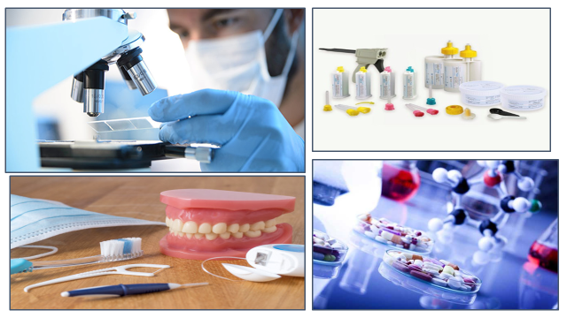

|  |  |  |
| --- | --- | --- |
| **PATHOLOGY LECTURES** | | |
| **S.NO** | **TOPICS** | **LEARNING OBJECTIVES** |
| 1 | Vascular & cellular phase of acute inflammation | Describe overview, enlist the causes and Vascular & cellular phase of acute inflammation |
| 2 | Mediators of Inflammation | Describe Plasma & cell derived mediators |
| 3 | Chronic Inflammation | Enlist causes of chronic inflammation  Explain the morphologic features and cells & mediators of chronic inflammation |
| 4 | Chronic Inflammation | Describe granulomatous inflammation and systemic effects of chronic inflammation. |
| 5 | Tissue Repair | Describe overview of tissue repair & tissue regeneration by first intention & secondary intention (Scar) |
| 6 | Tissue Repair | Enlist the factors effecting wound healing and defects in wound healing |
| 7 | Sterilization Disinfection | Enlist the Principles, methods & clinical uses of Sterilization Disinfection |
| 8 | Laboratory diagnosis | Explain the Specimen collection  bacteriological, Immunological & nucleic acid-based methods |

|  |  |  |  |
| --- | --- | --- | --- |
| **PATHOLOGY PRACTICALS** | | | |
| **S.NO** | **TOPICS** | **SKILL DETAILS** | | |
|  | Acute appendicitis |  | Identify the microscopic features of acute appendicitis | |
|  | Chronic cholecystitis |  | Identify the microscopic features of chronic cholecystitis under a microscope | |
|  | TB lymph node |  | Identify the microscopic features of tuberculous lymph node under a microscope | |
|  | Tissue processing | Enlist the methods for tissue processing | | |
|  | Catalase test | Perform catalase test stepwise. | | |
|  | Laboratory diagnosis | Describe specimen collection and gram staining | | |

|  |  |  |
| --- | --- | --- |
| **PATHOLOGY SGDs** | | |
| **S,NO** | **TOPIC** | **LEARNING OBJECTIVES** |
| 1 | Outcome of acute inflammation / Inflammatory cells | Describe outcome and defects of inflammation.  Identify the microscopic features of inflammatory cells |
| 2 | Bacterial Genetics | Describe Mutations, Conjugation,  Transduction, Transformation |
| 3 | Antimicrobial drug resistance | Describe Mechanisms of drug resistance  Describe Genetic & non genetic basis of resistance  Describe MRSA |
| 4 | Morphology of inflammation | Describe Morphology of inflammation. |

|  |  |  |
| --- | --- | --- |
| **COMMUNITY AND PREVENTIVE DENTISTRY** | | |
| **S.NO** | **TOPIC** | **TOPIC DETAILS** | |
|  | General epidemiology:  Cohort study 1 | Define Cohort study design  Enlist the Steps in conducting cohort study | |
|  | Cohort study 2 | Explain analysis of cohort study and interpretation of results.  Describe the plan /conduct a cohort study. | |
|  | General Epidemiology: Case control study 1 | Define case control study  Enlist the Steps in conducting case control study | |
|  | Case control study 2 | Explain the Analysis of case control study | |
|  | General epidemiology:  Randomized control trials-1 | Define randomized control trial  Enlist the Steps in conducting randomized control trial | |
|  | Randomized control trial -2 | Explain blinding technique  Define nonrandomized control trial | |
|  | Screening | Define screening  Describe the Criteria for screening  Enlist the types of screening  Explain the concept of predictive values | |
|  | Biostatistics-1: | Describe biostatistics  Enlist the methods of presentation of data and types of variables | |
|  | Biostatistics-2:  Sampling techniques | Define Sampling techniques  Describe the different techniques for sampling | |
|  | Biostatistics-3:  Measure of Central Tendency & Dispersion | Define descriptive statistics  Describe the Measures of central tendency and dispersion  Explain Normal distribution | |
|  | Biostatistics-4:  Statistical inference | Describe Estimation of population value | |
|  | Surveying and oral health-1 | Define survey  Enlist the Steps in conducting survey | |
|  | Surveying and oral health-2 | Describe Oral health survey-pathfinder survey  Explain the Subgroups-index ages and age groups | |

|  |  |  |
| --- | --- | --- |
| **COMMUNITY DENTISTRY PRACTICALS** | | |
| **S.No** | **TOPICS** | **SKILL DETAILS** | |
| 1 | FDI system | Perform and practice FDI system on models and patients | |

|  |  |  |  |
| --- | --- | --- | --- |
| **COMMUNITY DENTISTRY SGDs** | | | |
| **S.No** | **TOPICS** | **LEARNING OBJECTIVES** |
| 1 | General epidemiology:  Cohort study 1 | Define Cohort study design  Discuss the Steps in conducting cohort study  Explain analysis of cohort study and interpretation of results.  describe how to plan /conduct a cohort study. |
| 2 | General Epidemiology: Case control study 1 | Define case control study  Discuss the Steps in conducting case control study  Explain the Analysis of case control study |
| 3 | General epidemiology:  Randomized control trials 1 | Define randomized control trial  Explain the Steps in conducting randomized control trial  Explain blinding technique  Define nonrandomized control trial |
| 4 | Screening | Define screening  Describe the Criteria for screening  Discuss Types of screening |
| 5 | Biostatistics  Sampling techniques  Measure of Central Tendency & Dispersion  Statistical inference | Describe biostatistics  Explain the methods of presentation of data and types of variables  Define Sampling techniques  Describe the different techniques for sampling  Define descriptive statistics  Describe the Measures of central tendency and dispersion  Explain Normal distribution  Describe Estimation of population value |

|  |  |  |
| --- | --- | --- |
| **DENTAL MATERIALS LECTURES** | | |
| **S.NO** | **TOPIC** | **LEARNING OBJECTIVES** | |
|  | Glass ionomer cement | Define glass ionomer cement  Describe setting reaction of glass ionomer cement | |
|  | Glass ionomer cement | Explain manipulation & properties glass ionomer cement | |
|  | Glass ionomer cement | Explain properties and clinical applications of glass ionomer cements  Describe cermets, sandwich and Atraumatic restorative technique in regard to glass ionomer cements | |
|  | Requirements of luting, lining and base cements | Enumerate the Requirements of luting, lining and base cements | |
|  | Pulp protection materials | Enlist the various pulp protection materials | |
|  | Zinc oxide eugenol cement | Describe the composition, setting reaction, manipulative variables, properties and clinical applications of zinc oxide eugenol cement | |
|  | Calcium hydroxide cement | Describe the composition, setting reaction, manipulative variables, properties and clinical applications of calcium hydroxide cement | |
|  | Zinc phosphate cement | Describe the composition, setting reaction, manipulative variables, properties and clinical applications of zinc phosphate cement | |
|  | Zinc phosphate cement | Describe the composition, setting reaction, manipulative variables, properties and clinical applications of zinc phosphate cement | |
|  | Zinc polycarboxylate cement | Describe the composition, setting reaction, manipulative variables, properties and clinical applications of zinc polycarboxylate cement | |
|  | Zinc silico-phosphate cement  Copper cement | Describe the composition, setting reaction, manipulative variables, properties and clinical applications of zinc silico-phosphate cement and copper cement | |
|  | Adhesive restorative materials  Enamel bonding agents | Define adhesive restorative materials  Describe mechanism of adhesion  Explain enamel bonding agents | |
|  | Dentin bonding agents  Dentin bonding system | Explain dentin bonding agents  Classification of dentin bonding system | |
|  | Resin based filling materials  Acrylic resin  Composite resin | Describe acrylic resin and composite resin as a filling material | |
|  | Composite resin | Enlist types and phenomena of polymerization in composite resin | |
|  | Composite resin | Describe light activation units, manipulation and properties of composite resin | |
|  | Composite resin  Resin modified glass ionomer | Describe manipulation and applications of composite resin  Explain resin modified glass ionomer cement | |
|  | Impression materials | Define impression materials  Describe requirements of impression materials  Enlist impression trays, types and applications | |

|  |  |  |  |
| --- | --- | --- | --- |
| **DENTAL MATERIALS SGDs** | | | |
| **S.No** | **TOPICS** | **LEARNING OBJECTIVES** |
| 1 | Glass ionomer cement | Discuss glass ionomer cement  Discuss setting reaction of glass ionomer cement |
| 2 | Glass ionomer cement | Discuss manipulation &amp; properties glass ionomer cement |
| 3 | Glass ionomer cement | Discuss properties and clinical applications of glass ionomer cements  Discuss cements, sandwich and Atraumatic  restorative technique in regard to glass ionomer cements |
| 4 | Requirements of luting, lining  and base cements | Discuss the Requirements of luting, lining and  base cements |
| 5 | Pulp protection materials | Discuss the various pulp protection materials |
| 6 | Zinc oxide eugenol cement | Discuss the composition, setting reaction, manipulative variables, properties and clinical applications of zinc oxide eugenol cement |
| 7 | Calcium hydroxide cement | Discuss the composition, setting reaction, manipulative variables, properties and clinical applications of calcium hydroxide cement |
| 8 | Zinc phosphate cement | Discuss the composition, setting reaction, manipulative variables, properties and clinical applications of zinc phosphate cement |
| 9 | Zinc polycarboxylate cement | Discuss the composition, setting reaction, manipulative variables, properties, and clinical applications of zinc polycarboxylate cement |
| 10 | Zinc silico-phosphate cement  Copper cement | Discuss the composition, setting reaction, manipulative variables, properties, and clinical applications of zinc silico-phosphate cement  and copper cement |
| 11 | Adhesive restorative materials  Enamel bonding agents | Discuss the adhesive restorative materials  Describe mechanism of adhesion  Explain enamel bonding agents |
| 12 | Dentin bonding agents  Dentin bonding system | Discuss dentin bonding agents  Classification of dentin bonding system |
| 13 | Resin based filling materials  Acrylic resin Composite resin | Discuss acrylic resin and composite resin as a filling material |
| 14 | Composite resin | Discuss and Enlist types and phenomena of polymerization in composite resin |
| 15 | Composite resin | Discuss the light activation units, manipulation, and properties of composite resin |
| 16 | Composite resin  Resin modified glass ionomer | Discuss the manipulation and applications of composite resin  And ionomer cement |
| 17 | Impression materials | Discuss classification and requirement of impression materials  Discuss and Enlist the impression trays, types and applications |

|  |  |  |  |
| --- | --- | --- | --- |
| **DENTAL MATERIAL PRACTICALS** | | | |
| **S.No** | **TOPIC** | **SKILL DETAILS** |
| 1 | Manipulation of zinc oxide  eugenol cement | Identification of zinc oxide eugenol cement and to learn their handling and manipulative variables |
| 2 | Manipulation of zinc phosphate cement | Identification of zinc phosphate cement and to learn their handling and manipulative variables |
| 3 | Manipulation of glass ionomer cement | Identification of glass ionomer cement and to learn their handling and manipulative variables |
| 4 | Manipulation of calcium  hydroxide cement | Identification of calcium hydroxide cement and to learn their handling and manipulative variables |
| 5 | Manipulation of composite resin | Identification of composite resin and to learn their handling and manipulative variables |
| 6 | Making Rectangular slab  using plaster of Paris | Identification of plaster of Paris and to learn manipulative skills of plaster of Paris with objective to make a rectangular slab |
| 7 | Impression taking using  Impression compound | Identification of impression compound, its handling and manipulative variables |

|  |  |  |
| --- | --- | --- |
| **PHARMACOLOGY LECTURES** | | |
| **S.No** | **TOPIC** | **LEARNING OBJECTIVES** |
|  | Introduction to ANS pharmacology | Describe ANS and its division |
|  | Parasympathetic nervous system  Sympathetic nervous system | Describe parasympathetic nervous system  Enumerate neurotransmitters involve in parasympathetic nervous system  Describe transmitter types  Describe receptor, 2nd messenger and effectors involve in parasympathetic nervous system  Describe sympathetic nervous system  Enumerate neurotransmitters involve in sympathetic nervous system  Enlist transmitter types  Describe receptor, 2nd messenger and effectors involve in sympathetic nervous system |
|  | Cholinomimetic drugs | Classify cholinomimetic drugs  Describe cholinomimetics spectrum of action and cholinomimetic pharmacokinetics  Explain the mechanism of action and pharmacological action of cholinomimetic drugs |
|  | Direct acting cholinomimetics  Indirect acting cholinomimetics | Classify direct acting cholinomimetics  Describe prototypes  Explain molecular mechanism of action, tissue & organ effects, clinical uses and toxicity  Describe pharmacokinetics of direct acting cholinomimetics  Classify indirect acting cholinomimetics  Describe prototypes  Describe molecular mechanism of action, tissue & organ effects, clinical uses and toxicity  Describe pharmacokinetics of indirect acting cholinomimetics |
|  | Anticholinergic drugs  Nicotinic antagonists | Classify antimuscarinic drugs  Describe pharmacokinetics of anticholinergic drugs  Describe mechanism of action, effects, clinical uses and toxicity of anticholinergic drugs  Classify nicotinic antagonists  Describe pharmacokinetics of Nicotinic antagonists  Describe mechanism of action, enlist its effects, clinical uses and toxicity of nicotinic antagonists |
|  | Cholinesterase regenerators | Describe prototype drugs and enlist its Clinical uses  Describe organophosphate poisoning and its treatment |
|  | Sympathomimetics | Classify sympathomimetics  Describe their mode of action  Enumerate types of adrenoceptors Describe adrenoceptors location and their major effects  Describe endogenous and prototype adrenoceptor agonist drugs  Describe their effects, uses and adverse effects |
|  | Adrenoceptor blockers | Classify α blocking drugs  Describe pharmacokinetics α blocking drugs  Describe mechanism of action, effects, clinical uses & toxicity of selective α blocking drugs  Describe pharmacokinetics, mechanism of action, effects, clinical uses & toxicity of non-selective α blocking drugs |
|  | β blockers | Classify β blockers  Describe pharmacokinetics β blockers  Explain mechanism of action, receptor selectivity, effects, clinical uses & toxicity of selective β blockers  Describe pharmacokinetics of non-selective β blockers  Describe mechanism of action, receptor selectivity, effects, clinical uses & toxicity of non-selective β blockers |

|  |  |  |  |
| --- | --- | --- | --- |
| **PHARMACOLOGY PRACTICALS** | | | |
| **S.No** | **TOPIC** | **SKILL DETAILS** |
|  | Effects of pilocarpine on the rabbit’s eye | To demonstrate the effects of parasympathomimetic drug i.e. pilocarpine on the rabbit’s eye. |
|  | Effects of Atropine on the rabbit’s eye | To demonstrate the effects of parasympatholytic drug i.e. Atropine on the rabbit’s eye |
|  | Effects of Ephedrine on the rabbit’s eye | To demonstrate the effects of sympathomimetic drug i.e. Ephedrine on the rabbit’s eye |
|  | Organ bath & Kymograph | To demonstrate study of organ bath and kymograph and to prepare 1 litre of tyrodes solution |
|  | Effects of unknown drug on the rabbit’s eye | To demonstrate the effects of unknown drug on the rabbit’s eye |

|  |  |  |
| --- | --- | --- |
| **PHARMACOLOGY SGDs** | | |
| **S.No** | **TOPIC** | **LEARNING OBJECTIVES** |
|  | Enzyme induction and inhibition | Discuss enzyme induction and inhibition and its significance  Enumerate enzymes involve in drug metabolism  Enumerate drugs which are enzyme inducers or inhibitors |
|  | Demulcents and astringents | Discuss demulcents and astringents  Discuss pharmacokinetics & pharmacodynamics of demulcents and astringents |
|  | Irritants and counter irritants | Discuss and classify irritants and counter irritants  Discuss pharmacokinetics & pharmacodynamics of irritants and counter irritants |
|  | Antiseptics and disinfectants | Discuss and classify antiseptics and disinfectants  Describe pharmacokinetics & pharmacodynamics of antiseptics and disinfectants |
|  | Antihistamines (H1 blockers) | Discuss location, synthesis and release of histamine  Discuss and Classify 1st & 2nd generation H1 blockers  Describe pharmacokinetics and pharmacodynamics of 1st & 2nd generation H1 blockers |

|  |  |  |  |
| --- | --- | --- | --- |
| **JUNIOR OPERATIVE LECTURES** | | | |
| **S.No** | **TOPICS** | **LEARNING OBJECTIVES** |
| 1 | Hand Instruments | Enlist the hand instruments used in endodontics.  Classify the different types if hand instruments.  Differentiate between different types of hand instruments.  Identify the uses of hand instruments. |

|  |  |  |  |
| --- | --- | --- | --- |
| **JUNIOR OPERATIVE PRACTICALS** | | | |
| **S.No** | **TOPICS** | **SKLL DETAILS** |
| 1 | Instruments | Enlist the instruments used in endodontics.  Classify the different types instruments.  Differentiate between different types of instruments. |
| 2 | Caries classification & diagnosis | Classify dental caries  Discuss different diagnosis method |

ssss

|  |  |  |
| --- | --- | --- |
| **JUNIOR PROSTHETIC LECTURES** | | |
| **S.NO** | **TOPICS** | **LEARNING OBJECTIVES** |
| 1. | Impressioning during complete denture fabrication | Enlist steps of Impressioning during complete denture fabrication.  Explain in detail the steps of Impressioning during complete denture fabrication |

|  |  |  |
| --- | --- | --- |
| **JUNIOR PROSTHETIC PRACTICALS** | | |
| **S.NO** | **TOPICS** | **SKlLL DETAILS** |
| 1 | Denture base plate fabrication | Demonstrate and perform preliminary impression  Demonstrate and perform preliminary impression  Perform Pouring of the Model  Perform Fabricating of the custom tray  Perform Fabricating of the custom tray  Perform Finishing of the denture base plate  Perform Polishing of the dental base fabrication |
| 2. | Wax rims | Demonstrate and perform step wise preparation of wax rims. |

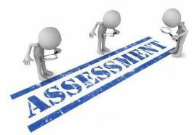

**ASSESSMENT METHODS FOR BLOCK EXAM:**

Evaluation is a continuous process comprising of block examination and annual university examination. Students will be evaluated throughout the year. The internal assessment will contribute towards the ﬁnal examination scores.

Multiple examination methods including MCQs, SAQs, OSPE and viva will be used. In line with PMC stipulation, the pass/fail marks for the test and examination will be 50%.

There will be a block exam at the end of each block.

**Theory (knowledge)**: MCQs (Multiple Choice Questions) and SAQs (Short Answer Questions) are used to assess the theory part for the block exam.

**MCQ:**

* + - * A MCQ has a statement or clinical scenario followed by four options (likely answers).
      * After reading the statement/scenario student select ONE, the most appropriate answer/response from the given list of options.
      * Correct answer carries one mark, and incorrect ‘zero mark’. There is NO negative marking.

**SAQ:**

SAQ are open ended questions that requires students to create an answer. They are commonly used in examinations to access the basic knowledge and understanding of a topic.

**OSPE**:

Objective Structured Practical Examination (See the proposed plan of OSPE)

* It may comprise between 12- 25 stations.
* The content may assess application of knowledge, or practical skills.
  + Student will complete task in deﬁne time at one given station.
  + All the students are assessed on the same content by the same examiner in the same allocated time.
  + A structured examination will have observed, unobserved, interactive and rest stations.
  + **Observed and interactive stations:**

They will be assessed by internal or external examiners through the task or viva.

* + **Unobserved station:**

It will be static station in which students will have to answer the questions related to the given pictures, models or specimens on the provided response sheet.

* + **Rest station:**

It is a station where no task is given, and during this time student can organize his/her thoughts.

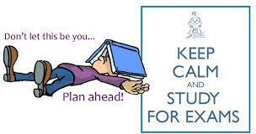

**BLOCK INTERNAL ASSESSMENT MARKS**

**SECOND YEAR BDS**

|  |  |  |  |  |
| --- | --- | --- | --- | --- |
| **BLOCK – 1** | **BLOCK – 2** | **BLOCK - 3** | **ATTENDANCE** | **ASSIGNMENT / PRESENTATION** |
| 5 | 5  Obtained marks / total marks x 5) | 5 | 2  Obtained marks % / 100 x 2 = | 3 |

**20% Internal Assessment**

* **20% Internal Assessment will contribute 20 marks in the final paper (Theory).**
* **15** marks for all the 3 blocks
* **5** marks per block
* (**Obtained marks / total marks x 5)**
* **2 marks** for attendance, which will be calculated by the **end of each year**.
* **3 marks** for continuous Assessment which includes assignments and presentations will also be calculated by the **end of each year.**

|  |  |  |  |  |
| --- | --- | --- | --- | --- |
| **BLOCK (THEORY PAPER) BREAKUP DETAILS** | | | | |
| **BLOCK** | **MCQs** | **SAQs** | **TOTAL MARKS IN EACH BLOCK** |
| **4** | **23** | **12** | **35** |
| **5** | **23** | **12** | **35** |
| **6** | **23** | **12** | **35** |

|  |  |  |  |  |
| --- | --- | --- | --- | --- |
| **BLOCK – 1** | **BLOCK – 2** | **BLOCK - 3** | **ATTENDANCE** | **BEHAVIOUR** |
| 5 | 5  Obtained marks / total marks x 5) | 5 | 2  Obtained marks % / 100 x 2 = | 3 |

* **20% Internal Assessment will contribute 20 marks in the final paper (Practical).**
* **15** marks for all the 3 blocks
* **5** marks per block
* (Obtained marks / total marks x 5)
* **2** marks for attendance, which will be calculated by the end of each year.
* **3** marks for behavior / discipline, will also be calculated by the end of each year.

**Practical Assessment for each block**

* OSCE Stations = 20 marks (4 marks each station)
* Viva Stations = 15 marks ( 5 marks each station)
* SGD Logbook = 2.5 marks
* Practical Logbook = 2.5 marks
* Total = 40 Marks
* **NOTE:** This all will contribute 5% to the total 20% of internal Assessment.
* **Obtained marks / 40 x 5 =**

|  |  |
| --- | --- |
| **LEARNING RESOURCES** | |
| **SUBJECT** | **RESOURCES** |
| **PATHOLOGY** | **Text Book :**  Robbins Pathology  **Reference book :**  Levinson |
| **PHARMACOLOGY** | **Text Book :**  Basic and Clinical Pharmacology, Katzung  **Reference Books :**   1. Lippincott Illustrated Reviews. 2. Rand and Dale’s Pharmacology |
| **COMMUNITY & PREVENTIVE DENTISTRY** | **Text Book :**  S.S Hiremath, Textbook of Preventive and Community Dentistry.  **Reference Book :**   1. Blainaid Daly, Richard Watt, Essentials of Dental Public Health. 2. Jong’s Community Dental Health, George M.Gluck 3. Joseph John, Preventive And Community Dentistry 4. Community Oral Health, Cynthia Pine, Rebecca Harris |
| **DENTAL MATERIALS** | **Text Book:**  Easy Approach Text By Dr. Tahir Khan  **Reference Book:**   1. Philips 11th edition 2. Mccabe |

|  |  |
| --- | --- |
| **OTHER LEARNING RESOURCES** | |
| **Hands-on Activities/ Practical** | Students will be involved in Practical sessions and hands-on activities that link with the foundation module to enhance the learning. |
| **Labs** | Utilize the lab to relate the knowledge to the specimens and models available. |

|  |  |
| --- | --- |
| **Skill Labs** | A skills lab provides the simulators to learn the basic skills and procedures. This helps build the confidence to approach the patients. |
| **Videos** | Video familiarize the student with the procedures and protocols to assist patients. |
| **Computer Lab/CDs/DVDs**  **/Internet Resources** | To increase the knowledge students should utilize the available internet resources and CDs/DVDs. This will be an additional advantage to increase learning. |
|  | SDL is scheduled to search for information to solve cases, read through different resources and discuss among the peers and with the faculty to clarify the concepts. |

