SECOND YEAR BDS 2023-24
BLOCK V (MODULE IX AND X)

FROM THE DESK OF PRINCIPAL

Health is a fast-evolving field and with new technologies taking over the traditionally man-dominated fields like radiology and robotic surgical suites assisted by Artificial Intelligence and learning are taking new dimensions with the help of Augmented Reality, we are indeed living in challenging time s. Today's student of Medicine and Dentistry will be in the field a decade from now, up against a disease burden that is as varied as the next strain of the Covid-19 Virus and as complicated as the genetic characteristic of Oral Cancer, the largest cancer amongst both genders in Pakistan and at the same time as unpredictable as the recent Covid-19 Pandemic.
It is therefore imperative that our curricula of the Medical and Dental Colleges be in tandem with the changing times with the ability to evolve with time, measuring up to the challenges thrown at the field of healing from the
Ever-evolving diseases.
These Student Guidebooks are reviewed every year with the same concept in mind that our future Physician and Dental Surgeon be ready for the challenges that lie ahead.

In the end, I give you the same prayer as is mentioned in the Quran



Prof. Shaheed Iqbal
BDS, MDS
Oral & Maxillofacial Surgery
Principal Sardar Begum Dental College
Gandhara University,
Peshawar.

2



On behalf of the block team, I would like to welcome you to Block-V (Module IX and X). As a part of the system-based curriculum, this block is an integrated presentation comprising system-based modules which links basic scientific knowledge to clinical problems. Integrated teaching means that subjects are presented as a meaningful whole. The students will be able to have better understanding of basic sciences when they repeatedly learn it in relation to clinical examples. Small group discussions, early exposure to clinics, wards, and skills acquisition in skills lab are characteristics of integrated teaching program.
The faculty are faced with determining how to present course material so the student not only gain knowledge of the discipline but also become self-directed learners who develop problem solving skills that they can apply in future courses and in their careers.

Our mission 1s to provide all educational opportunities to our students. Therefore, on completion of the BDS program graduate will possess an appropriate knowledge, skills and attitudes to be well prepared to practice safely and effectively
As a director I will be meeting with the facilitators to receive the feedback and will try to resolve any difficulties or problems faced during the block. Please do not hesitate to contact DME for any academic guidance need any help. I wish you an enjoyable and learning experience with block V

Director DME
Dr. Marina Khan



TABLE OF CONTENT
Block Team.................................................................................................................
List of abbreviations….................................................................................................
Aims of the study guide… ..........................................................................................
Modules distribution of 2ND year BDS......................................................................
Introduction of block …...........................................................................................
General Outcomes…....................................................................................................
Leaning Methodologies…............................................................................................
Rules Regulations........................................................................................................
Learning objectives & Course contents......................................................................
Assessment……………………………………………………………………………………
Learning Resources…………………………………………………………………………

BLOCK TEAM

Dr. Marina Khan
Director DME
Department of Medical Education
marinakahn@hotmail.com
DEPARTMENT OF DENTAL MATERIALS |  | Prof Dr. Tahir Ali Khan  Prof Dr. Amjad Naseer  Assist Prof Dr. Munazza Ijaz  Assistant Prof Dr. Maimona  Assistant Prof Dr. Asad
DEPARTMENT OF  COMMUNITY DENTISTRY |  | Prof. Dr. Babar Ahad  Prof Dr. Saira Afridi  Prof Dr. Sofia Shehzad  Assist Prof Dr. Sana Ruqayya  Assist Prof Dr Imran Gillani  Dr. Aiman Niaz
DEPARTMENT OF  PATHOLOGY |  | Prof Dr Syed Mukhtar Ali Shah  Prof Dr. Nisar Ahmed  Prof Dr. Ehsan Gul Khattak  Prof Dr. Naila Ismail  Associate Prof Dr. Shazia  Assist Prof Dr. Ibn-e-Amin  Assist Prof. Dr. Ronaq Zaman
DEPARTMENT OF PHARMACOLOGY |  | Prof Dr. Iftikhar Ud Din  Prof Dr. Saadat  Assist Prof Dr. Syed Hasnain Ali Shah  Dr. Ihtesham  Dr. Haseeb
DEPARTMENT OF MEDICAL EDUCATION |  | Assistant Prof Dr. Marina Khan  Assistant Prof Dr. Syed Muhammad Junaid  Dr. Aalia Zaib  Dr. Usama Aurangzeb

LIST OF ABBREVIATIONS

DME | Department of Medical Education
PATHO | Pathology
PHARMA | Pharmacology
DM | Dental Materials
CD | Community & Preventive Dentistry
J. PROS | Junior Prosthetics
J. OPER | Junior Operative
LGIS | Large Group Interactive Session
SGD | Small Group Discussion
SDL | Self-Directed Learning
DSL | Directed Self Learning
MCQ | Multiple Choice Question
SAQ | Short Answer Question
OSPE | Objective Structured Practical Exam

STUDY GUIDE:


This study guidebook was designed by combining the efforts of all topics throughout the year to give dentistry students at SBDC a resource material that highlights significant components of the curriculum. By providing students control over their learning, the study guide aims to promote self-regulated lifelong learning.
In regard to the course content, the study guide provides an overview of the anticipated course outcomes and objectives. The assessment approach is also customized to the intuitional strategy.
A successful curriculum has a significant impact on the final product, as well as on society. This study guide was carefully designed with the PMC curriculum and rules in mind, and Gandhara University stakeholders and faculty members worked hard to personalize it to the needs of students. They are further working to build, implement, and exercise a well-built curriculum considering changing demographic needs and disease prevalence in our society. Throughout the construction of the study guide, students' feedback was received and included. Curriculum is a living, dynamic entity that is constantly changing. With each passing day, we hope to improve it. This selfless effort on the part of the entire faculty serves as a beacon for our wonderful students.
Each module in this block has been created to cater the gap between basic and clinical subjects through pre-clinical learning. The block is divided into two modules in which the students are exposed to a variety of basic and clinical subjects. The integrated curriculum is enforced through interactive lectures, small group discussion, community outreach programs along with rotations at preclinical laboratory.


AIMS OF THE STUDY GUIDE

It is an aid to:
- Inform students how student learning program of the BLOCK- 5 wise module has been organized.
- Help students organize and manage their studies throughout the block.
- Guide students on assessment methods, rules, and regulations
- Communicates information on organization and management of the block. This will help the student to contact the right person in case of difficulty.
- Defines the objectives which are expected to be achieved at the end of the block.
- Identifies the learning strategies such as lectures, small group teachings, clinical skills and demonstration, tutorial that will be implemented to achieve the block objectives.
- Provides a list of learning resources such as books, computer assisted learning programs, web- links, and journals, for students to consult to maximize their learning.
- Highlights information on the contribution of block examinations on the student's overall performance.
- Includes information on the assessment methods that will be held to determine every student's achievement of objectives.
- Focuses on information pertaining to examination policy, rules, and regulations.

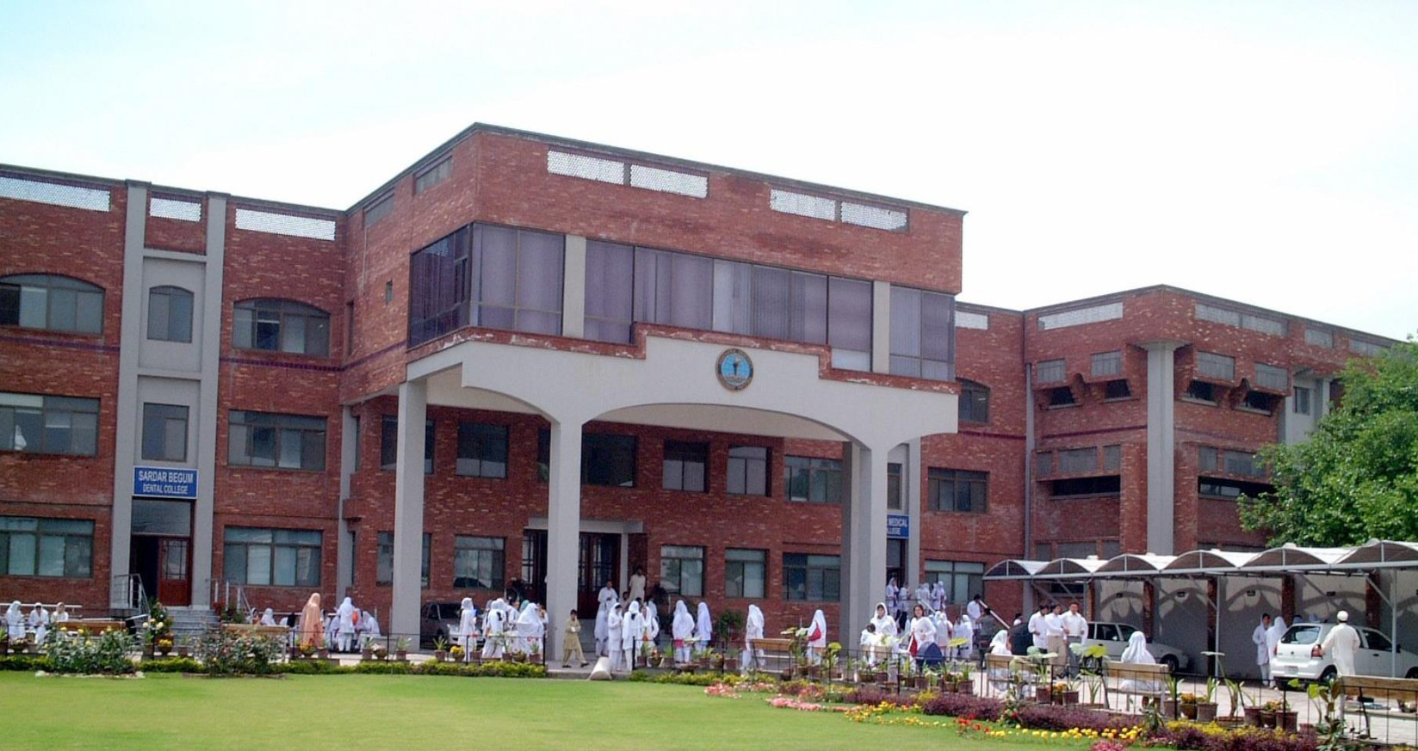


ORGANIZATION OF CURRICULUM

2nd YEAR BDS

Block-4 |  | Exam Block 4 | Block-5 |  | Exam Block 5 | Block-6 |  | Exam Block 6 | Final Exam
Module  7  Pre- and Para-Clinical Dental Sciences | Module  8  Restorative Material  and Dental Research | Exam Block 4 | Module  9  Epidemiology of Oral diseases and Auxiliary Materials-I | Module  10  Epidemiology  of Oral  diseases and Auxiliary Materials-II | Exam Block 5 | Module  11  Health  Promotion and Infection Control | Module  12  Neoplasia and Metallurgy | Exam Block 6 | Final Exam

LEARNING METHODOLOGIES
The following teaching / learning methods are used to promote better understanding:
- Interactive Lectures
- Small Group Discussion
- Practical
- Skills session
- E-Learning
- Self-Directed Learning

LARGE GROUP INTERACTIVE LECTURES (LGIS)

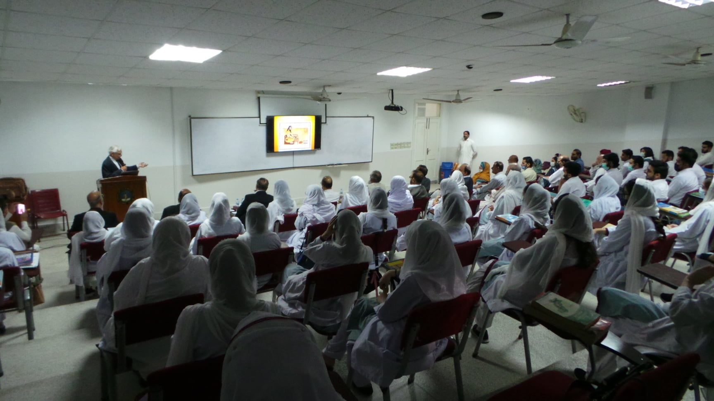

In large group, the lecturer introduces a topic or common clinical conditions and explains the underlying phenomena through questions, pictures, videos of patients' interviews, exercises, etc. Students are actively involved in the learning process.

SMALL CROUP DISCUSSIONS (SGD):


This format helps students to clarify concepts acquire skills or attitudes. Sessions are structured with the help of specific exercises such as patient case, interviews, or discussion topics. Students exchange opinions and apply knowledge gained from lectures, tutorials, and self-study. The facilitator role is
to ask probing questions, summarize, or rephrase to help clarify concepts.

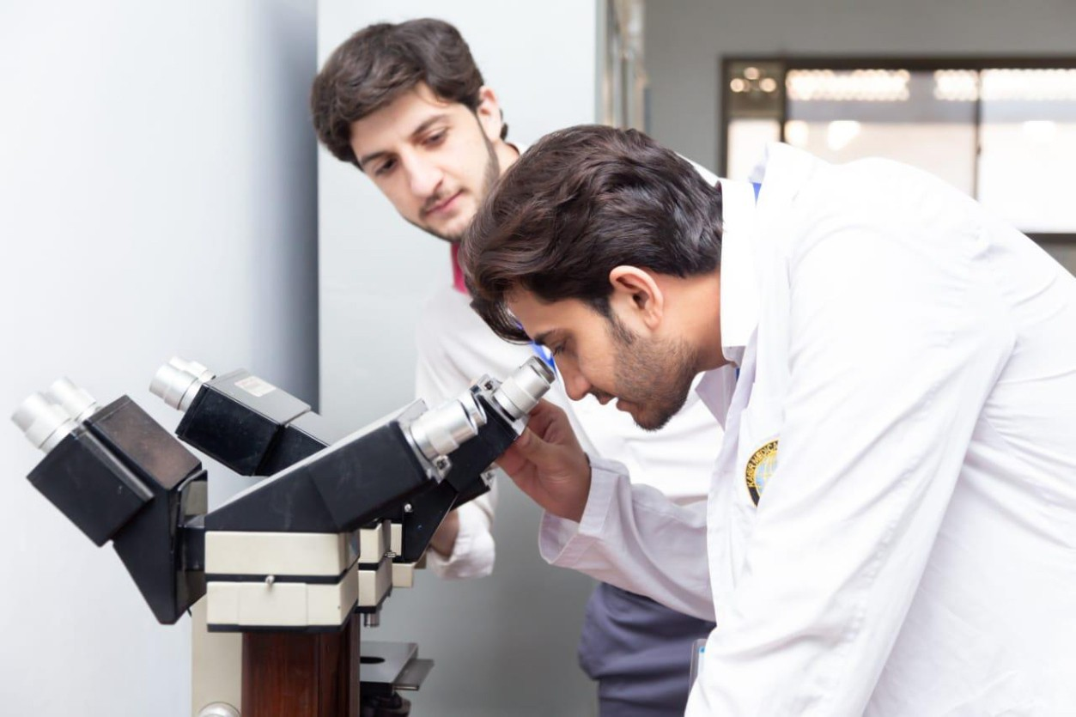
PRACTICAL

Basic science practical related to Dental Material, Community & Preventive Dentistry, Pharmacology and Pathology are scheduled for student learning.

SELF DIRECTED LEARNING SDL:
Students assume responsibilities of their own learning through individual study, sharing and discussing with peers, seeking information from Learning Resource Center, teachers, and resource persons within and outside the college. Students can utilize the time within the college scheduled hours of self-study.

E-LEARNING:
E-Learning is a strategy by which learning occurs through the utilization of electronic media, typically the Internet. The basic aspects of medical professionalism and ethics will be addressed through an e-learning course.



- Hands on Training

- Pathology, Pharmacology, Dental Materials, Community & Preventive Dentistry lab sessions:
practical’s will demonstrate your skills and help in clarifying your concepts practically.

- Clinical skill lab sessions Hands on
Practice of clinical examination.

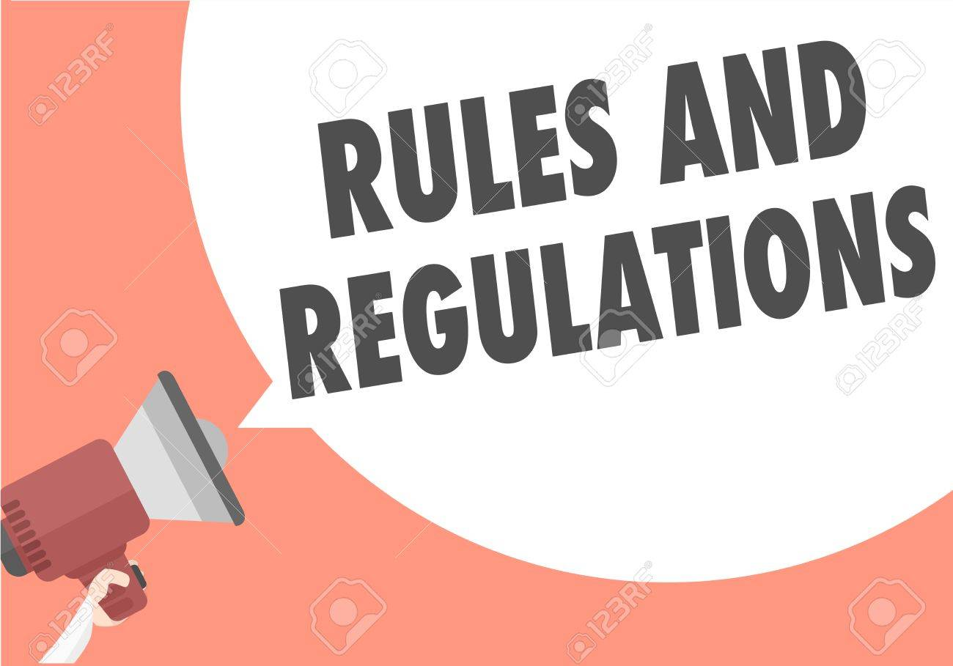

RULES AND REGULATIONS

We will be making the journey through block V in eleven weeks. Therefore, this course includes an intensive coursework load. Class attendance and participation are extremely important to student learning and are considered in the evaluation of the course grade. If there is anything that the module team can do to assist during the course, please feel free to contact. Attendance will be monitored during the different teaching activities. If the attendance is less than 75%, the student will not be allowed to sit for both block and annual examination.



All examinations must be taken on the date scheduled. No student will be allowed to enter the examination area after the scheduled time for examination. There will be a total of 3 block examination and the 30% weightage of these block exam will be contributed towards the 70 % of the annual professional exam as an internal assessment.

INTRODUCTION TO BLOCK - V

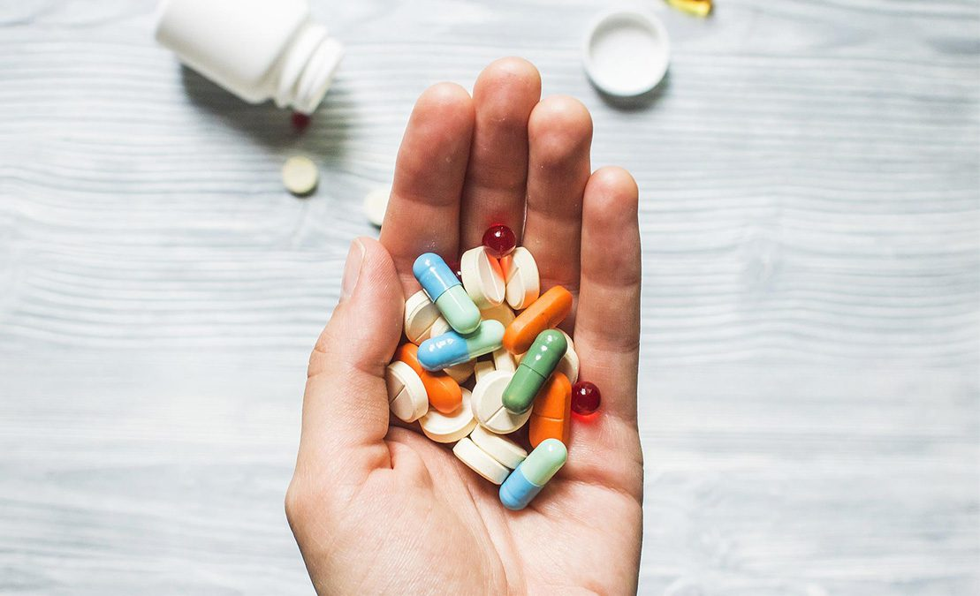
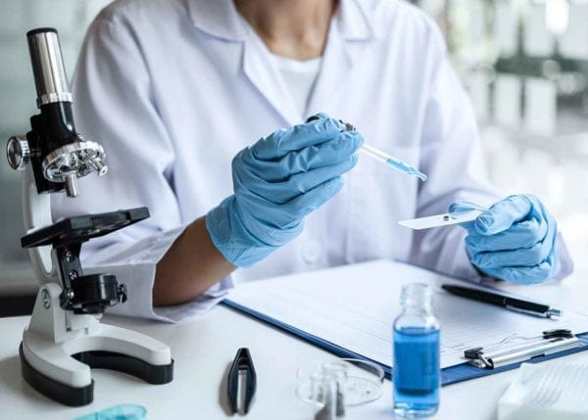

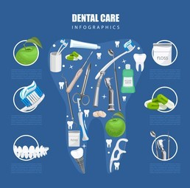
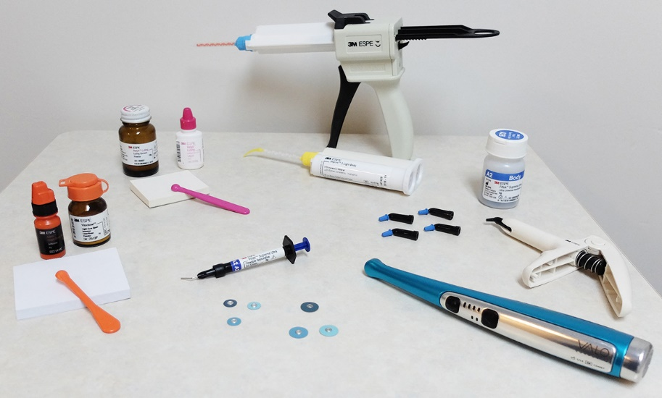
INTRODUCTION TO BLOCK V

The second year BDS block system is meant to provide a theoretical and practical understanding of the basic ideas of pathological and pharmacological aspects of disease, dental biomaterials, clinical applications, and community-based dentistry. Students are exposed to a variety of basic and clinical disciplines throughout the block, which is separated into two modules. Every module in the block is designed to demonstrate a connection to other modules in order to build a deeper grasp of each subject's key principles and their application in clinical encounters in the BDS undergraduate program's future years.

The nature of diseases and disorders related with the immune, hematological, gastrointestinal, and respiratory systems is highlighted in this Block V. A prologue on the pathogenesis of infections of the oral cavity, skin, and soft tissues is also included in the block. It also primarily relies on medications with cardiovascular pharmacology as well as those that influence the immunological and gastrointestinal systems. The block will also cover the direct restorative materials, such as dental amalgam and composite resins, as well as the indirect restoratives needed to make complete dentures. The students will learn about methods for preventing major oral illnesses through health promotion and the delivery of health care.

In block V, the students will apply what they learned in block IV regarding the nature and causes of human diseases, as well as drug interactions, to better comprehend how they affect specific organ systems. In addition, skills for cavity restoration and denture fabrication will be developed in block V and VI in the pre-clinical and dental material laboratory sessions using the knowledge obtained on basic properties and manipulation of dental materials.

Students will gain a better understanding of the pathological basis of oral diseases as well as therapeutics for enhanced diagnosis and treatment planning of a dental patient after completing block V. There will be a greater understanding of the procedures and biomaterials used to restore oral structures directly and indirectly.

The training provided at the undergraduate level during these blocks, which includes didactic and laboratory-based methods under supervision, as well as community outreach programs, will help produce competent and confident dentists who are ready to serve the community as soon as they graduate from dental school.

GENERAL OUTCOMES:


By the end of this block(V) the students would be able to

KNOWLEDGE:

- Describe the primary and secondary response and different types, structure, functions of antibodies, cell mediated immunity & clinical features of edema
- Define thrombosis & describe the Virchow’s triad, fate, clinical features of thrombosis & Phlebothrombosis pulmonary, systemic, air, amniotic fluid and fat embolism & clinical features of embolism, hemorrhage & hyperemia, and congestion.
- Have a clear concept about evidence-based dentistry and the steps in evidence-based dentistry,
- Have a clear concept, Epidemiological factors, Host, agent, environmental factors and Scoring criteria for dental caries.
- Know about all impression materials i.e. Hydrocolloid, alginate, agar, zinc oxide eugenol impression wax, impression compound and impression plaster, polysulphide, condensation silicone, addition silicone, polyether, elastomeric, gypsum products, its types, requirements, production, and manipulation
- know about the process and faults in casting process, denture processing errors, techniques of denture repair and hard reline materials, tissue conditioners, soft lining materials, dental wax, classification, composition & properties of dental wax
- to describe pharmacology, drugs target in CNS, sedatives, hypnotics, alcohol, skeletal muscle relaxants, antiepileptic drugs, antiparkinsonian drugs, antipsychotics, general anesthetics, and local anesthetics.
- describe blood pressure regulation, centrally acting sympatholytic, adrenergic neuron blockers, vasodilators, α & β blockers in hypertension, ACE inhibitors and ARBs, Angina, nitrates, calcium channel blockers, cardiac arrhythmias, Class I antiarrhythmic drugs.
- To know about the pathogenesis, clinical features, histopathology, diagnosis, and treatment of Pemphigus Vulgaris, Lichen Planus, Mycobacterium Tuberculosis, and Syphilis.

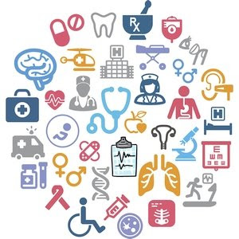
SKILLS:

By the end of block- V, the student should be able to:

- To demonstrate the effects of local anesthetic drug i.e., Alcaine on the rabbit’s eye
- To identify an unknown drug on rabbit’s eye
- Identify the uses of Sulphur ointment, carminative mixture calamine lotion, and adverse effects of Aspirin, Paracetamol and Caffein
- Construct a prescription for scabies. hypertension, congestive cardiac failure, angina, and myocardial infarction
- handle, bend and use a stainless-steel wire, which will facilitate them in future, while making a C-clasp
- Identify, handle &amp; manipulate zinc oxide eugenol cement, zinc phosphate cement, glass ionomer cement, calcium hydroxide cement, composite resin, plaster of Paris, impression compound.
- Perform and interpret the result of catalase test Triple sugar iron agar, antimicrobial sensitivity test, Motility tests for identification of bacteria and Coagulase test by tube and slide method
- Identify the microscopic features of AFB, plasmodium, Leishmania, taenia and Echinococcus
- understand the importance of history taking and how to take history from patients
- understand dental caries index for adults-DMFT index and how to perform it on models
- Construct questionnaire

ATTITUDE:

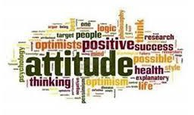
- By the end of this block, the students will be able to:

- Develop respect for the individuality and values of others - (including having respect for oneself) patients, colleagues, and other health professionals.
- Organize & distribute tasks.
- Exchange opinion & knowledge.
- Develop communication skills and etiquette with sense of responsibility.
- To equip themselves for teamwork.
- Regularly attend the classes.
- Demonstrate good laboratory practices.
- Carry out practical work as instructed in an organized and safe manner.
- Make and record observations accurately.
- Develop the ability to give and receive feedback.
- Respect for self and peers.

MODULE – IX
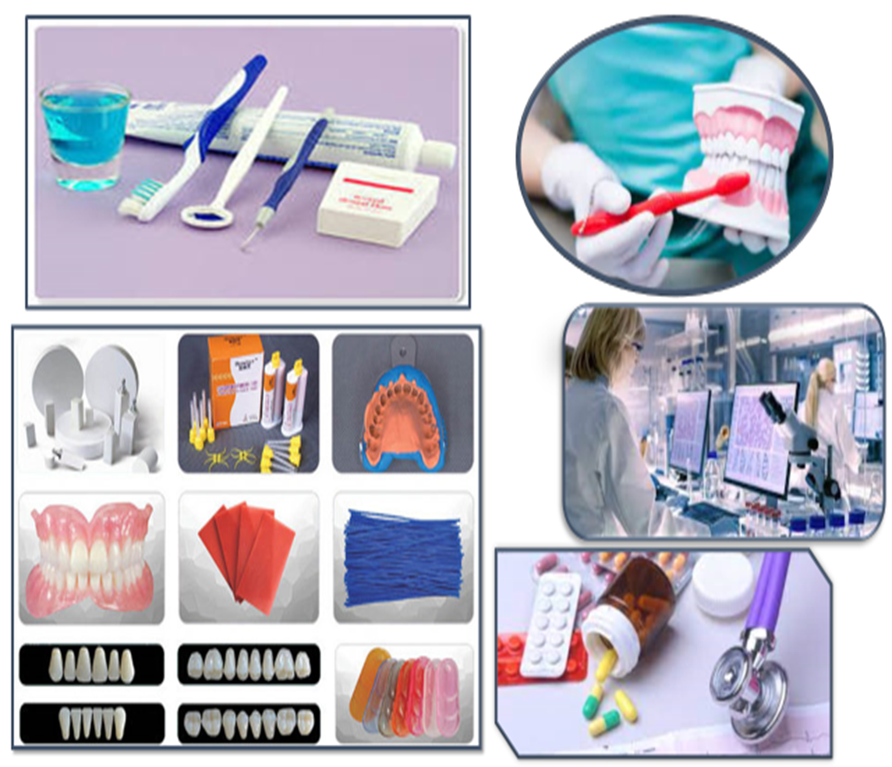
EPIDEMIOLOGY OF ORAL DISEASES AND AUXILIARY MATERIALS-I

LEARNING OBJECTIVE & COURSE CONTENTS
At the end of the teaching session the student should be able to achieve the following objectives
PATHOLOGY LECTURES
S.NO | TOPICS | LEARNING OBJECTIVES
1 | Humoral & cell mediated immunity | Describe primary and secondary response  Enlist different types, structure, and functions of antibodies  Describe cell mediated immunity
2 | Hypersensitivity reactions | Describe hypersensitivity reactions Enlist the clinical examples of hypersensitivity reactions
3 | Immunodeficiency diseases | Describe the Acquired immune deficiency syndrome (AIDS)
4 | Staphylococci | Describe the characteristics, transmission  Virulence factors, clinical findings & lab diagnosis of Staphylococci
5 | Streptococci | Describe the characteristics, transmission  Virulence factors, clinical findings & lab diagnosis of streptococci
6 | Edema | Define edema  Enlist the cause, types, morphology & clinical features of edema
7 | Thrombosis  Embolism | Define thrombosis  Describe Virchow’s triad, fate, Enlist the clinical features of thrombosis & Phlebothrombosis  Describe pulmonary, systemic, air, amniotic fluid, and fat embolism  Enlist the clinical features of embolism
8 | Infarction, hemorrhage, Hyperemia and Congestion | Define infarction  Enlist the causes, factors effecting development & morphology of infarction  Enlist the types & clinical significance of hemorrhage  Define Hyperemia and Congestion  Describe pulmonary & hepatic congestion
9 | Shock I | Define shock  Enlist the types of shock  Describe pathogenesis of septic shock
10 | Shock II | Enlist the stages, morphology & clinical course of shock

PATHOLOGY PRACTICALS
S.NO | TOPICS | SKILL DETAILS
1 | Catalase test |  | Perform and interpret the result of catalase test by tube and slide method
2 | Coagulase test |  | Perform and interpret the result of coagulase test by tube and slide method
3. | Triple sugar iron agar (TSI) |  | Perform and interpret Triple sugar iron agar (TSI) test for identification of enteric GNR
4. | Antimicrobial sensitivity test |  | Perform and interpret antimicrobial sensitivity tests
5. | Motility tests for identification of bacteria | Perform and interpret motility tests for identification of bacteria

PATHOLOGY SGDs

S.NO | TOPICS | LEARNING OBJECTIVES
1 | Innate immunity | Describe properties, recognition of microbes and effector mechanisms of innate immunity
2 | Antigen antibody reactions in the laboratory | Describe antigen antibody reactions in the laboratory  (Diagnostic tests)
3 | Complement | Describe complement and its clinical aspects
4 | Transplantation and various grafts | Describe transplantation and various grafts
5 | Autoimmune diseases | Describe genetic, hormonal and  Environmental factors in autoimmune disease & different autoimmune diseases

COMMUNITY AND PREVENTIVE DENTISTRY LECTURES

S.NO | TOPICS | LEARNING OBJECTIVES

 | Evidence based dentistry 1 | Define evidence-based dentistry  Enlist the Steps in evidence-based dentistry
 | Evidence based dentistry 2 | Enlist the Level of evidence and Strength of recommendation
 | Indices | Define indices  Describe the Objectives and properties of an index  Enlist the types of indices
 | Oral Hygiene Index-Simplified (OHI-S) | Define Oral hygiene and oral hygiene index simplified  Explain the Oral Hygiene Index –Simplified scoring criteria
 | Epidemiology of dental caries 1 | Define dental caries  Enlist the Epidemiological factors of dental caries  Explain the Host, agent, environmental factors
 | Epidemiology of dental caries 2: Dental caries index | Explain Indices for dental caries  Describe the Scoring criteria for dental caries index
 | Epidemiology of Peri oral cancers 1 | Define oral cancers  Describe Etiology and risk factors  State the diagnosis and treatment
 | Epidemiology of Peri oral cancers 2 | Describe the Prevention and control of oral cancer  Explain the Guide for tobacco cessation
 | Epidemiology of malocclusion 1 | Define malocclusion  Describe the Etiology of malocclusion
 | Epidemiology of malocclusion 2 | Explain the Preventive measures and Interceptive measures taken in malocclusion

COMMUNITY AND PREVENTIVE DENTISTRY PRACTICALS

S. No | TOPICS | SKILL DETAILS
 | History taking and examination | Perform history taking and examination on patients
 | Dental caries index | Perform dental caries index for adults - DMFT Index on models
 | DMFT -decayed missing and filled index | Perform DMFT Index on models  Perform DMFT Index and practice on models  Perform DMFT Index and practice on patients

COMMUNITY DENTISTRY SGDs

S. No | TOPICS | LEARNING OBJECTIVES
1 | Evidence based dentistry | Discuss evidence pyramid
2 | Indices | discuss the criteria for selection of an index with help of an example
3 | Special needs / Geriatrics oral health 2 | discuss management of different groups of patients according to their needs
4 | Epidemiology of dental caries 1 | discuss applied form of dental caries
5 | Epidemiology of periodontal diseases | Discuss periodontal diseases

DENTAL MATERIAL LECTURES

S.NO | TOPICS | TOPIC DETAILS

1 | Hydrocolloid impression material: Alginate | Define and classify hydrocolloid impression material  Explain Alginate impression material
2 | Hydrocolloid impression material: Agar | Describe Alginate impression material
3 | Non elastic impression materials  Zinc oxide eugenol  Impression wax | Explain zinc oxide eugenol impression material and impression wax
4 | Non elastic impression materials  Impression compound  Impression plaster | Explain impression compound and impression plaster
5 | Synthetic elastomers  Polysulphides | Describe polysulphide impression materials
6 | Synthetic elastomers  Condensation silicone | Describe condensation silicone impression materials
7 | Synthetic elastomers  Addition silicone | Describe addition silicone impression materials
8 | Synthetic elastomers  Polyether | Describe polyether impression materials
9 | Impression making using  elastomeric impression material | Explain impression taking with elastomeric impression material
10 | Gypsum products  Introduction  Types and requirements  Production and manipulation | Define gypsum products,  Enlist their types,  Describe the requirements, production & manipulation of gypsum products
11 | Gypsum products  Mechanism of setting  Factors affecting setting time | Describe mechanism of setting & factors affecting setting time
12 | Properties of gypsum product | Enlist the properties gypsum products
13 | Investment materials  Introduction  Requirements  Composition  Gypsum bonded investment | Define investment materials,  Describe their requirements and composition  Describe gypsum bonded investment
14 | Silica bonded investment  Phosphate bonded investment | Describe silica bonded and phosphate bonded investment material
15 | Casting  Introduction  Casting process | Describe casting process
16 | Casting process  Faults in casting | Describe casting process  Enlist the faults in the casting process

DENTAL MATERIAL PRACTICALS
S.NO | TOPICS | SKILL DETAILS
1 | Impression taking using  alginate |  | Identification of alginate, its handling  and manipulative variables
2 | Impression taking using  silicone impression  material |  | Identification of silicone impression  material its handling and manipulative  variables
3 | Making of C-Clasp for  partial denture |  | Perform circumferential (C) clasp on upper  and lower model w

DENTAL MATERIAL SGD’s
S.NO | TOPICS |  | LEARNING OBJECTIVES
1 | Hydrocolloid impression  material: Agar |  | Discuss Agar impression material
2 | Non elastic impression  materials  Zinc oxide eugenol  Impression wax  Impression compound  Impression plaster |  | Discuss zinc oxide eugenol impression material  and impression wax  Discuss impression compound and impression  Plaster
3 | Synthetic elastomers  Addition silicone  Polyether and Polysulphide |  | Discuss addition silicone impression materials  Discuss polyether impression materials  Discuss poly-sulphide impression materials
4 | Hydrocolloid impression  material: Alginate, |  | Discuss hydrocolloid impression material  Explain Alginate impression material
5 | Synthetic elastomers  Condensation silicone |  | Discuss condensation silicone impression materials
6 | Gypsum products  Introduction  Types and requirements  Production and manipulation |  | Discuss gypsum products,  types, requirements, production, manipulation  and properties
7 | Investment materials  Introduction  Requirements  Composition  Gypsum bonded investment |  | Discuss investment materials, their requirements and composition  Describe gypsum bonded investment
8 | Silica bonded investment  Phosphate bonded investment |  | Discuss silica bonded and phosphate bonded  investment material

GENERAL PHARMACOLOGY LECTURES
S. No | TOPICS | LEARNINGOBJECTIVES
 | Pharmacology of CNS | Describe pharmacology of CNS  Describe ion channel and neurotransmitter receptors  Enumerate sites of drug action
 | Drug targets in CNS | Enumerate neurotransmitters of CNS  Describe chemistry of neurotransmitters Describe acidic and neutral amino acid
 | Sedative  Hypnotics | Describe pharmacokinetics and pharmacodynamics of benzodiazepines and other anxiolytics  Describe pharmacokinetics and pharmacodynamics of barbiturates and other hypnotics
 | Sedative  Hypnotics | Describe pharmacokinetics and pharmacodynamics of benzodiazepines and other anxiolytics  Describe pharmacokinetics and pharmacodynamics of barbiturates and other hypnotics
 | Alcohol (Ethanol)  Skeletal Muscle relaxants | Describe basic pharmacology of ethanol  Describe management of acute alcohol intoxication,  alcohol withdrawal syndrome  and alcoholism  Classify skeletal muscle relaxants  Describe basic and clinical pharmacology of neuromuscular blockers
 | Antiepileptic drugs | Define seizures  Describe etiology of seizures  Classification of seizures  Classify antiepileptic drugs  Describe mechanism of action, use  and adverse effects of antiepileptic drugs  Describe pharmacokinetics of antiepileptic drugs
 | Antiparkinson drugs | Describe neurodegenerative diseases  Describe mechanism of action,  pharmacokinetics and adverse effects of antiparkinsonian drugs
 | Antipsychotics | Classify 1st generation low potency antipsychotics  Describe pharmacokinetics and pharmacodynamics of 1st generation low potency antipsychotics  Classify 2nd generation antipsychotics  Describe pharmacokinetics and pharmacodynamics of 2nd generation antipsychotics
 | General Anaesthetics | Define anaesthesia  Types of anaesthesia  Classification of general anaesthetics  Describe mechanism of general anaesthetic action  Describe pharmacokinetics and pharmacodynamics of general anaesthetics
 | Local Anaesthetics | Describe basic pharmacology of local anaesthetics  Describe pharmacokinetics and pharmacodynamics of local anaesthetics  Classify local anaesthetics  Describe clinical pharmacology of local anaesthetics
 | Anti-depressants | Describe pathophysiology of major depression, neurotropic hypothesis, and monoamine & other neurotransmitters  Classify antidepressant drugs  Describe mechanism of action,  pharmacokinetics and adverse effects of antidepressants

PHARMACOLOGY PRACTICALS

S.NO | TOPIC | SKILL DETAILS

 | Effects of Alcaine on the rabbit’s eye | Demonstrate effects of local anaesthetic drug i.e., Alcaine on the rabbit’s eye
 | 20 grams of 5% sulphur ointment | To prepare and dispense 20 grams of 5% sulphur ointment  Enumerate uses of sulphur ointment
 | 90ml (3 doses) of carminative mixture | To prepare and dispense 90ml (3 doses) of carminative mixture  Enumerate uses of carminative mixture
 | Powder  (Aspirin Paracetamol Caffeine) | To prepare 4 doses of A.P.C. (Aspirin Paracetamol Caffeine) (600mg each)  Describe uses and adverse effects of Aspirin, Paracetamol and Caffeine
 | Scabies  (Prescription) | Construct a prescription for scabies

PHARMACOLOGY SGDs

S. No | TOPIC | LEARNING OBJECTIVES
 | Platelet aggregation inhibitors | Classify antiplatelet drugs  Discuss the mechanism of action and adverse effects of antiplatelet drugs
 | Anticoagulants | Classify anticoagulant drugs  Discuss mechanism of action, uses, adverse effects of heparin, antidote of heparin  Discuss the mechanism of action, uses, adverse effects drug interactions of warfarin, antidote of warfarin
 | Cholesterol synthesis | Discuss the cholesterol synthesis and the types of dyslipidemias  Classify the lipid lowering drugs
 | Statins, Fibrates and Bile acid sequestrants | Discuss the mechanism of action, effect on plasma lipid profile, adverse effects, and drug interaction of HMGCOA reductase inhibitors  Discuss pharmacokinetics and pharmacodynamics of fibrates and Bile acid sequestrants
 | Niacin and cholesterol synthesis inhibitors | Discuss the mechanism of action, effect on plasma lipid profile and adverse effects of Niacin  Discuss pharmacokinetics and pharmacodynamics of cholesterol synthesis inhibitors

ORAL PATHOLOGY LECTURES

S.No | TOPICS | LEARNING OBJECTIVES
1 | Lichen Planus | - Define Lichen planus  - Discuss its Pathogenesis  - Enumerate its Clinical Features and Histopathology  - Discuss its Diagnosis and treatment planning
2 | Pemphigus Vulgaris | - Define Lichen planus  - Discuss its Pathogenesis  - Enumerate its Clinical Features and Histopathology  - Discuss its Diagnosis and treatment.

ORAL & MAXILLOFACIAL SURGERY LECTURES

S.No | TOPIC | LEARNING OBJECTIVES
1 | Anesthesia | 1)Types of Anesthesia  2)Methods of delivery

JUNIOR OPERATIVE LECTURES
S.No | TOPICS | LEARNING OBJECTIVES
1 | Engine Driven Instruments | Enlist different types of engine driven instruments Describe engine driven instruments
2 | Dental Caries | - Define dental caries  b. Classify dental caries  - Describe clinical aspects of dental caries  d. Enlist methods to prevent and restore dental caries
3 | Introduction to tooth preparation | - Understand the terms used in tooth preparation  Define different components in tooth preparation
4 | Fundamentals of tooth preparation | - Enlist the different steps in tooth preparation  - Explain the different steps involved in tooth preparation
5 | Isolation techniques | - Explain the importance of isolation in operative dentistry  Enlist methods used to isolate teeth

JUNIOR OPERATIVE PRACTICALS

S. No | TOPICS | SKILL DETAILS
1 | Mixing Materials | - Know the materials used in operative dentistry  - Know the physical and chemical properties of the materials  Mix the materials efficiently according to the recommendations
2 | Caries Classification and Diagnosis | - Classify caries according to their location  - Identify caries location on typodonts.  - Describe methods of caries removal.  - Demonstrate methods to diagnose caries  Clinically Demonstrate effective way to diagnose caries on extracted teeth

JUNIOR PROSTHETICS LECTURES

S. No | TOPIC | LEARNING OBJECTIVES
1 | MMR | Discuss the steps of MMR
2 | Trial of complete denture | Discuss the steps in trail of complete denture

JUNIOR PROSTHETICS PRACTICALS

S. No | TOPIC | LEARNING OBJECTIVES
1 | Fabrication of occlusal rims | By the end of lecture the student will be able to perform step wise articulation of model on articulator
2 | Articulation | By the end of lecture the student will be able to perform step wise fabrication of occlusal rim

MODULE -10
EPIDEMIOLOGY OF ORAL DISEASES AND AUXILIARY MATERIALS-II

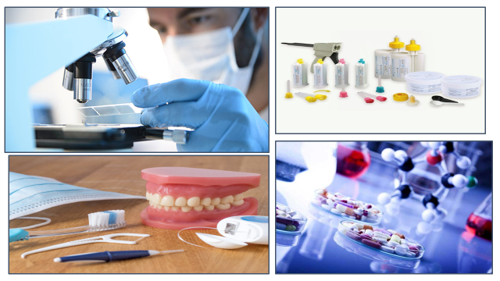

PATHOLOGY LECTURES
S.NO | TOPICS | LEARNING OBJECTIVES
1 | Escherichia coli | At the end of this lecture students will be able to describe characteristics, transmission, pathogenesis and laboratory diagnosis of Escherichia coli
2 | Salmonella | At the end of this lecture students will be able to describe characteristics, transmission, pathogenesis, and laboratory diagnosis of Salmonella
3 | Shigella & vibrio | At the end of this lecture students will be able to describe characteristics, transmission, pathogenesis, and laboratory diagnosis of Shigella & vibrio
4 | Campylobacter & Helicobacter | At the end of this lecture students will be able to describe characteristics, transmission, pathogenesis, and laboratory diagnosis of Campylobacter & Helicobacter
5 | Klebsiella & Proteus, Pseudomonas | At the end of this lecture students will be able to describe characteristics, transmission, pathogenesis, clinical findings, and laboratory diagnosis of Klebsiella & Proteus Pseudomonas,
6 | GNR related to respiratory tract | At the end of this lecture students will be able to describe characteristics, transmission, pathogenesis, and laboratory diagnosis of GNR related to respiratory tract
7 | Streptococcus pneumoniae & viridans streptococci | At the end of this lecture students will be able to describe the characteristics, transmission, pathogenesis, and laboratory diagnosis of Streptococcus pneumoniae & viridans streptococci
8 | Spore forming Gram positive | At the end of this lecture students will be able to describe, characteristics, transmission, pathogenesis, clinical findings, and laboratory diagnosis of Spore forming Gram positive rods
9 | Mycobacterium tuberculosis | At the end of this lecture students will be able to describe the characteristics, transmission, pathogenesis, clinical findings, and laboratory diagnosis of Mycobacterium tuberculosis
10 | Leishmania | At the end of this lecture students will be able to describe characteristics, transmission, pathogenesis, clinical findings, and laboratory diagnosis of Leishmania
11 | Plasmodium | At the end of this lecture students will be able to describe the
12 | Mycobacterium leprae | At the end of this lecture students will be able to describe types, characteristics, transmission, pathogenesis, and laboratory diagnosis of Mycobacterium leprae

PATHOLOGY PRACTICALS
S.NO | TOPICS | LEARNING OBJECTIVES
1 | Ziehl neelsen  staining |  | At the end of this practical students will be able to Identify the microscopic features of AFB
2 | Plasmodium |  | At the end of this practical students will be able to identify the microscopic features of plasmodium
3. | Leishmania |  | At the end of this practical students will be able to identify the microscopic features of Leishmania
4. | Taenia |  | At the end of this practical students will be able to identify the microscopic features of ovum of Taenia
5. | Echinococus | I At the end of this practical students will be able to identify the microscopic features of specimen of Echinococus

PATHOLOGY SGDs

S.NO | TOPIC | LEARNING OBJECTIVES
1 | Tuberculosis | Describe the laboratory diagnosis of tuberculosis
2 | Laboratory diagnosis of GNR related to enteric tract | Describe the laboratory diagnosis of GNR related to enteric tract
3 | Typhoid fever | Describe the lab diagnosis of typhoid fever
4 | Laboratory diagnosis of alpha hemolytic streptococci | Describe the laboratory diagnosis of alpha hemolytic streptococci
5 | Malaria | Describe the complications of malaria

COMMUNITY AND PREVENTIVE DENTISTRY
S.NO |  | TOPIC | LEARNING OBJECTIVES
1 | Epidemiology of Periodontal diseases I |  |  | Define periodontal diseases  Explain the etiology of periodontal diseases
2 | Epidemiology of Periodontal diseases II |  |  | Explain the epidemiological factors (host agents’ environmental factors)  Describe the periodontal disease index  And its scoring criteria
3 | Special needs / Geriatrics oral health 1 |  |  | Define special needs /geriatric oral health  Describe Demographics and socio-economic trends, Aging, function, and dependency in this group
4 | Special needs / Geriatrics oral health 2 |  |  | Explain Dental diseases and oral health status of special needs group  Describe Management of the older adult patient
5 | Ethics in dentistry |  |  | Define ethics  Enlist the Principals of ethics  Enlist the Codes of ethics  Discuss Ethical dilemmas
6 | Dental auxiliaries 1 |  |  | a. Define dental auxiliaries  b. Describe the Duties of operating dental auxiliaries  c. Describe the Duties of non-operating dental auxiliaries,  explain the dental manpower distribution
7 | Tobacco Cessation |  |  | Understand the impact of tobacco on health.  Understand the concept of tobacco cessation.  Learn how to use the 5As of tobacco treatment.  Learn pharmacology for tobacco cessation.

COMMUNITY DENTISTRY PRACTICALS

S. No | TOPICS | LEARNING OBJECTIVES
 | OHI-S: oral hygiene index | Perform oral hygiene indices  describe OHI-S scoring criteria  Perform OHI-S scoring on models
 | CPITN INDEX: Community periodontal index for treatment needs | Perform periodontal indices  describe CPITN index and its coring criteria
 | questionnaire designing and pilot testing | Construct questionnaire.
 | Pilot testing & Data Collection | Discuss pilot study, its objectives and methodology
 | health promotion activity | School visit for Health education and promotion activity

COMMUNITY DENTISTRY SGDs

S. No | TOPICS | LEARNING OBJECTIVES
1 | Epidemiology of oral cancers 1 | Discuss different levels of prevention for oral cancers
2 | Questionnaire Designing | Enlist and Discuss steps of Questionnaire Designing
3 | Presenting Research Work | Discuss Presenting Research Work

DENTAL MATERIALS LECTURES
S.NO | TOPIC | LEARNING OBJECTIVES
1. | Polymers  Introduction  Addition polymerization  Condensation polymerization | Describe polymers and its types
2 | Condensation polymerization | Describe condensation polymerization
3 | Denture base polymers  - Denture base materials  - Classification  - Acrylic resin | Describe denture base materials  Discuss its classification  Describe acrylic resin
4 | Acrylic resin: Heat activated | Describe heat activated acrylic resin
5 | Denture base polymers  Methods of denture fabrication | Describe various methods of denture fabrication
6. | Chemically activated acrylic resin | Describe chemically activated acrylic resin
7 | Denture processing errors  Denture repair  Hard reline materials | Describe denture processing errors and techniques of denture repair  Describe hard reline materials
8 | Tissue conditioners | Describe tissue conditioners
9 | Soft lining materials | Describe soft lining materials
10 | Dental wax | Define dental wax  Elaborate classification, composition, and properties of dental wax
11 | Denture modelling wax  Inlay wax  Processing wax  Impression wax | Describe denture modelling wax, inlay wax, processing wax and impression wax
12 | Artificial teeth | Describe artificial teeth  Enlist types of acrylic and porcelain teeth

DENTAL MATERIALS PRACTICLES

S. No | TOPIC | SKILL DETAILS
1 | Lower Acrylic dentures  fabrication | Make an acrylic partial  denture on lower models

DENTAL MATERIALS SGDs

S.No | TOPIC | TOPIC DETAILS
1 | Casting  Introduction  Casting process | Discuss casting process and faults in casting  process
2 | Polymers  Introduction  Addition polymerization  Condensation polymerization | Discuss polymers and its types
3 | Condensation polymerization | Discuss condensation polymerization
4 | Denture base polymers  - Denture base materials  - Classification  - Acrylic resin | Discuss denture base materials  Discuss classification  Discuss acrylic resin
5 | Acrylic resin: Heat activated | Describe heat activated acrylic resin
6 | Methods of denture fabrication | Discuss various methods of denture fabrication
7 | Chemically activated acrylic resin | Discuss chemically activated acrylic resin
8 | Denture processing errors  Denture repair  Hard reline materials | Discuss denture processing errors and  techniques of denture repair  Discuss hard reline materials
9 | Denture lining  Hard relining materials  Soft relining material | Discuss hard reline materials  Discuss soft lining materials
10 | Tissue conditioners | Discuss tissue conditioners
11 | Dental wax | Define dental wax  Discuss classification, composition and  properties of dental

PHARMACOLOGY LECTURES
S. NO | TOPIC | LEARNING OBJECTIVES
 | Antihypertensive drugs | Describe blood pressure regulation,  Enlist the causes of hypertension  Enlist different stages of hypertension  Enlist antihypertensive drugs  Describe white coat hypertension
 | Centrally acting sympatholytic  Adrenergic neuron blockers | Classify Centrally acting sympatholytic Explain mechanism of action, pharmacological action and drug interaction of methyl dopa and clonidine  Describe pharmacokinetics of methyl dopa and clonidine  Explain mechanism of action, pharmacological action and drug interaction of guanethidine and reserpine  Describe pharmacokinetics of guanethidine and reserpine
 | Vasodilators | Enumerate oral vasodilators  Explain mechanism of action, uses and adverse effects of oral vasodilators  Describe pharmacokinetics of oral vasodilators  Enumerate parenteral vasodilators  Explain mechanism of action, uses and adverse effects of parenteral vasodilators  Describe pharmacokinetics of parenteral vasodilators
 | α & β blockers | Classify α blockers  Describe mechanism of action, uses and adverse effects of α blockers in hypertension  Classify β blockers  Describe mechanism of action, uses and adverse effects of β blockers in hypertension
 | ACE inhibitors and ARBs | Classify Angiotensin converting enzyme inhibitors  Describe role of ACE inhibitors in hypertension  Classify Angiotensin receptor blockers  Describe role of ARBs in hypertension
 | Antianginal drugs  Nitrates | Define angina  Enlist the causes of angina  Describe different types of anginas  Classify antianginal drugs  Enumerate different nitrates  Describe mechanism of action of nitrates  Describe pharmacokinetics and pharmacodynamics of organic nitrates
 | Calcium channel blockers | Classify calcium channel blockers  Describe mechanism of action,  pharmacokinetics and adverse effects of calcium channel blockers
 | Antiarrhythmic drugs  Class I antiarrhythmic drugs  Class II & III antiarrhythmic dugs | Define and explain cardiac arrhythmias  Enlist the causes of cardiac arrhythmias  Describe different ECG patterns in cardia arrhythmias  Classify antiarrhythmic drugs  Enumerate Class I antiarrhythmic drugs  Describe the mechanism of action, uses and adverse effects of Class I antiarrhythmic drugs  Enumerate Class II & III antiarrhythmic drugs  Describe the mechanism of action and adverse effects of Class II & III antiarrhythmic drugs
 | Drugs for heart failure  Cardiac glycosides | Define heart failure  Enlist the causes of heart failure  Describe sign & symptoms of heart failure  Enumerate cardiac glycosides  Describe mechanism of action, clinical uses, toxic effects, and drug interaction of cardiac glycosides

PHARMACOLOGY PRACTICLES

S. No | TOPIC | SKILL DETAILS

1 | Hypertension (Prescription) | Construct a prescription for hypertension
2 | Congestive Cardiac Failure  (Prescription) | Construct a prescription for congestive cardiac failure
3 | Angina Pectoris  (Prescription) | Construct a prescription for angina Pectoris
4 | Myocardial Infarction  (Prescription) | Construct a prescription for myocardial infarction
5 | 20ml of calamine lotion | Enlist ingredients of calamine lotion  To prepare and dispense 20ml of calamine lotion  Enlist the uses of calamine lotion

PHARMACOLOGY SGDs

S.No | TOPIC | LEARNING OBJECTIVES
 | NSAIDs (Non-Steroidal Anti-Inflammatory Drugs) | Discuss NSAIDs  Discuss significance of COX I & COX II  Discuss the pharmacokinetics, mechanism of action, clinical uses and adverse effects of NSAIDs and other analgesics
 | DMARDs (Disease Modifying Anti Rheumatic Drugs) | Discuss DMARDs  Discuss management of rheumatoid arthritis
 | New drug development | Discuss new drug development  Discuss different phases of drug development  Discuss drug act
 | Anti-Gout | Discuss drugs for gout  Discuss pharmacokinetics and pharmacodynamics of drugs used for gout

JUNIOR PROSTHETICS LECTURES
S.NO | TOPICS | LEARNING OBJECTIVES
1 | Flasking, dewaxing,  Packing and curing finishing of complete denture | Enlist and discuss steps of flasking, dewaxing, Packing, and curing finishing of complete denture in detail.
2 | Complete denture insertion and post op maintenance | Enlist and discuss steps of Complete denture insertion and post op maintenance
3 | Removable cast and acrylic denture | Define & discuss removable cast and acrylic denture
4 | Components of acrylic partial denture | Enlist & Discuss components of acrylic partial denture

JUNIOR PROSTHETICS PRACTICALS
S.NO | TOPICS | LEARNING OBJECTIVES
1 | Articulation | Perform step wise articulation of model on articulator

JUNIOR OPERATIVE LECTURES
S.NO | TOPICS | TOPIC DETAILS
1 | Introduction to composite | a: Describe various types of composites  b: enlist indications and contraindication of composite  c: describe the advantages of bonding  describe steps of clinical technique for composite
2 | Introduction to Amalgam | a: Describe various types of amalgam  b: enlist indications and contraindications of amalgam  c: describe steps of clinical technique for amalgam

JUNIOR OPERATIVE PRACTICALS
S.NO | TOPICS | SKILL DETAILS
1 | The art of restoring occlusal surfaces | - Understand the reasons for restorations  - Recall the different steps involved in restoration  - Understand the concept of carving and finishing and their significance in post op complications.  d Practice replicating occlusal anatomy with composite and amalgam
2 | Class 1, Class 4, and Class 5 restoration | - Recall principles and steps of cavity preparation for direct restorations  - Describe factors affecting the cavity preparation  - Demonstrate outline, resistance, retention, and convenience form on typodont  - Apply principles of preparation on a typodont for direct restoration  Implement the filling techniques in restoring the typhodont

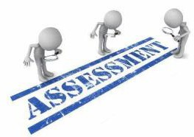
ASSESSMENT METHODS FOR BLOCK EXAM:
Evaluation is a continuous process comprising of block examination and annual university examination. Students will be evaluated throughout the year. The internal assessment will contribute towards the ﬁnal examination scores.
Multiple examination methods including MCQs, SAQs, OSPE and viva will be used. In line with PMC stipulation, the pass/fail marks for the test and examination will be 50%.
At the end of each block there will be an exam

Theory (knowledge):
MCQs (Multiple Choice Questions) and SAQs (Short Answer Questions) are used to assess the theory part for the block exam.

MCQ:
      - A MCQ has a statement or clinical scenario followed by four options (likely answers).
      - After reading the statement/scenario student select ONE, the most appropriate answer/response from the given list of options.
      - Correct answer carries one mark, and incorrect ‘zero mark’. There is NO negative marking.

SAQ:
SAQ are open ended questions that requires students to create an answer. They are commonly used in examinations to access the basic knowledge and understanding of a topic.

OSPE:
Objective Structured Practical Examination (See the proposed plan of OSPE)
- It may comprise between 12- 25 stations.
- The content may assess application of knowledge, or practical skills.
  - Student will complete task in deﬁne time at one given station.
  - All the students are assessed on the same content by the same examiner in the same allocated time.
  - A structured examination will have observed, unobserved, interactive and rest stations.
  - Observed and interactive stations:
They will be assessed by internal or external examiners through the task or viva.
  - Unobserved station:
It will be static station in which students will have to answer the questions related to the given pictures, models, or specimens on the provided response sheet.
  - Rest station:
It is a station where no task is given, and during this time student can organize his/her thoughts.

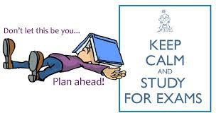

BLUEPRINT OF THE ASSESSMENT FOR BLOCK EXAM
Component from BLOCK EXAM= Theory and Practical: 140+140
Component from Internal Assessment= Theory and Practical 60+60
Theory=600 Marks Practical=600
Total Marks: 1200
MODULE/BLOCK |  |  | BLOCK – IV |  |  |  |  | BLOCK – V |  |  |  |  |  | BLOCK – VI
 |  |  | Module- 7 |  | Module-8 |  |  | Module-9 |  |  | Module-10 |  |  | Module-11 |  |  | Module-12
Professional Examination | Theory Marks |  | 100 |  | 100 |  |  | 100 |  |  | 100 |  |  | 100 |  |  | 100
Professional Examination |  |  | 200 |  |  |  |  | 200 |  |  |  |  |  | 200
Professional Examination | Practical Marks (OSPE) |  | 200 |  |  |  |  | 200 |  |  |  |  |  | 200
Professional Examination | Internal Assessment-IA |  | Theory: 60 Practical:60 |  |  |  |  | Theory: 60 Practical: |  |  |  |  |  | Theory: 60 Practical:60
Professional Examination | Subject wise distribution | Subjects | MCQ# | SAQs# | OSPE Stations | viva |  | MCQ# | SAQs  # |  | OSPE Stations# | viva |  | MCQs  # | SAQs  # |  | OSPE Stations | viva
Professional Examination | Subject wise distribution | Dental materials | 23 | 3 | 5 | 15 |  | 23 | 3 |  | 5 | 15 |  | 23 | 3 |  | 5 | 15
Professional Examination | Subject wise distribution | Community dentistry | 23 | 3 | 5 | 15 |  | 23 | 3 |  | 5 | 15 |  | 23 | 3 |  | 5 | 15
Professional Examination | Subject wise distribution | Pharmacology | 23 | 3 | 5 | 15 |  | 23 | 3 |  | 5 | 15 |  | 23 | 3 |  | 5 | 15
Professional Examination |  | Pathology | 23 | 3 | 5 | 15 |  | 23 | 3 |  | 5 | 15 |  | 23 | 3 |  | 5 | 15
Professional Examination |  | TOTAL# | 92  (I mark each) | 12  (4 marks each) | 20(4 marks each)  =80 | 60 |  | 92  (I mark each) | 12  (4 marks each) |  | 20(4 marks each) =80 | 60 |  | 92  (I mark each) | 12  (4 marks each) |  | 20  (4 marks each) =80 | 60
Professional Examination |  | Total | 92 | 48 | 140 |  |  | 92 | 48 |  | 140 |  |  | 92 | 48 |  | 140
Professional Examination | Total(theory+practiacl) |  | 140 |  | 140 |  |  | 140 |  |  | 140 |  |  | 140 |  |  | 140
 | Internal Assessment |  | 60 |  | 60 |  | 60 |  |  | 60 |  |  | 60 |  |  | 60
 | Total marks |  | 200 |  | 200 |  | 200 |  |  | 200 |  |  | 200 |  |  | 200
 | Total Marks |  | 400 |  |  |  | 400 |  |  |  |  |  | 400
Grand total | 1200

INTERNAL ASSESSMENT MARKS DISTRIBUTION
THEORY INTERNAL ASSESSMENT  15 MARKS |  |  | PRACTICAL INTERNAL ASSESSMENT  15 MARKS
ATTENDANCE  5 MARKS | ASSIGNMENTS AND PRESENTATIONS  5 MARKS | BEHAVIOUR /DISCIPLINE  5 MARKS | ATTENDANCE  5 MARKS | LOG BOOK  5 MARKS | BEHAVIOUR  5 MARKS
91 and above  5 marks  B/W 86% to 90%=  4 marks  B/W 81% to 85%=  3 marks  76% to 80%= 2 marks  75%= 1 mark | Grade A=5 marks  Grade B= 3 marks  Grade C= 1 mark  No assignments or presentations =0 marks | No misbehave or warning in lectures = 5 marks  Written warning given to student = 0 marks | Above 90%=  5 marks  B/W 85% to 90%=  4 marks  B/W 80% to 85%=  3 marks  75% to 80%= 2 marks  Upto 75%= 1 mark  Below 75 % = 0 marks | Completed and timely signed =5 marks  Completed and late submission=3 marks  Incomplete= 1 mark  No logbook =0 marks | No misbehave or warning in practical class= 5 marks  Written warning given to students= 0 marks

LEARNING RESOURCES
SUBJECT | RESOURCES
PATHOLOGY | Textbook:  Robbins Pathology  Reference book:  Levinson
PHARMACOLOGY | Textbook:  Basic and Clinical Pharmacology, Katzung  Reference Books:  - Lippincott Illustrated Reviews.  - Rand and Dale’s Pharmacology
COMMUNITY & PREVENTIVE DENTISTRY | Textbook:  S.S Hiremath, Textbook of Preventive and Community Dentistry.  Reference Book:  - Blainaid Daly, Richard Watt, Essentials of Dental Public Health.  - Jong’s Community Dental Health, George M.Gluck  - Joseph John, Preventive and Community Dentistry  - Community Oral Health, Cynthia Pine, Rebecca Harris
DENTAL MATERIALS | Textbook:  Easy Approach Text by Dr. Tahir Khan and Dr. Amjid Naseer  Reference Book:  - Philips 11th edition  - Mccabe

OTHER LEARNING RESOURCES
Hands-on Activities/ Practical | Students will be involved in Practical sessions and hands-on activities.
Labs | Utilize the lab to relate the knowledge to the specimens and models available.
Videos | Video familiarize the student with the procedures and protocols to assist patients.
Computer Lab/CDs/DVDs  /Internet Resources | To increase the knowledge students should utilize the available internet resources and CDs/DVDs. This will be an additional advantage to increase learning
SDL | SDL is scheduled to search for information to solve cases, read through different resources and discuss among the peers and with the faculty to clarify the concepts

